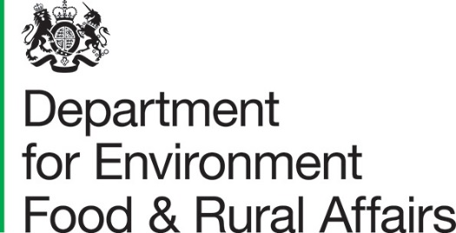

Note of the meeting of the UK Agricultural Market Monitoring Group, 12 March 2024

The UK Agricultural Market Monitoring Group comprises representatives from Defra, DAERA, Scottish Government and Welsh Government.

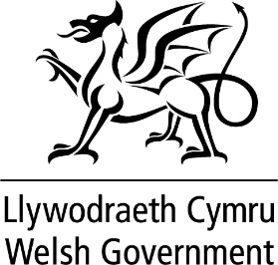

Contents
Introduction 3
Key points: Market situation​ 3
Intervention scheme announcements 3
Overview and market updates 3
Sector discussions 4
Eggs 4
Poultry 4
Pigs 4
Arable 4
Horticulture 5
Beef 5
Sheep 5
Dairy 5
Any other business 6
Date of next meeting 6

Introduction
This note records the key points discussed at the meeting of the UK Agricultural Market Monitoring Group (UK AMMG) held on 12 March 2024. Present were representatives of Defra, Scottish Government, Welsh Government and DAERA (Northern Ireland). The meeting assessed issues impacting on the agricultural sector and reviewed the market situation across a range of UK agricultural commodities.
The publication of these notes is in the interest of preserving transparency and accountability. The accompanying data reports will be published on the same GOV.UK landing page.

Key points: Market situation​
The market situation is largely stable across all sectors, but this will continue to be monitored closely.

Intervention scheme announcements
There were no new market intervention schemes announced.

Overview and market updates
Exchange rates have been generally stable over the last month, showing little change from the monthly average, while generally sterling continues to be stronger than the same point last year.
Average prices in February 2024 remained relatively stable as global demand for oil remains muted. Organisation of the Petroleum Exporting Countries (OPEC+) production cuts are being extended into Q2 of 2024. Prices remain reasonably steady, tracking the slight increases seen in the oil price over the last month.
Another large fall in the price of Tile Transfer Facility (TTF) natural gas occurred as mild weather over the continent kept demand low.
Currently the supply of seasonal workers continues to be meeting demand with no labour supply issues reported.
The 3-month weather outlook suggests that both rainfall and temperature should be around the average for the time of year.

Sector discussions

Eggs
Average prices remained stable in quarter 4 of 2023 at 138.4p per dozen on average, remaining higher year-on-year (YoY).
Egg production from Q1 to Q4 of 2023 has shown a steady increase through the year, with a Q4 demonstrating a 6.4% increase on Q1.​
Weekly average layer egg settings for January 2024 are up 19% MoM, whilst chick placements were down 9.1% MoM following the usual seasonal trend of dipping towards the end of the year.

Poultry
The average EU broiler price is marginally down but stable within levels seen over the last 12 months.
Average weekly turkey slaughter figures are down month-on-month as expected for time of year. A high percentage increase YoY is shown but overall slaughter numbers are lower.
Turkey continues to be a less popular meat for consumers and demand continues to decline.

Pigs
In December 2023 UK weekly pig meat production was 16.2 thousand tonnes of pigmeat, a 17% decrease YoY.
Deadweight pig prices have remained stable in February, at historically high levels.
In January 2024 weekly clean pig slaughter was up on the month but down 2.7% on the year.
Total pig meat import volumes for 2023 fell by 2.5% compared to 2022. Exports of pig meat remain low compared to previous years. For 2023, exports of pig meat were down by 20% when compared to 2022.

Arable
The final estimate of the UK 2023 wheat crop is down 10% from 2022 and the lowest since 2020. However, a lack of export competitiveness means the UK is looking at the unusual situation of larger end of season stocks despite a smaller crop.
Total availability of barley in 2023/24 is lower than 2022/23 levels largely due to a fall in production. Much like wheat however, despite a tighter balance on the year, reduced exports, and concerns over the 2024 crop, leave the heaviest ending stocks since 2014/15.
Defra will continue to closely monitor imports of sugar in light of worldwide trends.

Horticulture
There is an upward trend in the price of apples as we approach the end of the season alongside an increase in the yearly trend.​
Strawberries and raspberries have significantly increased prices from the same time last year as we are currently relying more on imports.
The price of onions has fluctuated over the last month, initially there was low supply but this has increased in the last week.​
Tomato prices remain high over the last month and the upward trend from last year has continued.​

Beef
The UK's beef market rose in January 2024, with production levels increasing 20% compared to December, which marks a 5.3% YoY increase.
For prices in February 2024, deadweight prime cattle continue to remain historically high, trading 4.2% higher YoY. Prices continue to significantly surpass the 5-year average.

Sheep
In January 2024, sheep production totalled 23,200 tonnes, which marks a 2.8% increase YoY, but down 0.3% compared to the 5-year average.
In January 2024, sheep slaughter totalled 1.139 million heads, an 8.2% YoY decline. Clean sheep slaughter for 2023 was 12.28 million head, up 0.2% from 2022.
Sheep prices continue to surge, exceeding traditional seasonal increases for this period.
Australian imports in 2023 increased by 18%, while those from New Zealand decreased 19%.

Dairy
UK January 2024 farmgate milk price (FGMP) of 37.7ppl is down very marginally month-on-month, and down 27% YoY.
UK milk supply has generally been contracting YoY since October 2023 which should provide some support for FGMPs.
Actual Milk Price Equivalent (AMPE) has fallen back while Milk for Cheese Value Equivalent (MCVE) have risen again, albeit from a low base. Broadly UK markets and margins remain delicately balanced with many FGMPS unchanged for February 2024 and March 2024: there have been some small increases, but no falls.

Any other business
No other issues were raised.

Date of next meeting
The next scheduled meeting of the UKAMMG will take place on 14 May 2024.

© Crown copyright 2023
This information is licensed under the Open Government Licence v3.0. To view this licence, visit www.nationalarchives.gov.uk/doc/open-government-licence/
This publication is available at www.gov.uk/government/publications
Any enquiries regarding this publication should be sent to us at
UKAMMGSecretariat@defra.gov.uk
www.gov.uk/defra

