Application Decision
by Harry Wood
Appointed by the Secretary of State for Environment, Food and Rural Affairs
Decision date: 2 April 2024

Application Ref: COM/3329745
Redhill and Earlswood, Land at Linkfield Street, Redhill, Surrey, RH1 6BY
Register Unit Number: CL 39
Commons Registration Authority: Surrey County Council

- The application, dated 10 September 2023, is made under Section 38 of the Commons Act 2006 (the 2006 Act) for consent to carry out restricted works on common land.
- The application is made by Lisa Robertson and Simon Greengrass.
- The works comprise:
The creation of an approximately 2.5m by 2.8m brick paved accessway to the applicants’ property.

Decision
- Consent is granted for the works in accordance with the application dated 10 September 2023 and the plans submitted with it subject to the following conditions:

- the works shall begin no later than three years from the date of this decision;
- the land shall be fully reinstated within one month from the completion of the works.
- For the purposes of identification only the location of the accessway is shown by the orange area on the attached plan.

Preliminary Matters
- I have had regard to Defra’s Common Land Consents Policy Guidance (November 2015) in determining this application under section 38, which has been published for the guidance of both the Planning Inspectorate and applicants. However, every application will be considered on its merits and a determination will depart from the guidance if it appears appropriate to do so. In such cases, the decision will explain why it has departed from the guidance.

- This application has been determined solely on the basis of written evidence. I have taken account of the representations made by the Open Spaces Society (OSS) and Natural England (NE).

- I am required by section 39 of the 2006 Act to have regard to the following in determining this application:
- the interests of persons having rights in relation to, or occupying, the land (and in particular persons exercising rights of common over it);
- the interests of the neighbourhood;
- the public interest; Section 39(2) of the 2006 Act provides that the public interest includes the public interest in; nature conservation; the conservation of the landscape; the protection of public rights of access to any area of land; and the protection of archaeological remains and features of historic interest. And
- any other matter considered to be relevant.

Reasons

- The applicants explain that the purpose of the works is to allow for a vehicular accessway to be created from the highway to their property across a thin strip of common land. Currently access is only available via concrete steps.

The interests of those occupying or having rights over the land

- Reigate and Banstead Borough Council is the owner of the land who were consulted by the applicant and stated they had no objections to the project. The common land register records no rights on the land. Rights were previously recorded but have since been made void.

- The applicants advise that they are not aware of any rights being carried out over the land.

- I am satisfied that all consultation required by the applicants has been completed and no comments were received.

The interests of the neighbourhood and public access
- The interests of the neighbourhood relate to whether the works will unacceptably interfere with the way the common land is used by local people and is closely linked with interests of public access. The creation of the accessway would have no negative affect on access to the common. It is planned to be a flat surface made of brick which would not offer impediment to or across the common.

- The section of land identified as the location for the accessway appears to have low recreational value. As detailed in photos from the applicants, it is a steep mud bank with grass and ivy coverage and a holly hedge. The applicants have stated they are not aware that anyone uses this section of land for any recreational purposes and it appears to be mostly overgrown.

- NE have stated they do not believe the works will have any adverse affect on public access.

- OSS have not commented on any affect the proposed works would have on the interests of the neighbourhood and public access.

- In this case the brick accessway will introduce a new permanent feature into the common. I believe the works will offer little improvement to the common other than the direct benefit to the applicants and providing a better walking surface over the accessway. The works will also have minimal impact on the recreational value of the common and the works will not unacceptably interfere with the interests of the neighbourhood or public rights of access.

The public interest
- As well as the public interest in the protection of public rights of access, the Guidance (November 2015) outlines the public interest in nature conservation, the conservation of the landscape and the protection of archaeological remains and features of historic interest.

Nature conservation and Conservation of the landscape
- NE advises that the site is not subject to any statutory or non-statutory designations for nature conservation however they expect that the conditions set out by the planning authority to manage and maintain the holly hedge and planting will be adhered to. In response, the applicants have stated they will adhere to these requirements.

- The common has no special designated landscape value.

- The proposed works will introduce new permanent artificial features as the current bank will be flattened and paved with brick to create the accessway.

- This will lead to a small loss in the commons’ natural areas and have a small impact on the visuals of the common. However, this part of the common is not noted as having any particular natural value, with the vegetation being unkept and overgrown. Additionally, the holly hedge is planned to be retained and further maintained by the applicant. The accessway will be in keeping with the other artificial features present on the common and would not block any views of the wider common.

- I am satisfied that nature conservation interests will not be harmed by the proposed works and I consider that overall the works will have only a small impact on landscape interests.

Protection of archaeological remains and features of historic interest.
- The applicant has stated that there are no archaeological features within the proposed works area. Historic England and the local authority archaeological service have been consulted and did not comment.

- There is no evidence before me to suggest that these interests will be harmed by the proposed works.

Other relevant matters

- OSS refer to section 11 of the Surry Act 1985 which sets out constraints to works on the common and that it is for the Council, in this case, Reigate and Banstead Borough Council, to authorise any works on this common. OSS consider that the wording of section 11 may prevent any restricted works on this part of the common from taking place or, alternatively, they may only go ahead with the consent of the Council. Consequently, the case is made that any consent under section 38 of the Commons Act 2006 would be of no effect in relation to the statutory context of this common and the Secretary of State should not grant consent for works which either do not require consent or are incapable of being given lawful effect.

- The Planning Inspectorate (PINS) take the view that it is for the person wishing to carry out the works to decide if section 38 consent is necessary and to seek any separate consents that may be required. It would not be appropriate, in the absence of a legal determination, to reject an application on the basis that a third party considers it unnecessary. OSS raise the issue that any section 38 consent given would be incapable of being given lawful effect, although OSS do not rule out the possibility that the regulator of the Surrey Act 1985 might be empowered to consent to the works if such consent were to be sought.

- In this case the applicant has acquired an easement and further planning permission from Reigate & Banstead Borough Council permitting the works to be carried out. From the evidence provided the Council appear fully aware of the planned works and have not offered any objection to the works detailed in this consent.

- PINS have emphasised prior to and during the application process that the applicant is responsible for seeking any further permissions that may be required to carry out restricted works. In this instance there is no reason before me why the submitted section 38 application should not be determined.

Conclusion

- Defra’s Common Land Consents Policy advises that ‘where it is proposed to construct or improve an access way across a common, such an application may be consistent with the continuing use of the land as common land, even where the access way is entirely for private benefit, because the construction will not in itself prevent public access, or access for commoners’ animals. The Secretary of State takes the view that, in some circumstances, a paved access way may be the only practical means of achieving access to land adjacent to the common and I am satisfied that the policy applies is this case.

- I conclude that the proposed works will enable the required access to the applicants’ property without unacceptably harming the interests set out in paragraph 5 above. Consent is therefore granted for the works subject to the conditions set out in paragraph 1.

Harry Wood

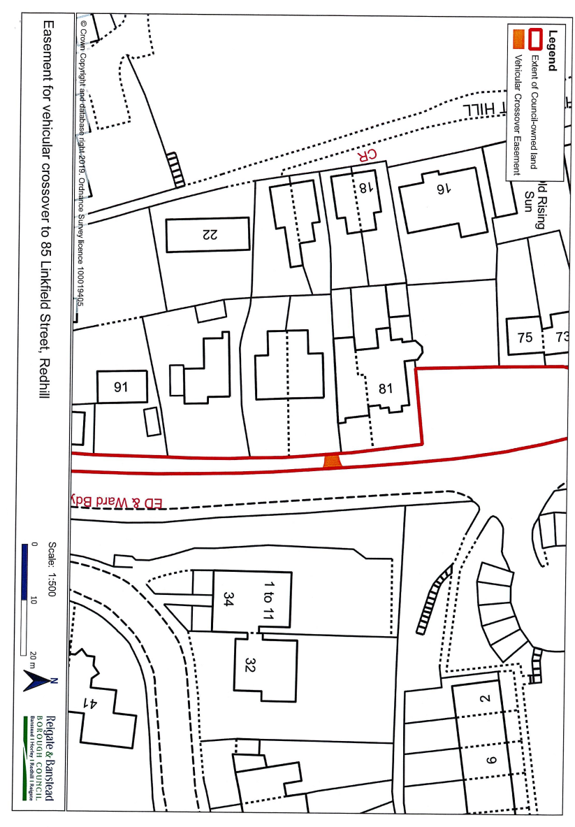
Plan 1 – Accessway through common land

