Application Decision
by Harry Wood
Appointed by the Secretary of State for Environment, Food and Rural Affairs
Decision date: 26 March 2024

Application Ref: COM/3330933
Land in the Parish of Doddington, Primrose Hill, Doddington, PE15 0SU
Register Unit Number: CL 42
Commons Registration Authority: Cambridgeshire County Council

- The application, dated 27 September 2023, is made under Section 38 of the Commons Act 2006 (the 2006 Act) for consent to carry out restricted works on common land.
- The application is made by Savills for UK Power Networks.
- The works comprise:
- the laying of approximately 245m of underground electricity cable;
- the excavation of an approximately 710m² trench for the laying of the cable to be completed in approximately 50m sections;
- temporary fencing consisting of plastic safety barriers measuring approximately 1m high. A total of approximately 100m of fencing to be in place at one time.

Decision
- Consent is granted for the works in accordance with the application dated 27 September 2023 and the plans submitted with it subject to the following conditions:

- the works shall begin no later than three years from the date of this decision;
- the land shall be fully reinstated within one month from the completion of the works.
- For the purposes of identification only the location of the works area is shown by the red botted lines (power cables) on the attached plans.

Preliminary Matters
- I have had regard to Defra’s Common Land Consents Policy Guidance (November 2015) in determining this application under section 38, which has been published for the guidance of both the Planning Inspectorate and applicants. However, every application will be considered on its merits and a determination will depart from the guidance if it appears appropriate to do so. In such cases, the decision will explain why it has departed from the guidance.

- This application has been determined solely on the basis of written evidence. I have taken account of the representations made by the Open Spaces Society (OSS) and Natural England (NE).

- I am required by section 39 of the 2006 Act to have regard to the following in determining this application:
- the interests of persons having rights in relation to, or occupying, the land (and in particular persons exercising rights of common over it);
- the interests of the neighbourhood;
- the public interest; Section 39(2) of the 2006 Act provides that the public interest includes the public interest in; nature conservation; the conservation of the landscape; the protection of public rights of access to any area of land; and the protection of archaeological remains and features of historic interest. And
- any other matter considered to be relevant.

Reasons

- The applicant explains that the purpose of the works is to address safety issues with the overhead power lines that are currently in place. The overhead power lines are to be removed and replaced with the electricity cables detailed in this consent which are considered more reliable and require less maintenance. The excavation of the trench is required to lay the electricity cable and the fencing is required under health and safety grounds while the works are taking place.

The interests of those occupying or having rights over the land
- Rosemary Lydia Paxton is noted as the owner of the land. They have been consulted by the applicant and have provided no objection to the project. The common land register has no recorded rights.

- The applicant advises that no rights are carried out over the land.

- I am satisfied that all consultation required by the applicant has been completed and no comments were received.

The interests of the neighbourhood and public access
- The interests of the neighbourhood relate to whether the works will unacceptably interfere with the way the common land is used by local people and is closely linked with interests of public access. The common comprises of multiple separate sections of land with the Primrose Hill road running through them. It appears the common has little recreational value other than as a green space for walking. The electricity cables themselves will have no impact on public access being an underground feature and will not interfere with the way the common is currently used.

- The temporary fencing and excavation of the trench would have a larger impact, blocking access to the areas of the common where they are located. However, the impact will be minimal due to the works being completed in sections and the majority of the common will be accessible via other routes around the working area. I am satisfied that such fencing is appropriate on health and safety grounds and that it will be removed on completion of the works, which can be secured by attaching a suitable condition to the consent.

- NE have stated that they do not believe the works will have an impact on access to the common provided any fencing is removed when the works have been completed and the trenches are refilled. The applicant has confirmed this is their intent and is a condition of this consent.

- OSS have provided no objection to the proposed works.

- In this case the permanent features that are being introduced into the common are underground so will have no effect on the common once the works are completed. The electricity cables will provide wider benefit to the neighbourhood being a safer and more reliable way of supplying electricity to the neighbourhood. I conclude the works will have minimal impact on the recreational value of the common and the works will not unacceptably interfere with the interests of the neighbourhood or public rights of access.

The public interest
- As well as the public interest in the protection of public rights of access, the Guidance (November 2015) outlines the public interest in nature conservation, the conservation of the landscape and the protection of archaeological remains and features of historic interest.

Nature conservation and Conservation of the landscape
- NE advises that the site is not subject to any statutory or non-statutory designations for nature conservation. However, they have noted there are several mature and semi mature native trees present on the common and all necessary measures should be taken to avoid excessive damage to their root systems which could result in them being lost, along with their wildlife interest and the positive contribution they make to the landscape of the area.

- They continue by outlining that any trenches should be infilled with the same soil removed as part of the works and some reseeding may be required to encourage grass and other semi natural vegetation to cover exposed areas of bare soil. The applicant in response has stated that appropriate measures will be made to protect tree root systems. The trenches will be infilled with same soil as removed and re-seeding will occur if it is required.

- The common has no special designated landscape value.

- The proposed works will not introduce any new visible permanent artificial features as they situated underground or will be temporary in nature.

- The applicant has stated that once the works have been carried out that the land will be returned to its original condition. This will negate any visual impact on the common created by the works.

- I am satisfied that nature conservation interests will not be harmed by the works and I consider that overall, the works will have only a small impact on landscape interests while the works are carried out.

Protection of archaeological remains and features of historic interest.
- The applicant has stated that there are no archaeological features within the proposed works area. Historic England and the local authority archaeological service have been consulted and did not comment.

- There is no evidence before me to suggest that these interests will be harmed by the proposed works.

Other matters

- The applicant has outlined in their application that the purpose of the application is to install new electricity cables and remove the exiting overhead cables. This will likely occur at the same time as these works are undertaken however there is no requirement under Section 38 for consent to remove features from commons and therefore this is not listed in the works consent has been granted for in this case.

Conclusion

- Defra’s Common Land Consents Policy advises that “works may be proposed in relation to common land which do not benefit the common, but confer some wider benefit on the local community, such as minor works undertaken by a statutory undertaker (e.g. a water utility) to provide or improve the public service to local residents and businesses. Consent under section 38 may be appropriate where the works are of temporary duration (such as a worksite), where the works will be installed underground (such as a pipeline or pumping station), or where their physical presence would be so slight as to cause negligible impact on the land in question (such as a control booth or manhole), and the proposals ensure the full restoration of the land affected and confer a public benefit.”

- I conclude that the permanent works will benefit the local community by facilitating the removal and replacement of the existing overhead lines with more reliable electricity cables and remove the health and safety risk presented by the overhead lines. The permanent works will not seriously harm the other interests set out in paragraph 5 above. Consent for the works is therefore granted subject to the conditions set out at paragraph 1.

Harry Wood
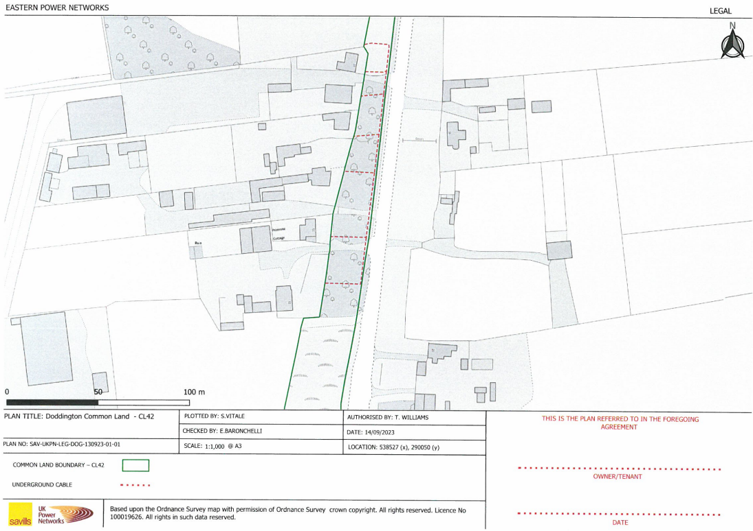
Figure 1 – Location of power cables

