Suspect pertussis in patients with a cough illness lasting 14 days or more without an apparent cause plus one of the following: (a) paroxysms of coughing; (b) inspiratory ‘whoop’; (c) post-tussive vomiting.
Testing for pertussis in Primary Care

All cases should be notified to your local HPT (insert phone number/email address). When notifying, it is helpful to let the HPT know if the case has had contact with pregnant individuals or children aged under 1 year, including through occupational exposure (e.g. healthcare or nursery settings).
Recommended tests for pertussis testing vary according to the length of time since cough onset:
- Less than 2 weeks from cough onset: PCR and culture
- Between 2 and 3 weeks from cough onset: PCR and culture and either oral fluid kit (if aged 2 to <17 yrs) or serology
- More than 3 weeks from cough onset: Either oral fluid kit (if aged 2 - <17 yrs) or serology
Sending a pertussis PCR test – free service

Insert local info:
Please submit samples to your local laboratory as per normal protocol. Samples will then be referred for Pertussis PCR detection by your local Public Health Laboratory (PHL). Pertussis PCR testing is not chargeable, when performed at a PHL. Please label clearly ‘for Bordetella pertussis PCR testing’
PCR testing can be performed on the following specimens:
- Throat swabs
Collected using a virology swab or dry swab in a sterile container
- Pernasal swabs
Use a dry swab with a flexible wire shaft and a rayon / Dacron / nylon bud. A rigid shaft is not suitable. Push the swab along the floor of the nasal cavity, as far towards the posterior wall of the nasopharynx as possible.
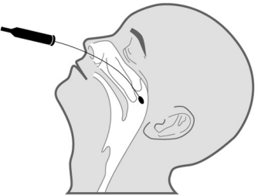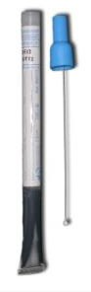
- Nasopharyngeal swabs
Use a dry or Copan style nasopharyngeal swab. See the following link for further guidance:
CDC video how to take a nasopharyngeal swab.
- Nasopharyngeal aspirate
Provide not less than 400 microlitres in a sterile container. See the following link for further guidance: CDC video how to take a nasopharyngeal aspirate.
Managing cases
If 3 weeks or less from cough onset, treat with appropriate antibiotics once PCR and culture tests have been taken. Exclude the case from school/work until they have completed 2 days of the antibiotic course. Work with the local HPT to identify and manage vulnerable close contacts. There is no need to prescribe a second course of antibiotics even if symptoms are not resolving.

If more than 3 weeks from cough onset, antibiotics are not required to manage pertussis even if the case still has symptoms. No exclusion of the case is necessary.
Further information is available in the Pertussis guidelines for public health management on the testing for and management of pertussis or please call your local HPT for further advice (insert relevant contact details)
Sending a pertussis serology test
For cases not aged 2 years to less than 17 years, a charged-for serology test using serum can be arranged via your local laboratory, either undertaken by them or then sent on to the Respiratory and Vaccine Preventable Bacteria Reference Unit (RVPBRU). Form R3 can be used.

Note that serology is not recommended if the case has been immunised against pertussis in the previous year as a positive result cannot be interpreted.
Requesting an oral fluid kit – free service
For cases aged 2 years to less than 17 years, notify the case to your local HPT and they will post an oral fluid kit (OFK) directly to the case.

Note that oral fluid testing is not recommended if the case has been immunised against pertussis in the previous year as a positive result cannot be interpreted.
Sending a pertussis culture
A nasopharyngeal swab or pernasal swab may be taken for culture. The swab should be placed in a culture medium (ideally charcoal) and submitted to your local microbiology lab. Please clearly label as ‘for pertussis culture’.

