

This information is not meant to be definitive, and is not a substitute for independent legal advice. Neither Her Majesty’s Government nor its staff take any responsibility for the accuracy of the information, nor accept liability for any loss, costs, damage, or expense that you might suffer as a result of relying on the information. The information contained in this guide is general and factual. You should contact local lawyers for independent legal advice (see page [19]).
Information Pack for British Nationals detained or imprisoned in Israel
British Embassy Israel
March 2024

Contents

Chapter 1: Key points
- Overview
- First Steps

Chapter 2: Detention conditions in Israel
- Visits
- Police custody and initial arrival at prison
- Prison: conditions and daily life
- Prison: access to help and services

Chapter 3: the Israel judicial system
- Overview and first steps
- Trial and legal assistance
- Reaching the end of your sentence

Chapter 4: Additional Information
- Additional Information
- Prisoners Abroad
- Glossary of Terms
- Annexes

Chapter 1: Key Points
Overview

If you are a British national, and are arrested or detained in another country, consular staff will do what they can to help you, but they cannot interfere with the local justice system, get you out of jail, or pay for services such as a lawyer. Information about who we can help, including the circumstances in which we can assist dual nationals, is available at: Support for British nationals abroad.
This detention information pack is designed to give you, and your family and friends, information about the local system in Israel and who can help. A printed copy is provided to those in prison or in custody, and an online version is available at: https://www.gov.uk/government/publications/israel-prisoner-pack
We welcome feedback to help us improve the information we can provide to others.

Contacting us

If you are arrested or detained in another country:

- The authorities should ask whether you want them to contact the British Embassy (and must do so if you want them to).

- Even if they do not ask, you can make the request yourself, and should do so, particularly if you are charged with a serious offence or need any kind of assistance.

- Friends or family can also contact the local British Embassy/Consulate or the Foreign, Commonwealth and Development Office (FCDO) in London on +44 (0)20 7008 1500.
In some countries, the authorities might notify the British Embassy/Consulate even if you don’t want anyone to know that you have been arrested. This is because there may be an agreement in place with the British Government which requires a mandatory notification to be made.

Who are the Consular Representatives?
Sigalit Salway – Vice Consul
Pnina Simchovitz – Pro Consul
192 Hayarkon Street, Tel Aviv 6340502
Telephone: 00 972 3 7251222, Fax: 00 972 3 5249176
Website: https://www.gov.uk/government/world/israel

You can also contact us by phone 24/7 for help or advice from anywhere in the world by calling the Foreign, Commonwealth and Development Office on 0207 008 1500.

What we can do
The FCDO can offer you impartial and non-judgemental help. Once notified of your arrest or detention, consular staff will aim to contact you as soon as possible so that we can assess how we can help you. We then aim to provide assistance according to your individual circumstances and local conditions: our priority is to provide assistance to those British nationals overseas that need our help the most.
In Israel notification by the authorities to the Embassy normally takes place several days after arrest, once we are notified, we aim to contact you as soon as possible.

We can also:
- provide a list of local English-speaking lawyers and interpreters].
See also page 31.
- provide general information about the country, detention conditions, and the local legal system (including if legal aid is available)
- provide general information about the local prison or remand system, including visiting arrangements, mail and censorship, privileges, and welfare services.
- keep in regular contact with you, either by visiting or by telephone/letter. The frequency of contact will depend on local conditions and your personal circumstances.
- tell the police or prison doctor, with your permission, about any medical or dental problems including medication.
- put you, or your family, in touch with a prisoners’ welfare charity called Prisoners Abroad.
- in some circumstances we may be able to help take up complaints with the police or prison authorities about ill treatment, personal safety, or discrimination, if you are not treated in line with internationally recognised standards.
- help to transfer money to you from your friends or family. In places where phone or postal services aren’t available, we can also pass on messages and deliver letters to the prison (but generally we cannot arrange for delivery directly to you – see page [15]).
- in some circumstances we may be able to help you apply for a transfer to a prison in the UK.

What we can’t do
- get you out of prison or detention.
- help you get special treatment.
- offer legal advice, start legal proceedings or investigate a crime.
- pay for any costs as a result of being arrested.
- forward you packages sent by friends or family.
- prevent authorities from deporting you after release.
First Steps

Can you / will you tell my family?
If you want us to, we can tell your family or friends that you have been detained and can provide them with information about how to contact you in prison or detention. With your consent, we can also keep them updated on your well-being.
If you are not sure about informing your family, we can help you consider the impact that not doing so might have. For example, it may cause them distress if they do not know where you are, or cannot contact you. It can also be a disadvantage to you if you need someone to send you money or act on your behalf while you are detained.
Will the UK Police be informed?
If you are accused of certain serious offences, such as sexual assault or drugs trafficking, we are obliged to share information about your arrest with UK police. It is therefore possible that information about this may appear if a Criminal Records Bureau check were carried out by a prospective employer. There may be other circumstances in which information about you may need to be shared by ourselves or authorities in Israel.
Do I need a lawyer? / How can I find a lawyer?
Although we cannot give legal advice, start legal proceedings, or investigate a crime, we can offer basic information about the local legal system, including whether a legal aid scheme is available. We can give you a list of local interpreters and a list of local English-speaking lawyers is attached to this pack. See also page 31.
You will want to consider the benefits of local legal representation and to discuss all the costs beforehand with the legal representative. In no circumstances can we pay your legal or interpretation costs.

Can you get me out?
We cannot get you out of prison or detention, nor can we get special treatment for you because you are British. However, if you are not treated in line with internationally accepted standards we will consider whether to approach local authorities. This may include if your trial does not follow internationally recognised standards for fair trial or is unreasonably delayed compared to local cases.
Who else can help me?
We can put you, or your family, in touch with Prisoners Abroad, a UK charity which supports British citizens detained overseas and their families: www.prisonersabroad.org.uk

Chapter 2: Detention conditions in Israel

Visits – friends and family

Can my family and friends visit me? How can I arrange a visit?
Regular visit times are Saturdays and Sundays, 09:00-12:00 and 14:00-16:00, and Friday, 09:00-14:00. The prison commander may determine additional visit days, subject to approval by the head of district. Visit hours vary from prison to prison; therefore visitors must verify that these details are up to date prior to arrival.

How many visits am I allowed?
A prisoner may be visited once after he has served the first three months of his incarceration period and then once every two months.
A detainee against whom charges were pressed has the right to be visited once a week for six months. A detainee against whom charges have yet to be pressed may not be visited unless approval is given by the person in charge of the investigation.
Frequency of visits for those who were sentenced to time in prison shall be as follows: criminal and security sentenced prisoners – once every two weeks.
Visits by a foreign resident (besides residents of the Palestinian Authority) who is a first or second degree relative of the prisoner, may take place up to twice a year.

Consular visits
The Consul or a member of her staff aim to contact you (by telephone or in person) within 24 hours of notification of your arrest. We will try to visit you as soon as possible afterwards, ideally within 48 hours, if you wish us to do so. If you are sentenced and are serving a prison sentence, we will visit you at least twice a year, unless there are specific reasons to visit you more frequently.

What can visitors bring?
Articles allowed to be brought in by the family for the prisoner:
- Dark coloured trousers and light coloured shirt
- Socks (up to 6 pairs)
- Towels (3)
- Underwear and undershirt (6 pairs)
- Pyjamas (2)
- Sport trousers
- Training suit
- One wool blanket
- Pillowcases (2)
- Bed sheets (2)
- Cushion (1)
- Reading/studying books (4) – subject to approval by an education officer
- Prayer mat
- Religious objects
- Tefillin
- Talit
- Wedding ring
- Photos and documents (up to 5 per visit)
Police custody and initial arrival at prison

Arrival at the police station & basic rights

A suspect will be interrogated in his language or in a language s/he understands and speaks. Interrogation of a suspect usually takes place at a police station, unless a police officer believes that interrogation at the police station is not possible or there exists an urgent need to conduct the interrogation elsewhere. Every interrogation must be documented visually or verbally (either by video or audio recording) or in writing.
An attorney may not be present in the interrogation room or during the interrogation itself. In most cases, the interrogation will include the taking of the suspect’s fingerprints, photographs and saliva specimens.

First steps if arrested

You will be brought before a Magistrate within 24 hours (or under certain circumstances within 48 hours if the arrest is by a police officer), for the extension of your remand or release.
If you are detained for overstaying your visa or for working illegally, there is no need for you to be brought before a Magistrate. You will be brought before a Detention Tribunal judge, usually at the place where you are being held. The hearing will relate only to the detention and you may appeal the decision given at the hearing to the Administrative Court. A deportation or removal order, if issued, can only be implemented after 72 hours (unless you agree to leave before the 72 hours are up or unless the Border Control Supervisor has agreed to postpone the deportation or removal for humanitarian reasons). During the 72 hours, you have the right to file a petition against the deportation or removal order to the Administration Court.

Right of representation/consultation

A suspect arrested by the officer in charge at a police station must be advised immediately of the reason for the arrest, of his right to notify a relative and an attorney of the arrest and of his right to meet an attorney. He shall also be advised immediately of his right to apply for representation by a public attorney (legal aid), in accordance with specified provisions of law. According to those provisions, the right to representation by a public attorney arises in the following cases:
- the suspect is less than 16 years old (and has been brought before a court which is not a Juvenile Court); or
- is suspected of having committed a murder; or
- is dumb, blind or deaf; or
- a concern exists that the suspect is mentally disturbed, lacks intellectual capacity or lacks financial means; or
- an application has been filed for the suspect’s extradition; or
- a suspect has been arrested for extradition purposes.

Prison: conditions and daily life

An accused found guilty of an offence or issued with a court order of arrest will be transferred to prison directly from the court or from the police detention quarters.
Upon arrival at the prison, a prisoner will undergo a physical examination and his personal belongings will be taken into custody (money, clothes and other prohibited items). He will then undergo a medical examination within 48 hours of his arrival at the prison as well as a social and intelligence examination. In certain cases, he will also undergo a mental, drug and employment examination. Every prisoner will be supplied with clothing and personal equipment.

The rules of separation prescribe the separation of women and men, adults and minors, prisoners who use drugs and prisoners who do not use drugs, physically or mentally ill prisoners and healthy prisoners, criminal prisoners and prisoners convicted of crimes against the security of the State, violent and dangerous prisoners and non-violent prisoners. A prisoner may be held in separate confinement for the purposes of national security, the security of the prison, maintaining a prisoner's health, maintaining discipline in the prison and to prevent violence in the prison.

Disciplinary and restraining measures include the use of reasonable force, the use of tear gas, hand and leg cuffing, use of weapons, separation and denial of benefits.
Saturdays and holidays are regarded as full rest days for prisoners. Search
Wardens may carry out a body search of prisoners at any time, provided that the search is
required for the purpose of maintaining national security or for preserving order and discipline in the prison. A body search of a prisoner or the visual examination of a prisoner’s naked body is permitted with the prisoner's consent or with the approval of an authorised officer.
A warden may also conduct a body search of a person visiting the prison, in order to prevent the entry of forbidden objects into the prison.

Isolation
An inspection of a prisoner who has been placed in isolation will be carried out by a paramedic on a daily basis and by a doctor once a week. Such confinement will not prevent a prisoner from sending letters or from filing a complaint or application. A prisoner in isolation will receive meals equivalent both in quality and quantity to those given to all other prisoners.
Religious Services
Every prisoner has the right to observe religious faith and customs. Persons serving as representatives of a particular faith are permitted to visit prisoners of that faith who may wish to obtain religious services and participate in prayer services.

Jewish prisoners:
Every prison has a program of Jewish religious activities, holds Jewish seminars, provides the prisoners with a supply of religious equipment and holy artefacts, operates religious rehabilitation programs, which include travelling seminaries and has separate sections for religious prisoners. Further, every prison has a synagogue and a rabbi who is responsible for the maintenance of Jewish dietary laws (Kashruth) and for conducting religious activities in the prison.

Muslim prisoners
Muslim prisoners may say their five daily prayers in their cells, with each of the five daily prayers lasting 30 minutes. Prior to the special public prayers on Fridays, which last an hour, a 20 minute sermon takes place. The prison designates a special public area for the purpose of holding the special Friday prayers.
On Muslim holidays, a Muslim prisoner may engage in special prayers, as prescribed by religious observance and custom.

Christian prisoners
Christian prisoners may say their prayers in their cell. On Sundays and holidays Christian prisoners may say their prayers alone or in a group.
Prayers on Sundays and on holidays are held in a public area, specially designated for this purpose by the prison.

How can I receive money?
The accounts department of each prison runs the prisoner’s deposit books. The following valuables and money are registered in the books:
  - Monies that were in the prisoner’s possession at the time of absorption.
  - Monies deposited by the family in his Postal Bank account.

Money can be deposited or withdrawn as recorded in the deposit book .A prisoner makes a request in writing to make a purchase. He may check his financial balance through the wing manager.

A prisoner’s family may deposit money in his account by deposit through the Israeli Postal Bank. The deposit sum shall be limited (depends on local prison orders). The wing manager can provide the account number (Kantina No.).

For family abroad who do not have access to the Israeli Postal Bank, money can be transferred through the FCDO account and consular staff in country will make the deposit on your behalf.

On the day of release, a prisoner shall be given the monies and valuables in his deposit.

Can I work or study in prison?
Every prisoner is obliged to work. A prisoner who refuses to work and whose refusal is not due to health considerations that have been confirmed by a doctor, will be put on disciplinary trial, which may result in him being denied some or all benefits.
Prisons usually provide suitable employment for each prisoner, often in manufacture-related employment.
A prisoner has the right to receive a salary for work performed, will be paid monthly into his deposit account.
Every prisoner is entitled to a weekly rest day and will not be required to work on the rest day or holidays.

Rehabilitation works
Rehabilitation work is work for which consideration is received or which involves participation in a rehabilitation educational program outside the perimeters of the prison, where leaving the prison is without accompaniment by a warden. The ability to go out and perform rehabilitation work is on the recommendation of the Rehabilitation Committee which operates in the prison.

Outside employment
Outside employment is work for which consideration is received or which is conducted as part of an educational program outside the perimeters of the prison, where leaving the prison to attend such employment is performed either individually or as part of a group, under the supervision of a senior warden. Outside employment is permitted only to prisoners who have already taken vacation from the prison, whose conduct is normal and whose presence outside the prison will not endanger the public peace or the security of the State.

Education
The prison operates an educational system that includes education, supplementary education, cultural events and pedagogic programs, carried out by the prison education officer and social instructors. Illiterate prisoners will be preferred for participating in educational courses. Prisoners studying in the various educational programs will be awarded a scholarship for their studies.
Every prison operates a library for the prisoners’ use.
In addition, based on his or her daily conduct and security restrictions, a prisoner may enrol in a correspondence study program, receive textbooks and study materials from his or her family, receive reading books, party games, journals, etc, from his or her family or may purchase these items through the prison.

Can I receive medical and dental treatment?
A prisoner is entitled to receive medical treatment. This is an intrinsic right, which cannot be revoked.
Each prison has a clinic, which operates throughout the entire day. Every prison has a general physician and a dentist. A Medical Centre is located in the central district.
A prisoner should provide correct and up-to-date information about his medical condition so that he can receive proper medical treatment.
In urgent cases requiring the transfer to a hospital, an inmate will be transferred to the nearest hospital to the prison.
In case of danger to the health or life of a prisoner, force may be used to carry out a doctor's orders.

Initial medical service
General practitioners provide medical services to inmates through clinics located in the prisons and detention centres five days a week during working hours. Medics are available in the clinics 24/7.
Any treatment, action or contact with a prisoner is documented and registered (including telephone consultation or a refusal by the team to provide or by the inmate to receive treatment).

Medical Consultants and physical rehabilitation
Services are provided within the prisons, hospitals and community centres according to clinical guidelines and doctors’ recommendations.
Consultant medical services include a variety of areas, such as: orthopaedics, dermatology, EEG, neurology, and - in rehabilitation - physiotherapy, occupational therapy, etc. Imaging services include photo imaging, ultrasound, etc.

Dentistry
Dentists perform dental services with the help of assistants. Treatments given at clinics include first aid, preservative and rehabilitative treatments. Treatment is based on the doctor's clinical decisions and the status of the inmate (detainee or prisoner).

Food and Diet
Meals are served three times a day, at regular hours.
A prisoner with special dietary needs will be referred to the clinic supervisor.

Mail/Parcels
A prisoner is entitled to send and receive letters through the Wing Director. A letter can only be sent through the prison.
Prisoners pay for postage.
The prison administration may open and examine any letter sent or intended for an inmate, if it seems suspicious.
A civilian visiting a prison may not receive a letter.

Can I make telephone calls?
An inmate will be allowed to use the pay phone installed in the prison. Phone privileges are a benefit, and can be revoked.

Leisure and entertainment
As mentioned above in education paragraph, page 11.

Drugs
Prisoners caught using, smuggling or trafficking drugs will be brought before criminal proceedings and will be denied the opportunity to go on vacations.
Prisoners using drugs are encouraged to approach the treatment agents within the prison and request assistance in drug rehab.
If a prisoner has stated that he uses drugs and is interested in quitting and participating in a therapeutic program, no criminal or disciplinary measures will be taken against him.
Rehab centres and different rehab programs operate within the prisons

How can I make a complaint about mistreatment?
Filing a Complaint
Prisoners are entitled to submit a complaint to the Prison Commander about the conditions of their imprisonment.

Official Comptroller
An Official Comptroller is a judge or another position holder, appointed by the Minister of Internal Security as a comptroller. His function is to visit the prisons and to examine the living conditions of the prisoners and the way they are treated.
A prisoner may appeal to the Prison Commander to meet an Official Comptroller. An Official Comptroller is allowed to speak to any prisoner.
After a visit, the Comptroller prepares a report which is sent both to the Legal Advisor to the Government and to the Prison Service.

Ombudsman
A prisoner is entitled to lodge a complaint with the Ombudsman.
The complaint will be sent in a sealed envelope. The prison administration is not allowed to open the envelope and will deliver it to the Ombudsman.

Petitioning the Court
A prisoner may petition the court about any matter relating to his imprisonment.
The petition will be transferred to a District Court presiding over the jurisdiction of the prison, where the prisoner is held at the time.
The prisoner must pay any fees or shipping expenses for the petition.

Chapter 3: the Israeli judicial system

Overview and first steps

Is the system the same as the UK?
The justice system in Israel is based on primary law, including basic (quasi-constitutional) and regular laws, as well as on secondary law, such as regulations and orders.
The three instances of courts in Israel are:
- The Magistrate's Court (one in each city, town or other geographical location), which also includes the Juvenile Court;
- The District Court (one in each geographical district), which also includes a Juvenile Court;
- The Supreme Court located in Jerusalem.

The justice system in Israel is adversarial in nature, in other words every criminal case will have two parties, the State of Israel as plaintiff (accuser) and a defendant (accused), as well as a neutral judge. Each criminal trial is conducted according to the allegations contained in the indictment (charge-sheet). Israel does not have a jury system.
There is no death penalty in Israel, save for acts of treason carried out during military operations initiated by Israel or against it and for acts carried out by Nazi criminals during the Nazi regime.

- The FCDO cannot interfere with the judicial system. We cannot ask for your case to be judged more quickly just because you are British, or ask the authorities to waive any penalties.

What should happen when I am arrested?
Arrest can take place with or without a judge's order.
An arrest can be for the purpose of investigation, where a person is only a suspect, or until completion of proceedings where an indictment has been filed against a person (see "Arrest after the filing of an indictment" below).
- Arrest without a court order
A police officer may arrest a person if:
  - the officer has reasonable grounds to suspect that such person has committed an offence the penalty for which exceeds three months’ imprisonment; and
  - the person commits an offence, the penalty for which exceeds three months' imprisonment, in the officer's presence or vicinity; and
    - the officer believes that such offence could endanger the safety of a person, the public or the security of the State; or
    - the officer reasonably fears that the person will not appear for interrogation (or one of a number of other conditions is fulfilled).
The officer in charge at the police station to which the arrested person is brought will verify the reasons for arrest and will decide whether he should be released or remain under arrest.
If arrested, the suspect must be brought before a judge within 24 hours. If the officer in charge believes that it is necessary to carry out an urgent investigation which can only be performed during the arrest and which cannot be postponed until after the suspect is brought before a judge, or if the offence is a security offence, he may postpone the bringing of the suspect before a judge for the purpose of performing the urgent investigation, for up to 48 hours from the arrest (that is, for an additional 24 hours).

- Arrest following a judge's order
A judge will only grant an order for arrest if the following conditions are met:
  - the judge is convinced that a reasonable suspicion exists that a person has committed an offence (with a penalty of at least 3 months’ imprisonment); and
  - either
    - a reasonable fear exists that release of the suspect or not arresting the suspect will disrupt the investigation or proceedings, will enable the suspect to evade the investigation or the serving of a prison sentence, or will lead to the destruction of property, will influence witnesses or have any other impact on the evidence; or
    - a reasonable fear exists that the suspect will endanger the safety of a person, the public or the security of the State; or
    - the court is convinced that an investigation is necessary which cannot be held unless the suspect is arrested (in which case the period of the arrest may not exceed 5 days, extendible up to a maximum of 15 days).
A judge will not grant an order for arrest if the purpose of the arrest can be achieved and the limitation on the suspect's freedom can be lessened by setting bail and terms of bail.
A person arrested under a court order given in the person's presence may be held for a consecutive period of 15 days. A judge may extend such 15-day period, from time to time, for an additional period or periods, not exceeding in total a further 15 days (that is, a maximum of 30 days).

- Conditions during arrest
A suspect against whom an indictment has not yet been filed will be held separately from prisoners who have already been sentenced and, if possible, separately from suspects against whom an indictment has already been filed. Further, if possible, first- time offenders will be held separately from those who have previously been arrested or imprisoned.
A suspect will be entitled to receive a bed, a mattress and blankets for personal use, food, in the proper quantity and composition required to maintain the suspect's health, reasonable illumination and ventilation in the cell, to have a daily walk in the open air (if the conditions in the prison make this feasible), visitors and telephone contacts (if these do not compromise the investigation) and may send and receive letters.

Interrogation
A suspect will be interrogated in his language in a language he understands and speaks. Interrogation of a suspect usually takes place at a police station, unless a police officer believes that interrogation at the police station is not possible or there exists an urgent need to conduct the interrogation elsewhere. Every interrogation must be documented visually or verbally (by video or audio recording) or in writing.
An attorney may not be present in the interrogation room or during the interrogation itself. In most cases, the interrogation will include the taking of the suspect’s fingerprints, photographs and saliva specimens.

Right to Claim Privilege against Self-Incrimination
Every person being interrogated has the right to claim privilege against self-incrimination. Accordingly, he may refuse to answer any question that might result in criminal proceedings being brought against him for the commission of any offence (and not only that for which he
is being interrogated). His right includes the refusal to provide an answer either orally or in writing, as well as the refusal to hand over any incriminating item. However, he cannot refuse any interrogation proceedings (i.e. line-ups and scientific examinations).

Arrest after the filing of an indictment
The court with which the indictment has been filed may order that the accused remain under arrest until completion of the proceedings if one of the following exists:
  - reasonable grounds for the fear that release of the accused or not arresting the accused will disrupt the investigation or proceedings, will enable the accused to evade investigation or service of the prison sentence, or will result in the disappearance of property, will influence witnesses or have any other impact on the evidence;
  - reasonable grounds for the fear that the accused will endanger the safety of a person, the public or the security of the State;
  - the indictment includes offences punishable by life imprisonment or death, security offences, offences falling under the Dangerous Drugs Ordinance and certain other serious offences; or
  - the court has ordered bail and bail has not been provided or one of its terms has been breached.
An order for arrest until the completion of proceedings will remain in force until the granting of judgment in the proceedings.
An accused who is under arrest until the completion of the proceedings will be released if the trial has not commenced within 30 days of the filing of the indictment. The court may postpone the commencement of the trial for another 30 days if requested by the accused or the accused’s counsel.
An accused who is under arrest until the completion of the proceedings will be released if a total of 9 months have passed since the filing of the indictment and judgment (in other words, whether the accused is guilty or not but not necessarily including sentencing) has not been given.
The court may extend the arrest of an accused who has been convicted, if the accused was convicted after having remained under arrest for a period of 9 months and if the court believes there are grounds for the continued arrest pending sentencing. An accused who has been under arrest will be released if a total of 90 days have passed since the conviction and sentencing has not been rendered.
The abovementioned periods may be extended by a judge of the Supreme Court. The Supreme Court judge may order an extension of the arrest or a new arrest, for a period not exceeding 90 days, and he or she may so instruct from time to time (without limit), or he or she may instruct the release of the accused, with or without setting bail. If the Supreme Court judge believes that the proceedings cannot be completed within 90 days due to the type of offence, the complexity of the case or the multiple defendants, witnesses or charges, he or she may extend the arrest for a period not exceeding 150 days (instead of 90 days) and he or she may so instruct from time to time (without limit).

Transfer of investigation material to the prosecutor
At the end of the investigation, the investigating authority will transfer all material obtained in the investigation of an offence to the prosecutor. The prosecutor, after receiving the investigation material, may order that the investigation be continued if the prosecutor deems it necessary for the prosecution or for the effective conduct of the trial.
In cases of offences for which the punishment is three years’ imprisonment or more, a notice of transfer of the investigation material to the prosecutor, will be given to the suspect, who will be allowed, within 30 days, to file a written reasoned application challenging the filing of an indictment.
If the prosecutor deems that the investigation material is sufficient to support an indictment against a person, the prosecutor will file an indictment and put the person on trial, unless the prosecutor believes that there is no public interest in the case. In exercising the prosecutor's discretion in this matter (which exercise must be reasonable), the prosecutor should take into account, among other things, the gravity of the offence, the personal circumstances of the suspect (such as age and health) and of the victim (if any), security and the political and public interests of the State.
If the prosecutor finds there is not sufficient evidence in the investigation material to file an indictment and to put the accused on trial, the prosecutor must consider whether the evidence in the file creates a reasonable doubt regarding the innocence of the suspect and, if so, the case will be closed due to "lack of sufficient evidence". If the existing evidence does not create such reasonable doubt, the file will be closed on the grounds of "lack of guilt".

- Should you have any questions concerning the legal aspects of your arrest, contact your lawyer. A list of local English-speaking lawyers is provided at the end of this pack.

For how long can I be remanded in custody?
A person cannot be arrested, for the same offence, for a consecutive period of more than 30 days, unless an application for extension of the arrest has been filed with the consent of the State Attorney, in which case the maximum period of arrest prior to filing an indictment is 75 days. A judge of the Supreme Court may order an extension of the arrest or a new arrest, for a period not exceeding 90 days, and he or she may so direct from time to time (without limit) or he or she may instruct the release of the accused, with or without setting bail.
At the end of the investigation of a suspect, the suspect will be released, unless the prosecutor declares an intention to file an indictment and the judge is convinced that there are grounds for arrest until completion of the trial proceedings. In such event, the period of arrest may be extended to enable filing of the indictment for an additional 5 days (subject to the overall maximum of 30 days prior to filing of an indictment, unless an application for an extension has been requested with the consent of the State Attorney).

What provision is there for bail?

Either the police officer in charge or the court, may determine the detainee's release under restrictive conditions, including the requirement to deposit a guarantee which may be set at various rates and are in line with the suspect’s economic situation and the type of offense for which they were arrested.
They can also establish that the bail will require a third party guarantor to whom the suspect will turn to in order to provide additional financial guarantee on his behalf.

Bail may be contingent to various conditions such as the deposit of a passport and a prohibition to leave the country, appear for questioning, avoiding contact with different parties involved in the investigation and more.
Violating bail conditions could result in the realisation of financial obligation or forfeiting the amounts deposited – these steps can only be taken following a court order.

- The FCDO is not able to facilitate the transfer of bail funds.

Trial and legal assistance

What kind of legal assistance is available?

Public Defence
The Public Defender's Office provides legal representation at all stages of the criminal proceeding. Representation begins with advice given to suspects during the police investigation and continues through their representation in remand hearings, including in the context of applications for remand of a prisoner to custody until the conclusion of proceedings.

The grounds for the appointment of a public defender are enumerated in the Public Defence Law and are based on several rationales. A person is entitled to be represented by a public defender when:
- the likely outcome of the legal proceeding will be grave and have serious consequences for that person (for example, prolonged detention until conclusion of the proceedings; a sentence of actual imprisonment; psychiatric hospitalization; extradition); or
- he is suffering from a personal disability that adversely impacts his basic ability to defend himself (for example, a defendant who is mute, blind or deaf; a fear as to mental illness or a defect in his intellectual capacity; and minors with no legal capacity); or
- exceptional rules of procedure and evidence are being applied in a trial (for example: a preliminary hearing, evidence given by video, hearsay evidence through a special investigator, and so forth); or
- he is unable to afford the services of a private defence counsel; or
- such representation is necessary to ensure due process and prevent a perversion of the law.
The grounds for the appointment of Defence Counsel are set out in detail in Section 18 of the Public Defence Law.
The Public Defender's Office Contact Details: Phone: 03-6932606, Fax: 03-6932617

What happens at the trial?

After an indictment has been filed, the court will set a trial date and if necessary, depending on the nature of the offence, a hearing for preliminary proceedings. The accused will be served with a summons, to which the indictment will be attached, to attend the hearing.
Generally, after an indictment has been filed regarding an offence the penalty for which exceeds 3 months' imprisonment, the accused will have the right to peruse all the investigation material, in order to enable preparation of the accused’s defence and any applications to the court relating to the criminal proceedings.
Prior to commencement of the trial, the accused may admit all or some of the facts set out in the indictment or contend additional facts in a written statement.
Such admission may also be made orally on commencement of the trial (after the charges in the indictment are read out to the accused). The accused or the accused’s attorney may respond to the charges or elect not to respond. In the response, the accused may admit or deny all or any of the facts alleged in the indictment and may contend additional facts. The judge may question the accused regarding the accused’s response. Failure to respond to the indictment or to answer the judge's questions may be used against the accused in corroboration of the prosecution's evidence.
If an accused wishes to contend that he or she was at another place when the alleged offence was committed ("alibi"), he or she must do so at the commencement of the trial, when responding to the indictment.
As soon as the judge begins hearing evidence, he must continue with the trial day-by-day until the end of the trial, unless the judge finds, for reasons that will be specified in the court record, that it is not possible to continue with the trial in that way.
A person cannot be tried in his or her absence, unless he or she has confessed, in writing, to all of the facts set forth in the indictment has expressly requested not to be present and is represented by an attorney, or if being present at the trial would harm his or her physical or mental health.
During the trial, the accused (whose mother tongue is not Hebrew) will be allowed to be aided by a translator, or the judge will do the translating.
If the accused does not confess to the facts of the indictment, then the prosecution will submit to the court, through witnesses, the prosecution's evidence. If the charges are not proven, even prima facie, by the prosecution’s evidence, the accused will be acquitted.
If the accused is not acquitted after submission of the prosecution's evidence, the accused may bring evidence, through witnesses, in support of his or her defence.
Failure by the accused to testify may be used against him or her in corroboration of prosecution’s evidence.
How can appeals be made?
Appeals
An accused found guilty by the Magistrates Court may appeal the judgment to the District Court.
An accused found guilty by the District Court at first instance may appeal the judgment to the Supreme Court.
An accused found guilty by the District Court at second instance (that is, on appeal from the Magistrates Court), may appeal the judgment to the Supreme Court on obtaining special leave from the Supreme Court.
The appeal may relate both to the conviction and to the sentence.
An appeal or application for leave to appeal must be filed within 45 days of the handing down of the judgment by the court of first instance.
If an accused has filed an application for leave to appeal the judgment, the appeal must be filed within 30 days of the date on which leave to file such appeal is granted by the court.
The court may accept the appeal in whole or in part, may order the return of the case to the lower instance, may reject the appeal or may give any other judgment which the lower instance was competent to give.
The prosecution also has the right to appeal a judgment.
If neither party appeals within the specified time limits, then the judgment becomes final and unappealable.
As the Supreme Court is the final appellate court, no further right to appeal its judgments exists (but see “Further Hearing” and “Retrial” below).

Further hearing
After a judgment of the Supreme Court has been given, either party may request a further hearing before an increased panel of judges. Such further hearing will be granted if the rule laid down in the judgment of the Supreme Court conflicts with a rule previously laid down by it, or in view of the importance, difficulty or novelty of a rule laid down in the judgment.

Retrial
In exceptional circumstances and after all appeals have been exhausted, for example, if new facts or evidence have been discovered which are likely to alter the outcome of the case in favour of a convicted person, that person may file an application for a retrial. A retrial may be granted for all or some of the charges on which the person has been convicted.

Reaching the end of your sentence

What provision is there for reduction of sentence (remission) e.g. for good behaviour?

An inmate who has completed two thirds of the sentence, in excess of six months, may apply for parole. The prisoner will be brought before a Parole Board who will determine whether there are grounds to accept the request.
The Parole Board will determine whether the prisoner may present a danger to the public if released from custody.
Other factors which are taken into account include the seriousness of the offense for which the sentence was given and the prisoner's behaviour during his sentence so far.
What provision is there for early release e.g. on parole?

Conditioned Release - Release Committee
A prisoner sentenced to over 6 months in prison who has served two thirds (or half, in some cases) of that period may be released on condition by the Release Committee.
For prisoners sentenced to over 25 years in prison or life prisoners whose exact punishment has been stated, sessions take place before a special release committee presided by a Supreme Court judge.
Life prisoners whose exact punishment has yet to be stated may address a special release committee once having served 7 years in prison, or 15 years in prison if they were sentenced to two or more life sentences.
The committee’s opinion is based partly on the opinion of the prison commander and a medical opinion.
Prisoners who have been paroled must comply with their release conditions, otherwise the committee may cancel the parole and the prisoner shall be brought back to prison and serve all or some of the remainder of their sentence.
The prisoner or his representative shall present his side to the Release Committee before it decides whether to approve a parole or not.
A release committee, making a decision regarding parole, shall consider the following:
- Nature of the offense
- Indictment contents
- Past convictions
- Previous sessions and decisions about the prisoner
- Penalty reductions determined by the President of Israel
- The prisoner’s behaviour during incarceration
- Opinions of others (if appropriate)
- Prisoner’s personal details, personality evaluation and future plans
- The extent of danger to the public and the state security
- Prisoner’s health
The date of the parole session depends on the total sentence excluding incarcerations due to non-payment of fines and times in prison due to parole cancelations.
The prisoner may read the opinions submitted to the committee except when the materials are confidential.
Administrative Release
If a limit has been set on the number of detainees at a facility, the IPS Commander may parole certain prisoners when the limit is exceeded.
The law determines the earliest time before release at which paroles may be delivered is determined by law. The period changes accordingly to the duration of incarceration.
Release cannot arise from personal reasons and detainees have no entitlement.

What provision is there for clemency or pardon?

Amnesties
Any person may submit to the President of Israel a request for clemency in respect of a conviction or the nature or term of the penalty imposed. The request must be based on economic, social or health considerations.
Requests for clemency may be directed to mitigation of the sentence, including reduction of financial penalties, reduction of the term of imprisonment (including life imprisonment), reduction in the statutory period of limitations and deletion of a criminal record.
What about any financial penalties?

As part of the criminal proceedings the court may rule in favour of financial compensation for the victims of crime. The compensation is limited to a maximum of 228,000NIS. The court is not required to award civil damages in favour of the victim and does not do so in all cases .

Is transfer to another prison within [Ruritania] possible?

Transfers are possible and can be initiated by the prisoner and his family, or by the prison management, for various reasons including personal, family, security or treatment.
Prisoners cannot request transfer before serving 3 months at the prison.
Transfer requests should be made in writing and submitted to the prison commander through the wing manager.
In the event that the prison commander decides not to accept a transfer request, the prisoner may submit a handwritten transfer request to the district commander.

Is transfer to the UK a possibility?

There is a treaty between Israel and the United Kingdom whereby British nationals who have been convicted and sentenced by the Israeli court may serve their prison sentence in the United Kingdom.
Such transfer is possible only with the consent of the prisoner, the government of Israel and the Ministry of Justice in the United Kingdom. A prisoner who has consented to the transfer cannot change his mind.
Within 21 days of a prisoner’s arrival at a prison in Israel, the head of the prison will notify the prisoner of his right to file an application to serve his sentence in his native country.

To transfer, you must:

- be a British citizen or have close family ties with the UK (normally through permanent residence in the UK)
- not be awaiting trial
- have exhausted all appeals against your conviction and/or the length of your sentence; or have waived your right to an appeal
- have at least 6 months of your sentence left to serve when you apply for transfer
- have no outstanding fines or other non-custodial penalties

The offence you were convicted for must also be a criminal offence in the part of the UK you wish to be transferred to: England, Wales, Scotland or Northern Ireland.
The authorities in the sentencing country may refuse your request. You should be aware that even if the sentencing State agrees to your transfer then the UK authorities may also refuse your request. Reasons for this might include if you have not lived in the UK for a number of years and you have no close family residents there.

To find out more about transfers to the UK:
In prison abroad: transfer to a UK prison

What are the procedures for release and deportation?

Release
A prisoner will be released on the day on which he becomes eligible.
On release, the prisoner will receive the items he deposited, his personal effects and the money credited to him.
A prisoner with no other means will receive a travel card from the prison.

Deportation
The decision to deport a foreign national back to their native country will be made by the court and will depend on the offense committed.
The prisoner may be escorted back to their native country or may be given a strict time frame to leave Israel on their own accord, depending on the extent of danger presented by the prisoner to the public,

Plea Bargaining
It is sometimes possible to make a plea bargain with the prosecution. A plea bargain is an agreement between the accused and the prosecution, whereby the prosecution agrees to waive some of the charges attributed to the accused, or to convert a severe charge into a less serious charge or to make a waiver affording the accused some assurance relating to outcome of the trial (for example, relating to the penalty to be imposed), in exchange for the defendant's admission of facts enabling his conviction. Any plea bargain must be approved by the Court.

Sometimes people find that they face difficulties adjusting to life in the UK once they have left prison. You may find yourself ready for life on the outside but not prepared for living in the UK. Possibly you have never lived in the UK and have no connections there, or perhaps you have lost touch with friends and family. You may simply want to talk to another person who understands what you have been through, to help you consider what to do next.
If you are registered with Prisoners Abroad you can visit Prisoners Abroad when you first arrive back in UK for advice, to take a shower, use their temporary luggage store, make essential phone calls or use a computer. If you have no belongings Prisoners Abroad may be able to help with basic toiletries and finding suitable clothing. If you know your release date in advance it is best to write and tell your caseworker when you are likely to arrive and what help you think you might need. If you have no money and nowhere to go, Prisoners Abroad’s Aftercare Service can help with:

- advice on finding emergency accommodation in the London area
- claiming welfare benefits, including emergency benefit payments if you are destitute
- making appointments with doctors and dentists
- putting you in touch with local agencies if you are not returning to the London area.

Later on you may want advice on housing, looking for work, applying for training or getting counselling. Prisoners Abroad can refer you to the right agency.

Other sources of practical help back in the UK are The Salvation Army – UK Helpline 020 7367 4888, Monday to Friday 8 AM to 4 PM, or contact your local Salvation Army branch – and The Prison Fellowship, UK Helpline 020 7799 2500, Monday to Friday 9 AM to 5 PM.

Would I have a criminal record in the UK?

We will not normally pass on information about your case to a third party without your consent. However, if you’re arrested for certain serious offences, such as child sex abuse or drugs crimes, our staff must tell other relevant UK authorities. It is therefore possible that information about this may appear if a Criminal Records Bureau check were carried out by a prospective employer.
Chapter 4: Additional Information

Additional Information

Prisoners Abroad
Since 1978 the charity Prisoners Abroad has offered practical support and advice to British citizens imprisoned overseas. It is the only UK charity providing this service and it is available to all, whether guilty or innocent, convicted or awaiting charge or trial. Prisoners Abroad is concerned with your health and welfare, both during your imprisonment and also on your return to the UK, through their resettlement service (if you have registered whilst in prison). They can also provide support and advice to your family during your imprisonment. In order to access any services, prisoners must first register with Prisoners Abroad by signing and returning their authorisation form.
Once you seek help from Prisoners Abroad, the Prisoner & Family Support Service will be your point of contact for advice and information. The type of assistance they can offer will vary from country to country, but generally they can provide you with information, in English, on:
- your rights as a prisoner and issues that may affect you such as health or transfer to the UK
- obtaining magazines, newspapers, books and the regular Prisoners Abroad newsletter
- learning the language of your country of imprisonment
- translation of documents
- grants for food if you are in a developing country and don’t have funds from other sources
- grants for essential medicines and toiletries if you don’t have funds from other sources
- preparing for release
- help for your loved ones, including information, family support groups and, in a few cases, assistance with the cost of visiting
Prisoners Abroad
89 – 93 Fonthill Road
London N4 3JH, UK
Telephone: 00 44 (0)20 7561 6820
or, for your relatives in the UK, Freephone: 0808 172 0098
(Mondays and Tuesdays 9.30 am to 6pm, and Wednesdays to Fridays 9.30 am to 4.30 pm, UK time)
Email: info@prisonersabroad.org.uk
Website: www.prisonersabroad.org.uk
Glossary of Terms

Useful legal terms and key phrases – English into Hebrew Numbers Misparim מספרים

One | Ehad | 1 | אחד
Two | sh’naayim | 2 | שניים
Three | Shalosh | 3 | שלוש
Four | Arba | 4 | ארבע
Five | Chamesh | 5 | חמש
Six | Shesh | 6 | שש
Seven | Sheva | 7 | שבע
Eight | sh’mone | 8 | שמונה
Nine | t’esha | 9 | תשע
Ten | Eser | 10 | עשר
Eleven | ehad-esrei | 11 | אחד עשרה
Twelve | sh’tem –esrei | 12 | שתיים עשרה
Thirteen | shalosh esrei | 13 | שלוש עשרה
Fourteen | ar’ba –esrei | 14 | ארבע עשרה
Fifteen | chamesh-esrei | 15 | חמש עשרה
Sixteen | shesh-esrei | 16 | שש עשרה
Seventeen | sh’va- esrei | 17 | שבע עשרה
Eighteen | shmona- esrei | 18 | שמונה עשרה
Nineteen | t’ sha- esrei | 19 | תשע עשרה
Twenty | Esrim | 20 | עשרים
Twenty one | Esrim ve’chad | 21 | עשרים ואחד
Twenty two | Esrim ve’shtayim | 22 | עשרים ושתיים
Twenty Three | Esrim ve’shalosh | 23 | עשרים ושלוש
Twenty Four | Esrim ver-arba | 24 | עשרים וארבע
Twenty Five | Esrim ve’chamesh | 25 | עשרים וחמש
Twenty Six | Esrim ve’shesh | 26 | עשרים ושש
Twenty Seven | Esrim ve’sheva | 27 | עשרים ושבע
Twenty Eight | Esrim ve’ sh’mone | 28 | עשרים ושמונה
Twenty Nine | Esrim ve’tesha | 29 | עשרים ותשע
Thirty | Shloshim | 30 | שלושים
Forty | Arbayim | 40 | ארבעים
Fifty | Chamishim | 50 | חמישים
Sixty | Shishim | 60 | שישים
Seventy | Shivyim | 70 | שיבעים
Eighty | Shmonim | 80 | שמונים
Ninety | Tishim | 90 | תשעים
One hundred | Mei’a | 100 | מאה

Days of the week Yamey ha-shavua ימות השבוע

Monday | Shenee | שני
Tuesday | Shlishi | שלישי
Wednesday | Re’vee-iy | רביעי
Thursday | Cha’mi-shi | חמישי
Friday | Shi-shi | שישי
Saturday | Shabat | שבת
Sunday | Reeshon | ראשון
Day | Yom | יום
Week | Shavoo-ah | שבוע
Month | Chodesh | חודש
Year | Shana | שנה
Today | Ayom | היום
Tomorrow | Machar | מחר
Yesterday | Etmol | אתמול
Tonight | Ha’layla | הלילה
Months | Chodashim | חודשים
January | Yanuar | ינואר
February | Februar | פברואר
March | Mertz | מרץ
April | Apreel | אפריל
May | Mai | מאי
June | Yuni | יוני
July | Yuli | יולי
August | Ogust | אוגוסט
September | September | ספטמבר
October | October | אוקטובר
November | November | נובמבר
December | Detzember | דצמבר
Weather | Mezeg ha-avir | מזג אויר
Hot | Cham | חם
Cold | Kar | קר
Summer | Kayitz | קיץ
Winter | Choref | חורף
Spring | Aviv | אביב
Autumn | Stav | סתיו
Rain | Geshem | גשם
Sun | Shemesh | שמש
Moon | Yare’ach | ירח
Wind | Rooach | רוח
Star | Kochav | כוכב

Time Zman זמן

The time is | Hasha-hi | השעה היא
What time is it? | Ma-ha-sha-a? | מה השעה?
One am | Ehad lifnot boker | אחד לפנות בוקר
Two in the afternoon | Shtayim bat-zo-ho-rayim | שתיים בצהריים
3:30am | Shalosh va chet- zee | שלוש וחצי
Four fifteen | Arba vareva | ארבע ורבע
Quarter | Reva | רבע
Half | Chetzi | חצי
Minutes | Dakot | דקות
Second | Shnee-ya | שניה
Day | Yom | יום
Week | Shavu-a | שבוע
Month | Chodesh | חודש
Year | Shana | שנה
Before | Lif-ney | לפני
After | Akarey | אחרי
Now | Akshav | עכשיו
Urgent | Da-choof | דחוף
Injury/illness | Petziya/Makala |  | פציעה/ מחלה
Doctor | Ro-fe | רופא
Medication | Troo-fa | תרופה
Pills | Kadurim | כדורים
Dentist | Raw-fe- shi-na-im | רופא שיניים
Operation | Ni-tu-ach | ניתוח
Head-ache | Ke-ev rosh | כאב ראש
Sick | Chol-eh | חולה
I don’t feel well | Anee lo margish tov | אני לא מרגיש טוב
High fever | Chom ga-voha | חום גבוה
Sore throat | K’ev garon | כאב גרון
A runny nose | Nazelet | נזלת
Stomach ache | K’ev beten | כאב בטן
Hygiene | Hygeena |  | היגיינה
Soap | Sabon | סבון
Toothbrush | Miv-reshet shi-na-yim | מברשת שיניים
Toothpaste | Mish-chat shi-na-yim | משחת שיניים
Shower | Mik-la-kat | מקלחת
Towel | Ma-gevet | מגבת
Bathroom | Shi-ru-tim | שירותים

Food | Ochel | אוכל
Meal | Aroocha | ארוחה
Breakfast | Aroochat-boker | ארוחת בוקר
Lunch | Arochat- tzo-o-riyim | ארוחת צהריים
Dinner | Arochat- erev | בארוחת ערב
Meat | Ba-sar | בשר
Fish | Dug | דג
Potatoes | Tapu-chey- adama | תפוחי אדמה
Vegetables | Yerakot | ירקות
Fruit | Peirot | פרות
Milk | Chalav | חלב
Tea | Tei | תה
Coffee | Cafe | קפה
Bread | Lechem | לחם
Salt | Mel-uch | מלח
Pepper | Pilpel | פלפל
Sugar | Soo-kar | סוכר
Eat | Ochel | אוכל
Water | May-im | מים
Hungry | Ra-ev | רעב

Money | Kesef | כסף
Deposit | Le-hafkid | להפקיד
Money | Kesef | כסף
Salary | Muzkoret | משכורת
To buy | Liknot | לקנות
Work | Avoda | עבודה

Local Services Shirutim Mekoomim שירותים מקומיים

Embassy | Shag-ree-root | שגרירות
Police | Mishtara | משטרה
Ambulance | Ambulans | אמבולנס
Hospital | Bet-cholim | בית חולים
Help | Ezra | עזרה

Some useful legal terms | Moosagim Mishpatim |  | מושגים משפטיים
Accused | Ne-sham | נאשם
Appeal | Eir-oor | ערעור
Conviction | Harsha-a | הרשעה
Court | Bet-mishpat | בית משפט
Defendant | Ne-e-tba | נתבע
Deportation | Geeroosh | גירוש
Extradition | Hasgara | הסגרה
Guilty | Aasem | אשם
Hearing | Shimua | שימוע
Human rights | Zichyot ha-adum | זכויות אדם
Imprisoned | Mahasar | מאסר
Interpreter | Me-toorg-mun | מתורגמן
Innocent | Chaf mipesha | חף מפשע
Investigation | Chakira | חקירה
Judge | Shofet | שופט
Lawyer | Orech-din | עורך דין
Legal aid | Sa-had mishpati | סיוע משפטי
Notary | Notarion | נוטריון
Plaintiff | To-veah | תובע
Power of attorney | i-puey- ko-ach | ייפוי כח
Prison | Keleh | כלא
Prosecutor | Tov-e-a | תובע
Release | Shich-roor | שחרור
Sentencing | Gzar-din | גזר דין
Social worker | Ovedet- so-sialit | עובדת סוציאלית
Witness | Ed | עד

Annex

- Annex 1: List of English-Speaking Lawyers
- Annex 2: List of Private Translators/Interpreters
- Annex 3: FCDO leaflet: Support for British Nationals Abroad: Summary https://www.gov.uk/government/publications/support-for-british-nationals-abroad-a-guide/support-for-british-nationals-abroad-summary
- Annex 4: FCDO leaflet: In Prison Abroad: Transfer to a UK Prison https://www.gov.uk/government/publications/in-prison-abroad/in-prison-abroad-transfer-to-a-uk-prison
- Annex 5: Prisoners Abroad Authorisation Form
- Annex 6: Prisoners Abroad Family Contact Form

Annex 1: List of English-Speaking Lawyers

List of lawyers in Israel

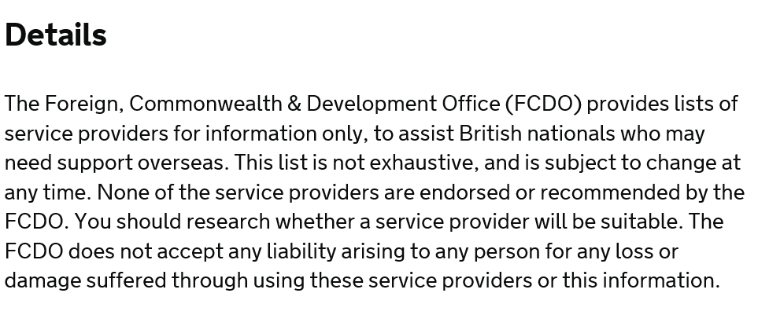

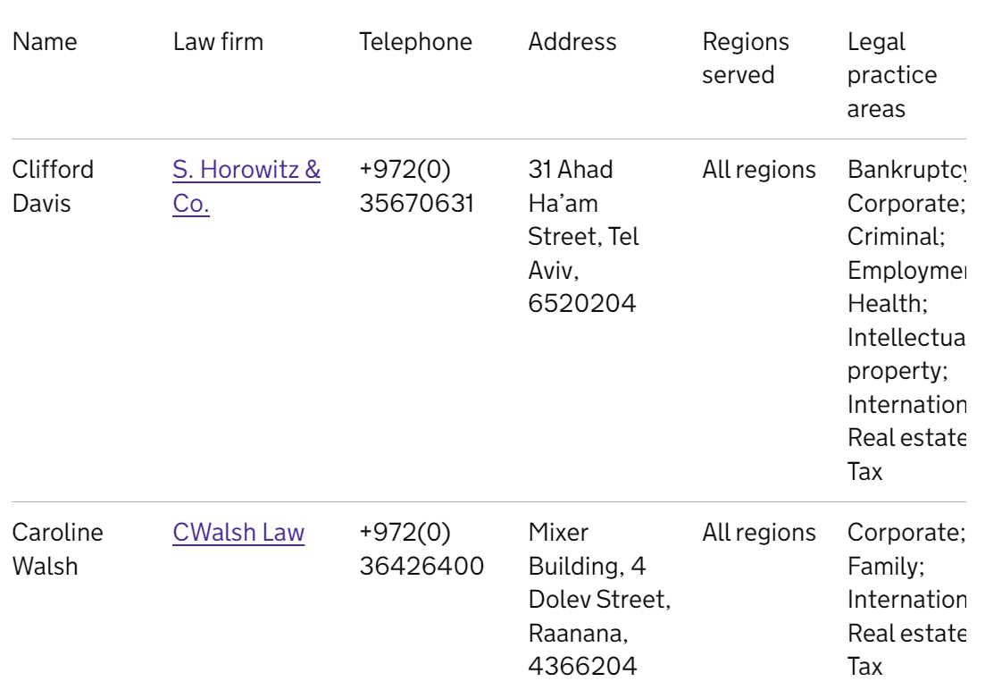

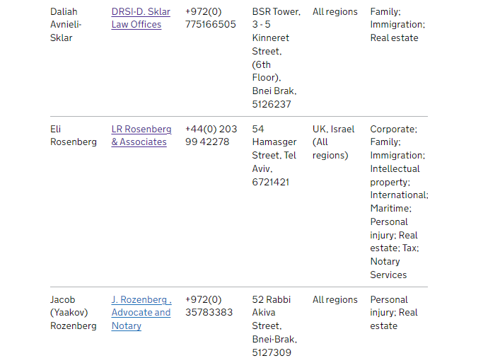
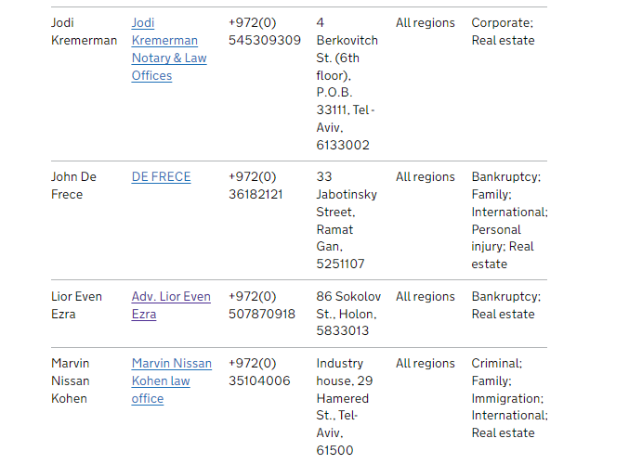

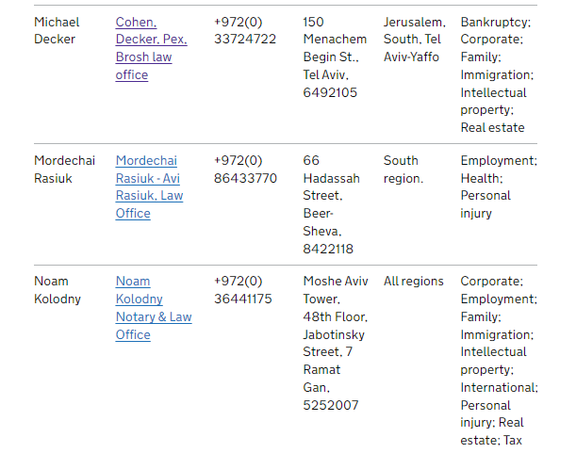
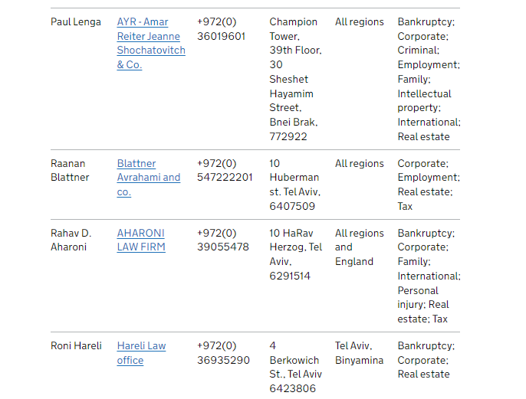
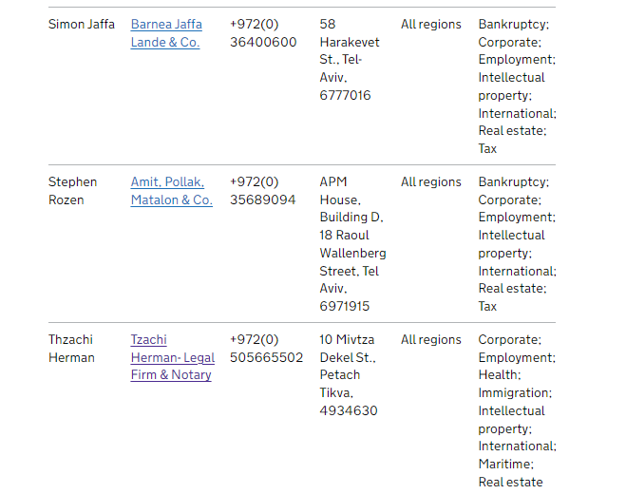
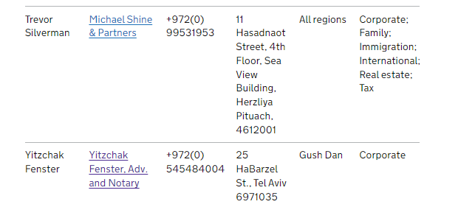
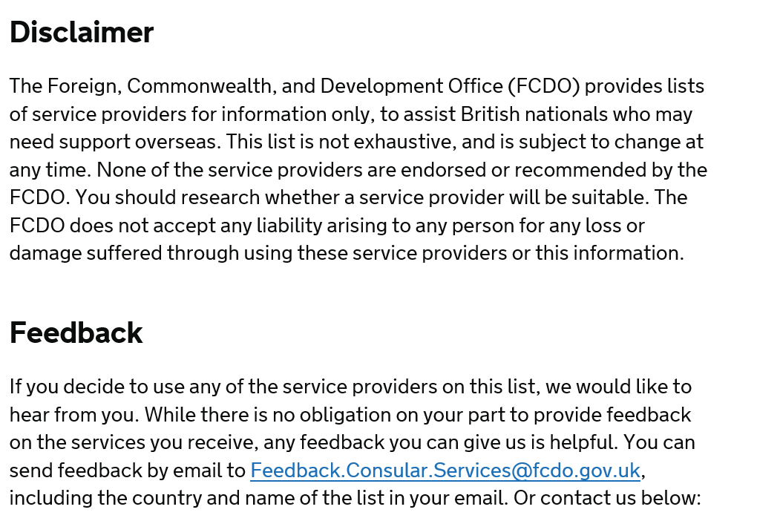

Annex 2: List of Private Translators/Interpreters

List of translators and interpreters in Israel

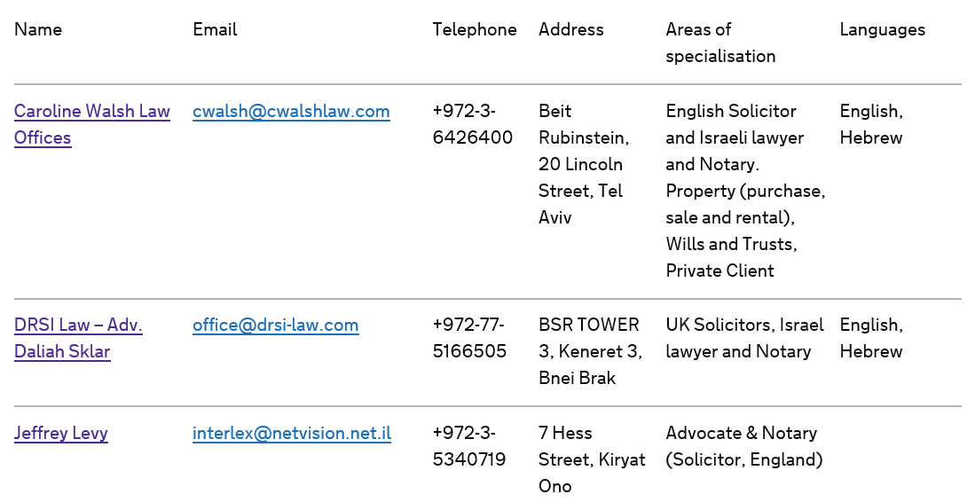

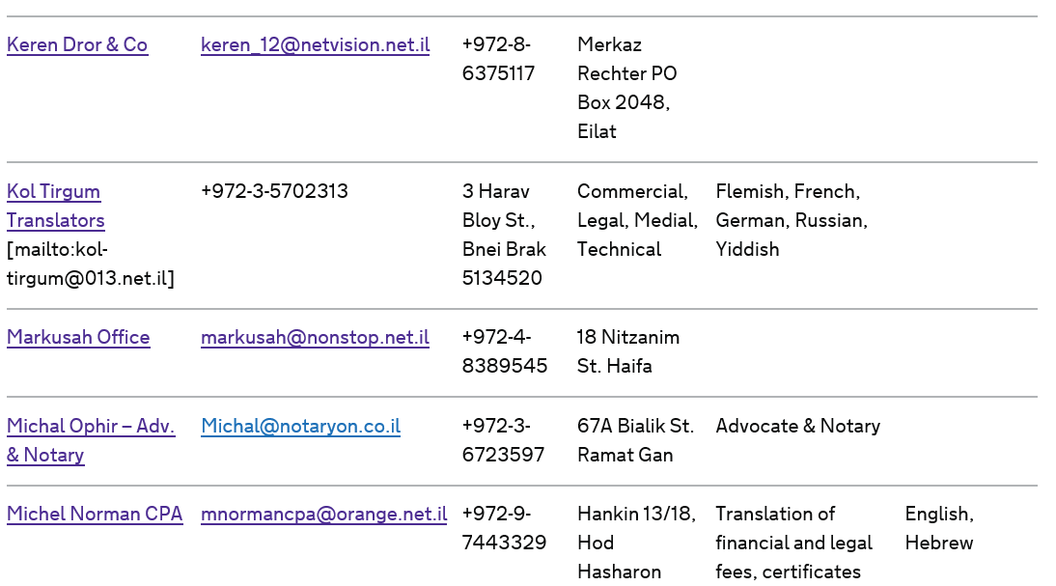

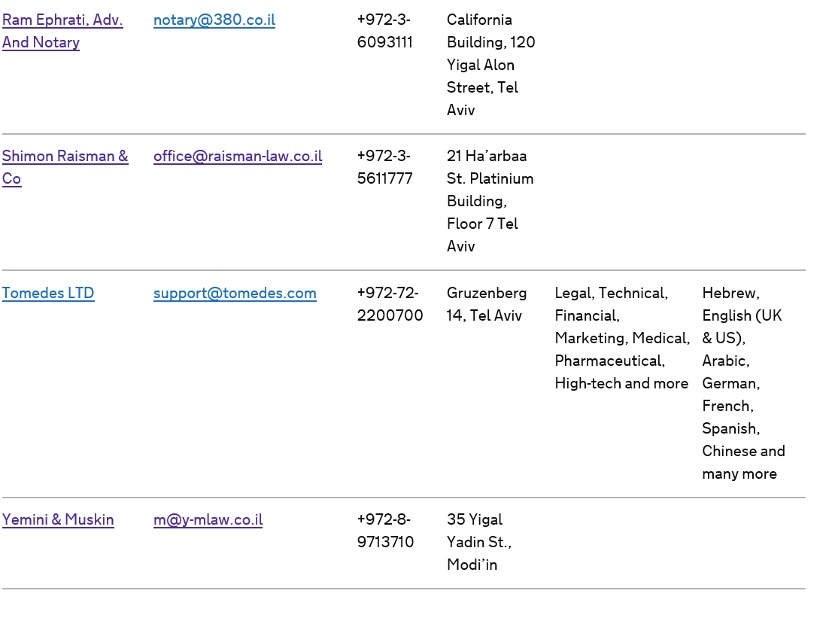

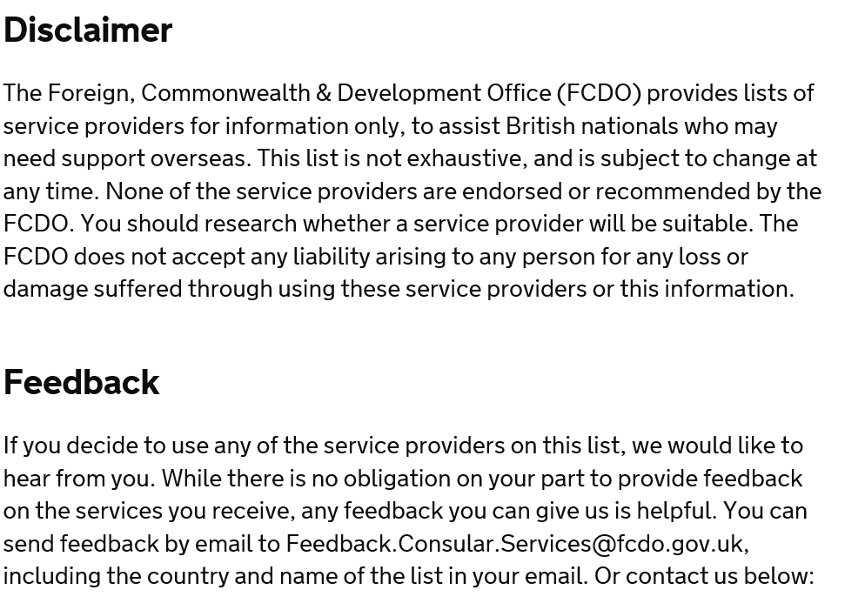

Annex 3 - Support for British nationals abroad: summary
Updated March 2024

Contents
- 1.Our Customer Charter
- 2. Summary
- 3. Staying safe overseas
- 4. Who we can help
- 5. How we’re funded
- 6. What kind of help we can provide
- 7. Crisis response
- 8. Our commitment
- 9. When our job is over
- 10. Important notes
- 11.Our duty of care to our staff

© Crown copyright 2019
This publication is licensed under the terms of the Open Government Licence v3.0 except where otherwise stated. To view this licence, visit nationalarchives.gov.uk/doc/open-government-licence/version/3 or write to the Information Policy Team, The National Archives, Kew, London TW9 4DU, or email: psi@nationalarchives.gsi.gov.uk.
Where we have identified any third party copyright information you will need to obtain permission from the copyright holders concerned.
This publication is available at https://www.gov.uk/government/publications/support-for-british-nationals-abroad-a-guide/support-for-british-nationals-abroad-summary

1.Our Customer Charter
This Charter sets out our commitment to provide a high quality service, and what we ask from you in return.

We will:
- Be professional, non-judgemental, polite and helpful to you whatever your gender, race, age, sexual orientation, marital status, disability, religion or belief
- Give clear information on how to contact us
- Tell you beforehand if there is a charge for a service we provide
- Deal with your enquiry accurately and efficiently, explaining clearly from the start what help we can give and when you should approach others for advice
- Keep waiting times to a minimum when you call or visit us and advise you of any delays
- Provide a private interview room if needed
- Protect any personal information you give us, in accordance with the General Data Protection Regulation (EU) 2016/679, the Data Protection Act 2018 and all other applicable data protection laws. You can find a copy of our privacy notice on consular services
- Use your feedback, comments and complaints to help us improve our services

We will aim to:
- Offer a fast response and consistent advice to your first-time telephone enquiries, worldwide and around the clock, with priority calls escalated for action
- Assess your needs promptly and provide effective assistance based on your individual circumstances and local conditions, making every effort to contact vulnerable customers1 within 24 hours of being notified of your situation
- Provide a rapid and high-quality response, with specially trained staff, if you are caught up in a crisis overseas, with consistent and regularly updated advice and assistance as the situation develops
- Meet our published targets for fee-bearing services, including issuing emergency travel documents which will normally be ready in two working days (in straightforward cases, once we receive your full and complete application online, or at our Embassy, High Commission or Consulate)
- Provide up-to-date and objective travel advice, offering a real-time response to your enquiries via social media (on weekdays from 9am-6pm and out-of-hours for urgent enquiries)

What we ask of you:
- Treat our staff with respect. If your behaviour is abusive, we may refuse to help you
- Be prepared to pay for some services e.g. an emergency travel document. We do not make a profit from these charges; they go towards the costs of providing consular services
- Provide us with feedback so that we can improve our services
- Buy adequate travel and medical insurance to help cover any unexpected costs
- Have any necessary vaccinations, pack enough medication to cover any unforeseen extended stays or emergencies and leave your contact details and itinerary with family or friends
- Follow our travel advice and local advice on what is safe and unsafe, respect local laws and take care of your money and passport (not forgetting to include your emergency contacts on the inside back cover)
Be aware that if we have done all we can to help you, and have explained that we are not able to do anything more, we may write to you explaining that we will no longer respond to your emails, phone calls or letters unless they contain new information.
Please note that we have a duty of care to our employees. We will not send staff into a situation where we judge that their safety could be seriously at risk. For more information on the services and support we provide or alternatively, please speak to a member of staff.

2. Summary

We expect British people to take responsibility for themselves and their safety while overseas. This guide highlights some of the main things you can do to prepare for your travel and stay safe abroad and what help we can provide if you do get into difficulty.

3. Staying safe overseas
- Ensure you check travel advice and sign up for country specific travel advice updates. Our travel advice will help you to form your own judgements about travelling or living in a particular country, and alert you to any new information. Keep an eye on news reports of any problems in the area you are visiting. Follow @FCDOtravel on Twitter and @FCDOtravel on Facebook for updates from the Foreign Commonwealth & Development Office (FCDO)
- Choosing to go to a country against our travel advice may seriously restrict any help we can provide and may also mean that your travel insurance is not valid2
- Before you travel, get comprehensive travel insurance which covers any pre-existing medical conditions you have, and all activities you plan to do – think particularly about the more adventurous activities which you would not normally undertake at home. If you do not take out adequate insurance, you will have to pay the costs of any emergency yourself, which could include an expensive medical bill or additional flights if as a result your travel plans have to change
- At least 8 weeks before travel, check the latest country-specific health advice on the National Travel Health Network and Centre (NaTHNac) TravelHealthPro website on travel-related risks and diseases, including vaccine recommendations. You may then wish to contact your health adviser or pharmacy for advice on other preventive measures and managing any pre-existing medical conditions while you’re abroad. Guidance is also available from: NHS (Scotland)’s fitfortravel website and the NHS website
- Take any prescribed medicine with you and keep it to hand, as well as a copy of the prescription. Ensure you take enough medication to cover your time overseas. Check that your medication is legal in the country by contacting the foreign embassy of the country you are travelling to
- Make sure your passport is valid and in good condition and that you have any necessary visas. Ensure you fill in the emergency contact details in your passport
- Leave copies of your passport, travel insurance policy (plus the insurer’s 24-hour emergency number), ticket details, your itinerary and contact details with your family and friends before you go. Take copies of these items with you as well
- Take enough money for your trip and some backup funds, credit cards, travellers’ cheques, or prepaid cash cards. Before you leave, ensure you know how to replace your credit cards and travellers’ cheques if you lose them or they are stolen, and know how to contact your bank. Keep a separate note of their numbers
- Before you go, get a good guidebook and get to know your destination. Find out about local laws and customs, and the standards of behaviour people expect in the country you are visiting so that you can follow them. Be aware of your personal security and take sensible precautions to protect yourself
- If you are going abroad for a long period, you might want to grant someone power of attorney to look after your financial affairs in the UK, while you’re away. You could also consider whether you want to give someone the power to make decisions about your welfare or health care in case a situation arises where you are unable or incapable to make decisions for yourself

There is no legal right to consular assistance. All assistance provided is at our discretion.

4. Who we can help
We can provide the support set out in this guide to people outside the UK who are:
- British nationals (whether or not they normally live in the UK – see page 6 of main guide
- British nationals with another nationality (known as ‘dual nationals’ – see page 6 of main guide, although this will depend on the circumstances - normally we cannot help dual nationals when they are in the country of their other nationality
- Nationals of European Union Member States without a local embassy or consulate)3
- Nationals of other Commonwealth countries where there is not a local embassy, but only in certain circumstances (see page 6 of main guide)
- We cannot provide this support to other countries’ nationals, even if they have been living legally in the UK

5. How we’re funded
Consular assistance provided to British nationals overseas is not funded from UK tax revenue, it is funded by a small premium included in the price of every British passport. The remainder of our income comes from the fees we charge for documentary, notarial and certain assistance services.
Fees are calculated based on the cost of our global consular operation so that every British national pays the same fee for the service they use no matter where they are in the world. The fees are approved by the Privy Council and laid before Parliament.

6. What kind of help we can provide
Our priority is to provide assistance to those British nationals overseas that need our help the most. The level and type of assistance we offer is tailored to the individual circumstances of each case. Our staff will make an assessment of your vulnerability and the needs you have, based on who you are, where you are, and your situation. We will then aim to offer assistance which helps meet your needs, such as:
- Provide advice and help if you have suffered rape and sexual or physical assault, are a victim of other crimes, are ill or in hospital
- Provide timely, accurate, local information so that you can help yourself effectively. This might include details of local lawyers, interpreters, doctors or funeral directors
- Issue emergency travel documents
- Provide information about transferring money through commercial providers
- Provide details of other organisations that may be able to provide specialist support
- Contact family or friends for you if you cannot do this yourself
In addition we also:
- Work alongside the local authorities, travel industry, insurance companies and others to provide rapid and effective support in the aftermath of major incidents affecting a large number of British nationals
- Provide documentary services such as consular birth or death registration, help with marriage or civil partnership documents, or providing notarial services

We cannot:
- Help you enter a country, for example, if you do not have a visa or your passport is not valid because each country has the authority to decide who they allow into their country
- Issue you with a new or replacement passport, or accept passport applications because passports are issued by Her Majesty’s Passport Office in the UK
- Pay any bills or give you money because we are not funded to do this and you would not get these bills paid for you if you were in the UK. You should take responsibility for yourself. It would be unfair for those who take out insurance to subsidise those who do not
- Ensure your safety and security in another country because this is the responsibility of the government and authorities of that country
- Give you legal advice or translate formal documents because such support is best provided by independent professionals. We do not have the funding or the expertise to provide these specialist services
- Carry out searches for missing people because doing so is the responsibility of the local authorities. To search effectively requires resources that only local authorities can provide
- Investigate crimes, get you out of prison, prevent the local authorities from deporting you after your prison sentence, or interfere in criminal or civil court proceedings. This is because we cannot interfere in another country’s processes and must respect their systems, just as we expect them to respect the UK’s laws and legal processes
- Get you better treatment in prison than local prisoners (although we may raise concerns with local authorities if treatment falls below internationally-recognised standards). Nor can we get you better treatment in hospital than the treatment that is given to local people. This is because we cannot interfere in another country’s processes just as we would not accept such interference in the UK
- Make travel arrangements for you, or find you work or accommodation, or make business arrangements on your behalf. This is because these are private arrangements which are your responsibility to make for yourself
- Get involved (including offering advice) in private disputes over property, employment, commercial or other matters. This is because we are in no position to judge the facts and have no jurisdiction overseas to resolve such matters

7. Crisis response
Major incidents that affect a large number of British nationals abroad may call for levels of response beyond those we describe on pages 25-28 of the main guide. It’s not easy to define absolutely what the circumstances might be, but they could be the result of natural disasters or large-scale accidents, civil unrest, terrorism or conflict.
We will work with the local authorities of the country, travel industry, employers, insurance companies and others in response to such incidents and will tailor our information and support to each crisis and the needs of those affected. In very exceptional circumstances we will seek Ministerial authorisation to enhance the level of support we are able to provide in order to assist those caught up in such incidents and at risk of harm.
If you fail to follow our travel advice this may restrict the help we can provide to you.

8. Our commitment
The Consular Customer Charter at the beginning of this guide sets out our commitment to providing a high level of service to you. It also sets out what we require from you in return.

9. When our job is over
We offer support to British nationals in difficulty abroad and to their families (either in the UK or elsewhere) to help them deal with the immediate effects of what has happened. In certain exceptional cases, our officers may be involved in a particular case for a longer period of time. For example, if a British national is murdered overseas or dies in suspicious circumstances, we will try to provide their family with information given to us by local investigating authorities if we are permitted to share it. But sometimes people need long-term help in areas where our staff are not trained professionals, such as support from bereavement counsellors. Although we cannot provide this help ourselves, we can suggest where you can go for guidance. This may mean going to another UK government department or getting in touch with a non-governmental organisation or charity.

10. Important notes
This document sets out the help which we aim to provide to British nationals who are in difficulty overseas. It does not cover the work undertaken by other government agencies, such as issuing passports (Her Majesty’s Passport Office) or visas (UK Visas & Immigration). We provide the support described in this guide in across the world in different and sometimes difficult conditions. Local factors such as security, the law, transport, medical facilities and relations with the local authorities, as well as our assessment of how vulnerable you are, may all define the help we can provide. And, like any government department, we have a responsibility to use public funds efficiently and effectively.

Our duty of care to our staff
We have a duty of care to take all reasonable steps to ensure the safety of our employees in the course of their employment. We will not send staff into a situation where we judge that their safety could be seriously at risk.
We recognise that many people need our support at a time of great personal distress or anxiety. Our staff will always aim to be empathetic and professional when supporting you. Please remember that our staff cannot replace specialist advisers such as translators, counsellors or lawyers.
We expect you to treat our staff fairly and with respect. If you are physically or verbally abusive, they may refuse to help you.
If you are not happy with the support we have provided, you can make a complaint.
- We consider that someone is vulnerable when they cannot protect themselves from significant physical or emotional harm, or be protected by others. We will almost always treat many types of consular case (e.g. victims of rape and other forms of sexual assault and forced marriage, and cases involving children and young people) as vulnerable. In others, it will depend on the circumstances. ↩
- No foreign travel can be guaranteed as safe and you take personal responsibility for any trip you make abroad. Any decision to travel to, stay in or leave a country is for you to take on your own responsibility on the basis of the best available information from our travel advice and other sources. While every care is taken in preparing our Travel Advice, the FCDO does not assume any responsibility, including legal responsibility, to those who read the travel advice and who choose to take it into account when making any decisions relating to a particular country, or to those affected by their decisions ↩
- In accordance with EU Directive 2015/637 ↩

Annex 4 - In prison abroad: transfer to a UK prison
Updated 3 January 2019

Contents
- Who can transfer
- Benefits of transferring
- Applying for a transfer
- Approving your transfer
- Liability for prosecution
- Release dates
- Consent to transfer
- Paying for your transfer
- Appealing your conviction
- Criminal records
- Transfers from EU countries
- Further information about transfers
- Feedback
- Disclaimer

© Crown copyright 2019
This publication is licensed under the terms of the Open Government Licence v3.0 except where otherwise stated. To view this licence, visit nationalarchives.gov.uk/doc/open-government-licence/version/3 or write to the Information Policy Team, The National Archives, Kew, London TW9 4DU, or email: psi@nationalarchives.gsi.gov.uk.
Where we have identified any third party copyright information you will need to obtain permission from the copyright holders concerned.
This publication is available at https://www.gov.uk/government/publications/in-prison-abroad/in-prison-abroad-transfer-to-a-uk-prison

Who can transfer
To transfer, you must:
- be a British citizen or have close family ties with the UK (normally through permanent residence in the UK)
- not be awaiting trial
- have exhausted all appeals against your conviction and/or the length of your sentence
- have at least 6 months of your sentence left to serve when you apply for transfer
- have no outstanding fines or other non-custodial penaltiess
The offence you were convicted for must also be a criminal offence in the part of the UK you wish to be transferred to: England, Wales, Scotland or Northern Ireland. There must be a transfer agreement between the UK and the country where you are imprisoned. See country-specific information for prisoners and their families.
If you are a British citizen, and the sentencing State agrees to your transfer then the UK authorities will normally approve your request. However, the UK authorities may refuse your request if, for example, you have not lived in the UK for a number of years, and you have no close family resident here. The authorities in the sentencing country can also refuse. Other conditions may apply, depending on the specific transfer arrangements with each country.

Benefits of transferring
If you transfer, you will:
- serve the rest of your sentence closer to your family and friends
- be in an English-speaking country
- be able to take courses and prepare for release in the UK

Applying for a transfer
You should normally apply through the prison authorities where you are detained. Prison authorities should give you information about applying, if you are in a country where transfers are possible and you have been sentenced.
You can also write to the nearest British consulate, who will pass on your letter to the UK authorities. The UK authorities will then make an application to the foreign authorities on your behalf.
If you are normally resident in the UK or are subject to a deportation or removal order from the country in which you are held, the authorities of that country may request your transfer without your consent. If such a transfer is sought you should be given an opportunity to make representations against transfer before transfer takes place.

Approving your transfer
You have no automatic right to transfer.
If the authorities in the country where you are imprisoned agree in principle to your transfer, they will forward information about you to the UK authorities, including:
- details of the offence(s)
- length and nature of the sentence
If the UK authorities agree to the transfer, they will tell the foreign authority and explain how they will continue to enforce your original sentence.
The length of time it takes to complete a transfer varies. In some countries, it can take more than 2 years. We will do everything we can to process your request as quickly as possible.
There is no statutory right of appeal against a rejected transfer request.

Liability for prosecution
You cannot be re-prosecuted in the UK for the offence for which you are sentenced. You will, however, be liable to detention or prosecution in connection with any other alleged offence committed in the UK.
If transfer takes place under an agreement which does not require your consent to transfer then you will normally be protected from prosecution for offences committed prior to your transfer until certain conditions are met. If you face further charges in the UK you should seek confirmation of your position before transfer takes place

Release dates
You will serve the sentence imposed on you by the foreign court. The UK authorities cannot increase the sentence. Nor can they reduce your sentence to one which might have been given in the UK.
Once transferred the amount on your sentence remaining at point of transfer will be treated as if it was a sentence imposed in the UK and the release provisions in the part of the UK to which you transfer will apply to your sentence. This will not change the length of your sentence, but may alter the time you spend in custody pursuant to that sentence.
In some cases (where the maximum sentence in the UK is less than your sentence) your sentence will be reduced to the maximum.
You need to be aware as to whether the transfer agreement requires your consent. The UK authorities will give you detailed estimates about your release dates in the UK before you agree to a transfer. It is your responsibility to ensure you understand the consequences of transfer before you give your consent.

Consent to transfer
In most cases, you will be asked to agree to transfer. You should make sure you understand the consequences of your transfer, including how your original sentence will be enforced in the UK, before you give your consent. If you are unsure, you should ask for clarification.
The UK is a party to a number of agreements which enable a prisoner to be transferred to the prisoner’s country of nationality or permanent residence without that person’s consent, providing both governments involved agree. Although in these circumstances your consent to transfer is not required you must be given an opportunity to make representations against transfer. This can be given either orally or in writing depending on the law of the country in which you are held.

Paying for your transfer
With most prisoner transfer agreements, you are required to pay your own airfare. You will be asked to sign an agreement to repay the cost after you arrive in the UK. The UK authorities will keep your passport and you will not be able to apply for a new one until you repay.
If you do not have a passport, you may need to pay for an emergency travel document.
The UK and foreign government will pay most of the other transfer costs.
You will not be required to make any payment if you are being transferred without your consent.

Appealing your conviction
The UK courts have no jurisdiction to review either your conviction or your sentence. This remains a matter for the courts in the country in which you were sentenced

Criminal records
Whether you return to the UK as a serving prisoner, or at the end of your sentence, you have a criminal record. The law requires that in certain circumstances you must disclose your previous criminal convictions. This includes convictions imposed abroad as well as those imposed in the UK. Failure to fully disclose your criminal convictions when required by law is a criminal offence.
If you are arrested for certain serious offences, such as child sex abuse or drugs crimes, Foreign Commonwealth & Development Office (FCDO) staff must tell other relevant UK authorities.

Transfers from EU countries
Prison transfer arrangements between the UK and EU countries continue unchanged until the transition period ends on 31 December 2020. British nationals serving prison sentences in EU countries can apply to transfer to a UK prison and serve their sentence in the UK.

Further information about transfers
You can ask either the prison authorities where you are serving your sentence or your nearest British consul.
You can also write to the relevant UK authorities:

England and Wales
Cross Border Transfer Section
HM Prison and Probation Service
Post Point 1.22
1st Floor
Southern House
Croydon
CR0 1XG
Email: crossbordertransfers@noms.gsi.gov.uk

Northern Ireland
Northern Ireland Prison Service
Operational Management Division
Dundonald House
Upper Newtownards Road
Belfast, BT4 3SU
Telephone: 028 9052 5065 (General Enquiries)
Email: info@niprisonservice.gov.uk

Scotland
Scottish Prison Service Headquarters
Communications Branch
Room G20
Calton House
Redheughs Rigg
Edinburgh, EH12 9HW
Telephone: 0131 244 8745

Prisoners Abroad
Prisoners Abroad is a UK charity. It can provide:
- information
- limited financial assistance
- vitamins in certain situations
- translations
- reading material
- support for families
Prisoners Abroad works with the FCDO to help British citizens held in prisons overseas. They will keep in touch with you and your family throughout your sentence, and can assist after your release if you are not transferred to a UK prison. They can also advise you on the transfer process and have a detailed factsheet on the subject.
Their address is:
Prisoners Abroad
89 - 93 Fonthill Road
London N4 3JH
Tel: 020 7561 6820
www.prisonersabroad.org.uk
Email: info@prisonersabroad.org.uk
You will not be entitled to Prisoners Abroad’s support (financial or otherwise) if you have transferred back to the UK to serve the remainder of your sentence. Nor will Prisoners Abroad be able to assist after your release from a UK prison

Feedback
We welcome your views on the support we provide. They will help us to identify what we do well and what we could do better. Please contact us with any feedback at:
Consular Directorate
Foreign, Commonwealth & Development Office
King Charles Street
London
SW1A 2AH
Email: feedback.consular.services@fcdo.gov.uk
Tel: +44 (0)20 7008 1500

Disclaimer
The information on this page is a brief introduction to transfers from prisons abroad. It is not a statement of your legal rights.
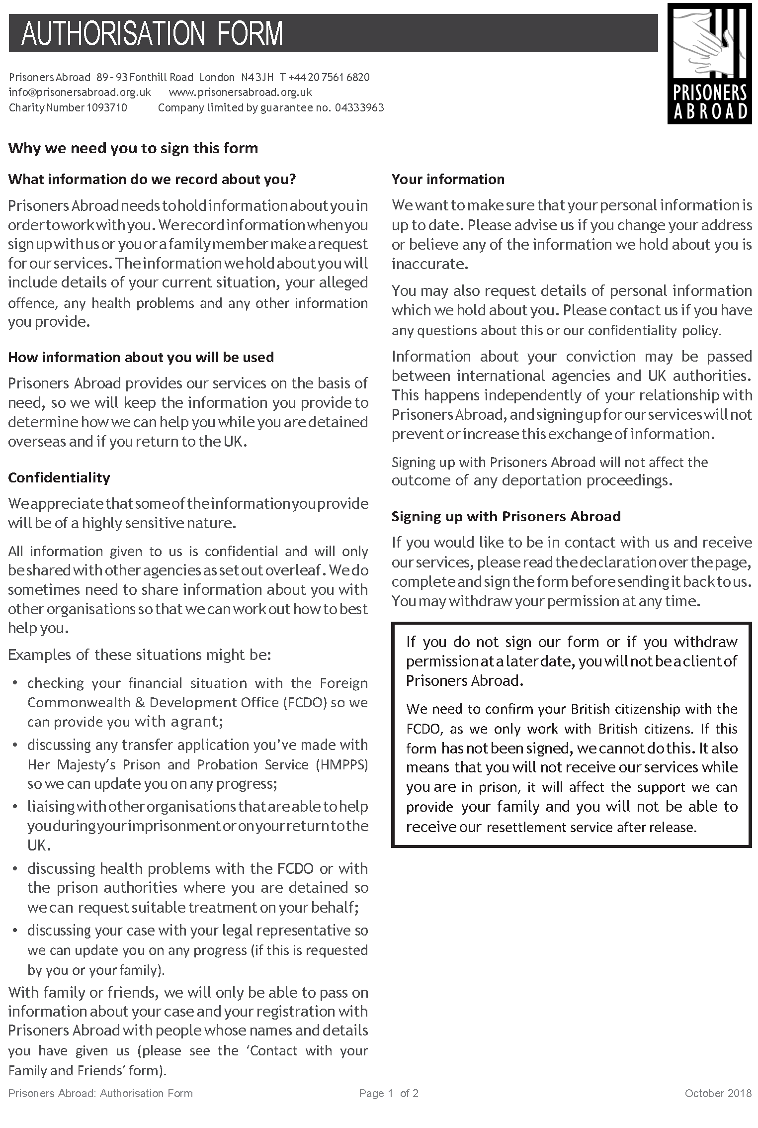
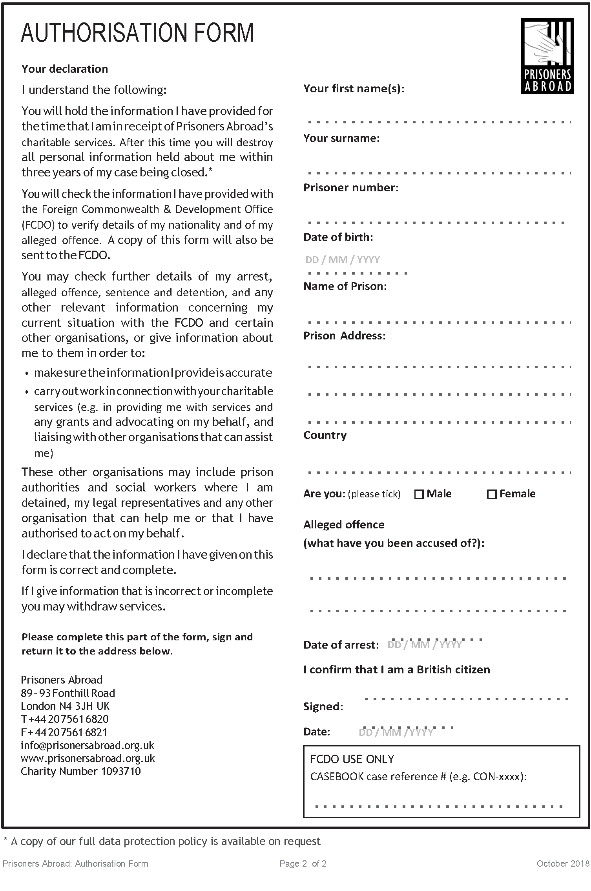

FORM
Contact with your family and friends

Prisoners Abroad, 89-93 Fonthill Road, London, N4 3JH, United Kingdom 020 7561 6820
www.prisonersabroad.org.uk | info@prisonersabroad.org.uk

Family members often contact Prisoners Abroad to ask us to find out information on behalf of their loved one in prison, to confirm where the person is being held, to check on money transfers, etc.

Please write below the names of any family and friends who you would like us to talk to about your case. By signing this form you are giving us your authorisation to discuss your case with them, if they contact us. They should be over 18. Please ensure the person is happy for their details to be given to Prisoners Abroad.

Prisoners Abroad’s strict confidentiality policy means we can only pass information of this kind to your partner / family if you have given us specific permission to do so. We will not share any information with loved ones or anyone else (we cannot even confirm if we are in contact with you) unless you have named them below. You can continue overleaf if you want to name more than two people.

Name: Name:

Address: Address:

Postcode: Postcode:

Their relationship to you Their relationship to you

Prisoners Abroad will:
- Send your relatives initial information about our services (including a newsletter and booklet about ways we help families)
- Share information / speak to them about your case at their / your request
- Liaise, where appropriate, with prison authorities / social workers etc. on your family’s request
- Give your loved one the opportunity to receive our newsletter three times a year

Prisoners Abroad will not:
- Phone your family to tell them you are in prison - you should ask the Foreign Office to do this if you cannot.
- Contact them proactively, unless absolutely necessary
I (please print name), hereby agree that Prisoners Abroad can discuss the details of my case, and any other information relating to my personal circumstances, with the members of my family as named above, except where instructed otherwise. I agree that the person(s) named above is/are happy for their details to be used as outlined.

Name of Prison: Country:
Signed: Date:
Prisoners Abroad: Contact with family and friends form Page 1 of 1 July 2017
Disclaimer
This booklet was compiled by the Consular Section, British Embassy in Tel Aviv. It is revised on a regular basis
If any of the information contained in this booklet is incorrect, please draw inaccuracies to our attention so that we can make amendments.
The British Embassy in Tel Aviv is not accountable for the information provided in this booklet. Local proceedings are subject to change at any time.

Thank you.

Last updated: March 2024

