Appeal Decision
by Claire Tregembo BA(Hons) MIPROW
An Inspector appointed by the Secretary of State for Environment, Food and Rural Affairs
Decision date: 17 November 2023

Appeal Ref: ROW/3321510
- This Appeal is made under Section 53(5) and Paragraph 4(1) of Schedule 14 of the Wildlife and Countryside Act 1981 against the decision of Kent County Council not to make an Order under section 53(2) of that Act.
- The application dated 28 July 2017 was refused by Kent County Council on 5 April 2023.
- The appellant claims that the Definitive Map and Statement of public rights of way should be modified to add a bridleway between bridleway ER16 and Ringwould Road opposite Hangman’s Lane (EE451)

Summary of Decision: The Appeal is allowed.

Preliminary Matters
- I have been directed by the Secretary of State for Environment, Food and Rural Affairs to determine this appeal under Section 53(5) and Paragraph 4(1) of Schedule 14 of the Wildlife and Countryside Act 1981 (the 1981 Act).
- The definitive map modification order (DMMO) application included two routes, A to B and A to C between bridleway ER16 and Ringwould Road. Kent County Council (the Council) determined there was sufficient evidence to make a DMMO for route A to B, but declined to make one for route A to C. The appeal relates only to route A to C (the appeal route).
- The appeal route straddles the boundary of two parishes and the application was made to include the route in both, but it is effectively one path. Bridleway ER16 runs between Hangman’s Lane, Ringwould and the parish boundary just east of Ringwould Road. The appeal route would connect ER16 to Ringwould Road opposite footpath EE451 which is also called Hangman’s Lane. A fork of ER16 also runs north west from Hangman’s Lane, Ringwould to Ringwould Road by The Forest. I will refer to the claimed and existing bridleways in my decision and I have appended maps showing them at the end of my decision.
- The application was made under Section 53(3)(c)(iii) to amend the particulars relating to bridleway ER16 within the parish of Ringwould to show it extending to Ringwould Road opposite Hangman’s Lane (EE451) and 53(3)(c)(i) to add a route that is not shown in the Definitive Map and Statement (DMS) which straddles the Ripple and Langdon parish boundary. As none of the appeal route is shown in the DMS, I consider the application only needs to meet the tests set out under Section 53(3)(c)(i).
- The appeal has been determined on the papers submitted. I have not visited the site, but I am satisfied I can make my decision without the need to do so.

Main Issues
- The application was made under section 53(2) of the 1981 Act which requires the surveying authority to keep their DMS under continuous review, and to modify them upon occurrence of specific events cited in Section 53(3)
- The need for an Order to be considered when evidence is submitted in support of a claim that a public right of way which is not shown in the definitive map subsists is dealt with under section 53 of the 1981 Act. Section 53 (3)(c)(i) of the 1981 Act provides that a modification order should be made on the discovery of evidence which, when considered with all other relevant evidence available, shows that a right of way which is not shown subsists or is reasonably alleged to subsist over land in the area to which the map relates.
- In arriving at my conclusions, I have taken account of the evidence submitted by the parties, the relevant part of the 1981 Act and the findings of the Courts in the cases of Secretary of State for the Environment ex parte Bagshaw and Norton (QBD) [1994] 68 P & CR 402 [1995] (Bagshaw and Norton) and R v Secretary of State for Wales ex parte Emery [1996] 4 All ER 367 (Emery).
- As made clear by the High Court in Bagshaw and Norton this involves two tests:

Test A - Does a right of way subsist on the balance of probabilities?

Test B - Is it reasonable to allege that a right of way subsists? For this possibility to exist, it will be necessary to show that a reasonable person, having considered all the relevant evidence available, could reasonably allege that a right of way subsists.
- In relation to Test B, the Court of Appeal recognised in the Emery case that there may be instances where conflicting evidence was presented at the schedule 14 stage. In Emery, Roche LJ held that “…The problem arises where there is conflicting evidence…In approaching such cases, the authority and the Secretary of State must bear in mind that an order…made following a Schedule 14 procedure still leaves both the applicant and objectors with the ability to object to the order under Schedule 15 when conflicting evidence can be heard and those issues determined following a public inquiry.”
- Roche LJ also held that “Where the applicant for a modification order produces credible evidence of actual enjoyment of a way as a public right of way over a full period of 20 years, and there is a conflict of apparently credible evidence in relation to one of the other issues which arises under s31, then the allegation that the right of way subsists is reasonable and the Secretary of State should so find, unless there is documentary evidence which must inevitably defeat the claim for example by establishing incontrovertibly that the landowner had no intention to dedicate or that the way was of such a character that use of it could not give rise at common law to any presumption of dedication”.
- The case in support relies on historical documents and maps. I need to consider if the evidence provided is sufficient to infer the dedication of public rights over the claimed route at some point in the past. Section 32 of the Highways Act 1980 requires a court or tribunal to take into consideration any map, plan, or history of the locality, or other relevant document which is tendered in evidence, giving it such weight as appropriate, before determining whether or not a way has been dedicated as highway.
- At this stage, I need only to be satisfied that the evidence meets test B, the lesser test.

Reasons

Ringwould Estate Maps
- The 1709 Ringwould Estate map shows the appeal route and the section of ER16 from The Forest to Hangman’s Lane coloured ochre with double solid edges. ER16 is not shown across the fields, although this could be because there is a summary of what the map shows over this area. This summary states the map shows footpaths and horse roads leading through or by the said land.
- On the 1846 Ringwould Estate map the south western end of ER16 and part of the appeal route are shown coloured ochre with double solid edges. ER16 continues across a field to Hangman’s Lane, Ringwould with a dashed line then north west towards The Forest with double solid edges and is all coloured ochre.
- The estate maps show the appeal route in the same manner as other public highways which suggest at least bridleway rights. However, they were produced for private purposes and may not have needed to differentiate between public and private routes. On the 1709 map, all the routes shown coloured ochre correspond with current public roads or rights of way. I only have a limited extract of the 1846 map so cannot see how other routes are depicted. However, it does show the appeal route as a continuation of ER16.

Ordnance Survey Maps and Records
- The 1797 Ordnance Survey (OS) drawings of Canterbury (East) and St. Margaret’s Bay, the 1797 Topographical Survey manuscript of Kent and Sussex, Mudge-Faden’s 1801 one inch OS and the 1831 one inch OS maps show the appeal route as a through route to Ringwould with ER16.
- The appeal route is not shown on the OS boundary sketch maps 1869 to 1871 for Ripple or Waldershare. The appeal route is shown alongside hedges in the boundary remark book for Oxney. The label alongside the appeal route indicates the parish boundary is 2 feet from the route of the hedge.
- The appeal route is shown as a dashed line on the 1873 and 1938 1:2,500 OS maps and with double dashed lines on the 1898 and 1907 1:2,500 OS maps. ER16 is shown with double dashed or solid and dashed lines on the OS maps between 1873 and 1938. The parish boundary is shown along the line of ER16 and the appeal route. On the 1873 and 1898 OS maps, this boundary is indicated to be to the side of the footpath along ER16 and 2 feet from the track hedge along the appeal route. On the 1907 OS map, the parish boundary along the appeal route is indicated to be along the centre of the footpath and to the side of the footpath alongside ER16.
- The 1946 1:25,000 OS map shows the appeal route with a single dashed line. ER16 is shown in the same way and labelled F.P.
- The appeal route is not shown on the 1957 or 1960 1:2,500 OS maps. ER16 is shown with double dashed lines and the parish boundary is indicated to be to the side of the footpath on the 1957 map. On the 1960 map, ER16 is shown with solid and dashed lines or a single dashed line and labelled F.P.

Commercial Maps
- Barlow-Hasted map of Kent 1797-1801 shows a route between Hangman’s Lane, Ringwould and Ringwould Road. However, the alignment does not follow the line of the appeal route or ER16.
- On Greenwoods 1819-20 map of Kent the appeal route and ER16 form a through route between Ringwould Road and Hangman’s Lane, Ringwould which is shown as a cross road. Fortune v Wiltshire Council [2012] EWCA Civ 334 and Hollins v Oldham [1995] C94/0206 both considered cross roads could be highways available to the public, particularly when supported by other documents.

Tithe Maps 1841
- Waldershare Tithe map shows the start of the appeal route coloured ochre in the same way as Ringwould Road and Hangman’s Lane (EE451). Public roads are unnumbered, and a total area is given for them. Occupation roads are given parcel numbers. The appeal route is not numbered which suggests it was part of the public road network.
- The Oxney Tithe map does not show the appeal route. The appeal route is not shown on the Ringwould Tithe map but is outside of the parish.
- The Sutton Tithe map 1841 shows the appeal route as an enclosed route along with the start of bridleway ER16, which is then shown continuing across a field by a dashed line. Ringwould Road and Hangman’s Lane (EE451) are also shown as enclosed routes in the same way.
- The purpose of the Tithe records was to identify titheable land capable of producing crops. Normally a detailed survey was undertaken, and they are statutory documents which were in the public domain. They were not produced to record public rights of way, although they can be helpful in determining the existence and status of such routes. Public roads would not have been capable of producing crops so would not have been subject to tithes. However, private tracks would not be capable of producing crops either.

Deposited Railway Plans
- The appeal route is shown as an enclosed route on the North Kent Railway plan of 1846. ER16 is not shown.
- The appeal route is not shown on the plans for the London Chatham and Dover Railway 1861, the Deal and Dover Railway of 1864, the Dover and Deal Railway of 1873-74 or the South Eastern Railway 1873-74.
- However, the appeal route is outside the limits of deviation for all the proposed railways and was not affected by them, so no information about it was provided in the relevant book of reference.

Definitive Map Records
- In the Ringwould Parish survey ER16 is claimed as a bridle road ending at the parish boundary at point A. The appeal route is not shown in the Longdon Parish survey.
- The appeal route is not shown on the Ringwould Draft Map or the Dover Provisional Map. The Statement describes ER16 as ending at the junction of the Ripple and East Langdon parish boundaries. The appeal route is not shown on the Ripple or East Langdon Draft maps.
- The appeal route is not shown on the 1952 Definitive Map. The Statement for ER16 describes it as ending at the parish boundary.
- The appeal route is not shown on the 1970 Draft Revised Map. The Statement for ER16 describes it as heading ‘to Road’.
- The appeal route is not shown on the 1987 or 2013 Definitive Map. Both Statements for ER16 refer to connections to ‘Ringwould Road (D1939), Hangman’s Lane (D1942), track leading to D1939’.

Conclusions on the Documentary Evidence
- The maps show the appeal route and ER16 formed a through route between Ringwould Road and Hangman’s Lane, Ringwould for over 100 years between 1709 and 1831. Claimed bridleway A to B is not shown on the maps during this period. The appeal route and A to B are both shown on most of the maps between 1841 and 1946 suggesting both could have been used. From the 1950s A to B is the only route shown. This suggests the appeal route was the original thoroughfare, then depending on the onward destination, two routes were available, with the appeal route becoming less well used over time. The appeal route may have fallen out of use, but there is no evidence before me to suggest any public rights over it were extinguished.
- I consider the depiction of the appeal route on the Estate maps and two Tithe maps in the same manner as other public highways, to be suggestive of public rights. It is shown as a cross road on Greenwood’s map which also suggests a public highway.
- The appeal route is only shown on the earliest deposited railway plans. It may have been omitted from the latter deposited plans because the surveyor did not consider it to be ‘a route of note’ or a public highway. Equally, it may not have been shown because it was outside of the limits of deviation of the railway, was no longer enclosed or because use had declined.
- The appeal route is shown on most of the OS maps indicating its physical existence. Most of the OS maps and records indicate A to B as a footpath route along with ER16 and the appeal route as a track. However, the 1907 OS map indicates the parish boundary along the appeal route was along the centre of the footpath. Overall, I consider the OS maps and records to be inconclusive as to public rights along the appeal route.
- Although the Draft Statement from 1970 indicates ER16 continues to Ringwould Road, it is not clear if this is along the appeal route or A to B. The Definitive Map records provide no evidence for the appeal route.
- I note that the appeal route is not shown on all the documents before me or is not shown in the same way as other public highway, particularly on later documents. There is some conflict within the documents before me, but I do not consider there is any incontrovertible evidence against the appeal route.
- None of the documents provide clear evidence of bridleway rights over the appeal route. However, I need to consider all the available evidence and determine if it points to the existence of public rights. Taken as a whole, I consider the evidence sufficient to reasonably allege that public bridleway rights subsist along the appeal route.

Conclusions
- Having regard to these and all other matters raised in the written representations, I conclude that the appeal should be allowed.

Formal Decision
- In accordance with paragraph 4(2) of Schedule 14 of the 1981 Act, Kent County Council is directed to make an order under section 53(2) and Schedule 15 of the 1981 Act within three months of the date of this decision to add the public bridleway between A and C, as proposed in the application dated 28 July 2017 and shown on the plan appended to this decision.
- This decision is made without prejudice to any decisions that may be given by the Secretary of State in accordance with his powers under Schedule 15 of the 1981 Act.

Claire Tregembo

INSPECTOR

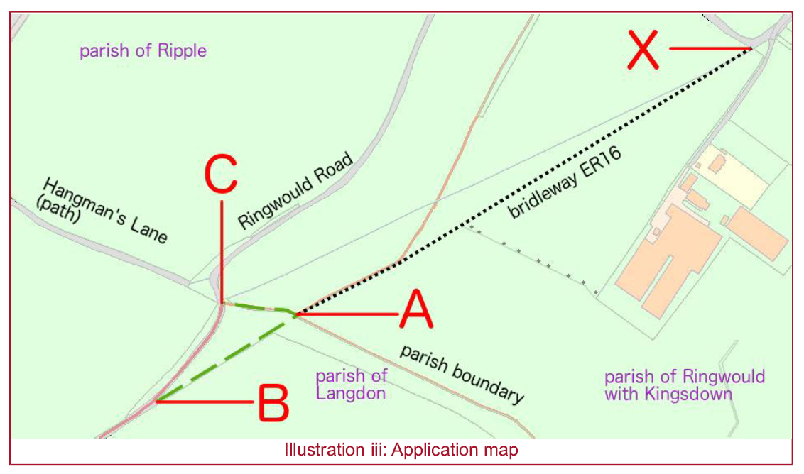
Application Map

Definitive Map Extract

