Application Decision
by Harry Wood
Appointed by the Secretary of State for Environment, Food and Rural Affairs
Decision date: 11 March 2024

Application Ref: COM/3330405
Dorney Common, Parish of Dorney, Elton Wick, Windsor, SL4 6JN
Register Unit Number: CL 56
Commons Registration Authority: Buckinghamshire Council

- The application, dated 29 September 2023, is made under Section 38 of the Commons Act 2006 (the 2006 Act) for consent to carry out restricted works on common land.
- The application is made by Fisher German LLP for Cadent Gas Ltd.
- The works comprise:
- the undertaking of repair works on existing valve chambers and to overhaul and replace the existing equipment currently in place;
- the creation of an approximately 330m² works area for the excavation and replacement of the valve chambers;
- temporary fencing consisting of Heras fencing with each panel measuring approximately 3.5m wide and 2m high. A total of approximately 150m of fencing to be in place at one time.

Decision
- Consent is granted for the works in accordance with the application dated 29 September 2023 and the plans submitted with it subject to the following conditions:

- the works shall begin no later than three years from the date of this decision;
- the land shall be fully reinstated within one month from the completion of the works.
- For the purposes of identification only the location of the works area is shown by the red area on the attached plans.

Preliminary Matters
- I have had regard to Defra’s Common Land Consents Policy Guidance (November 2015) in determining this application under section 38, which has been published for the guidance of both the Planning Inspectorate and applicants. However, every application will be considered on its merits and a determination will depart from the guidance if it appears appropriate to do so. In such cases, the decision will explain why it has departed from the guidance.

- This application has been determined solely on the basis of written evidence. I have taken account of the representations made by the Open Spaces Society (OSS) and Natural England (NE).

- I am required by section 39 of the 2006 Act to have regard to the following in determining this application:
- the interests of persons having rights in relation to, or occupying, the land (and in particular persons exercising rights of common over it);
- the interests of the neighbourhood;
- the public interest; Section 39(2) of the 2006 Act provides that the public interest includes the public interest in; nature conservation; the conservation of the landscape; the protection of public rights of access to any area of land; and the protection of archaeological remains and features of historic interest. And
- any other matter considered to be relevant.

Reasons

- The applicant explains that the purpose of the works is to carry out repairs on valve chambers located on the common that are linked to the supply of gas for the surrounding area. The repairs are required on health and safety grounds as the current valves have seized open. The fencing is required to prevent access to the works area while the works are being carried out for health and safety reasons.

The interests of those occupying or having rights over the land

- James Palmer is the owner of the land. They have been consulted by the applicant and have provided no objection to the project. The common land register records rights to graze cows, horses, sheep, hogs, one goose and one gander and to allow these animals to stray within the bounds of the common.

- The applicant advises that grazing rights are carried out over the land. They are uncertain of the individual who is carrying out these rights however have carried out the required consultation and only a small area of the common will be affected by the works.

- I am satisfied that all those with rights of common had the opportunity to comment about the potential impact of the application proposals on these rights and no such comments were received.

The interests of the neighbourhood and public access
- The interests of the neighbourhood relate to whether the works will unacceptably interfere with the way the common land is used by local people and is closely linked with interests of public access. Although the works area will not be accessible for the duration of the works it only covers a small area of the common and the wider common will be unaffected. Overall, the creation of the works area and excavation of the valve chambers will have a minimal impact on access and is temporary in nature.

- The temporary fencing would have a larger impact, blocking access to the areas of the common where the works are taking place, but this will be minimal due to the small size of the works area the fencing is surrounding and the common will still be accessible via other routes onto and around the area. I am satisfied that such fencing is appropriate on health and safety grounds and that it will be removed on completion of the works, which can be secured by attaching a suitable condition to the consent.

- NE have stated that they do not believe the works will have an impact on access to the common provided any fencing is removed when the works have been completed.

- OSS have provided no objection to the proposed works.

- In this case no new permanent features are being introduced into the common and I believe the new valve chambers will provide wider benefit to the neighbourhood. I conclude the works will have minimal impact on the recreational value of the common and the works will not unacceptably interfere with the interests of the neighbourhood or public rights of access.

The public interest
- As well as the public interest in the protection of public rights of access, the Guidance (November 2015) outlines the public interest in nature conservation, the conservation of the landscape and the protection of archaeological remains and features of historic interest.

Nature conservation and Conservation of the landscape
- NE advises that the site is not subject to any statutory or non-statutory designations for nature conservation.

- The common has no special designated landscape value.

- The proposed works will not introduce any new permanent artificial features as they are being carried out to repair or replace existing underground features or will be temporary in nature.

- The applicant has stated that once the works have been carried out that the land will be returned to its original condition. This will reduce their visual impact on the common.

- I am satisfied that nature conservation interests will not be harmed by the works and I consider that overall, the works will have only a small impact on landscape interests.

Protection of archaeological remains and features of historic interest.
- The applicant has stated that there are no archaeological features within the proposed works area. Historic England have been consulted and did not comment. The local authority archaeological service state that the proposed works are not likely to significantly harm the archaeological significance of any assets. They therefore have no objection to the proposed works and do not consider mitigation would be required.

- There is no evidence before me to suggest that these interests will be harmed by the proposed works.

Conclusion

- Defra’s Common Land Consents Policy advises that “works may be proposed in relation to common land which do not benefit the common, but confer some wider benefit on the local community, such as minor works undertaken by a statutory undertaker (e.g. a water utility) to provide or improve the public service to local residents and businesses. Consent under section 38 may be appropriate where the works are of temporary duration (such as a worksite), where the works will be installed underground (such as a pipeline or pumping station), or where their physical presence would be so slight as to cause negligible impact on the land in question (such as a control booth or manhole), and the proposals ensure the full restoration of the land affected and confer a public benefit.”

- I conclude that the permanent works will benefit the local community by improving the condition of the valve chambers and are required on health and safety grounds. The permanent works will not seriously harm the other interests set out in paragraph 5 above. Consent for the works is therefore granted subject to the conditions set out at paragraph 1.

Harry Wood

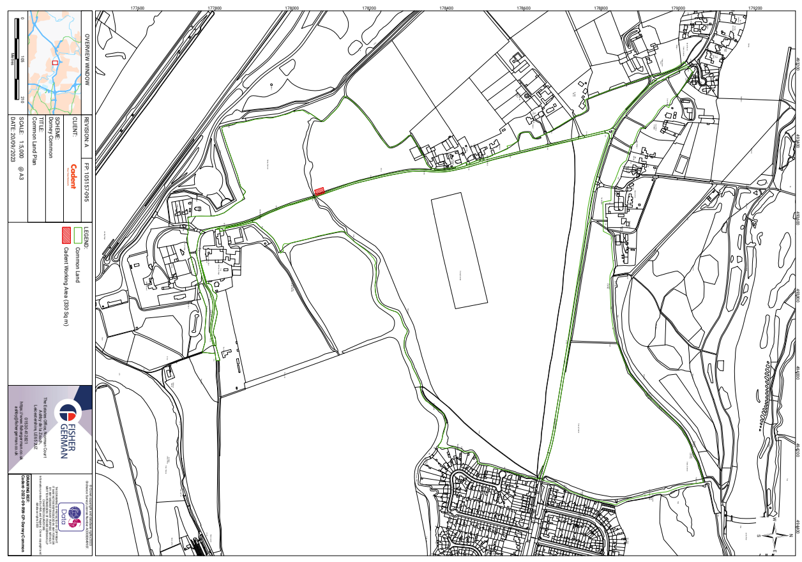
Figure 1 – Works area within common land

Figure 2 – Zoomed in works area
