Application Decision
by Harry Wood
Appointed by the Secretary of State for Environment, Food and Rural Affairs
Decision date: 1 March 2024

Application Ref: COM/3333418
Crookham Common, Old Thornford Road, Crookham Common, RG19 8EU
Register Unit Number: CL60
Commons Registration Authority: West Berkshire Council

- The application, dated 15 November 2023, is made under Section 38 of the Commons Act 2006 (the 2006 Act) for consent to carry out restricted works on common land.
- The application is made by Tom Hayward of Berks, Bucks & Oxen Wildlife Trust (BBOWT).
- The works comprise:
- two permanent wildlife tunnels measuring approximately 12m long x 0.625m wide with metal grid and 1m wide passing place for horses, with 8m of wing walls and ditching at the entrances of the tunnels (approximately 2m at each entrance);
- eight permanent metal bollards measuring approximately 1m high near where the tunnel entrances adjoin the road;
- temporary steel fencing panels, to be retained for a period of 10 years, measuring approximately 300m in total with 170m on the west side of the road and 130m on the east side. Fencing will be approximately 400mm above ground secured with 37mm x 37mm wooden stakes.

Decision
- Consent is granted for the works in accordance with the application dated 15 November 2023 and the plans submitted with it subject to the following conditions:

- the works shall begin no later than three years from the date of this decision;
- the land shall be fully reinstated within one month from the completion of the works;
- the fencing shall be removed on or before 1 March 2034.
- For the purposes of identification only the locations of the works are shown by the hard red (fencing) and blue (tunnels) lines on the attached plan.

Preliminary Matters
- I have had regard to Defra’s Common Land Consents Policy Guidance (November 2015) in determining this application under section 38, which has been published for the guidance of both the Planning Inspectorate and applicants. However, every application will be considered on its merits and a determination will depart from the guidance if it appears appropriate to do so. In such cases, the decision will explain why it has departed from the guidance.

- This application has been determined solely on the basis of written evidence. I have taken account of the representations made by the Open Spaces Society (OSS), Natural England (NE) and Jane Exelby.

- I am required by section 39 of the 2006 Act to have regard to the following in determining this application:
- the interests of persons having rights in relation to, or occupying, the land (and in particular persons exercising rights of common over it);
- the interests of the neighbourhood;
- the public interest; Section 39(2) of the 2006 Act provides that the public interest includes the public interest in; nature conservation; the conservation of the landscape; the protection of public rights of access to any area of land; and the protection of archaeological remains and features of historic interest. And
- any other matter considered to be relevant.

Reasons
- The applicant explains that the purpose of the works is to reduce fragmentation for a population of adders (Vipera berus) found at Greenham and Crookham Commons which they highlight is a Site of Special Scientific Interest (SSSI) with significant biodiversity interest on the urban fringe of the towns of Thatcham and Newbury, in West Berkshire. The purpose of the wildlife tunnels and fencing is to encourage and allow the adder (and other fauna) populations better access across the common. The bollards are required to prevent vehicles parking at the entrances of the tunnels and interfering with the project. The overall aim of the project is to assist in sustaining the populations of the adder which is under threat.

The interests of those occupying or having rights over the land
- West Berkshire Council is the owner of the land. They were consulted by the applicant and stated they had no objections to the project. The common land register records rights to take gravel, timber and underwood, bracken, gorse, turf and peat, edible nuts, leafmould and piscary (fish) as well as grazing rights for horses, ponies, sheep, cattle and goats and to turn out pigs, ducks and geese.

- The applicant advises that rights of estovers are exercised and gravel is taken for the repair of tracks. Grazing rights are also carried out on the common however none are carried out within the intended area of the works.

- I am satisfied that all those with rights of common had the opportunity to comment about the potential impact of the application proposals on these rights and no such comments were received.

The interests of the neighbourhood and public access
- The interests of the neighbourhood relate to whether the works will unacceptably interfere with the way the common land is used by local people and is closely linked with interests of public access. The wildlife tunnels are of a small width being designed to allow the adders access through the existing road. The top of the wildlife tunnels will be grated and on the same level as the existing road. The wing walls that form part of the wildlife tunnels structures are planned to come out at angles from the wildlife tunnel entrances. Once the temporary fencing is removed these wing walls could affect access acting as trip hazards, however the planned location for this wing walls lies within an area where natural barriers already exist, with large amounts of scrub growth within the landscape. It is likely that after the 10 year consent period these fences will be surrounded by the natural barriers which already impede access. I conclude that the wildlife tunnels will not present a major impact on public access.

- Concerns were raised by a party referred to by the applicant as the British Horse Association during the consultation stages of the application relating to the grating interfering with access on horseback. The applicant has responded to this by highlighting a 1m cross place will be left over the wildlife tunnels to allow for access on horseback.

- NE stated that Greenham and Crookham Common is an important and popular area for people to engage in recreational activities and enjoy the outdoors, providing a diverse range of wildlife habitats and well-marked paths. The proposed tunnels do not impede access directly as the use of a metal grid for the tunnels (which is to allow for sunlight for the reptiles) will be flush to the road’s surface. They also stated it would be helpful to know if the local highway authority has been consulted on these design amendments to accommodate equestrian use along the roads, as the most northerly tunnel appears to be near a slight bend in the road where views of motorised traffic could be obscured. Asphalt strips on either side of the road could help overcome any concerns with regard to horses having to move to the middle of the road at the tunnel locations. The applicant has stated that in response that Nick Coulsdon, Senior Engineer for West Berkshire Highways Authority, was consulted on the final specifications which included the design amendments to accommodate equestrian access, as presented in the submitted Section 38 application. He was happy with the specifications as presented and subsequently gave consent for works to proceed.

- The temporary fences would have a larger impact, blocking access to the areas of the common where they are located. The fences will not enclose an area of land but will impede some public access along their lengths as no access points are intended. However, the fence only measures 400mm high meaning those who are able can easily step over them. Additionally, there is no evidence before me to suggest that it will cross any tracks or established walk lines and no party has raised specific concerns about its impact on public access. Images provided by the applicant show large amounts of scrub and vegetation on either side of the road, which suggests the areas in which the works will be located at are not easily accessible on foot.

- NE have also provided a statement on this highlighting that they do not anticipate the western fence to cause any impediment to access due to the alignment running parallel to the existing stock proof fencing. Based on the map within the supporting information, the eastern fencing appears close to a northern path although the fencing is not expected to impede access to any existing paths or desire lines.

- The bollards are located to prevent vehicles parking at the entrances to the wildlife tunnels and will not present an impediment to access of the common with each bollard standing separately from the others.

- I conclude that the works will not seriously harm the interests of the neighbourhood and public rights of access.

The public interest
- As well as the public interest in the protection of public rights of access, the Guidance (November 2015) outlines the public interest in nature conservation, the conservation of the landscape and the protection of archaeological remains and features of historic interest.

Nature conservation and Conservation of the landscape
- The applicant has stated that the works fall within the Greenham and Crookham SSSI and consent under Section 28E(3)(a) of the Wildlife and Countryside Act 1981 for the works has been acquired from NE on 31 October 2023.

- NE have further stated in their representation that Greenham and Crookham Common is a SSSI designated for its large complex of open heathland, acid and neutral grassland, ancient woodland and secondary woodland on former heath to the east of Newbury. It is of very high importance in having the largest surviving area of open heath in Berkshire and has a large number of uncommon plants.

- NE further stated that they believe this project has the potential to deliver important conservation benefits for this nationally threatened species of adder. The wildlife tunnels will help the declining populations recover by providing a pathway to travel between priority habitats and prevent populations from becoming isolated in one area. The wildlife tunnels will also mitigate against potential effects of noncontact disturbance from public access routes preventing species from moving across to priority habitats.

- They also anticipate that a 10 year consent period for the fencing will allow enough time to determine how successful the project has been over that period and inform any future proposals. During this period they would however expect to see regular inspections and maintenance carried out to the tunnels when needed. They conclude landscape impacts overall will be minimal once the ground vegetation has become re-established.

- The proposed works will introduce new permanent artificial features into the landscape. The wildlife tunnels themselves will have virtually no visual impact as they travel through the existing tarmacked road. Their associated wing walls will introduce permanent features into the landscape however the visual impact of these will be mitigated by the surrounding scrub and foliage. I have also noted that although the wing walls will introduce a permanent feature on the common, they will form part of the permanent structure of the wildlife tunnel and will contribute to ongoing nature conservation efforts in the common.

- The temporary fencing and permanent bollards will have a slight impact on the visuals of the common however due to the fencings height and colour it will blend into the surrounding environment as the natural vegetation regrows after installation. Only eight bollards in total are planned to be installed (two at each entrance of the tunnels) which will only have a minor impact on the visuals of the common.

- OSS stated that the primary purpose of the wingwalls is to guide reptiles to the tunnels under the road. They query whether, once reptiles are habituated to using the tunnels if the wingwalls will retain any function, and ask whether they could be removed after a shorter term than ten years. In response the applicant highlighted how the wingwalls are an essential part of the project and are integral to the functionality of the tunnels. As a result, to ensure the project has the desired effect to benefit the reptile and amphibian populations on site, in addition to providing an effective case study to help inform similar projects elsewhere, they believe the fencing should remain for the 10-year period.

- I am satisfied that the proposed works will have a positive impact on the nature conservation interests of the common by assisting with the population management of the Vipera berus adder specimens and wider fauna in the area and overall, the works will have only a negligible impact on the visuals of the landscape.

Protection of archaeological remains and features of historic interest.
- The applicant has stated that there are no archaeological features within the proposed works area. Historic England and the local authority archaeological service have been consulted. HE did not provide comment. The local authority archaeological service stated they could see no major adverse impact on archaeological features or other heritage assets from this proposal to install wildlife tunnels, bollards or new fence panels.

- There is no evidence before me to suggest that these interests will be harmed by the proposed works.

Conclusion
- I conclude that the permanent and temporary works will benefit the nature conservation interests of the common by assisting in the management of the threatened species and wider fauna of the common and will only have a minor impact on the visuals and access of the common. The works will not seriously harm the other interests set out in paragraph 5 above. Consent for the works is therefore granted subject to the conditions set out at paragraph 1.
Harry Wood

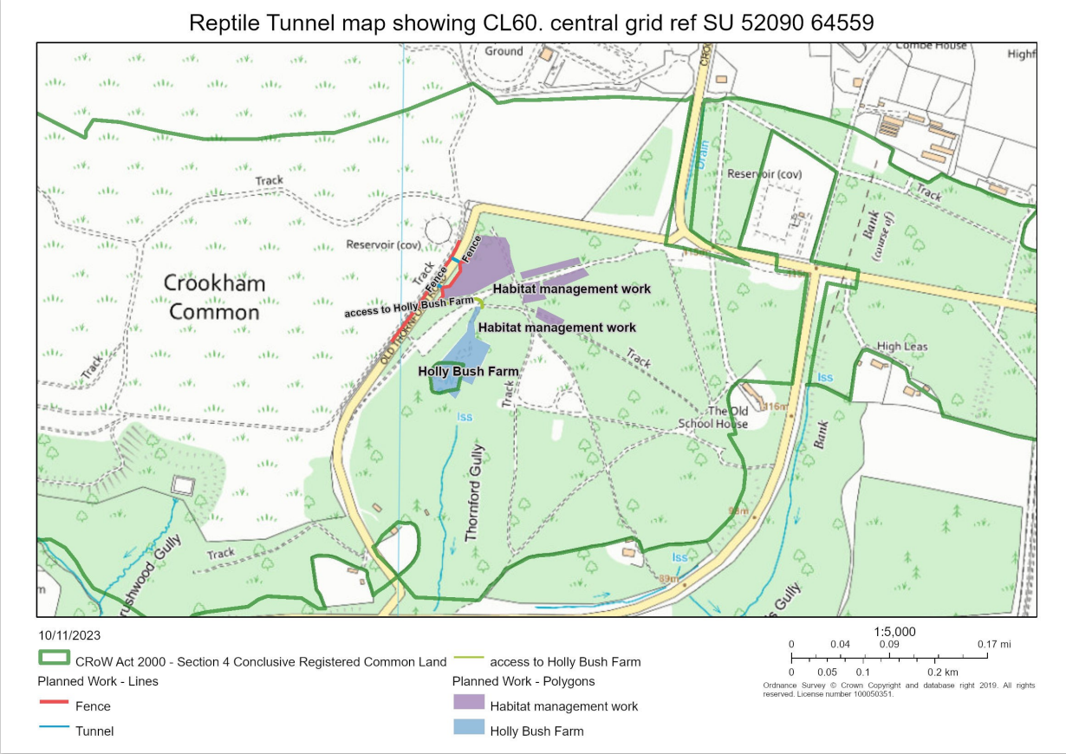
Figure 1 - Application Plan

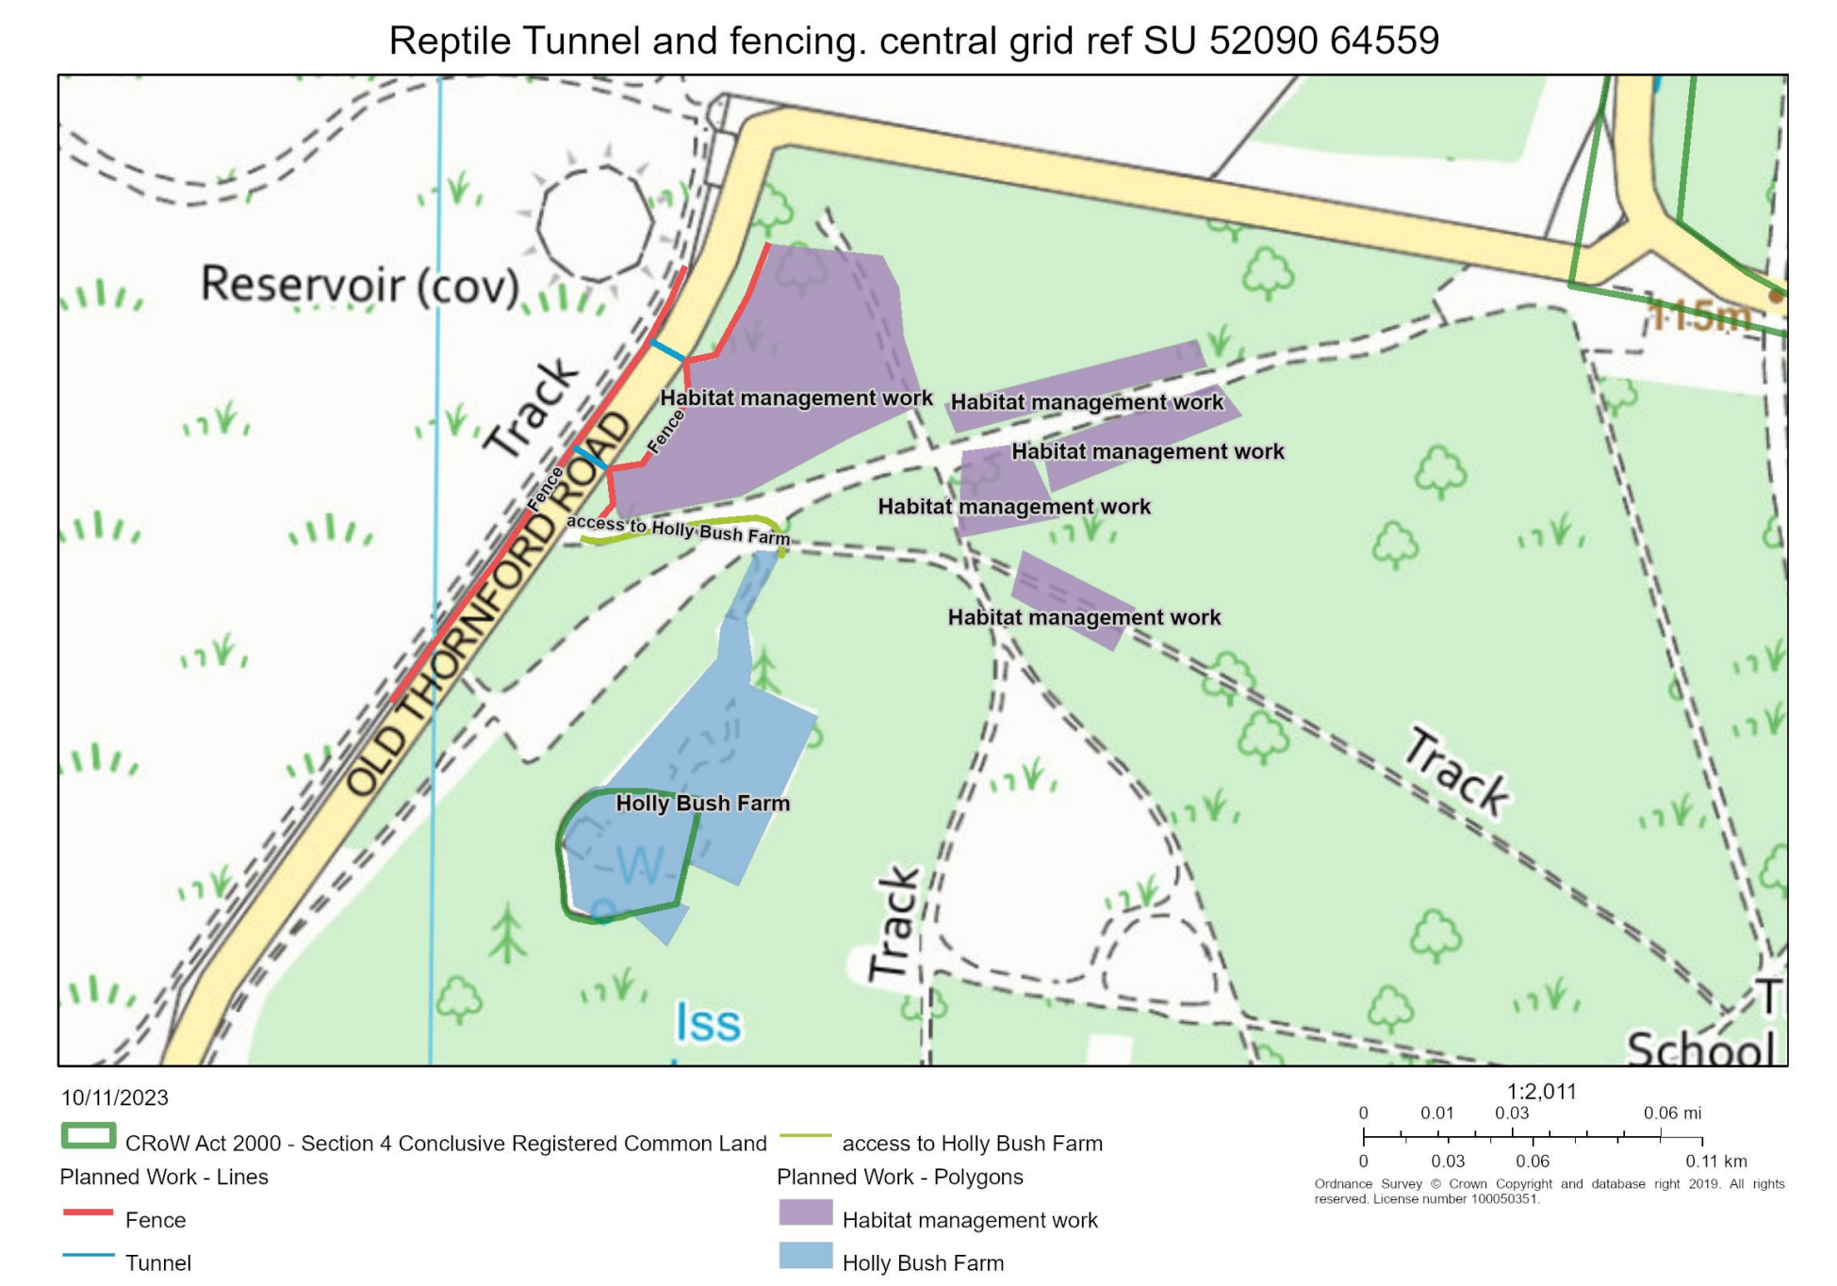
Figure 2 – Zoomed in Application Plan

