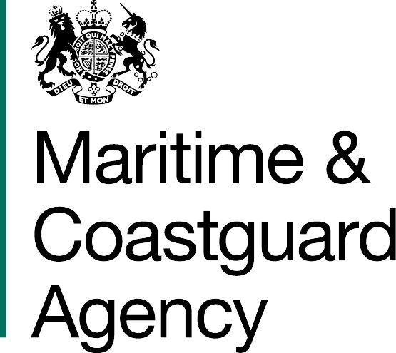 | GUIDANCE FOR COMPANIES  ON CONTINUOUS SYNOPSIS  RECORD (CSR) - MSF 5623 A

BACKGROUND

The Continuous Synopsis Record (CSR) is a form of logbook that stays with the ship for its whole life and records all changes of owner, flag, name, Class, ISM details etc. The Company, owner and master of a ship must ensure that a copy of the whole CSR is kept on board the ship, even when it transfers to another flag State, is sold to another owner, is taken over by another bareboat charter, or another company assumes the responsibility of the ship operation. The requirement for a CSR is contained in regulation 9 of the Merchant Shipping (Special Measures to Enhance Maritime Safety) Regulations 2024 (SI 2024/280) (“the 2024 Regulations”), which implements the requirement in regulation 5 of Chapter XI-1 of SOLAS. Criminal offences apply where there are contraventions of these requirements. A ship cannot be operated without the CSR.

A CSR must be maintained for:

- passenger ships on international voyages
- cargo ships of 500 GT and above on international voyages

The Master is responsible for the proper upkeep of the CSR on board UK flagged ships. It is important that the details are always correct as Port State Control will check the CSR as a matter of routine at inspections. The original CSR documents must not be modified, deleted, erased or defaced.

The CSR comprises:

- Form 1: Continuous Synopsis Record (CSR) Document Number … for the Ship with IMO Number: IMO … (latest up to date record of ship’s details)
- Form 2: Amendments to the Continuous Synopsis Record (CSR) Document Number … for the Ship with IMO number: IMO … (application to amend Form 1)
- Form 3: Index of Amendments to Continuous Synopsis Record (CSR) Document Number … for the Ship with IMO number: IMO … (record of applications made to amend the latest version of Form 1. Form 3 applies to the current Form 1, not to the entire CSR history.

Above mentioned forms can be downloaded from the gov.uk website here: https://www.gov.uk/government/publications/continuous-synopsis-record-csr-forms-and-guidance-msf-5623

For ships constructed before 1st July 2004, the Continuous Synopsis Record must provide the history of the ship as from 1st July 2004.

REGISTRY OF SHIPPING AND SEAMEN

The Registry of Shipping and Seamen (RSS) issues CSRs for UK registered ships in the English language. RSS can be contacted at:

E-mail | uksr@mcga.gov.uk | Tel: | +44 (0) 203 90 85200
Address | RSS, MCA, Anchor Court, Keen Road, Cardiff, CF24 5JW

APPLYING FOR A NEW CSR (FORM 1) FOR NEW BUILD SHIPS REGISTERING WITH THE UK FLAG.

- Please use the Application for Continuous Synopsis Record MSF 5623 D - (Document 1) to apply for your ship’s first CSR: CSR 1.

REQUESTING AMENDMENTS TO THE CURRENT CSR (FORM 1).

Ships flagging into the UK Ship Register:
- Complete at least Boxes 1, 15 and 16 on Form 2 and send it to your previous Flag Administration so they can issue their final CSR document.
- Complete Form 2 (MSF 5623 C) and send it to RSS at the above address.
- Whilst the ship is on the UK Flag, RSS hold a copy of the ship’s entire CSR history record. Please note that we can experience long delays in receiving the ship’s CSR file from the losing Flag Administration. It would be helpful when flagging in, if the ship could provide us with a full copy of its CSR file. Please keep the originals onboard.

Existing ships on the UK Ship Register with changing details:
- If any data entered on the current CSR (Form 1) requires amendment, please complete the changes required on Form 2 and Form 3 (MSF 5623 C).
- Attach the completed original Form 2 & Form 3 to the latest CSR (Form 1) on the ship and email a copy of Forms 1, 2 & 3 to RSS.
- RSS will issue a new CSR (Form 1) with the next consecutive number.
- If appropriate, a gap will be left in the numbering to allow the losing Flag Administration’s closure CSR to be inserted.
- In all cases, please check your new CSR carefully to make sure it is correct and that all the requested amendments have been completed. If not, please contact RSS who can arrange for the CSR to be amended and re-issued.
- If you find that there are amendments required which were not previously notified to RSS, you should begin the process again by completing a new Form 2 and Form 3.

LOST DOCUMENTS.

- If for any reason, the ship’s CSR records are lost or damaged, it is essential that they are restored as quickly as possible in order to avoid potential delays to the ship’s voyage. You should contact RSS immediately and they will provide signed and stamped duplicates. Please note that failure to do so is a criminal offence (see regulations 9(11) and 10(1)(b) in the 2024 Regulations).
- There will be a charge for issuing CSR documentation. Please contact the RSS for details.

LEAVING THE UK SHIP REGISTER.

- Please notify RSS of the name of the new Flag Administration and the date of the change, by completing boxes 1, 15 and 16 on Form 2, and by completing the Application to Remove a British Ship from the Register (MSF 4744).
- Either on, or as soon as possible after the transfer date, RSS will send you the closing UK CSR.
- RSS will forward a copy of the ship’s complete CSR file to the new Flag Administration.

More information
Maritime Security and MLC Operations
Maritime and Coastguard Agency
Bay 2/20
Spring Place
105 Commercial Road
Southampton
SO15 1EG
Telephone: +44 (0)203 81 72478
Email: hq_MaritimeSecurity@mcga.gov.uk
Website: www.gov.uk/mca
General enquiries: infoline@mcga.gov.uk
Please note that all addresses and telephone numbers are correct at time of publishing.
Published: March 2024
© Crown Copyright 2024

SOLAS is the International Convention for the Safety of Life at Sea, 1974, developed in the International Maritime Organization.

