Appendices 1 to 3: adult safeguarding decision guide, body map and concern proforma
Published 5 March 2024

Contents
Appendix 1: adult safeguarding decision guide 2
Appendix 2: body map 13
Appendix 3: adult safeguarding concern proforma regarding pressure ulceration 15

Appendix 1: adult safeguarding decision guide
You should review all 6 questions and see the score conclusion.

Person's information
Person's name:
Person's NHS number:

Assessor information
Assessing nurse’s name (print):
Job title:
Assessing nurse’s signature:
Note: when using an electronic patient record (EPR), this guide will be completed under one assessor's profile. However, if there is a second assessor present, you should record their name.
Second assessor’s name (print):
Job title:
Second assessor’s signature:

Question 1
Has the person's skin deteriorated to either category 3 or 4 or multiple sites of category 2 ulceration from healthy unbroken skin since the last opportunity to assess or visit?
Level of concern | Score | Evidence
Yes  For example, record of blanching or non-blanching erythema progressing to category 2 or category 2 progressing to category 3 or 4 | 5 | For example, evidence of redness or skin breaks with no evidence of provision of repositioning or pressure relieving devices provided
No  For example, no previous skin integrity issues or no previous contact health or social care services | 0

Question 2
Has there been a recent change, that is within days or hours, in their clinical condition that could have contributed to skin damage?
For example, infection, pyrexia, anaemia, end of life care (skin changes at life end), critical illness, emergency hospital visit.
Level of concern | Score | Evidence
Change in condition contributing to skin damage | 0
No change in condition that could  contribute to skin damage | 5

Question 3
Was there a pressure ulcer risk assessment or reassessment with an appropriate pressure ulcer care plan in place, and was this documented in line with the organisation’s policy and guidance?
Level of concern | Score | Evidence
Yes, current risk assessment and care plan carried out by a healthcare professional and documented appropriate to person's needs  If the person is not under the care of a healthcare professional, the carer responsible has screened for risk and implemented preventative care accordingly | 0 | State date of assessment, risk tool used and score or risk level
Yes, risk assessment carried out and care plan in place documented but not reviewed as person’s needs have changed | 5 | State the elements of care plan that are in place
No or incomplete risk assessment and/or care plan carried out | 15 | State the elements that would have been expected to be in place but were not

Question 4
Is there a concern that the pressure ulcer developed as a result of the informal carer wilfully ignoring or preventing access to care or services?
Level of concern | Score | Evidence
No or not applicable | 0
Yes | 15

Question 5
Is the level of damage to skin inconsistent with the person's risk status for pressure ulcer development?
For example, no risk factors that align with the category of pressure ulcer that has developed.
Level of concern | Score | Evidence
Skin damage less severe than person's risk assessment suggests is proportional | 0
Skin damage more severe than person's risk assessment suggests is proportional | 10

Question 6
Question 6 has 2 parts - which part you ask depends on the person:
- if the person has capacity to consent to every relevant element of the care plan, answer question 6a
- if the person has been assessed as not having mental capacity to consent to any or some relevant aspects of the care plan, answer 6b

Question 6a
Were the risks and benefits explained and understood by the person?

Was a plan of care agreed in line with shared decision making and has the person chosen to follow the relevant aspects of the plan?
Level of concern | Score | Evidence
Person has followed care plan, and local policies to support shared decision making have been followed | 0
Person followed some aspects of care plan but not all | 3
Person has not followed care plan or not given information to enable them to make an informed choice, or an opportunity to discuss reasons for not following the agreed plan and alter the plan accordingly has not been taken | 5

Question 6b
Was the relevant care undertaken in the person's best interests, following the best interests checklist in the Mental Capacity Act?
This should be supported by documentation - for example, capacity and best interest statements and record of care delivered.
Level of concern | Score | Evidence
Documentation of care being undertaken in person’s best interests | 0
No documentation of care being undertaken in person’s best interests | 10

Score conclusion
If the total score is 15 or over, discuss with the local authority (safeguarding) as determined by local procedures and reflecting the urgency of the situation.
When the decision guide has been completed, even when there is no indication that a safeguarding alert needs to be raised, the tool should be stored in the person's notes.

Appendix 2: body map
Body maps should be used to record skin damage and can be applied as evidence, if necessary, at a later date.
If 2 workers observed the skin damage, they should both sign the body map.

Person's information
Person's name:
Person's NHS number:

Assessor information
Assessing nurse’s name (print):
Job title:
Assessing nurse’s signature:
Note: when using an electronic patient record (EPR), this guide will be completed under one assessor's profile. However, if there is a second assessor present, you should record their name.
Second assessor’s name (print):
Job title:
Second assessor’s signature:
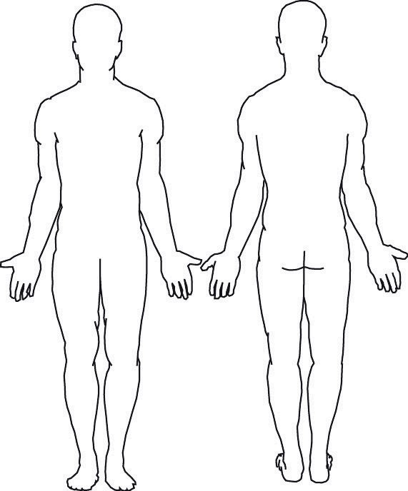

Appendix 3: adult safeguarding concern proforma regarding pressure ulceration
Fill this form in if the adult safeguarding decision guide score is 15 or over.

Person's information
First name:
Last name:
Date of birth:
NHS number:
Address:

Assessor information
Department or base address:
Organisation name:
Telephone number:
Assessing nurse’s name (print):
Job title:
Assessing nurse’s signature:
Note: when using an electronic patient record (EPR), this guide will be completed under one assessor's profile. However, if there is a second assessor present, you should record their name.
Second assessor’s name (print):
Job title:
Second assessor’s signature:
Date and time assessors witnessed pressure ulceration:
Date and time of completing documentation of concern:

© Crown copyright 2024
www.gov.uk/dhsc
This publication is licensed under the terms of the Open Government Licence v3.0 except where otherwise stated. To view this licence, visit nationalarchives.gov.uk/doc/open-government-licence/version/3.
Where we have identified any third party copyright information you will need to obtain permission from the copyright holders concerned.

