Terms and conditions for entering the competition

The competition is open to female applicants – whose prime country of residence is Lebanon, who are not at University and who are aged between 15-18 years old on the 27 May 2024.
There is no entry fee.

If the winners need to travel for an event or an activity, the British Embassy or one of its Embassy Partners will cover the reasonable travel expenses for the winners and one chaperone.

Route to entry for the competition and details how to enter are:
- All candidates must answer the following question – If you were Ambassador for a day, how would you promote inclusion in Lebanon?
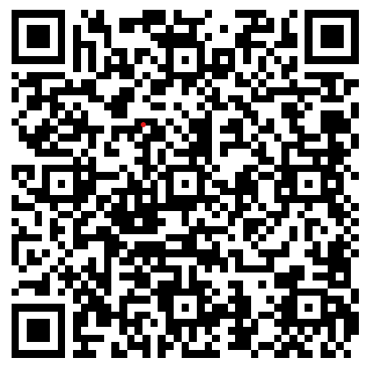
- The entries should be in written format (essay) within the word limit of 250 words or via video blog with a limit of 2 minutes. The essay or video can be in English or Arabic.
- Entries must be submitted via Ambassador for a Day - 2024
(you will need to have, or need to create, a free Google Account to fill in the form)

- Together with the entry, each candidate must include the following contact details: name, date of birth, email address, and their telephone number. These details will be used to inform candidates about the results of the competition.
- The candidates must enter the competition with essays or videos, which have not been published in print or online prior to the announcement of the Ambassador for a Day competition and have not been used for applying to similar initiatives. The content of the essays must be original and in line with the theme of the Ambassador for a Day campaign – “Inspire Inclusion”.
Only one entry will be accepted per person. Multiple entries from the same person will be disqualified.

​The estimated number of winners will be between eight and ten. However, the British Embassy reserves the right to amend this according to the number of applications. This decision will be at the discretion of the Embassy.

Closing date for entry will be 23:59 hrs, 07 April 2024. After this date, no further entries to the competition will be permitted.

No responsibility can be accepted for entries not received for whatever reason. In respect of the winners of the competition the British Embassy will be seeking consent (including parental consent) in respect of the following:
- The winners agree to be photographed and/or filmed during public and online engagements within the Ambassador for a Day campaign in order to promote the initiative.
- The winners must be available to travel to Beirut.
- Winners under 18 must have a chaperone, who is over 21 years old (parent, teacher, or guardian) in order to travel to Beirut.

The British Embassy Beirut and the Embassy of Canada’s decision in respect of all matters to do with the competition, including but not limited to the appraisal of the participants, the organisation of carrying out the competition and the awarding of the winners’ prizes will be final. The British Embassy Beirut and the Embassy of Canada reserve the right to change the date and order of awards if necessary, in such an event participants will be notified.

By entering this competition, the entrant and her lawful representative is indicating her agreement to be bound by these terms and conditions.

