Application Decision
by Harry Wood
Appointed by the Secretary of State for Environment, Food and Rural Affairs
Decision date: 15 February 2024

Application Ref: COM/3319474
Land At Felixstowe Ferry Common, Suffolk
Register Unit Number: CL 20
Commons Registration Authority: Suffolk County Council

- The application, dated 27 March 2023, is made under Section 38 of the Commons Act 2006 (the 2006 Act) for consent to carry out restricted works on common land.
- The application is made by Fisher German LLP for Eastern Power Networks PLC.
- The works comprise:
i. the installation of approximately 515m of underground cabling;
ii. excavation of a total of approximately 16,000m² works area for the laying of the cables to be completed and backfilled in sections;
iii. temporary fencing consisting of both Heras fencing with each panel measuring 2m high and 3.5m long and Chapter 8 road barriers with each panel measuring 1m high and 2m long. A total of approximately 100m of fencing to be in place at one time.

Decision
- Consent is granted for the works in accordance with the application dated 27 March 2023 and the plans submitted with it subject to the following conditions:

- the works shall begin no later than three years from the date of this decision;
- all temporary fencing shall be removed and the land shall be fully reinstated within one month from the completion of the works;
- For the purposes of identification only the location of the cable route are shown by the dotted red and blue lines on the attached plan.

Preliminary Matters
- I have had regard to Defra’s Common Land Consents Policy Guidance (November 2015) in determining this application under section 38, which has been published for the guidance of both the Planning Inspectorate and applicants. However, every application will be considered on its merits and a determination will depart from the guidance if it appears appropriate to do so. In such cases, the decision will explain why it has departed from the guidance.

- This application has been determined solely on the basis of written evidence. I have taken account of the representations made by the Open Spaces Society (OSS) and Natural England (NE).

- I am required by section 39 of the 2006 Act to have regard to the following in determining this application:
- the interests of persons having rights in relation to, or occupying, the land (and in particular persons exercising rights of common over it);
- the interests of the neighbourhood;
- the public interest; Section 39(2) of the 2006 Act provides that the public interest includes the public interest in; nature conservation; the conservation of the landscape; the protection of public rights of access to any area of land; and the protection of archaeological remains and features of historic interest. And
- any other matter considered to be relevant.

Reasons
The interests of those occupying or having rights over the land
- Felixstowe Ferry Golf Club is the owner of the land who was consulted by the applicant and did not provide comment. The common land register records rights to graze eight horses over the whole of the register unit.

- The applicant received no response to their consultation regarding these rights and advises that none of the above rights are currently being exercised. I am satisfied that all those with rights of common had the opportunity to comment about the potential impact of the proposals on these rights. No such comments were received.

The interests of the neighbourhood and public access
- The applicant explains that the electric cabling is being installed as part of a scheme driven by Area of Outstanding Natural Beauty (AONB) (now known as National Landscapes (NL)) officers to improve the Suffolk Coasts and Heaths as a NL and that the network using the cables will be improved benefiting customer suppliers. The purpose of the temporary works area, which will include ditches and fencing, is to facilitate the safe laying of the cables and removal of twelve wooden poles with overhead line.

- The interests of the neighbourhood relate to whether the works will unacceptably interfere with the way the common land is used by local people and is closely linked with interests of public access. The applicant has outlined that the programme of work has been created to minimise impact on the common with only 100m of fencing to be used at one time paired with the works being completed in sections to lessen the impact on access.

- OSS have commented that they welcome the application highlighting the benefits to the NL. They have also noted that the common is subject to rights of common on foot and horseback but do not consider that the works would impact access. I consider that the works will be of benefit to the neighbourhood by facilitating the goals of the NL scheme.

- The temporary fencing would have a larger impact potentially blocking access across the common, but this will be minimal due to the process of the works being completed in sections and the common will still be accessible via other routes and largely unaffected. I am satisfied that such fencing is appropriate on health and safety grounds and that it will be removed on completion of the works, which can be secured by attaching a suitable condition to the consent.

- NE anticipate that the works will affect the public footpath which runs across the site from east to west in the area where the works are due to take place. The applicant has informed NE that they intend to liaise directly with the relevant Highway Authority’s footpath officer in order to ensure any temporary diversions are in place and access is not unnecessarily disrupted.

- I am of the opinion that the works will not interfere with the use of the common or the interests of the neighbourhood.

The public interest
- As well as the public interest in the protection of public rights of access, the Guidance (November 2015) outlines the public interest in nature conservation, the conservation of the landscape and the protection of archaeological remains and features of historic interest.

Nature conservation and Conservation of the landscape
- NE advises that the site is not subject to any statutory or non-statutory designations for nature conservation although the works will take place within 50 metres of the Deben Estuary Site of Special Scientific Interest (SSSI), Special Protection Area (SPA) and Ramsar site. The site designations cover the estuarine saltmarsh, swamp and reed bed habitats, as well as the overwintering bird species avocet, redshank, black-tailed godwit, dark bellied brent goose and shelduck. The rare narrow-mouthed whorl snail is another key designation.

- NE further advises the operation will have no direct impact on the designated habitats within the estuary, however the land on which the operation will be carried out is close to the protected site, ranging from ~25-150m from the boundary. Consequently, they believe that disturbance to the designated bird species listed above is possible if works are carried out between 1st October and the end of February. If the proposed works are scheduled to take place during this period, they would wish to see further detailed information on the exact timing and duration of the operations as well as the kind of machinery to be used. The applicant has stated that it is likely the works will fall outside of these dates.

- The common lies within the Suffolk Coast & Heaths NL. The NL Conservation Board was consulted about the application and did not comment. The works covered in this decision involve the removal of poles with overhead wire which will positively affect the visuals of the NL and any excavations undertaken as part of the works are to be refilled with the same material to reduce the visual impact the works would have on the NL and to be in keeping with the wider landscape.

- I conclude that the works will conserve the natural beauty of the NL

- I am satisfied that nature conservation interests will not be harmed by the works and I consider that overall the works will have little to no impact on landscape interests.

Protection of archaeological remains and features of historic interest.
- The applicant has stated that there are no archaeological features within the proposed works area. Historic England and the local authority archaeological service have been consulted and not commented.

- There is no evidence before me to suggest that these interests will be harmed by the proposed works.

Other Matters

- In coming to a decision, I have noted that the applicant has included in their application intent to remove twelve wooden poles with overhead wiring. While I note that these features may fall within the temporary works area and fencing consent under Section 38 is not required for the removal, specifically, of these features.

Conclusion
- I conclude that the permanent works will benefit the interests of the neighbourhood by improving the NL. The temporary works will not seriously harm the other interests set out in paragraph 5 above. Consent for the works is therefore granted subject to the conditions set out at paragraph 1.

Harry Wood

Figure 1 - cable routes:
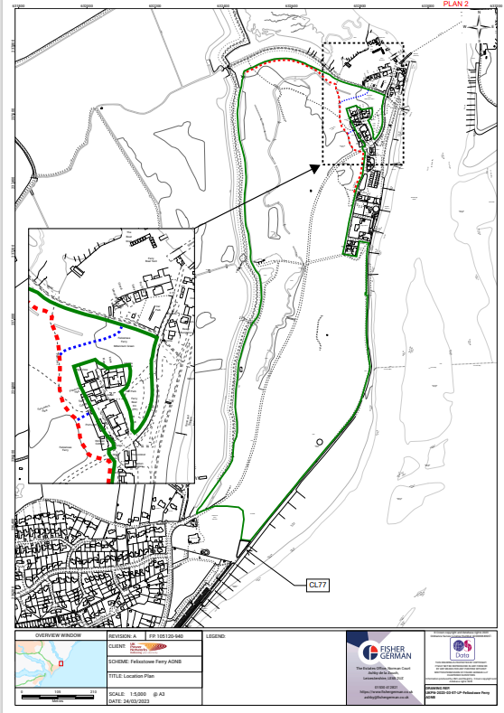

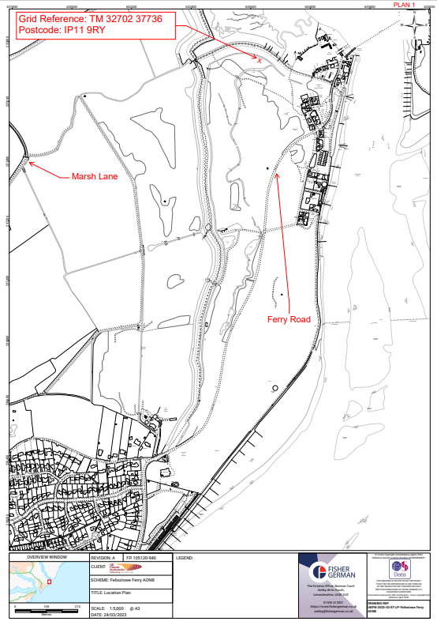
Figure 2 - Points of interest:

