NOTICE OF ORDER

Wildlife and Countryside Act 1981 S53
North Yorkshire County Council
Former West Riding of Yorkshire (Area 2)
Definitive Map and Statement
Bridleway No. 15.29/78 & Restricted Byway 15.29/79 Heyshaw to Lanes Foot Road, Dacre, Modification Order 2020

Notice is hereby given that the above referenced Order has been submitted to the Secretary of State for Environment, Food and Rural Affairs for determination. An Inspector will be appointed by the Secretary of State to determine the Order.

The start date for the above Order is 28 September 2022.

Consideration of the Order will take the form of a hearing.

The Hearing will be held at Pateley Bridge Town Hall, King Street, Pateley Bridge, North Yorkshire, HG3 5LE on 24 January 2023 at 10.00am.

The effect of the Order, if confirmed without modifications, will be to modify the definitive map and statement for the area by upgrading footpath no 15.29/42 to a public bridleway between GR SE 1728 6183 and GR SE 1804 6167 and to a restricted byway between GR SE 1804 6167 and GR SE 1821 6144; and upgrading public bridleway no. 15.29/79 to a restricted byway between GR SE 1821 6144 and GR SE 1835 6123.

Any queries relating to this Order should be referred to Clive Richards at The Planning Inspectorate, Rights of Way Section, Room 3/A Eagle Wing, Temple Quay House, 2 The Square, Temple Quay, Bristol, BS1 6PN. Telephone: 0303 4445502. Email: Rightsofway2@planninginspectorate.gov.uk or clive.richards@planninginspectorate.gov.uk Please quote reference ROW/3284255 on all correspondence.

Any person wishing to view the statements of case and other documents relating to this Order may do so by appointment at Harrogate Library, Victoria Avenue, Harrogate, HG1 1EG. Contact at NYCC: Sarah Blakemore, Tel: 07971 836186, Email: Sarah.Blakemore@northyorks.gov.uk

Timetable for sending in statements of case

Within 8 weeks of the start date [by 23 November 2022]

The Order Making Authority must ensure their statement of case is received by the Secretary of State. As soon as possible after the deadline, the Secretary of State will send a copy (excluding copies of any supporting documents, although these will be available to view at the Authority’s offices) to everyone who has made an objection or representation, the applicant and any other person who has written to us in respect of the Order.

Within 13 weeks of the start date [by 03 January 2023]
NOTE: 13 weeks rather than the usual 12 weeks have been given to take the Christmas holidays into account.
Everyone who has made an objection or representation and anyone who wishes to give evidence at the Hearing must ensure their statement of case is received by the Secretary of State. As soon as possible after the deadline, the Secretary of State will send full copies to the Authority. Copies will also be sent to the applicant, every person who has made an objection or representation and any other person who has written to us in respect of the Order (excluding copies of any supporting documents - these will be available to view at the Authority’s offices).

Within the same period the applicant (if applicable) must ensure their statement of case is received by the Secretary of State. As soon as possible after the deadline, the Secretary of State will send a full copy to the Authority. Copies will also be sent to everyone who has made an objection or representation and any other person who has written to us in respect of the Order (excluding copies of any supporting documents - these will be available to view at the Authority’s offices).

All parties must keep to the timetable set out above and ensure that statements of case are received by the Secretary of State on time. Late documents will be returned.

We cannot accept any inflammatory, discriminatory or abusive comments. Any documents containing such comments will be returned.

Notice of order for hearing
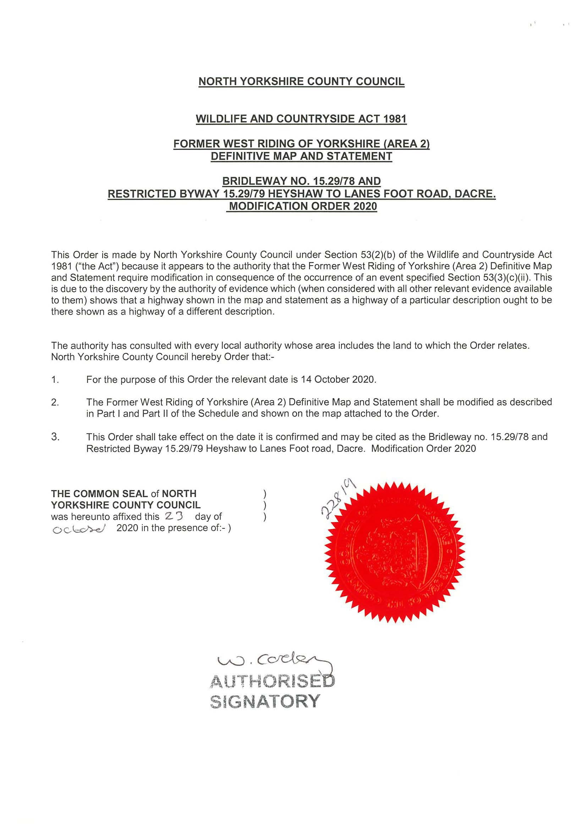
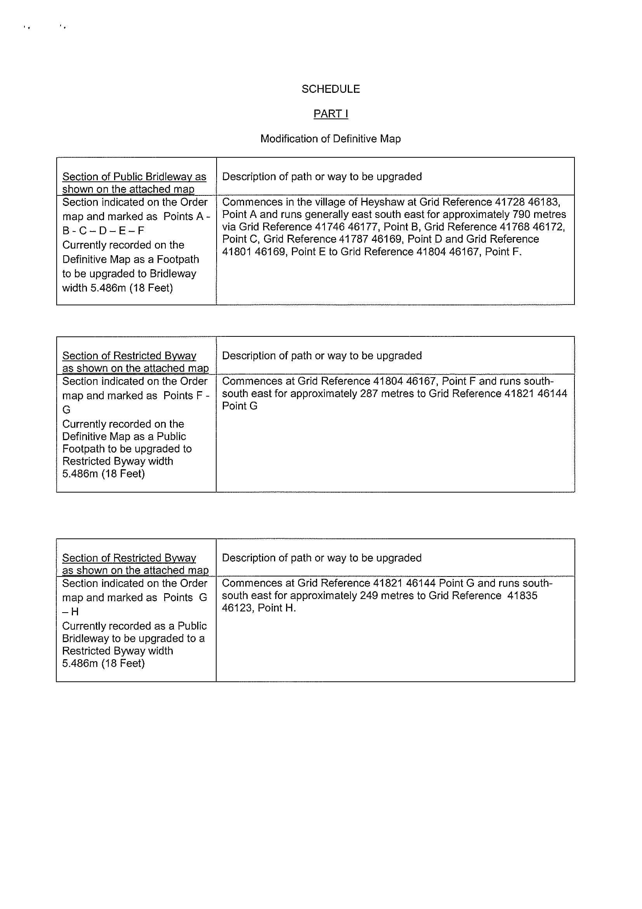
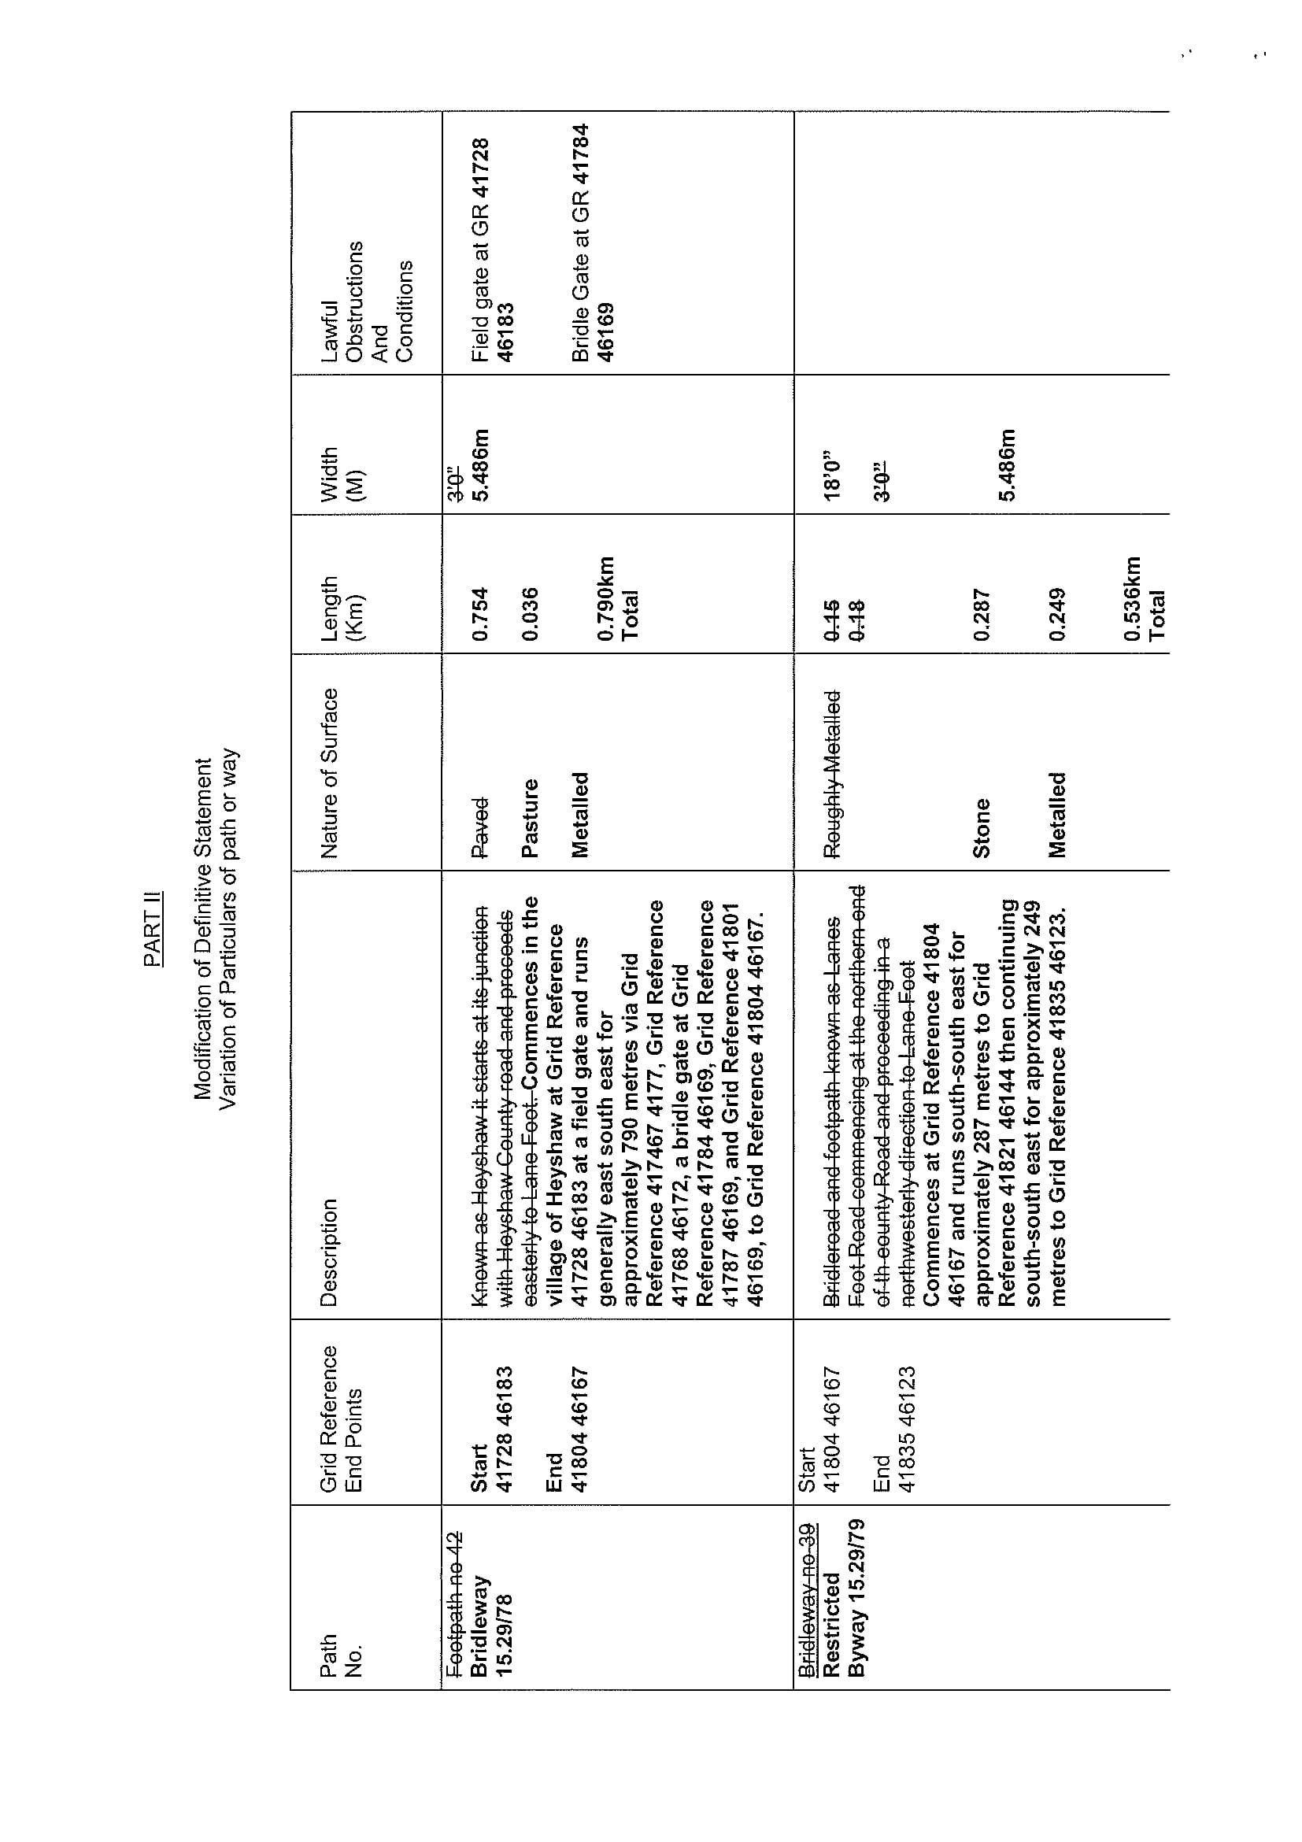
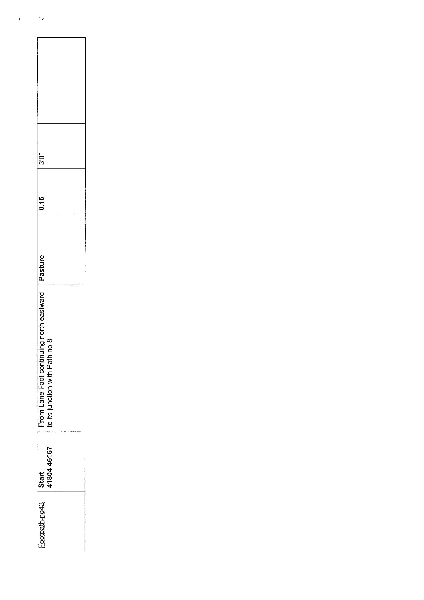
COPY – MAP NOT TO ORIGINAL SCALE
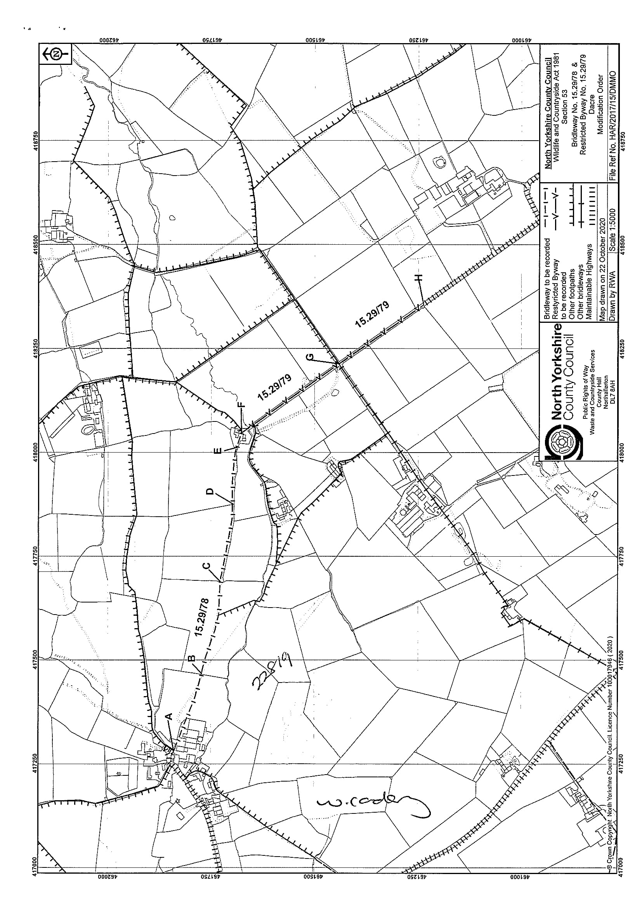

If you wish to make a legal submission, this should be submitted at the same time as your statement of case. Otherwise legal submissions will have to be submitted in writing on the day of the hearing.

