Application Decisions
Site visit made on 29 September 2023
by Grahame Kean MIPROW Solicitor
Appointed by the Secretary of State for Environment, Food and Rural Affairs
Decision date: 22 February 2024

Application A Ref: COM/3310344
Part of Blackdown Common, Devon
Register Unit No: CL 222 (original common land register number)
Commons Registration Authority: Devon County Council
- The application, dated 31 December 2020, is made under paragraph 4 of Schedule 2 of the Commons Act 2006.
- The application is made by Mr T Hannis, Landman LLP, on behalf of the Open Spaces Society.
- The application is to register waste land of a manor in the Register of Common Land.
____________________________________________________________________________________
Application B Ref: COM/3312767
Part of Blackdown Common and Black Lion Common, Devon

Register Unit No: CL 193 (original common land register number)
Commons Registration Authority: Devon County Council
- The application, dated 31 December 2020, is made under paragraph 4 of Schedule 2 of the Commons Act 2006.
- The application is made by Mr T Hannis, Landman LLP, on behalf of the Open Spaces Society.
- The application is to register waste land of a manor in the Register of Common Land.

Formal Decisions

Application A
- The application made on behalf of the Open Spaces Society (the OSS) is approved. The land coloured blue on Plan 1 attached to this decision letter shall be added to the Register of Common Land.

Application B
- The application made on behalf of the Open Spaces Society (the OSS) is approved. The land coloured blue on Plan 2 and Plan 3 attached to this decision shall be added to the Register of Common Land.

Procedural matters
- No one requested to be heard in relation to the applications. The applications were dealt with by way of the written representations procedure and unaccompanied inspection of the sites.
- Application B in relation to CL193 is for two parcels of land, one is adjacent to the land the subject of Application A which is related to CL 222. All applications are similar in substance and consequently I have agreed it would be beneficial if these matters were conjoined and considered within the same decisions letter.

The Application lands
- Application A relates to part of Blackdown Common owned by the Ministry of Defence (MoD) located on the east side of the A386 road between Lydford and Mary Tavy, approximately centred on grid reference SX521834.
- Land contiguous to east of the application land is within Willsworthy firing range area where military byelaws apply. Access is not permitted within this Range Danger Area, marked on the ground by red and white poles and signage when red flags are flying. Advance notice of live firing times is posted, but subject to changes at short notice. However the application land itself is outside the range boundary.
- Application B is in two parts. One parcel, owned by MoD, is immediately to the south of Application A land and is considerably larger in size, centred on grid reference SX519830. It too is outside the firing range boundary which lies adjacent to the east of the application land. The MoD owned land is subject to public access rights by agreement with the Dartmoor National Park Authority (NPA).
- The second parcel of land is known as Black Lion Common, centred on grid reference SX521803. It is not MoD owned and MoD does not object to registration of this parcel.

Main issue in relation to both applications
- The applications are made in accordance with paragraph 4 of Schedule 2 to the Commons Act 2006 (CA 2006). Devon County Council, the Commons Registration Authority (the CRA) has confirmed that the application has been processed in accordance with the relevant regulations.
- The main issue in each case is whether the land is waste land of manorial origin, at the date of the current application, and whether before 1 October 2008:

a) the land was provisionally registered as common land under section 4 of the Commons Act 1965;

b) an objection was made in relation to the provisional registration; and

c) the provisional registration was cancelled in the circumstances specified in sub-paragraphs (3), (4) or (5) of paragraph 4 of Schedule 2 to CA 2006.
- Sub-paragraph (5), on which the OSS relies, requires that the person on whose application the provisional registration was made requested or agreed to its cancellation (whether before or after its referral to a Commons Commissioner).

Reasons

The requirements of paragraph 4 of Schedule 2

Application A
- The application land was provisionally registered as part of unit CL 222 as a result of application number 1486, made on 19 June 1968 by the Church Commissioners of England. Objection No. 145 was made to the registration by the Secretary of State for Defence on 6 July 1970, on the basis that the land was not common land at the date of registration.
- As noted in Entry No. 2 of the Land section of the Register of Common Land (dated 3 July 1973) the applicants accepted Objection No. 145 and the provisional registration was cancelled. The applicant agreed to the cancellation of the registration before a hearing was held by a Commons Commissioner. Therefore, the circumstances meet those specified in paragraph 4 of Schedule 2 to CA 2006.

Application B
- The application land relates to two parcels provisionally registered as part of unit CL 193 on the initiation of the CRA. Several objections were made to registration. Objection No. 20 was made by the Secretary of State for Defence on 14 March 1969, in relation to the first parcel (Part of Black Down), on the basis that the land was not common land at the date of registration. Prior to a hearing held by a Commons Commissioner, the applicant accepted Objection No. 20 and requested modification of the provisional registration to exclude the objection land.
- The second parcel relates to Black Lion Common as it is referred to in the Decision Letter (209/D/310-312), being the area labelled B and hatched in red and violet on the register map. However there is no mention of the land besides the description of the location of the land “having a frontage of about 50 yards on the west side of the road between Horndon and Zoar and known as Black Lion Common”. Nor is there mention of any objection involving the land in the decision letter. The land had been hatched violet, indicating that the provisional registration was cancelled.
- It is noted within Entry No. 2 on the Land Section of the Register of Common Land, that the CRA accepted Objection Nos. 20, 116, 210, 437, 438, 524 and 547. Documents relating to Objection Nos. 210 and 547 appear to be missing. On the balance of probabilities, I accept that the provisional registration of Black Lion Common was objected to by either Objection No. 210 or Objection No. 547.
- I find from the foregoing that it is reasonable to assume that the provisional registration of the land, Black Lion Common was cancelled before the hearing was held by the Commons Commissioner. Therefore, the circumstances meet those specified in paragraph 4 of Schedule 2 to CA 2006. Both the Objection No. 20 land and Black Lion Common are eligible for re-registration under paragraph 4(5).

APPLICATION A

Whether at the time of the current application the land was waste land of a manor
- The definition of waste land of a manor arising from the case of Attorney-General v Hanmer [1858] 27 LJ Ch 837 is “the open, uncultivated and unoccupied lands parcel of the manor other than the demesne lands of the manor”. Demesne land is land that is owned and occupied by the lord of the manor for his own purposes.

Manorial origin
- The applicant concludes from its research including the Supplementary Historical Evidence, that the land was shown to have formerly been in the manor of Watervale (known also as Watervall alias Watervale or Waterfall).
- The applicant’s findings on this matter are not in dispute, and whilst there was some initial uncertainty over which of the manors within the parishes of Lamerton and Brentor comprised land the subject of the application, I note that the manorial documents register (MDR) is said to record that the manor of Watervale is in the parish of Brentor and one surviving record for the manor is held at the National Archives, a rental, with other manors (Ref-SC 6/HENVlll/597).
- The manor of Watervale was conveyed from Mr Blandford to Mr Cundy in April 1751. The conveyance records leases of land in the manor and includes the tenement known as Prescombe and land known as Geles Tenement. In his will of 1768, Mr Cundy bequeathed both tenements to his grandson. The properties were purchased by Devon County Council in 1912. The sale catalogue produced for the auction included a plan and description of the lots, and Lot 3 included the application land. The extract from the sales catalogue identifies the application land, numbered 962a on the plan, as unenclosed land formerly part of Black Down.
- Supporting evidence is found in the tithe survey records where at the time of the survey, area 962a had not been inclosed and was described as part of Black Down (tithe apportionment No. 1774). When the land was conveyed from Allan Bone to James Cole in 1871 the deed recorded tithe apportionment No. 1774 as Part of Blackdown Heath.
- From the foregoing I am satisfied that the application land was formerly of manorial origin other than demesne lands.

Waste of a manor
- The land is owned by the MoD whose objection to the application is based on the applicability of the concepts: open, uncultivated and unoccupied.

Open
- The applicant asserts that the land is wholly open and unenclosed. The MoD keep fences on the land to a minimum for military training purposes, and landscape reasons, given it is within a national park. Fencing was erected by commoners to the east of the car park at Willsworthy Range to prevent livestock straying off Mary Tavy Common and onto the A386. This includes fencing on the application land with the consent of the MoD. The commoners pay an annual licence fee for the fencing and cattle grids.
- A public footpath passes through the application land and the MoD permits (by arrangement with the Dartmoor National Park Authority) public access to Willsworthy Range including the application land which other than on the public footpath is permissive and controlled.
- Absence of fencing does indicate that the land is physically open. Discounting the external boundaries that are maintained by or on behalf of those managing adjoining land, I am satisfied that the application land is unenclosed and therefore for present purposes “open”.

Uncultivated
- The MoD has let the grazing of most of the application land under a long term grazing licence, enabling the licensee to enter into a stewardship agreement with Defra. It is accepted that the land is not cultivated, although it is occupied and managed by the licensee in accordance with the scheme requirements, thus the licensee may remove livestock from the land belonging to others, including livestock straying from common land elsewhere.
- There was no indication that the land was broken for productive purposes. Grazing per se is not incompatible with land being regarded as waste land. whatever may be detailed in the stewardship scheme which is not before me. The purpose of cultivation may be relevant but I have no useful information from which to infer such matters, eg whether it is conservation grazing, part of MoD/government policies to increase the country's food production, or purely to provide a source of additional income to the Ministry’s operations. Having regard to the nature of the land which is characterised by rough unimproved grassland with sporadic growth of gorse, the grazing is likely to be a fairly low level. From the foregoing I am satisfied that the land is uncultivated.

Unoccupied
- Whether land is let or licensed and the legal basis of occupation is relevant but not determinative of the issue whether the land is “occupied”. The authorities and decisions point more to an assessment to be made, whilst of course considering the status of lawful occupiers, of what control is exerted by the owner over the land and how that relates in a factual sense to “occupation” on the ground.
- The presumption by the MoD of public access where compatible with its interests is not strictly relevant to the matter. That said, its explanation of where some of its interests potentially impinge on those rights (ie “operational and military training uses, public safety, security” and the like) may inform, as a separate matter, my consideration of the extent to which the MoD as owner of the land exercises management and control over this part of its estate. The primary purpose for which the MoD owns or uses areas of land is for military purposes and in the interests of national defence. However there is a lack of detail in the information provided on how many or up to how many troops or military personnel may be on the application land itself at any particular time or times, how many units or on what different parts of the land, and so on.
- After purchase from Devon County Council in 1933, the application land was partially developed as part of the former Willsworthy Camp, temporary accommodation for troops using the Dartmoor training area and in particular Willsworthy Firing Ranges on adjoining land owned by the MoD. Although the evidence submitted for this previous occupation is inconclusive, the application land at least remains part of the Dartmoor training area, is used for military training and is therefore at times subject to such activity.
- Where military byelaws apply to the firing range, access is not permitted within certain areas, at certain times, and changes to permitted access can be enforced at short notice. Getting the appropriate security passes, health and safety briefings and gaining access through the right channels is all part of managing the defence estate. However, the application land is outwith the firing range area, albeit immediately adjacent thereto, and is on the periphery of the training area itself with the A386 to the west.
- I take into account that the application land as part of the training area would be used for military training, what is sometimes referred to as “dry” training, ie with no live ammunition. Of course there is still potential for conflict with military activity but as I have noted, it is not incompatibility per se between public access and occupation for military use that matters so much as how the owner, or anyone for that matter with possessory rights, exercises control over the land.
- The Countryside and Rights of Way Act 2000 (CROWA2000) allows the Secretary of State to exercise closer management and control of its land by excluding or restricting access to it if felt necessary for purposes of defence or national security. The authority to issue directions is devolved to Defence Infrastructure Organisation (DIO) and in particular the Designated Officer. I have not been made aware of any such directions in relation to the application land, despite it being understood to be part of the Dartmoor training area.
- It is of course true that were the land in question to be registered as common land and subsequently made the subject of s28 directions or byelaws, such action would be incapable of affecting its status as common land. The MoD has owned the land for several years. I may not have been given a full picture of various incidents of physical or legal activities on the land over the intervening years but I should look at the way in which the MoD as landowner has exercised control over the land and in particular the state of affairs as it existed at the time of the current application.
- Part of the land was let to Devon County Council under a lease dated 8 February 1972 (now assigned to the NPA) under which part of the land was developed as a car park. However a very small area of the car park at its extremity appears to be within the application land, according to the submitted application plan CL222. This area is of little significance in assessing whether the land as a whole is “occupied”.
- In addition, the land is “let” by MoD to an agricultural grazier, who uses the land for agricultural purposes. A decision in 1986 of the Chief Commons Commissioner is cited in Gadsden and Cousins on Commons and Greens, 3rd ed. 2020 (Gadsden), in which it was said that a tenancy “merely” gives the right to occupy. Traditionally, however a tenancy is supposed to impart exclusivity of possession as opposed to a licence to occupy, whether a bare licence revocable at will or contractual in nature. Not having the benefit of sight of the actual document I am unable to say what is the exact nature of the interest parted with. However from a practical point of view, whilst the issue of uncultivated land is regarded separately above, the arrangements under which even licences for grazing are granted would include the ability of the licensee to enter upon the land and remove livestock. For this to occur, liaison between licensees and military users would be essential to avoid conflict but that said, daily activity appears confined rather to the presence of livestock than a permanent presence on the land of the graziers.
- Interestingly, the commentary in Gadsden at paragraph 3-33 suggests that the overall test might be that “there must be practical occupation and improvement of the land sufficient to show an intention of exclusive and profitable use, compared to other land of similar character and origin.” This seems at first sight to combine, if not conflate the several tests set out in Hanmer, and there may be good reason for this approach, but I have dealt with each criteria separately as is usual. At any rate there is in the current application in my view, insufficient information from which to infer such intent of “exclusive and profitable use”.
- Consideration of all these matters should not be taken as in any way indicative of the position with regard to land that is not the application land before me. However, having regard to the foregoing I am not persuaded that the degree of control exercised in managing the defence estate as regards the application land, indicates that it is “occupied” in the sense intended by legislation and judicial authority for the purposes of registration as common land, of waste land which is of manorial origin.

Application A - summary of findings
- Taking account of the evidence as a whole the land in question is open, uncultivated and unoccupied. As a result, I am satisfied that the application land should be registered as common land.

APPLICATION B

Whether at the time of the current application the land was waste land of a manor
- The definition of waste land of a manor arising from the case of Attorney-General v Hanmer [1858] 27 LJ Ch 837 is “the open, uncultivated and unoccupied lands parcel of the manor other than the demesne lands of the manor”. Demesne land is land that is owned and occupied by the lord of the manor for his own purposes.

Manorial origin: part of Black Down
- The supplementary researches of the applicant suggest that part of Black Down was situated in the parish of Mary Tavy and the parish of Peter Tavy. Further, that John Buller (1771—1849) was lord of the manor of Willsworthy and also held the manor of Mary Tavy. The manor of Willsworthy was conveyed to CP Hamlyn in 1824, with a recital that John Buller 'is seised of or entitled to the manor or Lordship of Maritavy which adjoins the said manor of Willesworthy and of and to the Wastes and Commons appurtenant or belonging to the said manor of Marytavy and the soil of such Wastes and Commons and the mines and minerals within and under the same and he is also seised of or entitled to divers enclosed lands and other hereditaments within the said manor of Marytavy.”
- There is no mention in the conveyance of 1824 of the application land, i.e., that part of Black Down situated in the parish of Mary Tavy. Considering the applicant’s supporting evidence together with the 1910 deed between the Secretary of State for War and Mary Tavy Commoners, on the balance of probability it is likely that the application land was not in the manor of Willsworthy but in the manor of Mary Tavy.

Manorial origin: Black Lion Common
- It is understood there are no surviving manorial records for the manor of Mary Tavy which appears to have been connected with the manor of Longford but the extent and boundaries of both manors are unknown. Surviving records of land held by the Radcliff family and rentals of Longford manor were referred to by the applicant. An archaeological and historical survey in 2008 states that Yellowmead Farm, north of Black Lion Common was in Longford manor. The MDR does not record this manor in Mary Tavy parish, but in the parish of Tamerton Foliot where it is spelt Langford.
- A rent book of Longford manor records entries related to the land of Roger Cole at Horndon. Roger Cole and John Cole appear to have been tasked with making payments to the manor of Mary Tavy, held by Mr Butler. Roger Cole held a farm called Horndon situated in Longford manor which was sold, at an unknown date, to Mr Buller who held the manor of Mary Tavy (The applicant’s reference to a Richard Cole holding the farm appears to be in error).
- Black Lion Common is shown on the tithe survey records (Apportionment No. 232) as owned and occupied by John Buller, described as “common”. Fields adjacent and near to the application land were also owned by John Buller, ie enclosures taken in from the waste, as suggested for example by the name Newtake. It appears likely that John Cole was related to the family that held Horndon Farm and land in the vicinity of the application land.
- On the information supplied, it is reasonable to conclude on the balance of probabilities that the application land was in the manor of Longford and purchased by John Buller who held the manor of Mary Tavy. It was bounded only by fences of adjoining enclosures with the tithe map depicting it as open to the road, as I saw it remains today.
- Manorial boundaries are often difficult to determine, but the research undertaken by the applicant makes it tolerably clear in my view that both parts of the application land are manorial in origin.

Waste of a manor

Black Lion Common: whether open, uncultivated and unoccupied
- Black Lion Common is not owned by the MoD who raises no objection to registration of this parcel of the application land.
- The applicant asserts that the land is wholly open and unenclosed. I agree that Black Lion Common is, as I found it, open and accessible along its eastern boundary with the road between Zoar and Horndon. The road is open to the north where I saw sheep wandering freely on the edge of and just inside the application land. Whilst to the south a cattle grid restricts livestock movements further south to Horndon, the application land might be freely grazed by livestock turned out on land further north.
- The southern, western and northern boundaries of Black Lion Common are marked by historic stone walls which appear stock proof and would separate the land from the abutting agricultural land. The application land comprises rough grassland, bracken, scattered gorse and is replete with several boulders, large and small. Internally, the site is open and undivided, and outer boundaries appear to be for the benefit of adjoining owners who have fenced against the waste.
- There is no evidence before me that suggests profitable use of the land to the exclusion of others, or activity with the soil that means it is broken for productive purposes. Therefore, the land can be described as uncultivated.
- There was a stone feature close to the eastern edge of the site, which might conceivably be regarded as the remains of some human-built structure but it is difficult to tell and it is effectively subsumed within the landscape of heavy bracken and gorse cover. I observed telegraph lines over parts of the land but I have no information about them and their presence alone does not itself contradict the otherwise “unoccupied” state of the land.
- I am satisfied from the foregoing that Black Lion Common is “open”, “uncultivated” and “unoccupied”.

Part of Black Down: whether open, uncultivated and unoccupied
- The MoD owns this parcel of land, purchased by the War Department from EH Blaydon on 19 January 1910 to form part of the military training area on Dartmoor. It appears that rights of common were extinguished on this land by deed dated 4 April 1910, between the Secretary of State for War and Mary Tavy Commoners. However, the deed does not in itself prevent registration of the land, given the criteria for registration. Notwithstanding, the MoD objects to the application of this parcel of land based on the applicability of “open, uncultivated and unoccupied”.
- The MoD’s case follows the course of arguments made in relation to Application A where the land is very similar in character. I accept that for the reasons given which apply equally to the adjacent land the subject of Application B, the land is open and uncultivated.
- In relation to whether the land is unoccupied, again the objections made by the MoD follow those in Application A. The objection letters for the two MoD parcels make substantial use of standardised wording. However, for example it cannot be correct that land “contiguous to the north and east” of the Application B land is owned by the MoD and “forms part of the Willsworthy Ranges”, when the land to the north is the MoD land in Application A that is acknowledged to be not part of the firing ranges. I recognise that it may well be the MoD intends to refer to the general area known as Willsworthy Range but as I have described in relation to Application A, it is a relevant factor, although not determinative by itself, that the application land falls outside the actual firing ranges and danger area shown in the byelaws.
- The byelaws are a matter of public record. The Willsworthy Range Byelaws 1980 affect an area of land (referred to as the “Danger Area” identified by mean of a plan annexed to the byelaws (Plan of the Willsworthy Range) that clearly indicates that both MoD-owned parcels in (Application A as well as) Application B are outside, although adjacent to, the Danger Area. Nor have I been made aware of other military byelaws operating on this part of the application land.
- That said, I adopt the reasoning applied in relation to Application A to this application as it relates to whether the land in question is “unoccupied”. The application lands are contiguous and substantially similar in character. For the reasons given I find that the land, part of Black Down in Application B is also “unoccupied”.

Application B - summary of findings
- Taking account of the evidence as a whole the land in question is open, uncultivated and unoccupied. As a result, I am satisfied that both parcels of the application land should be registered as common land.

Overall conclusions in relation to Application A and Application B
- Having regard to these and all other matters raised in the written representations, I conclude that the criteria for the registration of the application lands as common land under paragraph 2(4) of the Schedule 2 to the 2006 Act has been met. The applications are approved as set out in the Formal Decisions above.

Grahame Kean
Inspector

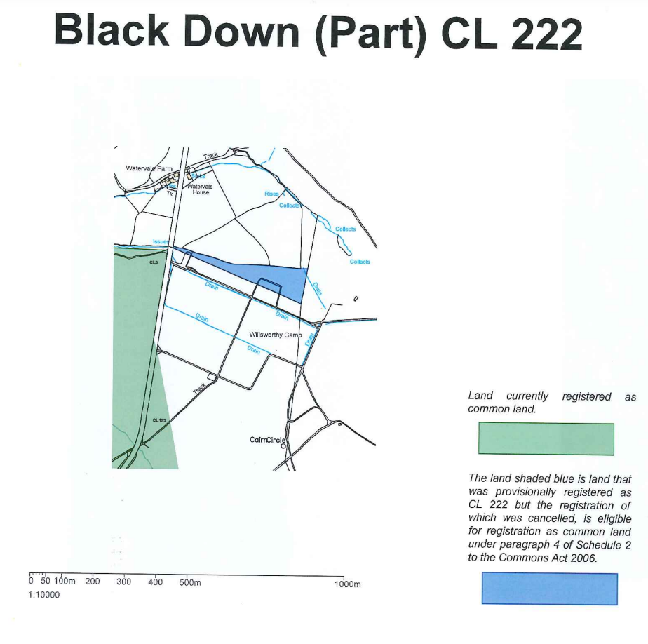
Plan 1 referred to in Decision Ref COM/3310344 (part of Black Down)

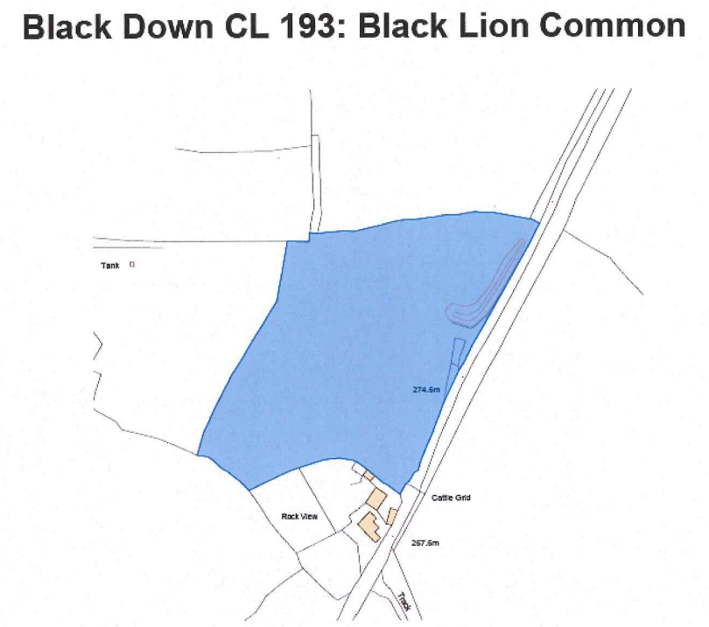
Plan 2 referred to in Decision Ref COM/3312767 (Black Lion Common)

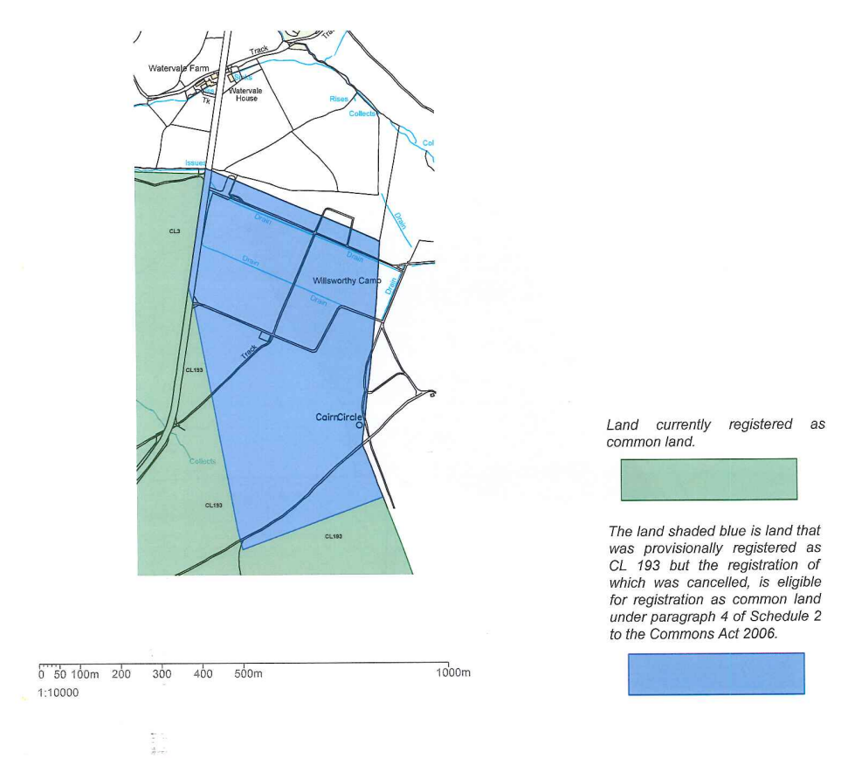
Plan 3 referred to in Decision Ref COM/3312767 (Willsworthy Camp)

