Application Decision
by Harry Wood
Appointed by the Secretary of State for Environment, Food and Rural Affairs
Decision date: 22 February 2024

Application Ref: COM/3330828
Walton Rise, Clent, Stourbridge, Worcestershire, DY9 9RT
Register Unit Number: CL 44
Commons Registration Authority: Worcestershire County Council

- The application, dated 5 October 2023, is made under Section 38 of the Commons Act 2006 (the 2006 Act) for consent to carry out restricted works on common land.
- The application is made by Fisher German LLP for Severn Trent Water Ltd.
- The works comprise:
- a water pump in a metal enclosure measuring approximately 1621mm x 1650mm x 850mm on a concrete plinth measuring approximately 1850mm x1050mm and 25mm above ground level with valves;
- two air valves with a surface cover of 380mm x 240mm;
- the replacement of 226m of water main with 63mm PVC water main;
- excavation of an approximately 226m² trench or drilling of trial holes for the laying of the water main to be completed and backfilled in approximately 57m long sections;
- temporary fencing consisting of Chapter 8 road barriers with each panel measuring approximately 1m high and 2m long. A total of approximately 120m of fencing to be in place at one time.

Decision
- Consent is granted for the works in accordance with the application dated 5 October 2023 and the plans submitted with it subject to the following conditions:

- the works shall begin no later than three years from the date of this decision;
- the land shall be fully reinstated within one month from the completion of the works
- For the purposes of identification only the locations of the works are shown by the hard red line (pipe route), red rectangle (pump), green crosses (trail holes) and purple area (safety barriers) on the attached plans.

Preliminary Matters
- I have had regard to Defra’s Common Land Consents Policy Guidance (November 2015) in determining this application under section 38, which has been published for the guidance of both the Planning Inspectorate and applicants. However, every application will be considered on its merits and a determination will depart from the guidance if it appears appropriate to do so. In such cases, the decision will explain why it has departed from the guidance.

- This application has been determined solely on the basis of written evidence. I have taken account of the representations made by the Open Spaces Society (OSS) and Natural England (NE).

- I am required by section 39 of the 2006 Act to have regard to the following in determining this application:
- the interests of persons having rights in relation to, or occupying, the land (and in particular persons exercising rights of common over it);
- the interests of the neighbourhood;
- the public interest; Section 39(2) of the 2006 Act provides that the public interest includes the public interest in; nature conservation; the conservation of the landscape; the protection of public rights of access to any area of land; and the protection of archaeological remains and features of historic interest. And
- any other matter considered to be relevant.

Reasons
The interests of those occupying or having rights over the land

- Pursuant to Commons Commissioner Decision 42/U/59 of 26 June 1973 following a hearing into the question of the ownership of the land, the Commons Commissioner was not satisfied that any person was the owner of part of CL 44 and it remains subject to protection by the local authority under s9 of the Commons Registration Act 1965 (now under s45 of the 2006 Act).

- The applicant has identified that there is no registered owner of the land. The application and consultation by the applicant detail that appropriate measures were taken to identify an owner of the land and I am satisfied that the owner of the application land is unknown.

- The common land register records no rights held over the land and the applicant has confirmed this.

The interests of the neighbourhood and public access
- The applicant explains that the purpose of the works is to address water pressure issues being experienced by residents living at the top of Walton Rise who have been identified as having inadequate pressure under the Director General 2 (DG2) Scheme. The purpose of the trench or trail holes and fencing is to facilitate the safe laying of the replacement waiter mains and installation of the water pump, its enclosure and two air valves.

- The interests of the neighbourhood relate to whether the works will unacceptably interfere with the way the common land is used by local people and is closely linked with interests of public access. The trench or trail holes will follow the route of the current water main mostly along the east edge of the land parcel. The applicant has outlined that the trench or trail holes will be completed in sections to lessen the impact on access.

- NE stated they are aware the area of registered common known as Walton Rise is designated as open access land under the provisions of the Countryside and Rights of Way Act 2000, whereby a right of access on foot is available to the public at all times. They understand that the location of works are on a public right of way. Any disturbance or alteration to the surface of any public right of way requires the prior authorisation of the Worcestershire County Council as the Local Highway Authority.

- The temporary fencing would have a larger impact, blocking access to the areas of the common where the works are taking place, but this will be minimal due to the process of the works being completed in sections and the common will still be accessible via other routes onto and around the common. I am satisfied that such fencing is appropriate on health and safety grounds and that it will be removed on completion of the works, which can be secured by attaching a suitable condition to the consent.

- The replacement mains are an underground feature so will leave no permanent impediments to access.

- The water pump, its enclosure and the new air valves will introduce new permanent structures on the common and mean these areas cannot be accessed. OSS have highlighted that they were consulted in the early stages of the application and the applicant revised the plans to adopt a less obtrusive location for the pumping station. The applicant also considered wider alternatives, such as locating the pump on private land to the east of the common, however the elevation of the land would not allow for successful functioning of the pump. Another location considered was in the south boundary of the common but this was not favoured by local residents due to negative visual impacts.

- In this case preventing future access to these areas of the common is necessary to allow the successful implementation of the works. I believe that possible alternatives have been considered and the pump will provide wider benefit to the neighbourhood. I conclude the works will have minimal impact on the recreational value of the common and the works will not unacceptably interfere with the interests of the neighbourhood or public rights of access.

The public interest
- As well as the public interest in the protection of public rights of access, the Guidance (November 2015) outlines the public interest in nature conservation, the conservation of the landscape and the protection of archaeological remains and features of historic interest.

Nature conservation and Conservation of the landscape
- NE advises that the site is not subject to any statutory or non-statutory designations for nature conservation.

- The common has no special designated landscape value.

- The proposed works will introduce new permanent artificial features into the landscape. The applicant has stated they intend to mitigate the visual impact of the water pump by locating it out of sight from residential properties and colouring the metal green to blend in with the surrounding natural features of the common.

- The other works are either located underground or will be temporary in nature and any excavations undertaken as part of the works are to be refilled with the same material to reduce the visual impact the works would have on the common and to be in keeping with the wider landscape.

- I am satisfied that nature conservation interests will not be harmed by the works and I consider that overall the works will have only a small impact on landscape interests.

Protection of archaeological remains and features of historic interest.
- The applicant has stated that there are no archaeological features within the proposed works area. Historic England and the local authority archaeological service have been consulted and not commented.

- There is no evidence before me to suggest that these interests will be harmed by the proposed works.

Conclusion

- Defra’s Common Land Consents Policy advises that “works may be proposed in relation to common land which do not benefit the common, but confer some wider benefit on the local community, such as minor works undertaken by a statutory undertaker (e.g. a water utility) to provide or improve the public service to local residents and businesses. Consent under section 38 may be appropriate where the works are of temporary duration (such as a worksite), where the works will be installed underground (such as a pipeline or pumping station), or where their physical presence would be so slight as to cause negligible impact on the land in question (such as a control booth or manhole), and the proposals ensure the full restoration of the land affected and confer a public benefit.”
- I conclude that the permanent works will benefit the local community by improving the supply of water to the local residents and the permanent works will not seriously harm the other interests set out in paragraph 5 above. Consent for the works is therefore granted subject to the conditions set out at paragraph 1.
Harry Wood

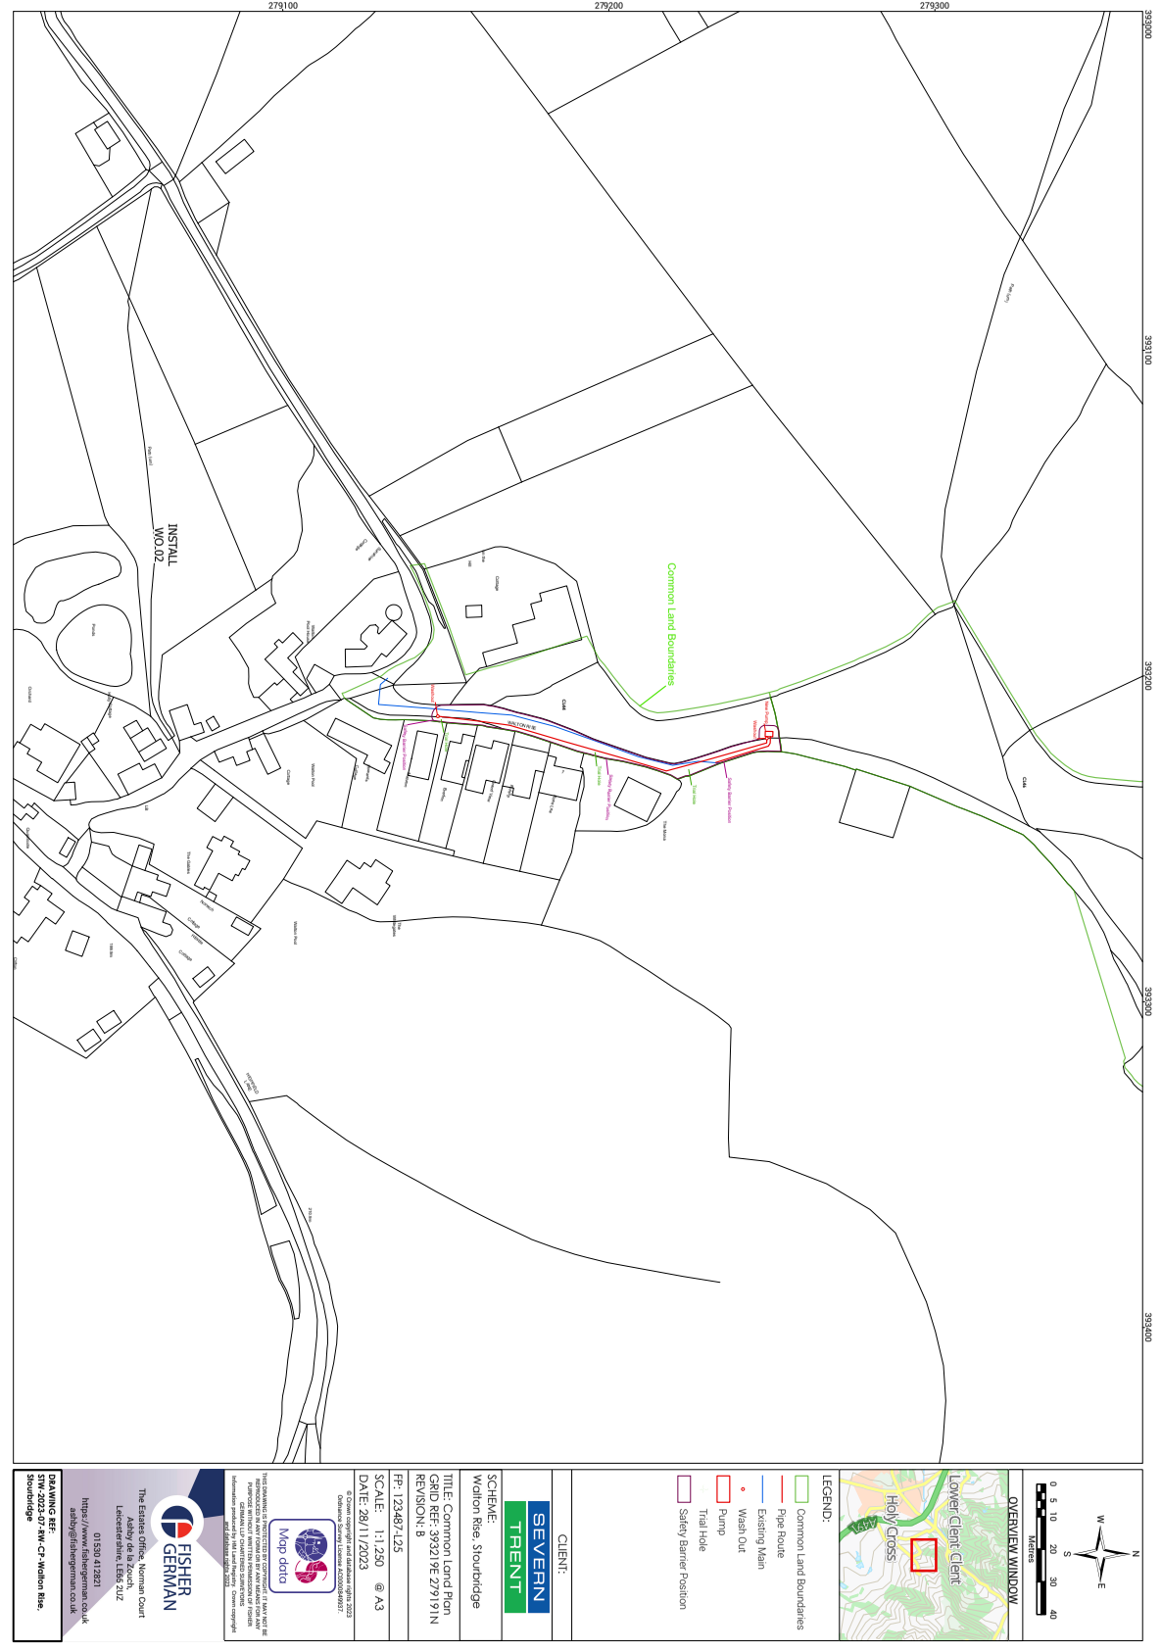
Figure 1 - Application plan

