Application Decision
Site visit made on 12 December 2023
by David Wyborn BSc(Hons) MPhil MRTPI
an Inspector appointed by the Secretary of State for Environment, Food and Rural Affairs
Decision date: 5 February 2024

Application Ref: COM/3319558
Land at Caradon Hill, Cornwall
Register Unit No: CL107
Commons Registration Authority: Cornwall Council

- The application, dated 29 March 2023, is made under section 38 of the Commons Act 2006 for consent to carry out restricted works on common land.
- The application is made by Mr Mark Bunt of Kivells on behalf of Mr Colin Medland.
- The application works are described as stock proof fencing consisting of tanalised posts, sheep netting and two strands of barbed wire, up to a maximum height of 1.2m. The total length being 255m in three separate locations.

Decisions
- Consent is granted for the permanent works so far as they relate to the construction of stock proof fencing consisting of tanalised posts, sheep netting and two strands of barbed wire, up to a maximum height of 1.2m, around the disused mine as shown on Plan 3, in accordance with the application dated 29 March 2023.
- Consent is refused for the works so far as they relate to the construction of stock proof fencing consisting of tanalised posts, sheep netting and two strands of barbed wire, up to a maximum height of 1.2m, around the built mining structures as shown on Plans 2 and 4, as proposed within the application dated 29 March 2023.

Preliminary Matters, Background and Application
- Section 38 of the Commons Act 2006 (the 2006 Act) prohibits restricted works on common land unless consent is obtained. Restricted works include works which have the effect of preventing or impeding access to or over land, and this includes the erection of fencing.
- In this case, the common land at Caradon Hill (CL107) extends to 430 acres or thereabouts in the Parish of Linkinhorne. The common land falls within the Minions Conservation Area, an Area of Great Landscape Value and the Cornwall and West Devon Mining Landscape World Heritage Site - Caradon Mining District section (WHS). Large parts of the broadly northern section of the common are designated a Scheduled Monument and is identified as medieval and post-medieval tin and copper mines with medieval field system on the middle and lower northern slopes of Caradon Hill. Located within the Scheduled Monument is a Grade II Listed building. The listed building is described as Wheal Jenkin group of two engine houses and one chimney. One of the engine houses together with the chimney (as shown on Plan 4) are somewhat separated from the other engine house (as shown on Plan 2) which lies to the broadly south-west of the engine house with chimney on this open common land. The application plan, which shows the general locations for the proposed fencing, is attached at the end of this decision.
- The two engine houses and the chimney are tall structures, prominent in the landscape and surrounded by open common land. There are some, now overgrown, piles of mining waste in their vicinities.
- The application seeks consent to separately erect fencing around both engine houses and the chimney. In the more south eastern section of the common, fencing is also proposed to circle a disused mine (as shown on Plan 3). This latter feature is located within the Conservation Area and WHS, but beyond the Scheduled Monument.
- The proposed permanent fencing, as indicated on the application form, would be constructed from tanalised posts, with netting stretched between them. The fence height would be 1.2m and in total the four lengths of fencing would extend to about 255m.
- The applicant has detailed that the fencing is required to fence around historic mining structures which pose a danger to the general public and grazing livestock. It is explained that the type of fencing would be suitable to keep out grazing sheep, cattle and horses and deter members of the general public from accessing the areas. The submissions set out that no other types of fencing have been considered on the basis that stock fencing is the accepted solution for the identified problem and is in keeping with the setting. The applicant does not consider that temporary fencing would be appropriate as a permanent solution is required in order to protect the general public and grazing livestock.
- In responding to representations from the OSS (Open Spaces Society), the applicant has explained that it is accepted that signage warning of a potential hazard could be beneficial. However, the applicant is concerned that signage alone may be an insufficient step to adequately protect persons from harm in this case, given the potential severity of the harm that could be caused to a person being injured by falling stone work. The applicant is also conscious of potential statutory obligations which may arise to fence off former mine workings.
- At my site visit, I was accompanied by the applicant’s agent, two Councillors from Linkinhorne Parish Council and a representative of the OSS. It was evident at the site visit that fencing around these features had been constructed. With the separate engine house, this fencing substantially aligned with the proposed fencing on the submitted plan (Plan 2) and connected with longstanding fencing around a small section of land to the immediate west of this engine house.
- The fencing around the disused mine to the south eastern section of the common, also substantially follows the boundaries of the top of the sloping sides to the mine area, and which is shown on Plan 3.
- However, with the engine house and associated chimney, rather than with the alignment shown on Plan 4 with each structure proposed to be separately fenced, the fencing enclosed both structures together and included a more extensive area of land. This creates a broadly rectangular shape. This materially differs from the fencing proposed in the application. It is necessary to consider the application proposal as submitted and, therefore, I will determine the fencing proposal around the engine house and chimney based on the submitted Plan 4, rather than the alignment and length of fencing that has been erected on the ground.

Main Issues
- I am required by section 39 of the 2006 Act to have regard to the following in determining this application.
- the interests of persons having rights in relation to, or occupying, the land (and in particular persons exercising rights of common over it):
- the interests of the neighbourhood:
- the public interest (which includes the interest in nature conservation, the conservation of the landscape, the protection of public rights of access to any area of land and the protection of archaeological remains and features of historic interest): and
- any other matter considered to be relevant.
- Section 39(3) of the 2006 Act provides that consent may be given in relation to all or parts of the proposed works and subject to such modifications and conditions relating to the proposed works as are thought fit.
- Defra’s Common Land Consents Policy (the Consents Policy), published in November 2015, sets out the policy objectives for protecting common land and the approach when considering applications for works on common land. I will have regard to this policy document in my considerations.

Reasons

Representations and Objections
- Linkinhorne Parish Council has commented that it is mindful that this is an Area of Great Landscape Value, a conservation area and a WHS and the Council’s preference is that, as both structures are listed buildings, these buildings are ultimately stabilised. Fencing should only be seen as a temporary measure providing its purpose is to facilitate the conduct of stabilisation works to the listed structures and it is required for public safety purposes.
- The Parish Council also comment that any positioning of fencing posts should be overseen / supervised by the county archaeologist to ensure that all features of historical and archaeological significance are protected.
- The OSS has made objections to the application. These include that the mining structures have endured since the 19th Century and have been unprotected for many years. The OSS say that there may be a risk to the public or to livestock, but no evidence has been adduced of the nature or scale of that risk, and whether fencing is justified so as to exclude the public from access to and around the structures. There is also no information as to whether minor repairs could be undertaken, or the occupier’s liability minimised by the display of warning notices.
- The OSS comment on the submissions from Historic England which explain that the location of the proposed fencing work lies within part of a Scheduled Monument, and that the proposed works involve ground disturbance or have the potential to have a visual impact within a Scheduled Monument. The OSS note that Historic England recommend that pre-application consultation takes place with it prior to any submissions for Scheduled Monument Consent. The OSS object to the application on the basis that the Environment Secretary, following the advice of Historic England, is now aware that the application will affect a Scheduled Monument, but has no information on which to assess the impact — other than that there will be an impact. On this basis, the OSS consider that the application should be refused.

The interests of those occupying or having rights over the land
- The Register identifies some easements and rights such as the provision of a mains water supply across a part of the common, and a company with a claimed right to prospect for drill test bore holes and work minerals below the surface of the ground.
- In terms of rights of common, the Register details that the occupant of Marke Valley, Upton Cross, Liskeard has a right to graze 10 head of cattle, 10 sheep and 2 horses over the unit, and that the occupant of East Caradon Farm has the right to graze 6 head of cattle or 6 ponies or 30 sheep over the whole of the register unit. A partial entitlement to exercise this latter right has been made and this now rests with Mr Bolitho of West Trezeland to graze 4 head of cattle or 4 ponies or 20 sheep over the whole unit. It is understood that this person is the only active commoner who exercises grazing rights throughout the year.
- There have been no objections to the proposed fencing from any of those with ability to exercise common rights. The fencing would exclude the ability to graze small sections of land around the buildings and the steep surrounding sides and base area of the disused mine, but given the limited extent of land in these areas which would be suitable for grazing, the enclosures would not prevent grazing to any meaningful extent.

The interests of the neighbourhood
- There is no definition of the concept of “neighbourhood” within the terms of the 2006 Act. However, in general terms works should only be permitted on common land if they maintain or improve the condition of the common, or where they confer some wider public benefit and are either temporary in duration or have no significant or lasting impact (paragraph 3.2 of the Consents Policy).
- Access to the common on foot is available under the Countryside and Rights of Way Act 2000. The works would not affect any public rights of way, but would prevent access within the enclosed sections of the common.
- With the disused mine site (Plan 3), this fenced area encloses the steep sides down to the base of the mine area. It was evident at the site visit that a section of land had fairly recently collapsed. With the sound of running water underground at this location, it is reasonable to assume that this section of land within the originally excavated area may not be stable. It is likely that the stability of the land in and around this immediate area could pose some form of risk in the short and longer term. The fencing prevents access to this area and maintains the safety of those using this part of the common, and is therefore in the interests of the neighbourhood.
- To help justify the fencing around the engine house (Plan 2) and that proposed around the engine house and chimney (Plan 4), there is no detailed report included with the application that surveys these structures to assess their stability and explain any related risk. Nevertheless, there are sections of these buildings where the masonry appears to be potentially an issue and the appearance of the structures show that some sections have fallen in the past. Some form of protection to prevent those using the common from coming close to the structures appears to be in the public interest. Fencing is proposed and whether this would be needed in the longer term is a matter I consider in more detail below.
- The areas of fencing around the built features would not impact upon the general public’s ability to view them at a safe distance. The applicant’s insurers advise works were necessary from a public liability perspective, noting the fencing is a short distance from the features and if access is required (subject to necessary insurance provision being provided), this can be obtained by access through the pedestrian gates. In respect of the proposals shown on Plan 2 and 4, I conclude on the interests of the neighbourhood and the public interest in the balance and main conclusion below.

The public interest

Nature conservation
- Natural England has commented that, at the scale of works proposed, it does not anticipate that there would be any significantly adverse effects on the common’s overall biodiversity, accessibility or its landscape value.
- Having regard to the comments of Natural England, the information forming the submissions and my site visit, in terms of nature conservation, there is no clear evidence to consider that the effects on biodiversity would, or have been, harmed by the fencing.

Archaeological remains and features of historic interest
- Historic England has commented on the proposals prior to the submissions of this commons land application. It explains that the land subject to this proposal contains a rich and internationally important suite of historic mining remains.
- Historic England explain that the location of the fencing works lies within part of the Scheduled Monument (although the fencing around the disused mine is beyond this area) and that proposals involving ground disturbance and/or which have the potential to have a visual impact within a Scheduled Monument are classed as “works” under Section 2 of the Ancient Monuments and Archaeological Areas Act 1979, and must first obtain Scheduled Monument Consent (SMC) from the Secretary of State for Culture, Media & Sport as advised by Historic England.
- Historic England further advise that SMC is not normally granted for works that would be harmful to the significance of a Scheduled Monument and so the applicant or their agent is advised to undertake pre-application consultation with Historic England so that it may advise on the proposed fencing to achieve a solution that meets both the landowner’s needs and its requirements in terms of conserving the significance of the Scheduled Monument. Historic England explain that its focus will be on minimising the extent of ground disturbance within the scheduled area, agreeing the extent and location of fencing, and its form/materials to minimise any visual intrusion.
- Based on this advice from Historic England, SMC will be required for the fencing works around the three built structures (Plan 2 and Plan 4) and that it appears the works could be potentially harmful to the significance of the Scheduled Monument. This application includes plans which show the alignment and length of the fencing, and the posts would involve some ground disturbance. There could, therefore, in all likelihood be some potential harm to archaeological remains and features of historic interest within the area. I am conscious that some fencing works have taken place and may have caused some ground disturbance. Nevertheless, I need to consider the scheme based on its merits taking into account the comments of Historic England.
- Given that the potential harm identified by Historic England would relate to a Scheduled Monument (and around a listed building), it is a matter of heritage significance to ensure that the nature of any harm is understood and can be assessed in the overall balance of considerations.
- Historic England recommended that the applicant consulted with it to seek to achieve a solution that met both the landowner’s needs and its requirements in terms that would then inform a SMC application. I sought information from the applicant as to whether this further consultation, in the form of pre-application advice with Historic England, had taken place and the nature of any response. However, I have no detailed information to show the outcome of any subsequent consultations with Historic England.
- As explained, this common land application seeks to have approved an alignment and length of fencing around the built structures within the Scheduled Monument. There will also be a need for SMC. It is appreciated that one of the consent processes will need to come before the other and that, therefore, there is a relationship between the two consenting procedures. However, this is a situation where Historic England has flagged the potential for harm to the significance of the Scheduled Monument from the fencing.
- It is with this background in mind that I need to consider the effect of the proposal on archaeological remains and features of historic interest, as part of the assessment of this application under the 2006 Act. In the absence of any detailed information from Historic England as part of any pre-application consultation process, I consider that I need to take a precautionary approach. I am not satisfied that there is sufficient information to provide reassurance that the alignment and length of fencing that forms the detail of this application, in terms of the proposals under Plan 2 and Plan 4, would not/has not harmed the Scheduled Monument. This is clearly a matter that weighs against the proposal.
- With the Plan 3 scheme, this land lies beyond the Scheduled Monument and there is no issue regarding the effect of the fencing on archaeology or in respect of any listed building.

Conservation of the landscape
- In relation to the wider common, the fencing would not impact on the wider area, but would be confined around the three built structures and the top of the disused mine.
- The fencing consists of timber posts and mesh fencing stretched between them. This type of stock fencing is considered to have a modest visual impact and would be fencing suitable for its function and is similar to some other fencing in the wider area. It would not be especially prominent, nevertheless, the fencing would add some clutter to the common.
- In terms of the justification for the fencing around the engine houses and chimney, the submissions from the applicant highlight the risk posed by these structures, and it is explained that there is no reasonable prospect of works in the foreseeable future to secure their maintenance. However, it would be preferable in terms of the landscape and the setting around these buildings within the Scheduled Monument if the fencing around these structures did not need to take place at all, or for no longer period than necessary.
- There is little clear evidence of any practical option towards securing the stabilisation of the structures at the present time such that any risk from falling masonry could be substantially reduced to a level that then may negate the need for the fencing. Nevertheless, if I was minded to consent to these fencing works, I would need to consider whether a temporary consent was warranted, such that it would enable the ability to assess the condition of the structures, and whether the need for the fencing at the end of any temporary period was justified at that time. This approach would accord with the advice in paragraph 4.2 of the Consents Policy.
- In the case of the disused mine, while this fencing adds a modest amount of clutter to the landscape, there is a clear safety reason for its provision and location and it is unlikely that this present risk could be reduced in the longer term.

Public access
- I have explained the effects of the proposal on public access in the section on the interests of the neighbourhood above. The evidence indicates that there is a long term need to restrict access to the disused mine area on health and safety grounds. While some form of fencing around the built structures appears to be justified at the present time, if I was satisfied by the alignment and I was minded to grant a consent it would be necessary to consider whether a temporary consent was more merited than a permanent consent. This is something I examine below.

Other Matters
- The main issues in this appeal have been considered above, and there are no other matters of material relevance to weigh in the following balance.

Overall Balance and Conclusion
- The area in and around the disused mine to the south east of the common (Plan 3) poses a health and safety hazard for both walkers and livestock. The fencing addresses this risk by preventing access to the section of land that has collapsed, as well as screening the steep slopes down to the disused mine area. This land lies beyond the Scheduled Monument and there is no issue regarding the effect of the fencing on archaeology or in respect of any listed building.
- While there is some harm at this disused mine area from the additional visual clutter of the fence posts within the landscape, this is more than outweighed by the need to ensure a safe environment for walkers and livestock within this part of the common. I conclude that the balance of considerations, and the public interest, clearly falls in favour of approval of this fencing. As there is no reasonable prospect of this health and safety hazard being resolved, because of the on-going nature of the hazard and the condition of the surrounding land, it is appropriate that the fencing should be allowed on a permanent basis. Signage is not an appropriate or proportionate response to addressing the safety issues around this disused mine area.
- In terms of the fencing around the built mining structures on the western side of the common (Plan 2 and Plan 4), the considerations are more balanced. There appears to be a hazard from the potential instability of parts of these structures, but this has not been fully quantified, for instance, in the form of a structural report from a qualified person. The applicant advises that there is no reasonable prospect of the condition of the structures being addressed in the foreseeable future. Furthermore, it is explained by the applicant that any remedial works to make safe the structures would be prohibitively expensive and the appearance of what is there at present could be altered to the structures’ detriment by any modern supporting structures, which is precisely what is sought to be avoided. However, they are iconic structures in the landscape related to the mining heritage of the WHS, a listed building and form part of the Scheduled Monument. In these circumstances, I am not satisfied by the evidence that, in time, some form of sensitive and agreed remedial action could not come forward to seek to stabilise them, and such an approach would be in the interests of the neighbourhood.
- In terms of the conservation of the landscape, the fencing adds a modest amount of clutter around these structures within this part of the common.
- In the absence of detailed assessment and comments from Historic England as part of the process of pre-application advice in advance of the SMC application, I do not have sufficient reassurance that the alignment of the fencing would minimise the potential harm to the significance of the Scheduled Monument. This is a necessary consideration of the public interest in this case, especially in regard of the assessment of the proposal in terms of archaeological remains and features of historic interest. These concerns apply both to the consideration of either a temporary or permanent consent. In these circumstances and on the basis of the evidence before me, I conclude that the balance falls against this part of the scheme and that the sections of the fencing around the built mining structures should not be approved either on a temporary or permanent basis, at this time.
- I consider that these conclusions are generally consistent with the representations from Linkinhorne Parish Council and the OSS.
- Section 39(3) of the 2006 Act says that consent may be given to all or part of the works subject to modifications and conditions relating to the proposed works as the appropriate national authority thinks fit. Consequently, a split decision may be granted, if appropriate. This application concerns proposals at three separate parts of the common and are shown on separate plans. The proposals are severable and could take place independent of each other. Having regard to the conclusions reached above, I intend to grant consent for the fencing works around the disused mine as shown on Plan 3, and refuse consent for the fencing works around the built mining structures, as shown on Plans 2 and 4.

David Wyborn

INSPECTOR

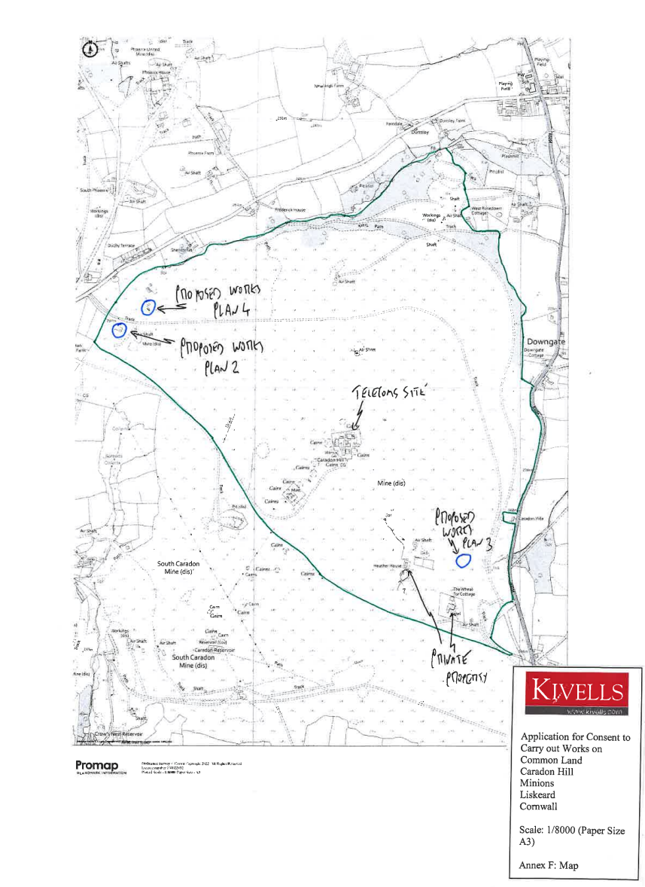

Copied so not to scale.

