Batch acceptance testing of fingerprint powders – November 2020 (Publication No. DSTLPUB119312)




Logo Copyright Forensic Capability Network
Logo Copyright University of Portsmouth

Published by: Dstl, Counter Terrorism and Security.

Authors: Deborah Cutler, Helen Bandey

Requirement / objectives
There is a requirement to gain ISO 17020 accreditation for crime scene processing and to be compliant with the Forensic Science Regulator codes. The aim of this document is to provide a standard method for batch acceptance testing of fingerprint powders, to assist with meeting this requirement. These methods can only be applied to powders that already have substantial data supporting their use (validation and verification data). These tests will provide assurance a new batch of powder performs similarly to an existing reference batch.
Prior to integration with Dstl, the Fingerprints Team within the Home Office’s scientific department (Police Scientific Development Branch/Home Office Scientific Development Branch/Centre for Applied Science and Technology) produced a considerable amount of research data, supporting the guidelines in the Fingermark Visualisation Manual [1] for commonly used fingerprint powders from 2004-2007 [2-6]. Dstl are not aware of any other comprehensive studies on the effectiveness of fingerprint powders in the literature, or otherwise. Thus, there must be assurances to demonstrate that current powders are consistent with those used during that time period if the data is to be used as evidence of validation. In this case, the powder specifications, as outlined in both the original newsletters [2-5] and the current Fingermark Visualisation Manual [1], must be met. If they are not met, further testing will be required and the extent of testing will be dependent upon factors such as the degree of difference between the specifications.
If users are satisfied that the existing data is suitable for validation of the powder, smaller scale verifications studies must be carried out to ensure the powders perform acceptably in the intended environment.
Each time a new batch of a verified and validated powder is received, batch testing should be carried out to provide assurances that the new batch of powder performs as well as the original ‘reference’ batch. This document aims to provide guidance on how this can be achieved.
Note: The methods outlined below are not suitable for validation or verification studies. For any powders (including new and novel powders of unknown performance) that require larger scale testing, for details of full validation methodology refer to [7; 8]. In addition to powder effectiveness, any evaluation of new powders should also include potential practicality and health and safety issues.

Method
Batch test assurance should be undertaken whenever a powder is received and it has a batch number that has not been previously tested. Periodic ‘in use’ checks should also be carried out according to internal Quality Assurance processes, and this method could be adapted for these purposes if required.
In order to carry out batch testing, a referance batch, whose performance is known to be acceptable should be identified. This could be the batch that was used during verfication testing.
Fingerprint powders are generally stable and have a long shelf life, however once the reference batch expires, or is depleted, a new reference batch must be identified. The procedure for identifying a new reference batch could involve a more extensive ‘batch test’ or verification test.
See Appendix 1 for a flow diagram illustrating the process described below, and Appendix 2 for an example record table.

- Pre-testing Checks

  - Information gathering

Check the documented information from the supplier/manufacturer, for both the reference and the new batch of powder. Useful documents will include the Safety Data Sheet (SDS), label information and could include the Certificate of Conformity. Look for:
- Powder type (e.g. aluminium)
- Batch number
- Chemical composition (which components are present and in what percentages, e.g. 95-97% aluminium; 3-5% stearic acid)
- Particle shape and size (e.g. flake, 4-10 µm)
- Date of Manufacture
- Shelf life

If this is not provided, contact your supplier for the missing information. The powder type, chemical composition, and particle shape and size should be consistent with the reference powder.

  - Initial examination of the powder

Examine the physical characteristics of the new batch of powder and compare them to the reference batch. Consider:
- Whether the colour and general appearance is the same
- Whether the powder ‘moves/flows’ the same when disturbed
- Whether they load onto the brush or applicator in a similar way (Magnetic powders should reform back to their original shape when the applicator is removed from a surface[1])
- Whether it behaves/deposits as expected when applied to a surface (a quick ‘look-see’ test to identify gross differences)
There should be consistency between the new batch of powder and the reference powder. If useful, photographs can be taken to record the results. If the pre-testing checks are not satisfactory, do not use the new powder and follow internal QA procedures.

- Performance Check

If possible, two members of staff are required to carry out this process, one to apply the powders and one to compare the powdered marks. This will allow an independent assessment, and help prevent bias (refer to Section 2.6).

  - Select and prepare suitable surfaces

- Select a surface that is representative of those that the powder would commonly be applied to operationally.
- If required the surface could be cut into panels of an easily handled size (approximately A4 size is generally suitable for both handling and mark deposition).
- For consistency, any pre-existing contaminants should be removed by thorough cleaning of the surface [7]. If it is not possible to clean surfaces, effort should be made to source items that have not been touched. Cleaning should be done in a way that:
  - Leaves the surface unaltered chemically.
  - Leaves the surface undamaged physically.
  - Does not introduce new contamination that may interfere with experimental results (e.g. cleaning products, dried water droplets, unintentional fingermarks etc.).
- NOTE – If during the development stage you observe smears or extraneous fingermark development, your cleaning procedure is not sufficient and will need to be reviewed.
- If required the samples can be marked with a grid to assist with fingermark deposition.
- Handling of cleaned and prepared samples should be kept to a minimum, and gloves should be worn to prevent contamination.

  - Donor Selection

- Local rules on donor consent (including GDPR) should be followed.
- Using only one donor is sufficient for a batch acceptance test.

  - Fingermark Deposition

- Use ‘natural’ fingermarks to create a deposition series. The Donor should be instructed to NOT wash their hands or apply cosmetics in the 30 minutes prior to donation. During those 30 minutes they should go about their normal business so that ‘natural’ secretions/contaminants are present on the hands/fingers. Additionally the donor SHOULD NOT deliberately wipe their hands over their face or hair just prior to donation.
- Ask the donor to rub their hands together to evenly distribute fingermark residues across all fingers. It is important to rub hands in multiple directions in order to achieve this.
- Fingermarks should be deposited using a depletion series. The number of fingermarks in a depletion series will be dependent upon: (1) the quality of your donor; (2) the space you have available on your surface. Ten fingermarks per depletion is often adequate provided there is a clear drop off in performance of the powder down the series (A drop off is important in order to observe any differences in the powders. If there is no clear drop off the experiment should be repeated, with more depletions in the series or using a different donor).
- Using a ‘multiple depletion’ series, as shown in Figure 1, is the simplest method of mark deposition for donors to follow (This method compares marks from different depletion series. However, as they are deposited from the same donor at almost the same time, the marks should have similar chemical composition, quality and pressure, if the deposition procedure has been followed correctly).
- Ask donors to deposit marks down a column on a surface until the required length of depletion is reached.
- Repeat using the same donor but different finger in the second column.
- As multiple depletion methods compare marks from different depletion series, it is important to recognise that consistency between depletion series may vary if sweat isn’t evenly distributed across the hands/fingers, or if donors significantly vary the pressure used with different fingers. Both of these issues can be controlled by effective donor training, if required.

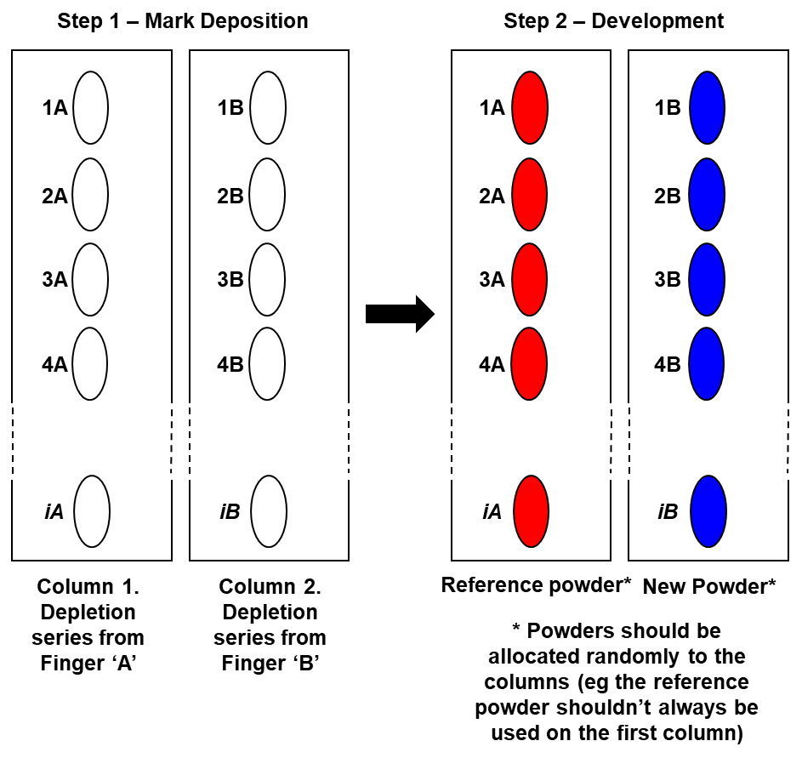

Figure 1 – Diagram depicting a multiple depletion series.
2.4 Ageing of Fingermarks
Ideally, the surface with the depletion series should be placed in a location where they will not be disturbed or touched, to allow them to age for at least 4 hours prior to development (Ageing of fingermarks is important in validation and verification studies, as fingermark composition changes with time [7]. This is less important for batch testing. However, if possible, aging marks is best practice and the time period should reflect a typical time period from when the crime is committed to when the surface of interest is powdered, 4 hours is suggested as a minimum).
2.5 Powdering
- Powdering should be done in an environment where suitable illumination is available and practitioners are protected from airborne dust hazards.
- Powder should be applied using an appropriate brush or applicator, following the forces Standard Operating Procedures and guidelines given in the Fingerprint Visualisation Manual [1].
- Keep the brush type, practitioner and application technique the same for the two powders being compared. Where possible a new brush should be used for each of the powders to avoid cross-contamination.
- Powder one depletion series with the new batch of powder, and the other with the reference batch. Powders should be allocated randomly, so that the assessor does not know which column / series is visualised with which powder (see Figure 1).
- If required one half of the surface can be masked whilst powder is applied to the other half, to prevent cross contamination.

2.6 Examination and Grading
The method for assessing developed fingermarks from the new batch and reference batch must be consistent. There are many ways in which this can be done and one option is given here, but others are equally valid provided they distinguish between fingermarks of varying quality.
- All fingermarks should be evaluated by the same person. To avoid bias, (if possible) this should be a different individual to the one that powdered the marks, and they must not know which depletion series is visualised with which powder.
- The person carrying out the grading should maintain a consistent approach throughout the assessments.
- For each column of depletion series, consider mark development, powder sensitivity (e.g., how far down the depletion series marks have developed), contrast and background staining. This could be recorded in a table as shown below (Table 1). This table forms part of a larger results record table available in Appendix 2.
 | The series in column 1 is ‘…….’ when compared to column 2  (delete as appropriate) | Comments / observations
Mark development | Better / Worse / Same
Sensitivity | Better / Worse / Same | e.g How far down the columns did ‘usable’ marks develop?
Contrast | Better / Worse / Same
Background Staining | Better / Worse / Same

Table 1 - Suggested table format to record observations.

2.7 Interpretation
Compare the information obtained from the two deposition series– if the new batch performs worse than the reference batch in any area, repeat the process up to a total of three times to remove the potential for human error. If, after repeating the procedure, the ‘new’ batch of powder still performs worse than the original, the new batch has ‘failed’ the performance test

If the new batch of powder performs as well (or better) than the original it has ‘passed’ the performance test.

2.8 Record and Action results
Record the outcome of the batch testing:
- An example record sheet for this process is given in appendix 2.
- If useful, photograph the two powdered depletion series, under the same conditions, to provide a record of the test (Note – It is not possible to compare images from different dates / tests, as the donor marks, environment etc. will be different).
If a new batch of powder passes the pre-testing and performance checks, it can be accepted into operational use.
If new powder fails any stage of the testing, follow internal QA procedures (e.g. Inform QM, raise non-conformance, label do not use etc.).
3. References
[1] HOME OFFICE. Fingermark visualisation manual. Home Office Centre for Applied Science and Technology (CAST), 2014.
[2] BANDEY, H. The Powders Process, Study 1: Evaluation of Fingerprint Brushes for Use with Aluminium Powder. Home Office Police Scientific Development Branch (PSDB) Fingerprint Development and Imaging Newsletter: Special Edition 2004, (54/04).
[3] BANDEY, H.L. and GIBSON, A.P. The Powders Process, Study 2: Evaluation of Fingerprint Powders on Smooth Surfaces. Home Office Scientific Development Branch (HOSDB) Fingerprint Development and Imaging Newsletter: Special Edition, 2006, (08/06).
[4] BANDEY, H. and HARDY, T. The Powders Process, Study 3: Evaluation of Fingerprint Powders on Textured Surfaces and U-PVC. Home Office Scientific Development Branch (HOSDB) Fingerprint and Footwear Forensics Newsletter: Special Edition 2006, (67/06).
[5] BANDEY, H.L. Fingerprint Powders Guidelines. Home Office Scientific Development Branch (HOSDB) publication, 2007, (09/07).
[6] BLEAY, S. and others. Home Office Centre for Applied Science and Technology Fingerprint Source Book v2.0, Second ed. 2017, (81/17).
[7] SEARS, V.G. and others. A methodology for finger mark research. Science & Justice, 2012, 52(3), 145-160.
[8] INTERNATIONAL FINGERPRINT RESEARCH GROUP (IFRG). Guidelines for the assessment of fingermark detection techniques Journal of Forensic Identification, 2014, 64, 174-200.

Appendix 1: Flow diagram illustrating the performance check process
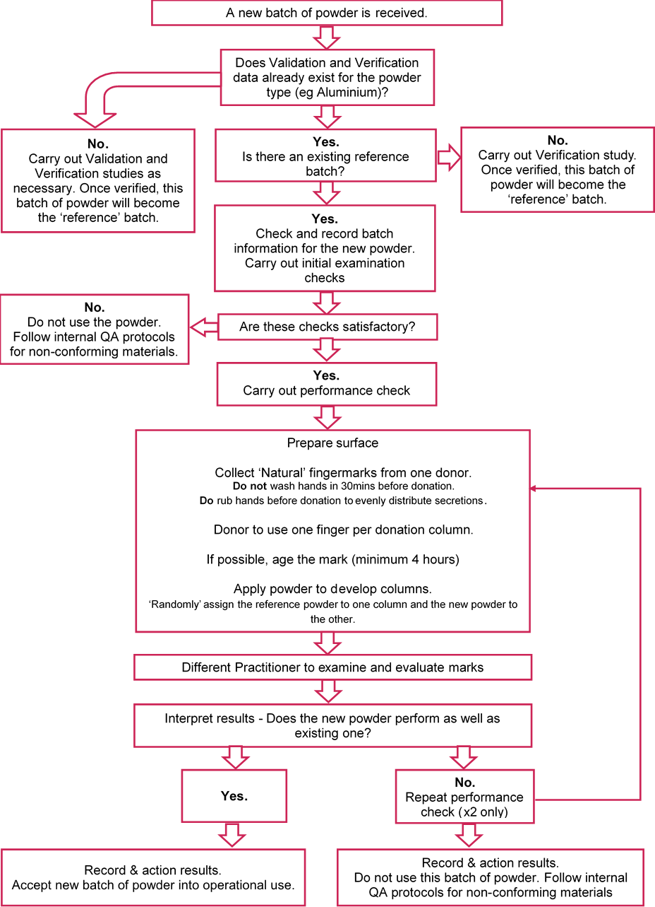

Appendix 2: Example record sheet for batch testing
 | Reference batch of powder. | New Batch of powder. | Comments /  Observations
Information
Powder type (e.g. aluminium)
Batch Number
Supplier
Date of Manufacture
Chemical composition
Particle shape & Size (if possible to determine)
Shelf life & Exp. Date
Initial examination
Is the colour & General appearance the same? | Yes / No
Do the powders move / flow the same when disturbed? | Yes / No
Do they load onto brush / applicator in a similar way? | Yes / No
Do the powders deposit similarly applied to a surface? | Yes / No
Performance test | The series in column 1 is ‘…….’ when compared to column 2  (delete as appropriate)
Mark development | Better / Worse / Same
Sensitivity | Better / Worse / Same
Contrast | Better / Worse / Same
Background Staining | Better / Worse / Same
Powder used (to be completed after assessment to avoid bias) | Column 1:  Column 2:
Results
Notes
Conclusion (delete as appropriate) | Accept / Reject batch Ref……………  Date………………… Name……………. Signature……………….

Release conditions
This procedure for batch testing powders was produced by Dstl for the Transforming Forensic Programme under funding from the Home Office Commissioning Team Order / Contract Reference SecSys SLA.

The submitted work is protected by/includes material subject to Crown copyright. To conform to the use/re-use of public sector information in line with UK Crown copyright policy, non-exclusive publishing rights in the Crown copyright aspects of the submitted work are provided under the Open Government Licence v3.0. Dstl is not permitted to assign/transfer Crown copyright. Furthermore, Dstl is only permitted to provide non-exclusive copyright licences, and thus cannot provide an exclusive licence to reproduce or distribute a Crown copyright work. If accepted, the submitted work should be used under the Open Government Licence v3.0, and furthermore include the following attribution:

Copyright

© Crown copyright (2020), Dstl. This material is licensed under the terms of the Open Government Licence except where otherwise stated. To view this licence, visit http://www.nationalarchives.gov.uk/doc/open-government-licence/version/3 or write to the Information Policy Team, The National Archives, Kew, London TW9 4DU, or email: psi@nationalarchives.gov.uk

