This publication was withdrawn on 26 January 2024
This information has been withdrawn as it is out of date.

                - 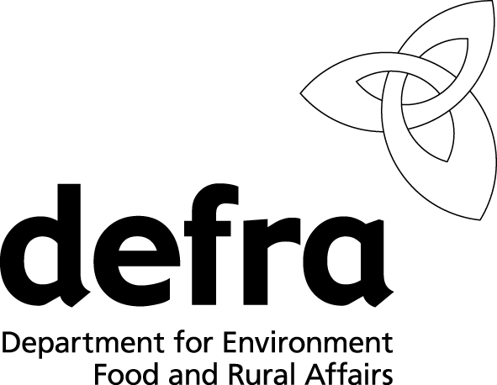Department for Environment, Food and Rural Affairs
www.defra.gov.uk
                - Scottish Government
                - Welsh Assembly Government Rural Affairs Department
PMR 2 |  | Application for Registration  of a Producer
Poultrymeat
Regulations

- Before you start to complete this form, please read carefully the Explanatory Leaflet (PMR 1) on the EC Poultrymeat Marketing Regulations: Special
Marketing Terms.
- If you are applying for more than one form,
please complete separate forms for each form.
- If you have any difficulties or enquiries, please contact the Animal Health Office at the address given opposite.
- Please use black ink and BLOCK letters and complete all sections. [Incomplete forms may be returned.]
Please send your completed form to:
- The Regional Animal Health Office
Address
Telephone
For Official Use Only:
Registered Number

Section A: Applicant’s details

1. Forename
Surname
Full postal address
Postcode
Email address
Telephone No. (including
national dialling code

Mobile No.

2. Name and full postal address of premises to which you wish registration to apply (if different to 1)
Postcode
Telephone No. (including
national dialling code
CPH

Section B: Marketing

3. Special Marketing Term (SMT) to be used
Tick ALL that apply
- Fed with ......% of ......
- Extensive Indoor (Barn Reared)
- Free Range
- Traditional Free Range
- Free Range Total Freedom
4. Species of bird to be produced
Tick ALL that apply
- Domestic fowl: chicken
- Domestic fowl: hen
- Turkey
- Geese
- Duck
- Guinea fowl

5. Source of birds (Hatchery)

Name and address
Postcode

Section C: Feed

6. Please give the following details
Species | SMT | Type of feed | Fed until  age in days) | Source of feed (state if mix own)  Name and address
If necessary, continue on a separate sheet and tick this box
Section D: Housing and land (Free Range, Traditional Free Range and Free Range Total Freedom only)

7. Please give the following details:
House number | Floor space available to birds (sq. m) | Number of pop-holes | Size of pop-holes | Area of land available  to birds in hectares | Ordnance Survey map reference of land  (i.e. field number(s)) | CPH
8. Is the land:
● owned ● rented ● leased ● subject to another arrangement
Note: unless the land is owned, please provide evidence of the contract authorising use of the land
Section E: Processors
Processor’s name and address | Processor’s name and address | Processor’s name and address | Processor’s name and address

Section F: Declaration

- I/We would like to apply for the above premises to become a registered producer to use the Special Marketing Term(s) as highlighted in Section B.
- I/We declare that the information given in this form is correct to the best of my/our knowledge.

Signature

Name in
BLOCK letters

Status |  | Date

Your personal data on this form will be held on a database. The information you have provided will be used for the purpose of enforcing poultrymeat marketing and related legislation and may be released to other enforcement agencies for that purpose. The information may also be used for statistical and research purposes. We may release the information for other purposes in accordance with the law, including disclosure under the Code of Practice on Access to Government Information, the Freedom of Information Act and the Environmental Information Regulations.

