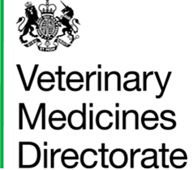
EMS Application Form
2024

Personal Information
Name:

University: | Date expecting to graduate:
Email address: | Contact phone number:
Personal statement (200 words maximum)
Please indicate why you would like to attend EMS at the VMD, and any relevant interests or experience you may have.

Please email to ems@vmd.gov.uk

