
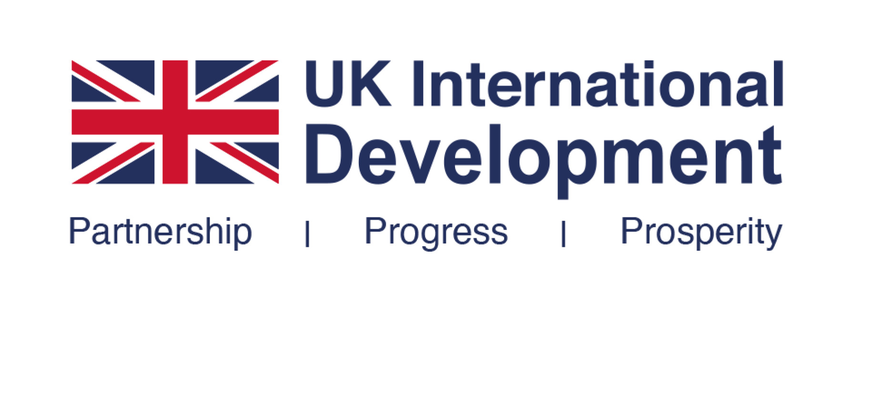

Developing new products and technologies to improve health outcomes in low- and middle-income countries

Call for Expressions of Interest

December 2023

1. Background
FCDO’s global health research supports R&D across the globe. Our mission is to find solutions which build health security for all, support healthier and more resilient populations, and help end the preventable deaths of mothers, babies and children in low- and middle-income countries. This includes tackling emerging and existing infectious diseases (including neglected tropical diseases) and improving sexual and reproductive health and rights (SRHR). FCDO is driving open scientific collaboration so the latest research, evidence and technology can help the world recover lost ground on the Sustainable Development Goals and build global resilience for all, including women and girls and the most marginalised. We do this through a range of R&D mechanisms, to drive the development of, and equitable and affordable access to, new technologies as well as ensure policy uptake, drawing on the best of global health expertise, including in the UK.
The UK has been a strong supporter of product development for more than two decades through public-private Product Development Partnerships (PDPs) and other international R&D partnerships. Since 2017 we have supported 8 PDPs covering infectious diseases of poverty (including malaria, TB, HIV and Neglected Tropical Diseases) and reproductive health. Overall, the PDP model has supported the development of at least 80 new health technologies since 2010, which have reached at least 2.4 billion people.
This new call for Expressions of Interest is driving equal opportunities for all as highlighted in the UK Government’s White Paper on International development in a contested world: ending extreme poverty and tackling climate change. Through collaborative research and end-to-end approaches, it harnesses the power of science and technology for development of new products to improve health and health security for all, including through digital and AI-driven technologies.
2. Scope of this call

FCDO is seeking Expressions of Interest for funding of product development by PDPs, and other established not-for-profit organisations/partnerships with similar objectives and values (see below), which aim to improve health outcomes for the poorest and most vulnerable, in low- and middle-income countries (LMICs). It is expected that these organisations will harness the best of industry, academia, research organisations and other actors, generating global attention to innovative technologies (including digital and AI) which may also have potential for adaptation and application to other areas of the health sector.

This call focuses on the development of new products in three FCDO priority areas:
- Women and girls’ health, including comprehensive sexual and reproductive health and rights (SRHR, which includes maternal and newborn health) – We are looking for products that address, diagnose and prevent the major causes of morbidity and mortality among women and girls in LMICs. We are looking for novel sexual and reproductive health products and innovations for contraception, safe abortion, maternal and newborn health that increase choice and access to reduce unmet need, reduce inequities, and empower women and girls. This can include diagnostics, vaccines and treatments for infectious diseases which disproportionately affect women and girls in LMICs (see below).
- Infectious diseases of poverty – Despite huge achievements in the area of infectious diseases, global progress is still off track with increasing drug resistance adding to the challenges. Tackling infectious diseases of poverty such as TB, malaria, HIV and Neglected Tropical Diseases will depend on the development of improved technologies including diagnostics, vaccines and treatments and other new tools (eg vector control). Products will also need to be better applicable to target groups, including child friendly formulae or products that can be easily administered, including in humanitarian settings.
- Emerging infectious diseases and diseases of epidemic potential – Emerging infectious diseases pose huge threats to global health and economies, especially affecting the lives and livelihoods of the poorest in LMICs. These include, but are not restricted to, Ebola/Marburg, emerging coronaviruses (incl. MERS and SARS), Lassa Fever, Nipah and ‘Disease X’, as well as growing epidemic diseases such as cholera and dengue. FCDO is looking to invest in novel health products and other innovative technologies that address these diseases, and meet needs in LMICs, including vaccines, diagnostic tools, and treatments.

Applications can respond to one or more of the above three areas. The above areas outline challenges and diseases that are compounded by climate change and environmental degradation as well as conflict and food insecurity. They disproportionately impact people in LMICs with less resilient economies and weak public health and social protection. The emergence of some infectious diseases from animals emphasises the need for a One Health perspective.

3. What we are looking for

FCDO expects that applicants will have the following features:
- Organisational aim: An established organisation or partnership which develops products or technologies that focuses on diseases and health issues where there are market failures and that impact on the poorest in LMICs.
- Structure: Organisations should draw on the joint strengths of a wide range of global partners (especially those in LMICs) which include academia, industry, NGOs and other public sector partners.
- Status: The applicant must be a registered not-for-profit organisation with a public health objective rather than a commercial goal.
- Research focus and end-to-end perspective: The primary operational focus of the applicant must be on Research and Development (R&D). However, the applicant should have a clear end-to-end perspective where beneficiary needs must be considered from the outset. This should include consideration of target product profiles, intellectual property rights, regulatory approval/licensing and inclusion in treatment guidelines in LMICs, and a clear pathway for technology transfer, manufacturing and supply ideally including LMIC partners.
- Equitable access policy: Organisations must have strong equitable access policies and the ability to develop and bring to market affordable, acceptable, and accessible products for people in need in LMICs.
- Track record: The applicant should have an established R&D portfolio, have been in existence for at least 3 years and have at least 1 product in advanced development (equivalent to at least phase IIb).
- Management: Organisations should use private sector management practices including portfolio management and industrial project management.
- Funding: The amount of funding applied for should not be more than 25% of the applicant’s budget over the relevant period.
- Number of proposals: The same organisation must not submit more than one application to this call.
- Equitable partnerships and locally led approaches: We expect all applicants to have strong presence in LMICs and work in equitable global partnerships throughout the R&D continuum.
- Use of new technology: We expect applicants to harness the potential of new technology and approaches such as digital, Artificial Intelligence, and engineering biology.
- Open science: We expect partners to drive open scientific collaboration,
- Research quality standards: The applicant must adhere to international research quality and transparency standards (for reference, the UK’s Green Paper is available by Health Data Research UK).

Other information

FCDO expects to allocate up to £130 million to between 6 to 10 partnerships or organisations over a 3 to 4-year period from 2024, subject to availability of funding and ministerial priorities.
It is likely that this competition will result in a mixture of both core organisational, and project/portfolio-based funding awards; and in a mixture of funding agreement types, both Accountable Grants and Memoranda of Understanding (see for FCDO standard templates containing the terms of each). Details of the nature and terms of funding that would be awarded, if proposals were to be successful, will be included in the feedback provided to each shortlisted applicant. Decisions will take account of: organisations’ track record and experience of working with FCDO; the nature of the organisation’s portfolio and overall relevance to FCDO’s objectives; and the organisation’s financial standing, and approach to management and governance.

Amounts to be awarded to each organisation will depend on a detailed appraisal (including internal and external peer review) of the full applications received and assessment against published criteria.

Funding agreements could be extended if further funding becomes available in future.

Expressions of Interest will be assessed against criteria listed here. Organisations that are successful at this stage will then be invited to submit full applications.

4. How to apply

Organisations wishing to compete for FCDO funds should respond to the questions below. Please use font Arial, font size 12 or larger, in no more than 10 pages of text (not including cover/title page and table of contents) with no more than three annexes:

- A performance framework, which should be no more than two pages.
- An organogram, which should be no more than one page.
- An objective assessment of what has been delivered over the past 5 years compared with what was anticipated by your organisation, which should be no more than two pages.

An electronic version of your application (in Word and PDF format) must be received no later than 14:00, UK time, on 23 February. Expressions of Interest received after the due time and date will not be considered. All financial information should be presented in Pound Sterling (£).

Expressions of Interest should be emailed to PDP.2023@FCDO.gov.uk and file names must include the name of the applicant organisation (e.g. ABC-application.doc). Receipt of all Expressions of Interest will be acknowledged.

Please note that any Expressions of Interest not conforming to the guidance given in this document will be rejected without appraisal or further correspondence.

The following conditions also apply:

- FCDO is unable to provide any advice to applicants on the content or administrative structure of the EoIs. Ministers and officials cannot meet with organisations to discuss the competition or the EoIs.
- When EoIs are short-listed, the organisation submitting the full proposal must be the same as the organisation which submitted the EoI.

At any stage of the process, before funding agreements are finalised, FCDO reserves the right to annul the competition and not make any awards.

5. Evaluation process

Expressions of Interest will be assessed against our expectations as set out in section 2 and 3 using the following criteria (with equal weighting):
- Alignment with the scope of this call and potential impact on poverty and health for people in LMICs (see also page 2)
- Alignment with FCDO priorities/expectations (see also page 3)
- Approach to portfolio management, intellectual property and equitable access
- Organisational structure and governance arrangements
- Likely value for money / return for the proposed FCDO investment

FCDO’s decision will be final and will not be open to appeal.

FCDO will provide feedback only to shortlisted applicants, in order to support the quality of full proposals.

6. Guidance for preparing applications for funding

When preparing your application please ensure you provide brief answers to the following questions (also see the above guidance under sections 2-4):

Contact details
- Name and details of CEO
- Name and details of main contact person for FCDO
- Website address

Organisational arrangements
- What is your mission?
- When were you established?
- What is the legal status of your organisation?
- Is your organisation a not-for-profit organisation Yes/No?
- A brief description of the organisation, the different areas of work included and details of boards and advisory committees. An organogram should be included as a separate one page as Annex 2.
- Who are your key partners?

Funding of your organisation (all financial values should be sterling)
- What is the anticipated value of funding you are requesting from FCDO?
- Is your preference to apply for core/organisational or project/portfolio based funding?
- Who are your key funders?
- How much funding have you received to date over the past 3 years?
- What was the total expenditure for your last complete financial year?
- What are your projected budgets for the next four financial years (i.e. 2024/25 to 2027/28)?

What does the organisation do?
- How will your organisation support improving health outcomes for the poorest and most vulnerable in LMICs
- Please include a copy of your performance framework as Annex 1 (no more than two extra pages)
- Please give a brief description of your product portfolio (including number of projects at the different stages in the pipeline and likelihood of new products
- How do you manage your portfolio (incl. explicit criteria for selection and prioritisation, independent scientific review) and ensure adherence to research quality standards?
- What is your strategy for Intellectual Property Rights?
- Please provide a description of how you consider and meet beneficiary needs throughout the product development continuum (including target product profiles, licensing and uptake in guidance).
- What is your strategy to ensuring equitable access to products?
- What are five key achievements to date (you may use examples from all areas of your work)?

Potential impact of your organisation
- What is the current disease burden for the areas covered by your work?
- What are the deficiencies in current treatment and/or prevention options?
- How does your work provide value for money for FCDO.

Achievements in past 5 years (or the lifetime of your organisation if less than five years)
- As Annex 3, please provide an objective assessment of what has been delivered over the past 5 years compared with what was anticipated by your organisation, including results of any independent evaluations, which should be no more than two pages.

7. Due Diligence Questionnaire

Please complete the attached due diligence questionnaires – both general and safeguarding - referring to the attached Guidelines (this will not form part of the evaluation process)

8. Indicative Timelines*

Competition launched | December 2023
Expressions of Interest to be submitted | 23 February 2024
Applicants notified of decisions re shortlisting | By 12 April 2024
Full Proposals to be submitted. | June 2024
Funding decisions to preferred bidders. | August 2024
*Estimated and may change

9. Contacts and guidance

FCDO is unable to respond to individual enquiries about the competition. Any questions emailed to PDP.2023@FCDO.gov.uk will have responses posted at: International development funding
All FCDO research products to qualify as Her Majesty’s Government (HMG) capital spend must follow an internationally recognised OECD Frascati Definition of R&D and be approved by the Chief Scientific Advisor, who is responsible for reporting FCDO R&D to the Office for National Statistics and internationally.
To support both FCDO project teams and researchers, FCDO R&D delivery follows the FCDO Programme Operating Framework (PRoF).
All FCDO funded research is expected to comply with the FCDO Ethical Guidance for Research, Evaluation and Monitoring Activities; FCDO guidance on safeguarding for external partners and UKCDR: Guidance on Safeguarding in International Development Research | UKCDR; Government Social Research Assurance and Ethical Checklist; Fraud reporting guidance for FCDO-funded grants; United Nations Framework Convention on Climate Change (UNFCCC) Paris Agreement 2015; UK Government Guidance on Aligning UK international support for the clean energy transition; and the UK’s Environmental principles policy statement.
FCDO also strives towards embedding equality, diversity and inclusion in all R&D investments, including equitable research partnership principles such as developed by Equitable Partnerships Resource Hub | UKCDR. See also FCDO’s Disability Inclusion and Rights Strategy.

Keeping the Promise: Product Development Partnerships’ Role in the New Age of Health Research and Product Development. Keeping the Promise (keepingthepromisereport.org)
Applicants are advised to note that FCDO already invests in CEPI, which is addressing vaccine candidate and technology platform development for several priority epidemic pathogens as well as ‘disease X’
Applicants may wish to consider UK priorities in the health sector in FCDO approach/position papers on ending preventable deaths in mothers, babies and children and health systems for global health security

