



What effect will ocean temperatures have on the rate of
ice melting?
Method
Measure out 200ml of cold water using a measuring jug
Add this to a container
Measure and record the temperature using a thermometer
Add 5 ice cubes to the water and immediately start the stopwatch
Record the time taken for the ice to melt
Repeat steps 1-5 using warm water

Equipment
- Container
- Warm and cold water
- Ice cubes
- Thermometer
- Stopwatch
- Measuring jug
(NB pupils can use different ratios of warm and cold water if no thermometers are available or if the activity needs simplifying)
Do not allow pupils to handle hot water
Results

Temperature of water /ºC | Time taken to melt /s




What effect will ocean temperatures have on the rate of ice melting?

Questions
What factors did you keep the same throughout the experiment? (these are the “control factors”)
During each experiment I…

Is there a pattern between temperature and time taken for the ice to melt?
The hotter the…

What do you think could happen if the sea temperature went up?

Animals might…

Icebergs will…

What effect does sea acidity have on shells?

Method
Measure 200 ml of water using a measuring jug. Add to a cup/jar.
Add 2 teaspoons of salt to the water and stir.
Add a shell (or part of an egg shell) to the cup/jar
Repeat steps 1-3 but replace 200ml of water with
150 ml of water and 50 ml of vinegar
100 ml of water and 100 ml of vinegar
50 ml of water and 150ml of vinegar
200ml of vinegar and no water
If measuring the pH, use your pH paper to record the pH of each sample
Record any immediate observations.
Leave the samples for 24 hours and record your observations again at the end. What’s changed?

Equipment
- 5 jars or cups
- measuring jug
- thin shells (e.g. mussel shells) or egg shell can be used as a replacement
- salt
- white vinegar
- water
- pH paper
- teaspoon
(NB pupils can use different ratios of vinegar and water if no pH paper is available or if the activity needs simplifying)

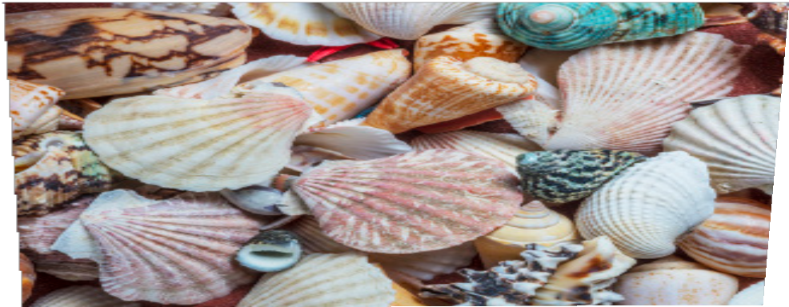

What effect does sea acidity have on shells?

Questions

Why did you add salt to each sample?

What factors did you keep the same throughout the experiment? (these are the “control factors”)
During each experiment I…

Is there a pattern between acidity and strength of shell?
The higher the…

Why do you think scientists are using satellites to monitor ocean acidity?

What | effect does | sea | acidity
have | on shells?

Volume of water/ml | Volume of vinegar/ml | pH (if recorded) | Initial observation | Final observations
200 | 0

