MSF 3900 REV 12/23

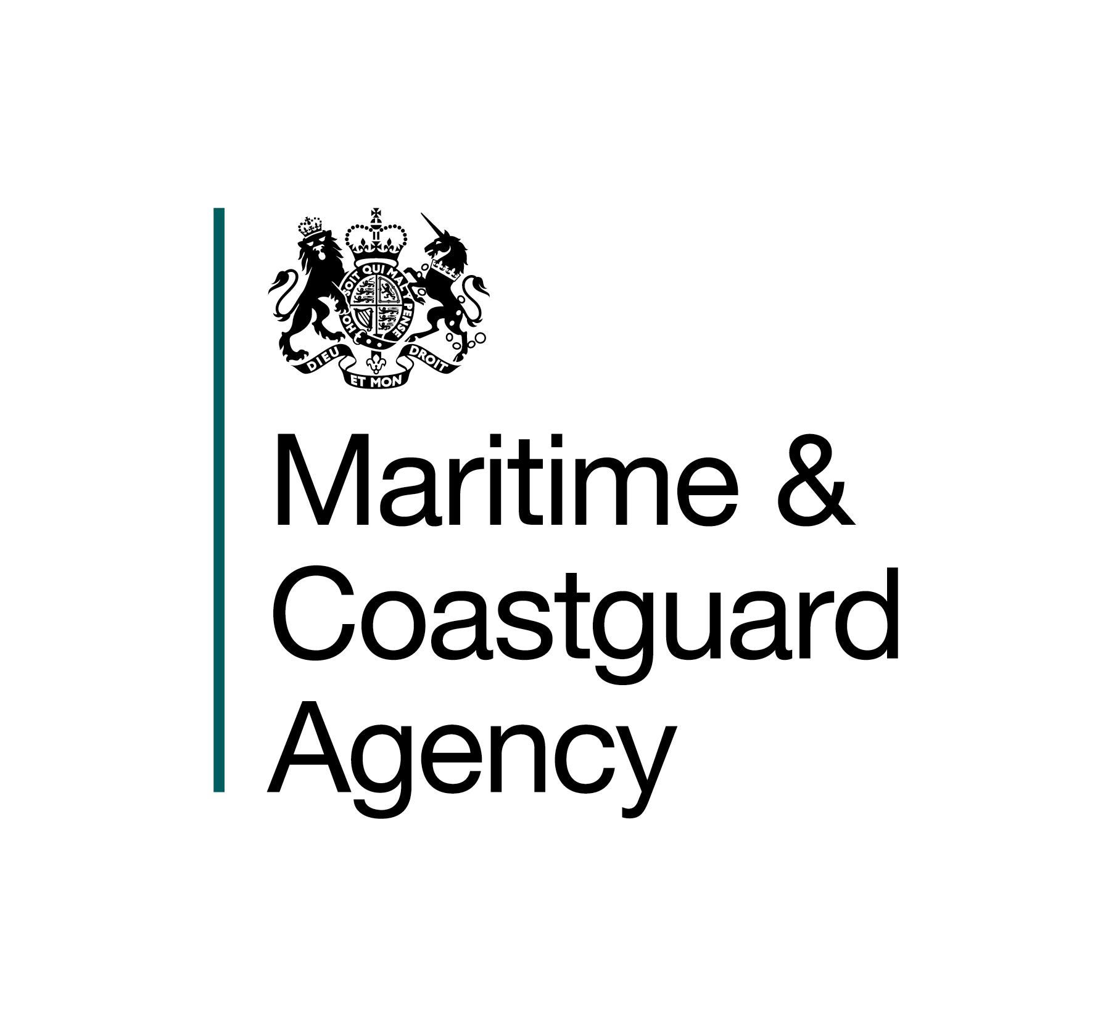

APPLICATION FOR THE REPLACEMENT OF A

FLAG STATE ENDORSEMENT

RFSE

This form should be used when a current valid FSE has been lost/stolen and you require an exact replacement of that FSE. Please email your completed application to: fse@mcga.gov.uk

1 PERSONAL DETAILS

Title Mr/Mrs/Miss/Capt etc |  | Sex (Male/Female)
Surname / Family name
Forename(s) in full
Date of Birth (DD/MM/YYYY)
Place of Birth |  | Country of Birth
Nationality

 | Return Delivery Address
Address
District
Town / City
County/State
Post Code/Zip
Country
Telephone No |  | Mobile No.
Email Address
If your FSE was stolen, you MUST report it to the Police

Date Reported
Police Report Reference Number
Name and Address of Police Station

Please do not write below this line

Received Date: |  | Documents: |  | SDS No:

2 Lost, Stolen or Damaged FSE

Certificate No: | Capacity/rank of certificate:
Have you lost a FSE before Yes No
Date of issue (please approximate if unknown):
Please provide FULL details of the circumstances of the loss of your certificate, including date, place, time and contact details of any witnesses. We may need to contact witnesses or contact you again for further information.

(The maximum penalty for a false declaration is £5000)
3 Your signature and declaration

I understand that completing and returning this form will result in the related Certificate being cancelled, that it may never be used again and, if subsequently found, it should be returned to the Maritime and Coastguard Agency (MCA) immediately. The information given on this form is true to the best of my knowledge, true and complete. Please refer to our privacy statement in Section 5 of this application which explains how we use the personal information we collect from you.

Signature:
For office use only
Today’s date: …………………………..

Please sign with your usual signature within the signature box above.

- Please print this form to sign it.
- You must use black ink only.
- You must not extend beyond the boundary of the box.
- The maximum dimensions for your signature are 0.6 cm (h) x 5.0 cm (w).
- You must scan in at a minimum of 200dpi and the signature must be clearly legible.

This signature will be transferred to your certificate. If your signature does not meet the above criteria, we will not be able to issue your certificate.

4 PAYMENT

IMPORTANT NOTE: If you are sending documents from outside the UK and indicate to your courier company that the documents have a value of over £100 GBP, you will be liable to pay any import charges.

You must ensure you pay the appropriate fee (as laid down in the current Merchant Shipping Fees Regulations).

Payment should be made in pounds sterling (£), by BACS transfer, credit or debit card via online payment facility Gov.uk Pay by following the links below.

We are unable to accept cheques, postal orders, banker’s drafts or cash.

The fee is £74 for a UK return address, £94 for EU/EEA return address and £104 for the rest of the world.

Please tick () the appropriate box below to indicate your chosen method of payment.

Replacement Certificate Application

To pay via Gov.UK Pay for delivery to the UK: £74

https://www.gov.uk/payments/seafarer-training-courses/replacement-fse-application-uk

To pay via Gov.UK Pay for delivery to the European Union or EEA: £94

https://www.gov.uk/payments/seafarer-training-courses/replacement-fse-application-eu

To pay via Gov.UK Pay for delivery to the Rest of the World: £104

https://www.gov.uk/payments/seafarer-training-courses/replacement-fse-application-row

If you wish to pay by BACS transfer, please email seafarer.finance@mcga.gov.uk for our bank details

5 PRIVACY STATEMENT

Personal information which you supply to us will be used to process your application to meet the applicable Standards of Training Certification and Watchkeeping (STCW) requirements. To check and report on how effective the MCA and the services it commissions have been. To make sure that the MCA gives value for money. We may use your information to investigate complaints, legal claims or important incidents. We may use your information for crime prevention and prosecution of offenders.

The information you provide is primarily used for issuing your UK Flag State Endorsement (FSE) but may also be used for other related purposes and shared with other statutory bodies/organisations to enable them to fulfil their statutory obligations.
We will not disclose any financial details you provide to us. Once your payment has been processed all financial details are securely destroyed.
For more information on how we use your information, and your rights to access information we hold on you, please see our full privacy policy available on our website:
https://www.gov.uk/government/organisations/maritime-and-coastguard-agency

