NOTICE OF ORDER

Wildlife and Countryside Act 1981
East Sussex County Council
(Public Footpath Wadhurst 79a, 79b, 79c, 79d, 80, 81 & 82) Definitive Map Modification Order 2023

Notice is hereby given that the above referenced Order has been submitted to the Secretary of State for Environment, Food and Rural Affairs for determination. An Inspector will be appointed by the Secretary of State to determine the Order.

The start date for the above Order is 04/01/2024.

Consideration of the Order will take the form of a public local inquiry.

The Inquiry will be held at Bells Yew Green Village Hall, Bells Yew Green, Tunbridge Wells TN3 9BJ on 4 June 2024 at 10.00am.

The effect of the Order, if confirmed without modifications, will be to modify the Definitive Map and Statement for the area by adding public footpaths as follows:

A route comprising a series of seven public footpaths with an arbitrary centreline route, as detailed below, and as shown on the Order Plan between points B-D; D-E; E-F; F-G; A-D; C-E; F-H.

The public footpath commences from a point along existing public footpath Wadhurst 51, in the civil parish of Wadhurst, at point B, near the southern end of Oak Wood, at TQ 6294 3338.

From point B it continues in a generally south-easterly direction through woodland and a clearing for 150 metres, to point D near the western edge of Stonebridge Wood at TQ 6306 3329.

From point D, the footpath continues in a generally east southeasterly
direction through Stonebridge Wood for 35 metres to point E, at TQ 6309 3327.

From point E the route continues in the generally east southeasterly
direction through Stonebridge Wood for 115 metres, to point F, near the eastern edge of Stonebridge Wood, at TQ 6320 3323.

From point F, the route continues in a generally south-easterly direction for 125 through woodland with a clearing to join existing public footpath Wadhurst 45 at point G, at TQ 6328 3315.

From point A, at a point on existing public footpath Wadhurst 51, at TQ 6299 3329, the footpath continues in a generally easterly direction for 20 metres to meet a stream at TQ 6301 3328. The route continues over and beyond the stream in a generally east north-easterly direction for 45 metres to point D, at TQ 6306 3329.

From point C, at a point on existing public footpath Wadhurst 51, at TQ 6291 3346, the footpath continues in a generally easterly direction through Oak Wood, for 90 metres to TQ 6300 3345, then in a south-easterly direction through Oak Wood for 60 metres to TQ 6304 3340, and then in a south-south easterly direction through Oak Wood for 100 metres to near the edge of Stonebridge Wood at TQ 6307 3331, then continuing in the same south-south easterly through Stonebridge Wood for 35 metres, to point E, at 6309 3327.

From point F, at TQ 6320 3323, the footpath continues in a generally easterly direction through woodland for 60 metres to TQ 6326 3323, then continues in a generally east southeasterly direction through woodland for 75 metres to join existing public footpath Wadhurst 45 at point H, at
TQ 6332 3320.

The width of the public footpath between will be 1.5 metres throughout.

The total length of the public footpath to be added is 910 metres.

Any queries relating to this Order should be referred to Joanne Reid by email: rightsofway2@planninginspectorate.gov.uk quoting reference number ROW 3330122 on all correspondence. Alternatively, queries may be sent in writing to The Planning Inspectorate, Rights of Way Section, Room 3/A Eagle Wing, Temple Quay House, 2 The Square, Temple Quay, Bristol, BS1 6PN. Telephone: 0303 444 5136.

Any person wishing to view the statements of case and other documents relating to this Order may do so by appointment at East Sussex County Council, County Hall, St Anne’s Crescent, Lewes, East Sussex BN7 1UE. Please contact Stephen Kisko Tel; 07795 237425 or 0345 6080193 or alternatively email: Stephen.kisko@eastsussex.gov.uk. Copies of the Order and Order Plan can also be viewed at Wealden District Council, Vicarage Lane, Hailsham, East Sussex BN27 2AX between the hours of 8.30am and 5pm Monday, Tuesday, Thursday, Friday and 9.30am and 5pm on Wednesday.

Documents may also be viewed online at https://www.eastsussex.gov.uk/leisure-tourism/discover-east-sussex/rights-of-way/definitive-map-statement/claiming-changing-public-right-of-way/register-definitive-map-modification-order-applications

Timetable for sending in statements of case and proofs of evidence

Within 8 weeks of the start date [29/02/2024]

The Order Making Authority must ensure their statement of case is received by the Secretary of State. As soon as possible after the deadline, the Secretary of State will send a copy (excluding copies of any supporting documents - these will be available to view at the Authority’s offices) to everyone who has made an objection or representation and the applicant and any other person who has written to us in respect of the Order.

Within 14 weeks of the start date [by 11/04/2024]

Everyone who has made an objection or representation and anyone who wishes to give evidence at the Inquiry must ensure their statement of case is received by the Secretary of State. As soon as possible after the deadline, the Secretary of State will send full copies to the Authority. Copies will also be sent to the applicant, every person who has made an objection or representation and any other person who has written to us in respect of the Order (excluding copies of any supporting documents - these will be available to view at the Authority’s offices).

Within the same period the applicant (if applicable) must ensure their statement of case is received by the Secretary of State. As soon as possible after the deadline, the Secretary of State will send a full copy to the Authority. Copies will also be sent to everyone who has made an objection or representation and any other person who has written to us in respect of the Order (excluding copies of any supporting documents - these will be available to view at the Authority’s offices).

4 weeks before the date of the inquiry [by 07/05/2024]

The Authority, everyone who has made an objection or representation, the applicant (if applicable) and anyone who wishes to give evidence at the Inquiry must ensure their proof of evidence (together with any summary) is received by the Secretary of State. As soon as possible after the deadline, the Secretary of State will send copies of:

- the Authority’s proof of evidence to everyone who has made an objection or representation, the applicant and anyone who has submitted a statement of case (including copies of any supporting documents – although none should be submitted with a proof of evidence);

- the applicant’s proof of evidence to the Authority, everyone who has made an objection or representation and anyone else who has submitted a statement of case (including copies of any supporting documents – although none should be submitted with a proof of evidence); and

- all other proofs of evidence to the Authority, the applicant, everyone who has made an objection or representation and anyone else who has submitted a statement of case (including copies of any supporting documents – although none should not be submitted with a proof of evidence).

All parties must keep to the timetable set out above and ensure that statements of case and proofs of evidence are received by the Secretary of State on time. Late documents will be returned.

We cannot accept any inflammatory, discriminatory or abusive comments. Any documents containing such comments will be returned.

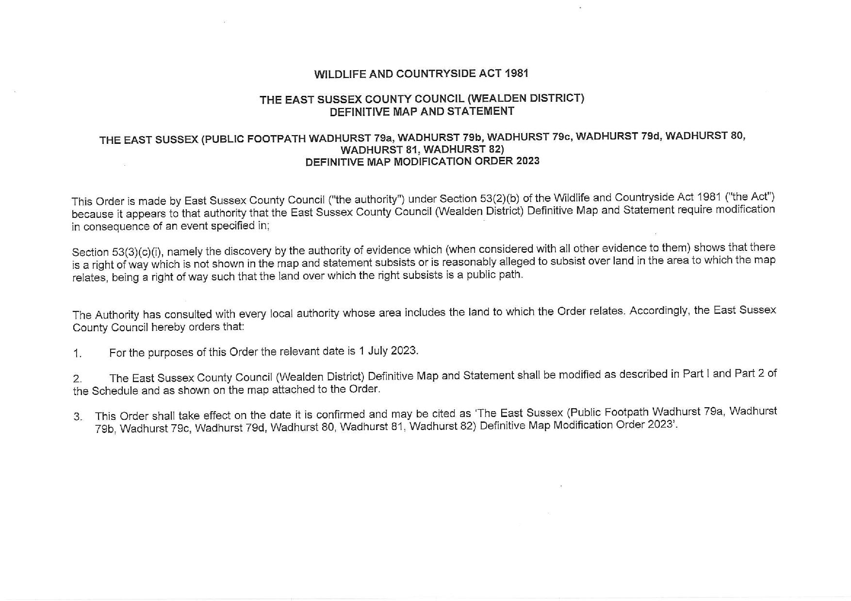

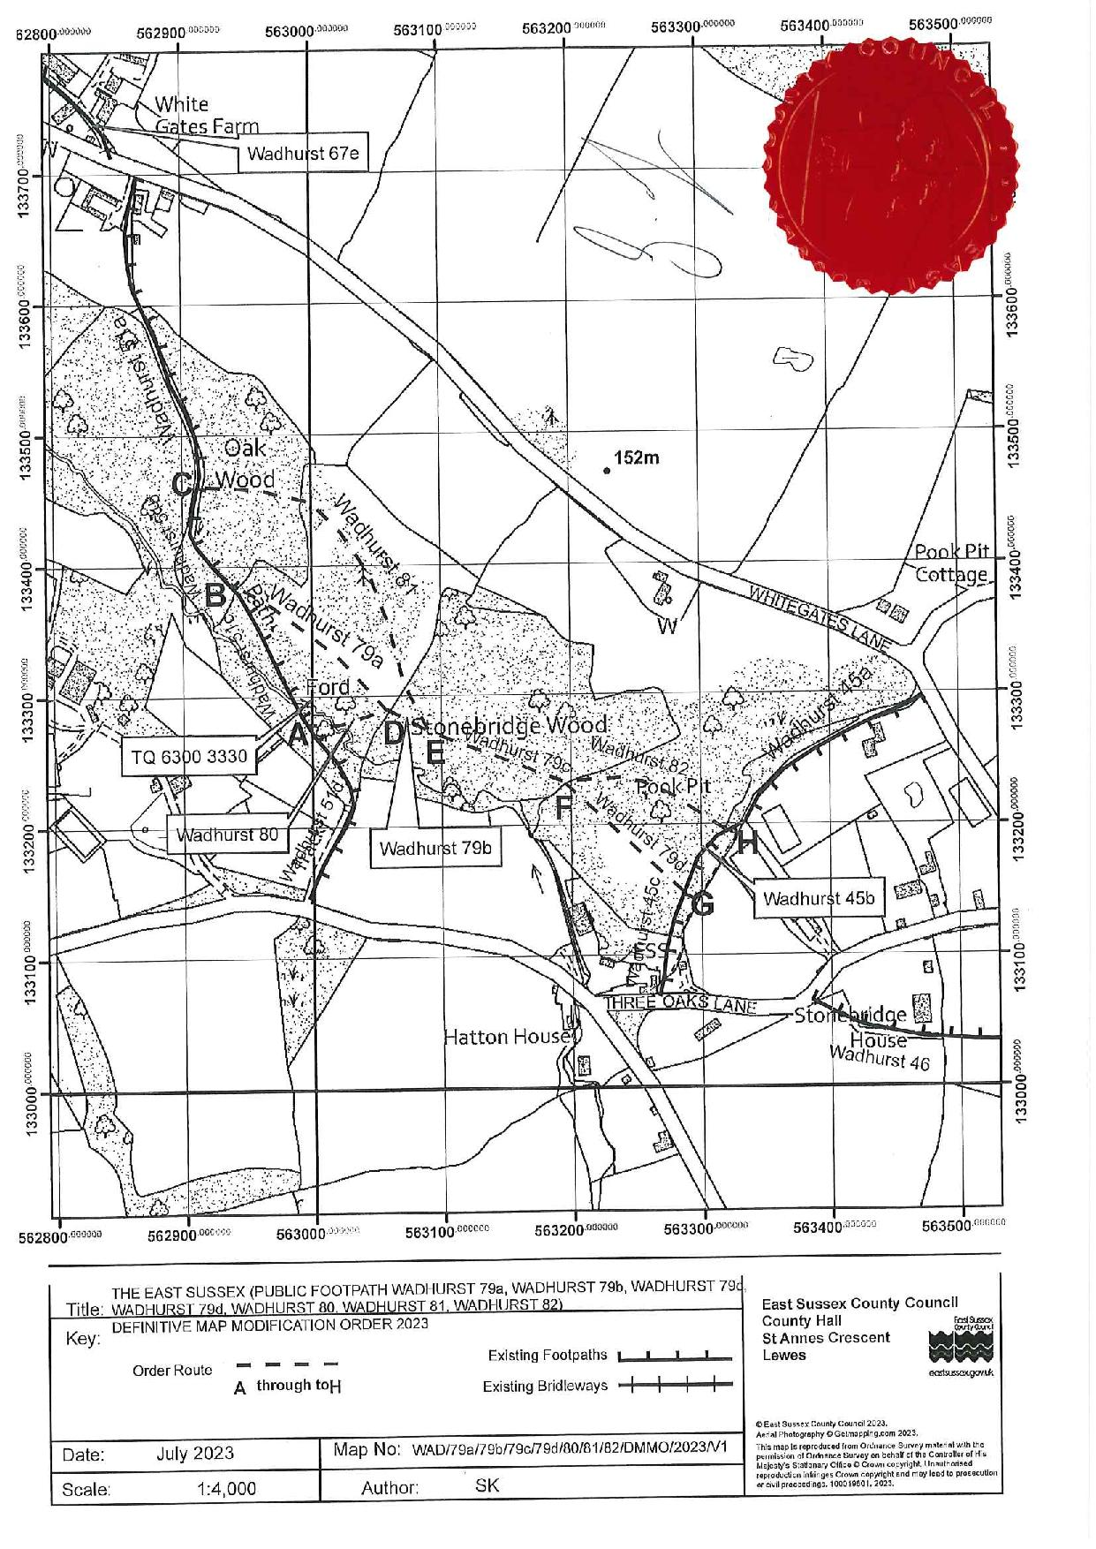

If you wish to make a legal submission, this should be submitted at the same time as your statement of case. Otherwise legal submissions will have to be submitted in writing on the day of the inquiry.

