




Applying for Restorative Measures
Information and guidance on how to apply
January 2024

What’s this guide for?
If you, or someone you know, served under and was impacted by the Ban on LGBT personnel in the Armed Forces between 1967 and 2000, you/they may be eligible for restorative measures.
This document provides information on all of the non-financial restorative measures being provided by the Ministry of Defence. It explains the:
- Restorative measure
- Eligibility criteria
- Application process
- Other relevant information for applicants, including expected timelines.
Information on applying for the financial award scheme will be added to the LGBT Veterans: Support and next steps GOV.UK page when available.
Some of the restorative measures have already been implemented in response to the LGBT Veterans Independent Review. You can read the full review, recommendations, and the Government’s response on GOV.UK.

Who can apply for the restorative measures?
- Anyone, regardless of sexuality, gender identity or serving status, who was affected by the Ban while serving in HM Armed Forces between 1967 and 2000.
- A Person of Sufficient Interest, including Next of Kin, to a deceased veteran who was affected by the Ban while serving in HM Armed Forces between 1967 and 2000 (see pages 18-19 for the full definition).
The restorative measures cover a variety of different circumstances. Check your eligibility for each measure, as not all restorative measures will apply to everyone.

How do I claim restorative measures?
We have separated the restorative measures into three sections. This is to help you understand which measures you may be eligible for and how to apply or register an interest in them.
- Section one: Pre-existing restorative measures.
- Section two: New restorative measures.
- Section three: Planned restorative measures.
We have done this because the pre-existing measures (section one) were already in progress or available before the review was published and have separate application forms. Application forms for all of the pre-existing measures in section one can be found on the LGBT Veterans: Support and next steps GOV.UK page.
For the restorative measures that are new or planned (section two and three), you will need to complete an Application and Registration of Interest form.
You can find all application and registration of interest forms for all restorative actions detailed in this guide on the LGBT Veterans: Support and next steps page.
Please only apply or register your interest for the restorative measures you believe you or the applicant are eligible for.

Contents

What’s this guide for? 1
How to apply? 3
Section 1 – Pre-existing restorative measures 4
Table of eligibility 4
Armed Forces Veterans’ Badge 5
Restoration of medals 5
Disregard & Pardon scheme 6
Section 2 – New restorative measures 7
Table of eligibility 7
Letter of apology from Service Chief of Staff 8
Replacement beret and/or cap badge 8
Service details published in The Gazette 9
Written reproduction of the Prime Minister’s apology 9
Receiving restorative measures in a Service ceremony/event 10
Replacement discharge papers 10
Provide testimony to form part of the historic record 11
Engaging in Service events and with LGBT Networks 11
Section 3 – Planned restorative measures 12
Table of eligibility 12
Awareness ribbon 13
Qualification of an administrative discharge 14
A Person of Sufficient Interest criteria and definition 15
Guidance for transgender veterans 17
For more information 18

How to apply?

Who is A Person of Sufficient Interest?
A Person of Sufficient Interest, including Next of Kin, is someone who had a long-standing, close personal relationship to the deceased person. This may be a relative, spouse, civil partner, long-term partner, child(ren), adopted family member, executor or similar.
Defence has adopted this broader definition to help include those whom the veteran may have nominated as their Next of Kin.
The full definition, types and evidence you need to prove your relationship can be found on pages 15-16.

You can apply for all of the new and planned restorative measures listed in section two and three, by completing the relevant Application and Registration of Interest form below.
The form includes the planned restorative measures that will be ready soon. You can register your interest for these if you are eligible. The Defence Restorative Action team will deliver these as soon as they are available. You do not need to apply more than once.

Application and Registration of Interest Form
If you are eligible, there are two forms that can be completed depending on who is applying:
Form for Anyone directly affected:

Receiving your restorative measures
You can elect to receive eligible restorative measures in one of two ways.

A Service ceremony or event
A member of the appropriate Service will contact you to make arrangements for the ceremony or event within six months of your application.
Any restorative measures not ready by the ceremony or event date may be posted to you separately.

Postal delivery
Defence will try to post restorative measures in one delivery, or in as few deliveries as possible.
The timeline for delivery is dependent on the measures you’ve applied for. But you should receive your first delivery of restorative measures within six months of applying.
.

- Veterans and serving personnel that were affected by the historic policy.
Form for a Person of Sufficient Interest:
- A Person of Sufficient Interest to a deceased veteran.
- Supporting evidence must be submitted to prove the relationship to the veteran. Guidance on this can be found on pages 18-19.
All forms can be found on the LGBT veterans: support and next steps - GOV.UK page.

How long will it take?
Some of the restorative measures are available now, others will take longer.
You will receive confirmation of your application by email or post.
The time it will take to process your application will depend on the measures applied for. But all applicants should be contacted by Defence within six months of applying. Unfortunately, we are unable to provide updates on applications before this point.

Section 1 – Pre-existing restorative measures

The restorative measures in this section were already in progress or available before the LGBT Veterans Independent Review was published. This means they have separate application forms and processes from the restorative measures detailed in sections two and three.
You can find information on each restorative measure, the eligibility and links to the separate application forms detailed in this section.

Table of eligibility
Restorative measure | All veterans | Serving personnel | A Person of Sufficient Interest*
Armed Forces Veterans’ Badge (recommendation 4) | Yes | N/A | Only those in receipt of a War Widow’s/Widowers pension and recipients of the Survivors Guaranteed Income Payment
Restoration of medals withheld or withdrawn (recommendations 5 & 6) | Yes | N/A | Where there are no related convictions
HM Armed Forces Veterans’ Card (recommendation 9) | Yes | N/A | N/A
The Disregard & Pardon scheme (recommendation 25) | Yes | Yes | N/A

*The definition for who qualifies as ‘A Person of Sufficient Interest’ is on pages 15-16.

Armed Forces Veterans’ Badge

Description
You can apply for a free HM Armed Forces Veterans’ Lapel Badge. The badge aims to raise the profile of our veterans, helping the public to recognise your Service.

Eligibility
If you have served in HM Armed Forces, including Volunteer and Regular Reserves.
You cannot apply if you served in the armed forces of another country or if you served alongside the UK Armed Forces, for example, in the Royal Australian Air Force or Royal Canadian Navy.
Only next of kin in receipt of a War Widow’s/Widower’s pension and recipients of the Survivors Guaranteed Income Payment.
Application
Search Apply for a medal or veterans’ badge and complete the form on GOV.UK.
You can also find the application form on the LGBT veterans: support and next steps - GOV.UK page.
If your application is successful, the badge will be posted to you.

Restoration of medals

Description
If you were discharged or dismissed solely on the basis of your sexuality, you can apply for any medals that were withheld or forfeited as a result.
Eligibility
Veterans who earned a medal(s) during service in any of the following:
- Royal Navy
- Royal Marines
- Army
- Royal Air Force
- Home Guard
- Reserve forces.
Any related convictions will first need to be Disregarded.
You must meet the eligibility requirements for the medal you’re applying for.

Application
Search Military Awards Commemorations and complete the form on GOV.UK.
You can also find the application form on the LGBT veterans: support and next steps - GOV.UK page.
If your application is successful, the medal will be posted to you.

HM Armed Forces Veteran Card

Description
If you served in the UK Armed Forces, you are eligible for a HM Armed Forces Veteran Card.
The cards allow veterans to easily verify their service to the NHS, their local authority, and charities. This helps with accessing support and services where needed.

Eligibility
Veterans who served in the UK Armed Forces and have a UK address.

Application
You do not need to apply if you have left since 16 December 2018. Defence has been automatically issuing all service leavers with a physical Veteran Card.
If you left before on or before 16 December 2018, the online application process can be found at Apply for an HM Armed Forces Veteran Card - GOV.UK. The link is also available on the LGBT veterans: support and next steps – GOV.UK page.
The application process for veterans who live abroad is expected to launch later this year; the LGBT veterans: support and next steps - GOV.UK page will be updated when this is available.

Disregard & Pardon scheme

Description
If you have a conviction for same-sex sexual activity under an offence which has since been repealed or abolished, you can apply to have the conviction disregarded – meaning it will be removed from official records.

Eligibility
Anyone with a historical conviction for same-sex sexual activity under an offence that has now been repealed or abolished is eligible to apply.

Application
Search Disregards and pardons for historical gay sex convictions and complete the form on GOV.UK.
You can also find the application form on the LGBT veterans: support and next steps - GOV.UK page.
Section 2 – New restorative measures
All of the restorative measures in this section are available now.
You can find information on each restorative measure, the eligibility and how to apply in this section.

Table of eligibility
Restorative measure | All veterans | Serving personnel | A Person of Sufficient Interest*
Individual letters of apology from relevant Service Chief of Staff (recommendation 2) | Yes | Yes | Yes
Replacement beret and/or cap badge (recommendation 7) | Yes | N/A | Yes
Publishing of service details in The Gazette (recommendation 8) | Former officers only | N/A | Former officers only
Written reproduction of the Prime Minister’s apology (recommendation 14) | Yes | Yes | Yes
Option to receive restorative measures in a Service ceremony/event (recommendation 15) | Yes | Yes | Yes
Replacement discharge papers where a discharge or dismissal is disregarded/ qualified/ nullified (recommendation 27) | Yes | N/A | Yes
Opportunity to provide testimony to form part of the historic record (recommendation 49) | Yes | Yes | Yes
*The definition for who qualifies as ‘A Person of Sufficient Interest’ is on pages 15-16.

Letter of apology from Service Chief of Staff

Description
You can apply for an individual letter from the relevant Service Chief of Staff apologising for the unacceptable treatment you, and others received during the Ban.

Eligibility
- A veteran or service person who served during and was affected by the Ban.
- A Person of Sufficient Interest to a deceased veteran who served during and was affected by the Ban.

Defence will use the service details to confirm service during the Ban. No further evidence is required.

Application

Complete the application and registration of Interest form on page 3, or on the LGBT veterans: support and next steps - GOV.UK page.

You can choose to receive this in a Service ceremony/event, or by post.

Replacement beret and/or cap badge

Description
You can apply for a replacement beret and/or cap badge. Defence will provide the relevant cap badge wherever possible, but if the cap badge has been retired, we will provide a modern alternative.

Eligibility
- A veteran who served during and was affected by the Ban.
- A Person of Sufficient Interest to a deceased veteran who served during and was affected by the Ban.
Defence will use the service details to confirm service during the Ban. No further evidence is required.

Application

Complete the application and Registration of Interest form on page 3, or on the LGBT veterans: support and next steps - GOV.UK page.
You can choose to receive this in a Service ceremony/event, or by post.
Please note that veterans impacted by the Ban have the same limited rights to wear uniform and use retired commissioned rank in correspondence as any other veteran when authorised. Any historic orders or correspondence to the contrary should be disregarded.

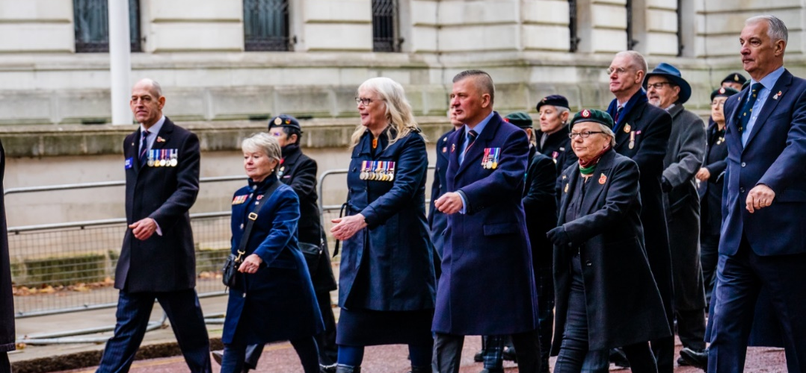
Service details published in The Gazette

Description
If you are a former officer you can apply to have your service details published in The Gazette, as part of the official record. This is an alternative to reinstating former officers to the Service Retired List (as this is no longer published).

Eligibility
- A former officer who served during and was affected by the Ban.
- A Person of Sufficient Interest to a deceased former officer who served during and was affected by the Ban.
Defence will use the Service details to confirm Service as an officer during the Ban. No further evidence is required.
Application

Complete the Application and Registration of Interest form on page 3, or on the LGBT veterans: support and next steps - GOV.UK page.
Confirmation of the veteran’s details being published will be sent via post or email.
Transgender veterans should refer to page 17 for additional guidance.
The Gazette’s privacy notice can be found on the Gazette’s website.

Written reproduction of the Prime Minister’s apology

Description
You can apply for a written reproduction of the Prime Minister’s apology in the House of Commons on 19 July 2023, to those affected by the Ban.

Eligibility
- A veteran or service person who served during and was affected by the Ban.
- A Person of Sufficient Interest to a deceased veteran who served during and was affected by the Ban.
Defence will use the service details to confirm service during the Ban. No further evidence is required.

Application
Complete the Application and Registration of Interest form on page 3, or on the LGBT veterans: support and next steps - GOV.UK page.
You can choose to receive this in a Service ceremony/event, or by post.
Transgender veterans should refer to page 17 for additional guidance.

Receiving restorative measures in a Service ceremony/event

Description
You can choose to receive any restorative measures you are eligible for in a Service ceremony or event.

Eligibility
- A veteran or service person who served during and was affected by the Ban.
- A Person of Sufficient Interest to a deceased veteran who served during and was affected by the Ban.

Application

Complete the Application and Registration of Interest form on page 3, or on the LGBT veterans: support and next steps - GOV.UK page.
A member of the appropriate Service will contact you to discuss and make arrangements.

Replacement discharge papers

Description
You can apply to have a Certificate of Service issued. Please note, discharge reasons are not stated on the Certificate of Service.

Eligibility
- A veteran who served during and was affected by the Ban.
- A Person of Sufficient Interest to a deceased veteran who served during and was affected by the Ban.
Defence will use service details to confirm that replacement discharge papers are appropriate. No further evidence is required.
To note, if you have applied for the qualification of administrative discharge, or the restoration of rank, these actions will need to be completed before we can issue a Certificate of Service.

Application
Complete the Application and Registration of Interest form on page 3, or on LGBT veterans: support and next steps - GOV.UK page.
You can choose to receive this in a Service ceremony/event, or by post. You can also indicate whether you would like your Service Number included on the certificate.

Provide testimony to form part of the historic record

Description
You can submit testimony to Defence which will be added to those given to the Review and submitted to The National Archive. This will form part of the historic record of the Ban.

Eligibility
- A veteran or service person who served during and was affected by the Ban.
- A Person of Sufficient Interest to a deceased veteran who served during and was affected by the Ban.
Defence will use the service details to confirm service during the Ban. No further evidence is required.
Application
Complete the Application and Registration of Interest form, and then submit your testimony via email to lgbt-furthertestimonies@mod.gov.uk.
The form and template can be found on page 3 or the LGBT veterans: support and next steps - GOV.UK page.

Engaging in Service events and with LGBT Networks

Description
Veterans, serving personnel and loved ones can connect with each other at Service events, conferences, community functions and LGBT Networks.

Eligibility
- A veteran or service person who served in the UK Armed Forces.
- A Person of Sufficient Interest to a veteran who served in the UK Armed Forces.

Application
Army – you can engage with Regimental Associations, the full list is on the COBSEO page. You can also join the Army LGBT+ Network on Facebook, Instagram, and Twitter.
RAF – you can connect via the RAF Alumni page on the RAF Galaxy platform. You can also join the RAF LGBT+ Network on Facebook, Instagram and Twitter.
Royal Navy – is developing an online platform for Summer 2024. In the meantime, you can join the Royal Navy LGBTQ+ Network on Facebook, Instagram and Twitter.

Section 3 – Planned restorative measures

All of the restorative measures in this section are expected to be ready for delivery in 2024. Further information will be added to LGBT veterans: support and next steps - GOV.UK page when the measures become available.
You can find information on each planned restorative measure, the eligibility and how to register your interest in this section. Once you’ve completed the form, the Defence Restorative Action team will deliver these as soon as they are available. You do not need to apply again.
Please note, this does not include the financial award, which will have a separate application process once eligibility and the design of the scheme have been confirmed. The Application and Registration of Interest form for non-financial restorative measures will ask you to indicate your interest in applying for a financial award. This does not guarantee eligibility but will enable the Government to learn more about those affected and thereby design the most appropriate scheme.

Table of eligibility
Restorative Measure | All veterans | Serving personnel | A Person of Sufficient Interest*
Restoration of rank/ commission (recommendation 3) | Yes | N/A | Where there are no related convictions
LGBT Service Ribbon (recommendation 10) | Yes | Yes | Yes
Qualification of an administrative discharge (recommendation 26) | Yes | N/A | Yes

*The definition for who qualifies as ‘A Person of Sufficient Interest’ is on pages 15-16.

Restoration of rank/commission

Description
You can register an interest to restore your rank and/or commission in service records held by Defence if you were demoted as a result of a discharge/dismissal due to the ban.

Eligibility
- A veteran who was demoted as a result of a discharge or dismissal due to the Ban.
- A Person of Sufficient Interest to a deceased veteran who was demoted as a result of a discharge or dismissal due to the Ban.
Any convictions must first be Disregarded.

Application

Complete the Application and Registration of Interest form on page 3, or on the LGBT veterans: support and next steps - GOV.UK page.

LGBT Service Ribbon

Description
You can register an interest for an LGBT Service Ribbon as an alternative to a special Veterans’ badge for those who Served at the time of the Ban.

Eligibility
- A veteran or service person who served during and was affected by the Ban.
- A Person of Sufficient Interest to a deceased veteran who served during and was affected by the Ban.

Application

Complete the Application and Registration of Interest form on page 3, or on the LGBT veterans: support and next steps - GOV.UK page.

Qualification of an administrative discharge

Description
You can register an interest to have an administrative discharge, which was based solely on sexuality, or perceived sexuality, qualified.
Successful applicants’ records will be amended or annotated to record the discharge reason as being “pursuant to a policy subsequently held by the European Court of Human Rights to be unlawful”.

Eligibility
- A veteran who was administratively discharged during the Ban, solely based on their sexuality, or perceived sexuality.
- A Person of Sufficient Interest to a deceased veteran who was administratively discharged during the Ban, which was based solely on their sexuality or perceived sexuality.

Application

Complete the Application and Registration of Interest form on page 3, or on the LGBT veterans: support and next steps - GOV.UK page.
You will be exempted from any call out or recall liability (as applicable) which may result from the qualification of an administrative discharge. However, if you would like to accept any extant call out or recall liability (as applicable), please contact LGBT-RestorativeAction@mod.gov.uk.

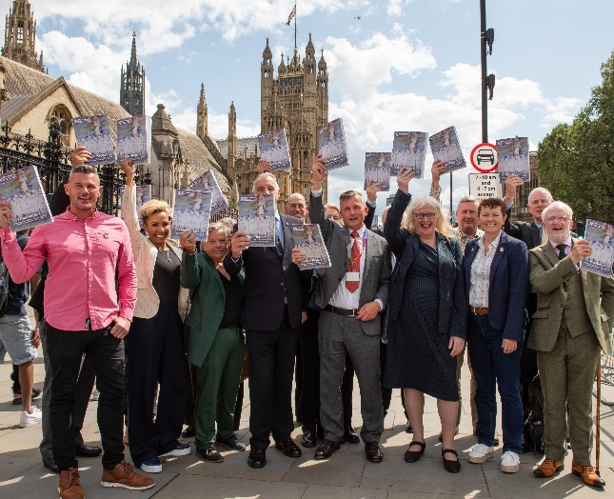

A Person of Sufficient Interest criteria and definition
A Person of Sufficient Interest, including Next of Kin, is someone who had a long-standing, close personal relationship with the deceased person, who could be expected to represent the wishes of the deceased. This may be a relative, spouse, civil partner, long-term partner, child(ren), adopted family member or similar.
Defence has adopted this broader definition to help include those whom the veteran may have nominated as their Next of Kin.
All applications submitted by a Person of Sufficient Interest must be supported by evidence submitted to the Defence Restorative Action team via email to LGBT-RestorativeAction@mod.gov.uk.
Your email should include your name, the veteran’s name, and the veteran’s Service number to enable the team to allocate the evidence to the appropriate application.
This can be a difficult area to navigate. If you believe you should be considered as a Person of Sufficient Interest but aren’t listed below, please email LGBT-RestorativeAction@mod.gov.uk.

The table below shows the definitions of a Person of Sufficient Interest and the required evidence:
Person of Sufficient Interest types | Evidence required
The personal representative of the deceased’s estate.  - This will be the Executor named on the Grant of Probate where the deceased had a will.  - This will be the Personal Representative named on the Letters of Administration where the deceased had no will. | - Certificate of death  - Grant of Probate/Confirmation (only in Scotland) or Letters of Administration
A person who is entitled to personal property under the proved will of the deceased (a beneficiary). | - Certificate of death  - Will
Official Next of Kin of the Deceased.  This will be the first person from the following list who is still alive:  - Surviving Spouse or Civil Partner  - Children (or their descendants)  - Parents, Brothers or sisters (or their descendants)  - Half siblings (or their descendants)  - Grandparents  - Uncles or aunts (or their descendants)  - Half uncles or aunts (or their descendants) | - Certificate of death  - Proof of relation (this could include birth certificates, marriage certificate, adoption records etc)
A person who was in a relationship or living with the person who has died, at the time of the person's death as their long-term partner. | - Certificate of death  - Evidence of shared assets or long-term relationship (this could include Mortgage or Tenancy documents showing joint ownership or rental of a property; proof of joint responsibility for a child; joint bank account; proof that both partners’ names were on the Electoral Roll at a shared address; a Council Tax bill for the same property in joint names; loan documentation of major assets such as homes, cars  or major appliances in both partners’ names; utility bills in both names.
Any person who was treated as a child of the deceased.  or  Any person who immediately before the death of the deceased was being financially supported either wholly or partly, by the deceased. | - Certificate of death  - Evidence of financial or domestic commitments (examples as above)

Guidance for transgender veterans
The Application and Registration of Interest form will ask you for your full name, and then for your name during service if your name has changed since. Defence needs your name during service to locate your service records.
For some of the restorative measures, Defence will need to pull information from service records to deliver the restorative measure.
If you are transitioning, or have transitioned, and have changed your name since service and would like any correspondence or items to include your preferred name, please send a copy of your photo ID and evidence of your name change to LGBT-RestorativeAction@mod.gov.uk once you have submitted your application form.
You only need to submit evidence if you are applying for the following:

- Publishing of details in The Gazette – Eligible former officers can apply to have their name, rank and date of retirement published in The Gazette (see page 9). Defence will publish your current name once the requested evidence has been received.
- Replacement discharge papers – Eligible veterans can apply to have a Certificate of Service issued (see page 10-11). Defence will issue this in your current name once the requested evidence has been received.
Service numbers are also included on Certificate of Services, if you would prefer yours to not be included, please indicate this on the Registration of Interest form.

For more information

If you have any questions or need more information on the restorative measures, you can:
- Email the Defence Restorative Action team on LGBT-RestorativeAction@mod.gov.uk
- Contact the Veterans UK helpline:
  - Email: veterans-uk@mod.gov.uk
  - Freephone (UK only): 0808 1914 2 18
  - Telephone (overseas): +44 1253 866 043
You can also find a full list of support, welfare and advice channels listed on the LGBT veterans: support and next steps - GOV.UK page.

