Order Decisions
26 September 2023
by Claire Tregembo BA(Hons) MIPROW
An Inspector appointed by the Secretary of State for Environment, Food and Rural Affairs
Decision date: 17 November 2023
Order Ref: ROW/3302626 | Extinguishment Order
- This Order is made under Section 118A of the Highways Act 1980 and is known as Doncaster Borough Council Public Footpath Rossington Number 10 (Part) Rail Crossing Extinguishment Order 2019.
- The Order is dated 25 June 2019 and proposes to extinguish the public right of way shown on the Order plan and described in the Order Schedule.
- There was one objection outstanding when Doncaster Borough Council submitted the Order to the Secretary of State for Environment, Food and Rural Affairs for confirmation.
Summary of Decision: The Order is confirmed.
Order Ref: ROW/3282627 | Creation Order
- This Order is made under Section 26 of the Highways Act 1980 and is known as Doncaster Borough Council Public Footpaths Rossington Numbers 17 and 18.
- The Order is dated 25 June 2019 and proposes to create two public footpaths as shown on the Order Plan and described in the Order Schedule.
- There was one objection outstanding when the Doncaster Borough Council submitted the Order to the Secretary of State for Environment, Food and Rural Affairs for confirmation.
Summary of Decision: The Order is confirmed.

Procedural Matters
- I undertook an accompanied site visit on 26 September 2023 with representatives of Network Rail (NR), Doncaster Borough Council (the OMA), the owner of the land and the objector. The crossing is currently closed by a Temporary Traffic Regulation Order and the decking has been removed, so we could not cross it. The Level Crossing Manager opened the locked gate on the western side of the railway to allow us to view it from the crossing point. The gate on the eastern side is welded shut so it was not possible to view it from this side.
- Following the making of the Orders, an objection to the Extinguishment Order (EO) was made by a resident. Since the Orders were made, the land on the east side of the railway line has changed hands and the new owner objects to the Creation Order (CO). Section 26 of the Highways Act 1980 (the 1980 Act) does not require permission from the landowner for a right of way to be created over land.
- When the Orders were made, there was a proposal for a development for a golf course and approximately 500 houses which would increase the use of Penny’s Crossing. This development is no longer going ahead. NR asked the OMA to withdraw the Orders so they could submit a new application based on the current situation. However, the OMA still considers the EO necessary on the grounds of public safety and declined to withdraw the Orders. NR’s statement of case is based on the current situation with no consideration given to any future development proposals.

The Main Issues
- The section of footpath proposed to be extinguished crosses the East Coast Main Line (ECML) railway at grade.
- The CO would create footpaths on both sides of the railway to link to an existing footbridge to allow the public to cross the railway.
- Under Section 26 of the 1980 Act, if I am to confirm the CO, I need to be satisfied there is a need for the footpaths and that it is expedient that they should be created having regard to:
- the extent to which the paths would add to the convenience or enjoyment of a substantial section of the public, or the convenience of persons resident in the area; and
- the effect which the creation of the paths would have on the rights of the persons with an interest in the land, account being taken of the provisions for compensation.
- Under Section 118A of the 1980 Act, if I am to confirm the EO, I need to be satisfied that it is expedient to extinguish the footpath over the level crossing, having regard to all the circumstances, and in particular to:

a) whether it is reasonably practicable to make the crossing safe for use by the public, and

b) what arrangements have been made for ensuring that, if the Order is confirmed, any appropriate barriers and signs are erected and maintained.
- I consider the key points to be considered are:
- the extent to which the CO would provide an alternative path;
- the current safety of the pedestrian railway crossing for the public;
- whether any improvements to the pedestrian crossing, so as to make it safe, are reasonably practicable; and
- whether, if the Order is confirmed, adequate arrangements have been made to secure the redundant crossing.
- I must have regard to ‘all the circumstances’ and these could include the use currently made of the existing path, the risk to the public, the effect the loss of the path would have on users of the public rights of way network as a whole, the impact on the owner of the land and their agricultural activities, the options for alternative measures and the relative cost of such measures.
- I must also have regard to any material provision of any Rights of Way Improvement Plan (ROWIP) for the area and to the Public Sector Equality Duty (PSED).

Reasons

The Creation Order
- The CO would provide two new footpaths on either side of the railway line between Rossington 8 and 10. Rossington 17 is on the western side of the railway shown between A and C on the CO plan appended to the end of my decision and Rossington 18 is on the eastern side shown between B and D.

The need for the proposed paths
- I am advised that a definitive map modification order application (DMMOA) has been made for a footpath between B and D supported by evidence of use for twenty years. I have not seen this application or the evidence which supports it, but the claim could suggest there is a need for this footpath. There is also a very clear worn line along the proposed footpath indicating it is well used.
- NR believe the footbridge on Rossington 8 is the preferred route over the railway and most walkers cross here and walk along the Rossington 18 to reach Common Lane. The objector advises that regular dog walkers use the footbridge to cross the railway and walk a circular route using Penny’s Crossing and the CO footpaths as do other walkers and joggers.
- I am satisfied that there is a need for the proposed footpaths.

The extent to which the paths would add to the convenience or enjoyment of the public or the convenience of residents
- Most of those walking this path network will be starting from New Rossington to the north of the Order route.
- Rossington 17 would provide a traffic-free alternative to Stripe Road for anyone who wanted to walk in that direction. Stripe Road has a 40 to 60 mph speed limit and south of Hall View Road, there is no pedestrian footway. Therefore, Rossington 17 would provide a safer route for public use.
- Looking at the wider path network, Rossington 18 would ensure a footpath that could be used as part of a circular walk adding to the enjoyment of the public. The DMMOA and the worn line would suggest this footpath would add to the enjoyment of the public or residents.
- For these reasons, I consider the proposed footpaths would add to the convenience and enjoyment of the public and residents.

The effect on persons with an interest in the land
- The proposed footpath on the western side of the railway is over land owned by NR who requested the Order.
- When the CO was made, the owner of the land on the eastern side of the railway agreed to the creation of the footpath. However, the land has since been sold and the new owner does not support the creation of Rossington 18.
- The new owner intends to use the land for agricultural purposes and his farming business includes breeding sheep and cattle. They are likely to use it to graze their livestock. The owner considers the footpath would need to be fenced off from the field for health and safety reasons and to reduce the likelihood of dog attacks on livestock and injuries to walkers. NR are willing to fund the provision of a stock-proof fence if the CO is confirmed.
- If the Order is confirmed, the owner would be entitled to statutory compensation for depreciation in the value of the land and disturbance under Section 28 of the 1980 Act which NR are prepared to pay.
- The objector also has concerns about what would happen if the land was developed or if the owner prevented access. If the CO is confirmed, the footpaths would be recorded on the definitive map and statement for public use and would need to remain open and available unless they were legally diverted or extinguished.
- Although the creation of Rossington 18 would affect the interests of the owner, NR are willing to fund stock-proof fencing alongside the proposed footpath and pay any compensation for the depreciation in the value of the land and disturbance to the owner. I consider any negative impacts can be addressed by way of compensation.

Conclusions on the Creation Order
- I consider there is a need for the proposed footpaths and that it is expedient to create them taking into account the beneficial effects of the creations for the public, which are not outweighed by any adverse effects upon the rights of the persons with an interest in the land.

The Extinguishment Order
- Rossington 10 runs along Common Lane and crosses the railway over a pedestrian level crossing known as Penny’s Crossing. It is shown on the EO plan between A and B appended to the end of my decision. It is a passive crossing which relies on those using it to ‘stop, look, and listen.’ There are two sets of pedestrian gates on either side of the railway, at the line side and set back from the railway.
- NR advises that Penny’s Crossing is compliant with level crossing standards, but a compliant crossing is not the same as a safe crossing. They consider there are factors that make it a high-risk crossing which cannot be made safe and therefore should be closed.

The extent to which the Creation Order would provide an alternative way
- The alternative route would be along the proposed footpaths shown in the CO plan to reach Rossington 8 which crosses the railway line using an existing footbridge. The proposed footpath on the western side of the railway would be along an access track owned by NR and used for maintenance purposes. On the eastern side, it would be along a field edge path.
- The proposed footpaths are already securely fenced off from the operational railway. There appears to be limited vehicular use of the maintenance track. The owner of the field may keep livestock in it which they consider could put the public at risk. However, NR is prepared to fund stockproof fencing to separate the public from livestock. Therefore, I consider the proposed alternative route would be significantly safer than Penny’s Crossing.
- The footpaths in the CO are 570 metres and 580 metres long. Therefore, anyone wishing to walk the full length of Common Lane would have to walk approximately 1.2 km further. This additional distance would be less convenient to the public. However, Common Lane does not provide access to any amenities or points of interest. The footpath and connecting path network are used for recreational and dog walking purposes. There are few properties and limited paths south of Common Lane.
- Whilst the additional distance weighs against the EO, it is a recreational path network, and the additional length is unlikely to discourage use of Common Lane. Although the alternative would not be as convenient, it would not be significantly less convenient given its recreational use and the safety considerations.
- The proposed footpaths are both level with mostly grass and earth surfaces, although some sections of the maintenance track have a stone surface. There are some puddles within the vehicular tracks on the western side of the railway but the ground between them is dry. On the eastern side, the walked line is dry and level. There are no steps on the existing footbridge. I do not consider the surface would affect the convenience of the public.
- The proposed footpath on the eastern side of the railway has good views across open fields and appears to be a popular route. Views on the western side of the railway were limited by a tall sweetcorn crop. However, the crop would not be present all year round. Furthermore, Rossington 8 is a similar width with sweetcorn growing on either side. Given the number of walkers I saw, the crop did not appear to deter use or reduce its enjoyment.
- It is claimed the crossing is used to access horse fields off Stripe Road, but no owners of the fields have come forward in objection to the closure of the crossing.
- A census of Penny’s Crossing in Summer 2022 showed average daily use by 34 people, which I consider to be low.
- I consider the proposed alternative route, if I were to confirm the CO, would be significantly safer and as enjoyable as the existing footpath. The increased distance would make it less convenient, but I do not consider it to be significantly less convenient given the recreational nature of the footpath and surrounding path network.

Whether the current crossing is safe
- Penny’s Crossing is over two high-speed tracks used by InterCity trains with speeds of up to 125 mph and long freight trains with speeds of up to 75 mph. The ECML is used by 212 trains daily and has the capacity to run up to 310 trains which is approximately five times the national average. NR considers the ECML to be the most important route in the UK railway network and it connects London with the North East, East and Scotland.
- NR uses an application called All-Level Crossing Risk Model (ALCRM) to provide a consistent method of assessing safety risk at level crossings. It incorporates a quantitative and qualitative approach to achieve a rounded and balanced analysis of risk. It has been developed through extensive research and a collaborative partnership between NR and the Rail Safety Standards Board.
- The most recent level crossing risk assessment determined an ALCRM Risk Rating of B3 which is a high-risk category. The letter represents the risk to an individual per traverse. A represents the highest risk and M the lowest. The number represents the collective risk based on total harm or safety loss with 1 representing the highest risk and 13 representing no risk.
- Although Penny’s Crossing has good sight lines, the speed of the approaching trains gives little time to cross safely. From the shortest sighting distance, a train takes 16 seconds to reach the crossing. A fit and healthy person requires 9 seconds to cross, with vulnerable users requiring 13.88 seconds. A safe crossing relies on the path user crossing quickly and continuously checking for approaching trains. NR considers the margin for error on Penny’s Crossing is very low.
- A census in 2019 found all users were considered to be vulnerable. Vulnerable users include older users, those with mobility issues and young people who may not be fully aware of the dangers of using a level crossing. Sight lines can also be reduced by rain, fog, snow, and sun-glare. The crossing is primarily used by dog walkers and the Rail Accident Investigation Board advises that a high proportion of fatalities at level crossings involve pedestrians with dogs. I am satisfied that, given the number of dog walkers and vulnerable users, the crossing times are marginal and would be a risk to public safety.
- The variations in speed difference between the InterCity trains and freight trains is at least 50 mph. This makes it more difficult for path users to judge the speed of the trains. The freight trains can also take over a minute to pass through Penny’s Crossing which can make path users impatient. I consider this speed variation could pose a risk to public safety.
- The InterCity trains are 260 metres long and freight trains vary in length from 420 to 775 metres. This can lead to trains being hidden by trains passing in the opposite direction. London North East Railway company have confirmed many of their trains pass each other close to Penny’s Crossing making this a significant risk and hidden trains have been the cause of many near-misses and actual fatalities. During the site visit, two trains passed each other close to the crossing. Given the marginal crossing times with full sight lines, I consider hidden trains a significant risk to public safety in this location.
- Between 2006 and 2022, 56 incidents were recorded at Penny’s Crossing. These include three fatalities, six significant near misses where train movements were suspended, seven incidents of obstructions being placed on the line and five reports of deliberate misuse. Twelve of these events occurred between March 2022 and 2023, including two fatalities and three attempted suicides.
- Penny’s Crossing is in a quiet, rural location and attracts young people who have been photographed sitting on the crossing and loitering around it.
- There were three suicides at Penny’s Crossing between 2017 and 2022. During this time there were 173 suicides nationally, with 13 level crossings having two suicides and only two having three. Its quiet location could be a factor in the number of suicides and attempted suicides.
- Due to the ALCRM risk rating, the limited crossing time, the train speeds, the significant risk of hidden trains, and the number of incidents on the line, I consider Penny’s Crossing does present a risk to the public.

Whether it is reasonably practicable to make the crossing safe for use by the public
- Several measures have previously been implemented to try and reduce the risk at Penny’s Crossing. These included straightening the deck to reduce crossing times, anti-slip surfacing, clearly defining the decision point, corral fencing to prevent users from deviating off the approaches, signs with contact details for the Samaritans and the installation of CCTV and signage to deter misuse. Security patrols by NR and British Transport Police were increased and focussed safety campaigns were used to highlight the issues to residents and children. These measures do not remove the risk of human error and appear to have had limited impact on safety or misuse.
- A wider deck would enable users to pass each other more easily. However, this would also require wider gates which would allow the crossing to be accessed by horse riders, motorbikes, and quad bikes, leading to an increase in risk.
- Illuminating the crossing could lead to an increase in people gathering at night, anti-social behaviour, misuse, and trespass. Common Lane and the surrounding area are unlit. Illuminated crossings in an otherwise dark environment can cause distractions to train drivers and make it more difficult for path users to see approaching trains.
- Whistle boards need to be fitted 400 metres from a crossing to be heard. At Penny’s Crossing the whistle boards would need to be erected 776 metres from the crossing to provide the minimum 14 second warning. Therefore, this is not feasible and is likely to lead to complaints from residents of New Rossington where a whistle board would need to be located.
- Supplementary audible warning devices would give an audible warning at the crossing when a train passes a whistle board. However, they can only be installed with a whistle board. There is no way for crossing users to tell if they are not working and they can be a target for regular vandalism which makes their efficiency questionable.
- Reducing the line speed would cause delays to train services on the line and have an effect on services to the North East, East Coast, Scotland, and London. NR advises the operational efficiency of this strategic railway line needs to be maintained and Government expectation is that line speeds should be maintained, services and capacity increased and journey times reduced. Therefore, this is not considered to be a feasible option.
- Miniature Stop Lights (MSL) could be installed. However, due to the location of Auto Stop signals, the cheaper overlay MSL cannot be used. The more expensive integrated MSL would cost at least £1 million but the cost-benefit analysis determined this would be disproportionate to the benefits it would give. A flex MSL is currently under development but does not have safety approval. The effectiveness of MSL at Penny’s Crossing would be significantly reduced by the variations in train speeds and lights would be red for a significant amount of time and for prolonged periods. The installation of MSLs would only achieve a partial and inadequate risk reduction.
- A stepped footbridge would cost approximately £2.7 million, a ramped footbridge approximately £4.5 million and a subway approximately £6.5 million. The census undertaken in summer 2022 recorded a low number of users. Therefore, I consider the cost of these options to be disproportionate to the benefits achieved.
- For the above reasons, I consider it is not reasonably practicable to make the crossing safe for use by the public.

Arrangements for appropriate barriers and signs to be erected and maintained
- NR has entered into an agreement with the OMA to defray any expenses incurred in the erection or maintenance of barriers and signs. At the time of my site visit, the high outer security gates were locked on the western side of the railway and welded shut on the eastern side. The gates on the western side would be welded shut on confirmation of the extinguishment order. Therefore, I am satisfied appropriate arrangements would be made to secure Penny’s Crossing and erect appropriate signage if I were to confirm the EO.

Other Considerations
- NR has a duty to promote operational efficiency of the railway network by virtue of the Railways Act 1993. Operational efficiency is affected by delays to train services, timetable disruptions, compensation payments to train operators and reduced scope for enhancing services, increasing speeds, or reducing journey times. When trains are delayed or services suspended due to an incident on a line, it almost inevitably affects the wider network.
- For every incident that requires the suspension of train services NR is required to pay around £100 compensation for every minute of delay for every train that is affected. Following the fatality on Penny’s Crossing in May 2022, four services were cancelled, and 1,594 minutes of delays occurred. The total cost of compensation paid was £180,191.
- Given the number of incidents at Penny’s Crossing which resulted in delays, stoppages, or suspension of services, the closure of the crossing would promote operational efficiency on the ECML and given the importance of the line, potentially the wider rail network.

Conclusions on the Extinguishment Order
- I am satisfied that it is expedient to extinguish the footpath across Penny’s Crossing having regard to all the circumstances, and in particular to whether the crossing can be made safe and the arrangements for appropriate barriers and signs.

Rights of Way Improvement Plan
- The ROWIP for the area includes policies for developing the rights of way network by creating new routes and improving safety when the network interacts with railways. The Orders would meet the aims of these ROWIP policies.
- Where NR wish to close level crossings the ROWIP aims to ensure that the alternative route is not less convenient or not substantially longer than the route to be extinguished. The OMA accepts the alternative route is longer than the crossing to be extinguished. However, they do not consider this to be a negative factor given the recreational nature of the footpath and the opportunity to connect with other rights of way.

Public Sector Equality Duty
- The alternative routes are level and in a similar condition to the existing footpath network with no gates or stiles. There are no steps on the footbridge on Rossington 8. There are four gates on the section of Rossington 10 proposed to be extinguished which could restrict access to people with mobility issues. The alternative route would be longer than the existing footpath proposed to be extinguished. However, use of this footpath network is predominantly for recreational purposes and most path users access it from Rossington 8 rather than Rossington 10. Therefore, I consider the PSED to be discharged.

Overall Conclusions
- Having regard to these and all other matters raised in the written representations I conclude that the EO and CO should be confirmed.

Other Matters
- References were made to the safety of, and proposals for other crossings in the area, but I am only able to consider the Orders before me.

Formal Decision

The Creation Order
- I confirm the Order.

The Extinguishment Order
- I confirm the Order.

Claire Tregembo

INSPECTOR

Creation Order Plan

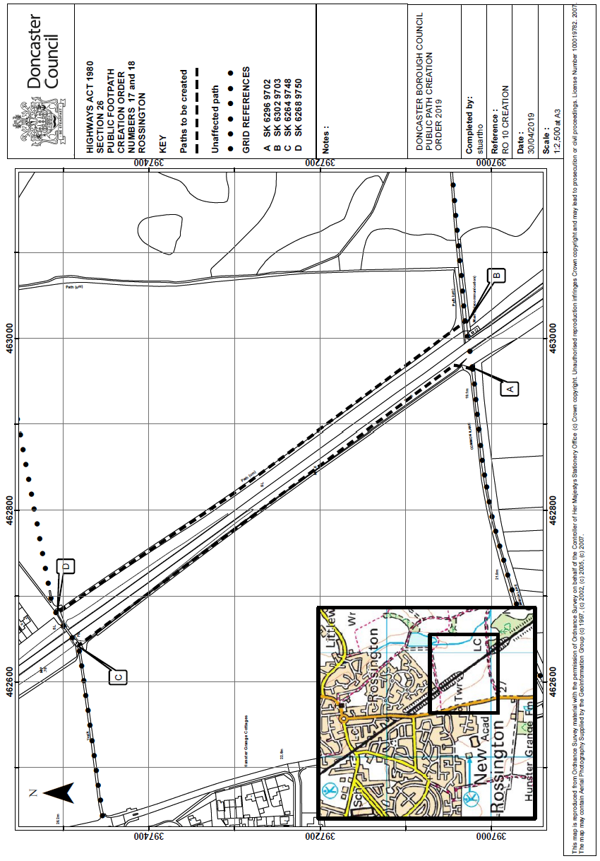

Extinguishment Order Plan

