Application Decision
Site visit made on 31 August 2023
by Paul Freer BA (Hons) LLM PhD MRTPI
an Inspector appointed by the Secretary of State for Environment, Food and Rural Affairs
Decision date: 13 December 2023

Application A Ref: COM/3317298
Foulride Green, Lower Willingdon, Eastbourne, East Sussex BN20 9NY
Register Units: CL57 & CL96
Registration Authority: East Sussex County Council

- The application, dated 24 February 2023, is made under Section 16 of the Commons Act 2006 (“the 2006 Act”) to deregister and exchange common land.
- The application is made by Mr Peter Vine and Mr Robert Vine.
- The release land comprises a total of 5,202 m² on the east side of Eastbourne Road.
- The replacement land comprises 6,763 m² of land on Mornings Mill Farm, Eastbourne Road, Lower Willingdon.

Application B Ref: COM/3317303
Foulride Green, Lower Willingdon, Eastbourne, East Sussex BN20 9NY
Register Unit: CL57 & CL96
Registration Authority: East Sussex County Council

- The application, dated 24 February 2023, is made under Section 38 of the 2006 Act for consent to carry out restricted works on common land.
- The application is made by Mr Peter Vine and Mr Robert Vine.
- The application is for works including, in summary, the provision of two new access roads on the east side of the A2270 Eastbourne Road, widening the carriageway of Eastbourne Road on the east side of the road, provision of a footway/cycleway and a southbound bus lane, the installation of traffic signals, a stretch of footway and street furniture on the west side of Eastbourne Road.

Decision: Application A
- Consent is granted and an Order of Exchange given in accordance with the application dated 24 February 2023, to deregister and exchange common land at Foulride Green, Lower Willingdon, Eastbourne, East Sussex BN20 9NY. As part of the Order of Exchange a copy of the application plans (Drawing A) showing the areas for deregistration and exchange are attached to these decisions.

Decision: Application B
- Consent is granted for the proposed works in accordance with the application dated 24 February 2023 and plans submitted with it (attached to this Decision as Drawing B) subject to the condition that (1) the works shall be begin no later than 3 years from the date of this Decision.

Preliminary matters
- I carried out an inspection of the release land and the exchange land on Thursday 31 August 2023 in the company of one of the applicants and his representatives, as well as objectors to the proposal that included representatives of Willingdon & Jevington Parish Council (Parish Council) and local residents.
- Following advertisement of the applications, a total of 14 representations were received.
- The applications have been determined on the basis of the written evidence and my own observations of the sites and surroundings.

Main Issues
- I am required by Sections 16(6) and 39(1) of the 2006 Act to have regard to the following in determining these applications:

(a) the interests of persons having rights in relation to, or occupying, the land
(and in particular persons exercising rights of common over it);

(b) the interests of the neighbourhood;

(c) the public interest, including the public interest in nature conservation; the conservation of the landscape; the protection of public rights of access to any area of land; and the protection of archaeological remains and features of historic interest; and

(d) any other matter considered to be relevant.
- In considering these tests, regard should be given to the Department for Environment, Food and Rural Affairs Common Land Consents Policy of November 2015 (“the consents policy”) which has been published for the guidance of both the Planning Inspectorate and applicants.

The applications
- On 28 September 2022, outline planning permission was granted on appeal for a comprehensive development of a mixed-use urban extension comprising up to 700 dwellings including affordable housing, 8,600 square metres of employment floorspace, medical centre, school, community centre, retail, playing fields, children’s play space, allotments, amenity open space, internal access roads, cycle and footpath routes and associated landscaping and infrastructure at Mornings Mill Farm, Eastbourne Road, Lower Willingdon (APP/C1435/W/22/3297419). The land to which that planning permission relates is generally to the north-east of Foulride Green. The development that has been permitted would be accessed by two new access roads linking with Eastbourne Road, both of which would cross Foulride Green. These applications are primarily in association with the two new access roads , but also involve associated works including a footway/cycleway, a bus lane and the installation of traffic signals, as well as a stretch of footway and street furniture on the west side of Eastbourne Road.

Reasons
- Although “any other matter considered to be relevant” is listed last in my paragraph 2 above, I intend to address this first because it informs my consideration of the matters to which I must have regard in determining both applications. Under this heading I propose to examine whether the exchange land that is offered is at least equally advantageous to the interests set out in Sections 16(6) of the 2006 Act.

Other matters considered to be relevant (Application A)
- The Secretary of State’s primary objective in determining applications under section 16(1) is to ensure the adequacy of the exchange of land in terms of the statutory criteria. Therefore, even where an applicant makes an otherwise compelling case for an exchange, the Secretary of State’s expectation will be that the interests (notably the landowner, commoners, and the wider public) will be no worse off in consequence of the exchange than without it, having regard to the objectives set out above. The expectation is more likely to be realised where the replacement land is at least equal in area to the release land, and equally advantageous to the interests. I must evaluate the exchange in terms of both quality and quantity. The consents policy indicates that an inadequate exchange will seldom be satisfactory, whatever the merits of the case for deregistration might otherwise be.
- In quantitative terms, Application A proposes the release of 4,544m² of CL57 and 658 m² of CL96, totalling 5,202 m², all on the eastern side of Eastbourne Road and contiguous with the southern part of CL96. The area of the proposed replacement land totals 6,763 m². This equates to a net gain in the area of common land of some 1,561 m², which equates to a net gain of approximately one third. This comfortably exceeds the expectation in the consents policy of the replacement land being at least equal in area to the release land.
- In qualitative terms, the proposed replacement land is all existing pasture. It is suggested in some representations that the latter, together with a part of the replacement land that adjoins CL96, is thought to have been common land historically and as such should not count towards replacement land for the purposes of Application A. However, the consents policy indicates that in considering an application under section 16(1), it will be assumed that the release land is correctly registered. In this case, the Commons Register clearly shows the release land as being registered as common land but does not include the replacement land. I have been provided with no documentary evidence to support the contention that the replacement land was historically registered as common land. Consequently, whilst I understand that records may have been lost over time, on the evidence that is before me I have no reason to exclude either of those parcels of land from the replacement land that is proposed.
- The greater part of the replacement land would be adjacent to CL96 where it would form part of the amenity land to be provided as part of the comprehensive development of Mornings Mill Farm. This replacement land would be further from the busy carriageway of the A2270 than the release land and in part would be screened from traffic noise by intervening trees and vegetation. It would therefore be a more pleasant environment for recreation than the release land, which directly adjoins the A2270 and is adversely affected by traffic noise. Furthermore, the release land comprises a relatively narrow strip of land, which both severely limits the potential for recreation and offers no escape from the traffic noise associated with the A2270.
- Reference is made by the Parish Council and others to the replacement land offered being known to be very wet and not able to be used for anything else. The Parish Council therefore questions whether this is adequate as replacement land and whether it is land which could be used fully by the community. In that context, the consents policy indicates that the purpose of section 16 is not be interpreted as being to facilitate the deregistration of ‘unwanted’ or ‘useless’ pieces of common land or green; but to enable registered land to be released in exchange for replacement land of equal value.
- I did note at my site visit that one part of this land was heavily churned up from (it would appear) use by livestock and gave the impression of being very wet. However, other parts of the proposed replacement land did not show any signs of being waterlogged and/or churned up. There is no technical or photographic evidence before me to support the views expressed in representations. Accordingly, I have no reason to conclude that the replacement land would not be able to be used fully by the community.
- Concerns are expressed in representations that the replacement land would be used to provide an attenuation pond that is proposed as part of the permitted development at Mornings Mill Lane. As I understand it, the location of that attention pond has yet to be finalised. However, in any event, Section 17(6) of the 2006 Act provides that where an Order of Exchange is made in respect of common land any relevant provision applying to the release land will cease to apply to the release land but instead will apply to the replacement land. It follows that in this case the replacement land must be made available for the same purposes as the release land and could not be used to provide the attenuation pond, in whole or in part.
- In summary, the release land comprises a narrow strip of land adjoining a busy carriageway. It is adversely affected by traffic noise, from which there is no escape, and offers very limited scope for recreation. In contrast, the replacement land is of a greater area and is a more usable space for recreation. Moreover, the replacement land is away from (and in part screened from) the traffic noise emanating from the A2270 road. It is a considerably more pleasant environment to be in. Whilst I note the concerns expressed in representations regarding the usability of that land, those concerns have not been substantiated through evidence. I therefore conclude that, when looked at in the round, the replacement land is of at least equal value to the release land and accords with the consents policy in that regard.

The interests of those occupying or having rights over the land
- The land is not occupied and there are no rights registered in relation to the release land. I understand that the occupiers of some of the houses on the west side of the A2270 enjoy easements over that part of the wider common land at Foulride Green that is owned by the Parish Council and which are negotiated with the Parish Council. However, that part of Foulride Green does not form part of Application A and the applicants have deleted the area of replacement land on the west side of Eastbourne Road in favour of a corresponding increase in the replacement land area on the eastern side of the road. The rights held by those residents are private rights in any event. I am therefore satisfied that the interests of those occupying or having rights over the land are not adversely affected by the proposals.

The interests of the neighbourhood
- It is apparent from the representations made that local residents and the Parish Council value the common land on both sides of the A2270 as an amenity asset for the community. However, the common land at Foulride Green sits astride the busy A2270 road. Due to the proximity to the carriageway and its narrow width, that space is dominated by traffic noise and (in inclement weather) by water spray from the passing traffic. It is not a pleasant environment to be in.
- For the reasons that I set out above, I consider that the replacement land is of at least equal value to the release land in terms of the potential for recreation. Indeed, I put it higher than that and consider that, on balance, the replacement land is superior to the release land, both in terms of area and usability for recreation. It is certainly a more pleasant environment to be in. I therefore conclude that, on the whole, the exchange of land and the works proposed in these applications are in the interests of the neighbourhood.

The public interest

The conservation of the landscape
- The proposed works include two new access roads, the widening of the carriageway of Eastbourne Road, provision of a footway/cycleway and a southbound bus lane, the installation of traffic signals, a stretch of footway together with street furniture on the west side of Eastbourne Road. These works would, both individually and collectively, result in the urbanisation of the landscape and would thereby cause harm to that landscape. In this context, Natural England (NE) comments that the overall impact of the loss of common land and subsequent visual impact of the new roads could be better mitigated. However, that harm would be experienced in the context of the existing carriageway with its traffic lights, telegraph poles and street furniture. The carriageway therefore already exhibits a semi-urban character. Consequently, the harm arising from the proposed works would not be significant.

Nature conservation
- NE does not anticipate any benefits to nature conservation arising from the proposed replacement land or works. However, NE are concerned at the potential loss of what appears to be a mature hedgerow and associated scrub vegetation, which in its view could lead to a loss of biodiversity on the existing common land (emphasis added). NE comment that there is currently no evidence to suggest that this will be compensated for by the replacement land and consider that this could be better mitigated by extending and developing the wildlife potential of the replacement land.
- In response, the applicants confirm that the intention is to preserve and enhance these features as detailed landscape proposals are worked up and finalised. Moreover, given the qualified language used in their consultation response, NE are evidently not themselves convinced that the hedgerow is mature and/or of value as a habitat, and that its loss would result in a loss of biodiversity. I am also mindful that the comprehensive development of Mornings Mill Farm that would be facilitated by the works proposed in Application B was found by the Inspector to result in a biodiversity net gain. For all these reasons, I attach only limited weight to the concerns expressed by NE.

The protection of archaeological remains and features of historic interest
- Historic England have not commented on the applications. However, on the limited evidence available to me, there is no indication that any archaeological remains or features of historic interest would be lost or damaged as a result of the works proposed in Application B.

The protection of public rights of access to any area of land
- Concern was expressed in representations that the construction of the attenuation pond associated with the proposed development of Mornings Mill Farm would require the diversion of the public footpath known locally as the ‘1066 Footpath’. The appellant has subsequently confirmed that the footpath will be maintained on its current route, with no change in level being necessary.
- Similarly concerns was expressed that the proposed works would interfere with the footpath at the junction of the access to Mornings Mill Farm and the A2270 linking to the new development at Meadowburne Place. However, on my reading of the plans submitted with the applications, that footpath would not be directly affected. I am therefore satisfied that the proposed works would not adversely affect connectivity to the surrounding networks of public footpaths.

Other matters considered to be relevant (Application B)
- It would be in the public interest to have a greater area of common land available for recreation and which, in my view, is both more usable and set within a more pleasant environment than the release land. But there are other benefits too.
- The works proposed in Application B are necessary to facilitate the comprehensive development of Mornings Mill Farm. In allowing the appeal (APP/C1435/W/22/3297419), the Inspector found that the proposed development would deliver a number of benefits, including a significant number of much needed market and affordable houses, economic benefits through job creation during construction and operation of the development, delivery of open space and sports facilities and a biodiversity net gain, amongst other things. Taken together, the Inspector concluded that the benefits of the scheme attracted substantial weight. The benefits identified by the Inspector would accrue to the wider public interest. Insofar as the works proposed in Application B are necessary to facilitate the development and thereby secure those benefits, I similarly afford them appropriate weight.

Other matters raised in representations
- A number of other matters have been raised in representations, including issues surrounding the placement of the traffic signals from a highway/pedestrian safety perspective, the presence of Japanese Knotweed on the release land and the maintenance of driveways that are on the common land. A common theme in the representations received is the increase in traffic in the area resulting from the development permitted at Mornings Mill Farm. That is a matter already considered by the Inspector as part of the appeal for the comprehensive development of Mornings Mill Farm appeal (APP/C1435/W/22/3297419). Whilst these are clearly matters of importance to those who made the representations, they are not relevant to my consideration of these applications which must be determined on the basis of the criteria set out in Sections 16(6) and 39(1) of the 2006 Act as expanded upon in the consents policy.

Conclusion
- The comprehensive development of Mornings Mill Farm for which outline planning permission was granted in September 2022 would bring significant benefits. Those benefits would be in the public interest and can only be secured by providing vehicular access from the A2270 Eastbourne Road. That would in turn necessitate crossing common land.
- The replacement land proposed in Application A would be of at least equal value to the release land and, in my view, would be of greater value in terms of offering potential for recreation. The works proposed in Application B would result in some visual harm to the landscape, but that harm would not be significant. The works proposed would be in accordance with the consents policy in all other respects. In weighing the overall balance, I conclude that the proposals in Application A and Application B are acceptable and that consent should be granted.

Paul Freer
INSPECTOR

CONSENT ORDER

On behalf of the Secretary of State for Environment, Food and Rural Affairs and pursuant to section 17(1) and (2) of the Commons Act 2006, I HEREBY ORDER East Sussex County Council, as commons registration authority for the area in which the release land and the replacement land are situated:
- to remove the release land from its register of common land, by amending register units CL57 and CL96 to exclude the release land;
- to register the replacement land as common land, by amending register unit CL96 to include the replacement land; and
- to register as exercisable over the replacement land (in addition to remaining exercisable over the remainder of the land comprised in register unit CL96) any rights of common which, immediately before the date on which the release land is removed from the register, are registered as exercisable over the release land and the remainder of the land comprised in register unit CL96.

First Schedule – the release land

Colour On Plan | Description | Extent
Edged and hatched red | Land forming part of register units CL57 and CL96 comprising a strip of land on the east side of the A2270 Eastbourne Road. | 5,202 m²

Second Schedule – the replacement land

Colour On Plan | Description | Extent
Edged and hatched green | Land contiguous with CL96 and extending in a generally easterly direction to the north of the side/rear of properties fronting Oxendean Gardens. | 6,763 m²

Paul Freer
INSPECTOR

Drawing A – Release and Replacement Land (Not to scale)

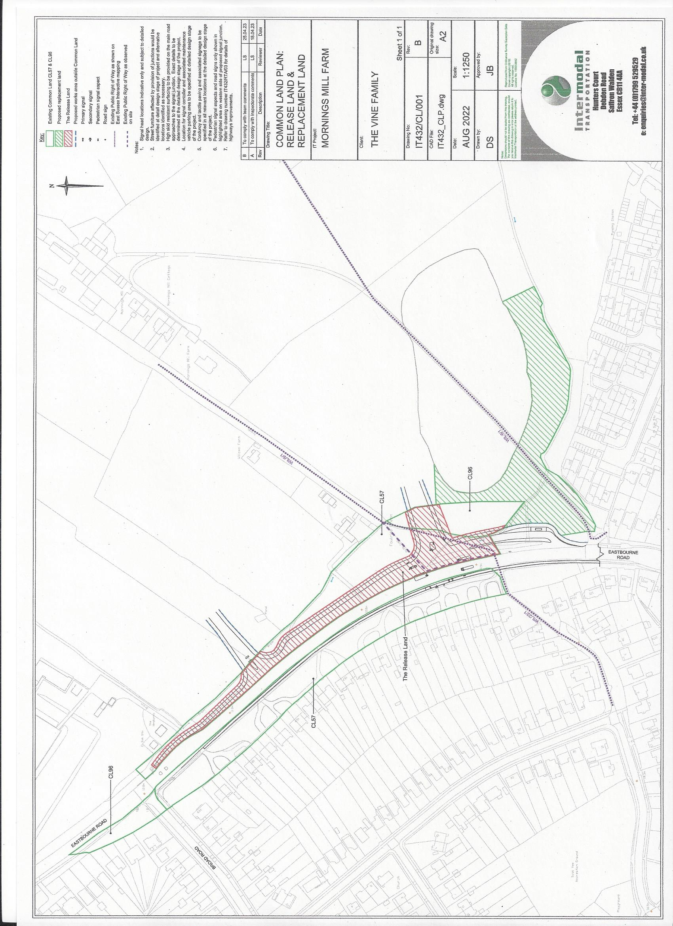

Drawing B – Proposed works (Not to scale)

