Aviation Safe Operating Environment Manual (ASOEM)
(For Non-MOD Aerodromes, Helicopter Landing Sites or when Recreational Flying is the Sole Activity at MOD Aerodromes)

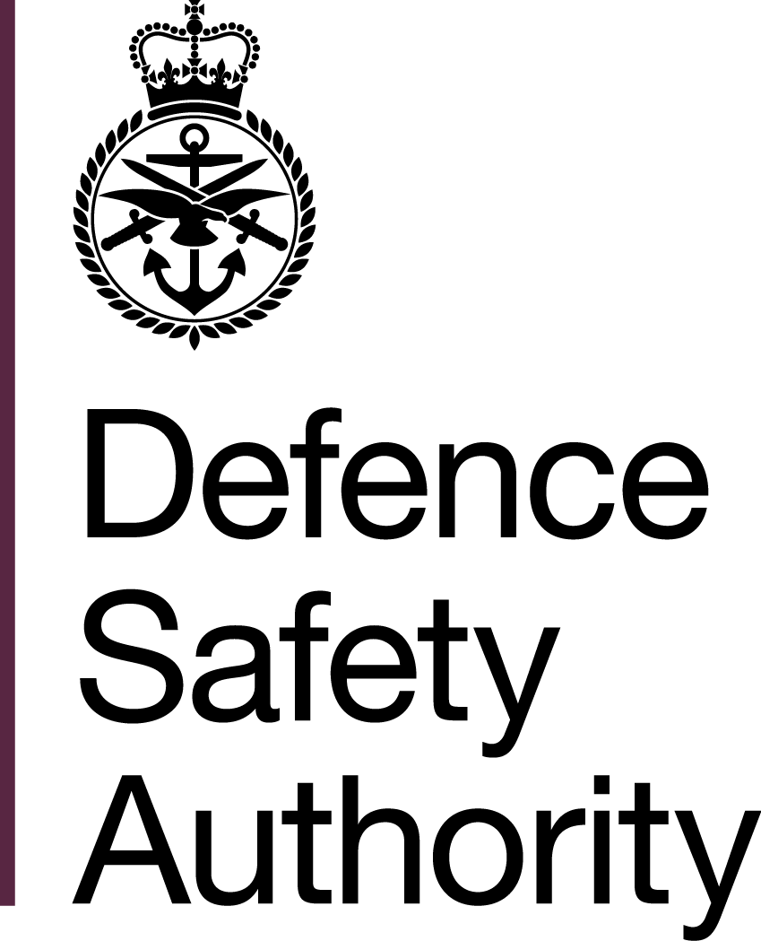

Military Aviation Authority

Notes for completion

- ►The Aviation Safe Operating Environment Manual (ASOEM) aims to provide Aviation Duty Holders (ADHs), Accountable Managers (Military Flying) (AM(MF)) and Heads of Establishment (HoEs) at relevant tiers of establishment, a tool to utilize in assessing that a Safe Operating Environment (SOE) is being provided. The ASOEM can be used by a HoE to provide Assurance of their Aerodrome (where appropriate) or for deployments to fixed bases or austere field sites. Where relevant and when appropriate, the ASOEM can be handed over to subsequent deployments.
- The ASOEM is a living document and will therefore be subject to regular review. Amendments may be developed and staffed with stakeholders, as required. Where existing documents, such as Flying Order Books (FOBs) or Flight Information Publications, cover the information required in the ASOEM, duplication of information is not required and a simple reference to the source document may be inserted.
- As the ASOEM template caters for a broad range of uses, not all sections will be relevant for every unit. Where this is the case, it may be explained in the corresponding section to evidence that it has been considered. Equally, additional sections and information may be inserted, where it is deemed to be relevant.◄
- Where concurrent or adjacent exercises / operations are being conducted from the same location full details of the event and the key points of contact need to be recorded in the ASOEM. If the event becomes complex with multiple platform types and different chains of command, then separate ASOEMs may be required.
- Administration Section. To include:
  - Location Data. Location data will include details of an appropriate senior Host Nation / Local ►or◄ Liaison Officer based at, or local to the location who can provide suitable liaison with key post holders and is suitably connected and knowledgeable to provide information on the location Hazards and facilities. A local area map ►that details the Aerodrome access points and any major routes in the vicinity of the Aerodrome can◄ be included ►◄. Organizational structure may identify any Duty Holder posts or Safety organizations that operate from within the ►establishment.◄ Where mixed Civilian - Military installations exist, a consultation structure may be established to foster coordination and to determine limits of responsibilities. Details of concurrent or adjacent exercises may be sought. The ASOEM may contain copies of all formal agreements between user and location.
  - Overseas Location. Details of the Defence Attaché within the British Embassy to the Host Nation may be recorded; especially in the crash plan and immediate contact list. Every effort ►is to◄ be made to communicate with other allied / national airspace users to deconflict air operations. Details of other local and foreign airspace activity may be sought from the Embassy and the Liaison Officer.
- Operations (Ops) Section. To include:
  - Aircraft Ops. Some of this data may be available in other publications and ►does not◄ therefore need ►to◄ be repeated in the template. However, it may be referenced, and details of the latest amendment date may be included.
  - Airfield / Helicopter Landing Site (HLS) / Field. ►Not all categories within this section may be applicable or suitable and where this is the case, they are to be annotated as such. However, whenever there is a concern relevant to a category, it is to be documented and, when relevant, the associated mitigations annotated.◄
  - Air Traffic Control. ►To assist in the safe conduct of operations, local ATC operating procedures and any specific airspace restrictions are to be referenced. The inclusion of information such as radio / transponder requirements and if the navigational aids are available and calibrated is to be considered.◄
  - Fire and Rescue Services. HLS, ►particularly those that are◄ temporary in nature, are unlikely to have Rescue or Firefighting Services. Consequently, ADHs, ►AM(MF)s or◄ HoEs may conduct a Risk Assessment and provide direction about the level of Rescue and Firefighting Services required. The Risk Assessment must be recorded and the decision on the appropriate level of Aerodrome Rescue and Fire Fighting (ARFF) cover documented in local orders. Where Fire and Rescue Services are available, the relevant Aircraft Hazard Data Sheets may be made available either electronically or in hard copy. The distribution of the data is to be confirmed and recorded in the ASOEM.
  - Medical. Details of medical facilities may be included along with plans if local medical services do not exist or are not considered suitable.
  - Meteorological (Met). Details of any Met services, if available, may be documented along with details of actions to be carried out in the event of adverse weather conditions, such as excessive heat, lightning or strong winds.
  - Post-Crash Management (PCM). ►When operating outside of the United Kingdom (UK) the contact details of the individual who will be acting as the UK National Representative, that has a valid Overseas Aircraft Post Crash Management Incident Officer (APCMIO) qualification, is to be annotated here. Typically, the Host Nation will provide PCM iaw North Atlantic Treaty Organization (NATO) Standardization Agreement (STANAG) 3531, and a reference to their local plan is to be clearly annotated. Where an external organization is not providing PCM a local PCM plan is to be created and as a minimum, include details on the process for deploying an Incident Officer and what PCM equipment may be required, for example, Aircraft jacks and bespoke lifting slings.◄
- Technical Section. To include:
  - Engineering, Services and Facilities. Local orders / agreements may be referenced here.
  - Petrols, Oils and Lubricants (POL). Arrangements for POL may be referenced here, along with details of Assurance processes to ensure ►that◄ they are of a suitable quality if any doubt exists. Other parts in this section may be covered by FOB / Standard Operating Procedures (SOP) and therefore referenced.
- Hazard Log Section. A Location Hazard Log may be maintained and ►is to◄ clearly indicate ►what the Hazard is and the implications it may cause, including how it will be mitigated.◄ To ensure that published Hazard logs remain standard, the format in the template is to be employed, however additional columns may be added if required.
- The ASOEM Template supports and must be read in conjunction with the following:
►RA 1010(6): Aviation Duty Holder / Accountable Manager (Military Flying) Safe Operating Environment Responsibilities◄
RA 1030 – Defence Aeronautical Information Management
►RA 1032 – Aviation Duty Holder-Facing Organizations and Accountable Manager (Military Flying)-facing Organizations – Roles and responsibilities◄
RA 1200 – Air Safety Management
RA 1400 – Flight Safety
RA 1410 – Occurrence Reporting and Management
RA 1430 – Aircraft Post Crash Management and Significant Occurrence Management
DSA02 DFSR – Defence Aerodrome Rescue and Fire Fighting (ARFF) Regulation
Manual of Air Safety (MAS)
Manual of ►Aircraft ◄ Post-Crash Management ►(MAPCM)
Aircraft Post Crash Management (APCM) Aide Memoire◄

Safe Operating MANUAL

For

(INSERT Exercise or Operation NAME or Location)

(Insert badge / logo here)

Compiled by (Name and Rank)
Role
Signature
Date
[Insert Air System] Delivery Duty Holder Approved
Signature
Date

Amendment No. | Amendment Date | Date of Incorporation | Name | Role | Signature
SECTION 1 – ADMIN

LOCATION DATA
Location
Address
Telephone / Fax
E-mail
Web Site
Airfield Liaison Officer
Address
Telephone / Fax
E-mail
Concurrent / Adjacent Exercises (full details below). | YES / NO
Formal Agreements
Operating Hours
Security
Organizational Structure
Remarks
Concerns / Issues

Concurrent / Adjacent Exercises (Ex) / OPERATIONS (Op)
Ex / Op Name
Ex / Op Officer Commanding
Location (Local)
Telephone / Fax
E-mail
Web Site
Ex / Op Liaison Officer
Location (Local)
Telephone / Fax
E-mail
Aircraft Number and Type
Personnel Numbers
Vehicle Total Numbers
Specialist Vehicles / Equipment
Formal Agreements
Operating Hours
Organizational Structure
Remarks

SECTION 2 - OPERATIONS

OVERSEAS LOCATIONS
British Embassy Contact Details
Point of Contact (POC)
Address
Telephone / Fax
Email
Adjacent British Military
POC
Address
Telephone / Fax
Email
Adjacent Foreign Military
POC
Address
Telephone
Fax
Customs and Immigration
Remarks
Concerns / Issues

AIRCRAFT OPERATIONS
Aeronautical Information Service / Flight Planning Office Hours and Contact Details
Arrangements for Allocating Aircraft Parking Positions
Arrangements for Initiating Engine Start
Electrical Ground Power
Flight Following Procedures
Foreign Object Damage Prevention and Orders
‘Follow-Me’ Orders
Marshalling Services
Passenger Handling
Noise Abatement Procedures
Overdue Action Procedures
Snow and Ice Plan
Taxi Plan
Temporary Obstructions Orders
Remarks
Concerns / Issues
AIRFIELD / HLS / FIELD
Airfield / HLS / Field Elevation
Airfield Obstacles
Approach Lighting
Armed Aircraft Safe Headings
Dispersal Dimensions
Dispersal Lighting
Dispersal Markings
Dispersal Surfaces
Hours of Operation and Contact Details
Identification Beacon
Obstruction Lighting
Runway / Hardened Landing Surface (Heli) Lighting
Runway / ►HLS◄ Markings
Runway / ►HLS◄ Surfaces
Taxiway Lighting
Taxiway Markings
Taxiway Surfaces
Remarks
Concerns / Issues

AIR TRAFFIC CONTROL
Availability and Contact Details
ATC Orders Applicable
Arrival and Departure Procedures
Comms Failure / Missed Approach Procedures
Bird / Wildlife Control Availability
Local Traffic Regulations
Local Airspace Restrictions
Low Visibility Operations
Noise Abatement and Special Procedures
Radio and Navigational Aids
Remarks
Concerns / Issues

RESCUE AND FIRE FIGHTING SERVICES
Availability and Contact Details
Crash Category
Capability for Removal of Disabled Aircraft
Fire Appliance / Rescue Equipment
Method of Raising Alarm
Number and Type of Fire and Rescue Vehicles
Aircraft Hazard Data Sheets Release
Remarks
Concerns / Issues

MEDICAL
Availability and Contact Details
Local Hospital / Med Centre Contact Details
Local Hospital / Med Centre Capability and Capacity
Method of Raising Alarm
Number and Type of Medical Response Vehicles
Remarks
Concerns / Issues

MET
Contact Details
Hours of Service
Information Available for Briefing or Consultation
Adverse Weather Orders
Remarks
Concerns / Issues

POST CRASH MANAGEMENT (PCM)
Airfield / Site / Deployment PCM Plan
Local PCM Organization
►Details of UK National Representative /◄ Incident Officers
PCM Equipment
PCM Table Top / Live Exercise Dates
Remarks
Concerns / Issues
SECTION 3 – TECHNICAL

ENGINEERING, SERVICES AND FACILITIES
Armoury / Explosive Storage Area Procedures
Cargo Handling Facilities
Dangerous Goods Handling Procedures
De-Icing Facilities
Ground Support Equipment
Hanger Space
Repair Facilities
Safety Equipment Section
Remarks
Concerns / Issues

POL
Availability and Contact Details
Assurance Procedures
Fuel / Oil / Hydraulic Types
Fuelling Capacity
Fuelling Safety Procedures
Fuel Spillage Procedures / Plan
Fuelling with Engines Running
Fuelling with Passengers on Board
Fuelling with Rotors Turning
Remarks
Concerns / Issues

HANDLING SERVICES & FACILITIES
Cargo Handling Facilities
Fuel / Oil / Hydraulic Types
Fuelling Facilities / Capacity
Oxygen
De-Icing Facilities
Starting Units
Hanger Space for visiting ►Aircraft◄
Repair Facilities for visiting ►Aircraft◄
Remarks

SECTION 4 - LOCATION HAZARD LOG

Nature of Hazard | Position of Hazard | Permanence of Hazard (Temporary / Permanent?) | How is the Hazard affected by season / light or time? | What mitigation has been employed, if any, to reduce its impact?

Intentionally Blank for Print Pagination

►Refer to RA 1010 - Head of Establishment Aviation Responsibilities and Aviation Duty Holder / Accountable Manager (Military Flying) Establishment Responsibilities.◄
Training material is to be in accordance with (iaw) NATO STANAG 3896 – Aerospace Emergency Rescue and Mishap Response Information (Emergency Services).
►Refer to NATO STANAG 3531 – Safety Investigation and Reporting of Accidents / Incidents involving Military Aircraft, Missiles and / or UAVs.◄

