

Reporting sexual offences
What you can expect during an investigation

October 2023
1
What and who is this booklet for?

If you have been sexually assaulted or raped it is important to
remember it is not your fault.
No matter who you are, how long ago the incident happened or what took place, the most important thing is that you get the help and support you need.
We recognise that the decision to report a crime is not an easy one to take, and it takes courage and can be difficult to talk to the Service Police.
This booklet explains:
- The support available to you
- What happens when you report a sexual offence
- The Service Police investigation process and what you can expect
- What happens at the end of an investigation
- Your rights, useful links and contacts

You don’t need to read this booklet all at once. Keep the booklet and come back to it as the investigation progresses.

2
Contents

Useful things to write down | 4
The investigation process | 5
Contacting the police to report a crime | 6
Victim Witness Care Unit (VWCU) | 7
Independent Sexual Violence Advisor (ISVA) | 8
What happens after your report to the police? | 9
Need help talking to Service Police? | 10
The Service Police investigation process | 12
What happens during your interview? | 13
Gathering Evidence and personal information | 14
What happens at the end of an investigation? | 15
Role of the Service Prosecuting Authority (SPA) | 16
What happens if a suspect is charged? | 17
What happens if no further action is taken? | 18
What happens at a plea hearing? | 19
What happens if my case goes to court? | 20
Will I be in court for the trial? | 21
Support available during the trial | 22
Rights to review and complain | 23
Other resources you can use | 24
How to give feedback or raise concerns | 25
Useful links | 26
Useful contacts | 27

Useful things to write down

You can write down the following information to ensure you
stay updated and get any support you need.

Name of Service Police
officer:
Email Address:
Phone number:

The Service Police will give your case a ‘Unique Reference Number’ (URN). This unique number helps officers search for your case in their files, so it’s useful to have if you call Service Police about your case.
Ask for your Unique Reference Number and write it here:
Unique Reference Number (URN):

Your central point of contact will be your own Victim Liaison Officer (VLO), who will tailor and co-ordinate support to help you through this process. Further details can be found on page 7.

Name of VLO:
Email Address:
Phone number:

4
The investigation process

Report made to Service Police
If ‘first response’ is needed:
Response Team officers check you’re safe and collect any forensic evidence. They may take you for a forensic medical examination.

Service Police investigation
- An investigator will meet with you to explain the process and what to expect.
- You will be assigned a VLO who will be available to support you as your case progresses through each stage of the Service Justice System.
- Evidence will be gathered by the Service Police. Everything will be assessed at the end of the investigation and a decision will be made on whether the case will be referred or not.

Main outcomes of a Service Police investigation
- Your case is referred to the Service Prosecuting Authority (SPA), who will decide if there is enough evidence to charge the suspect and take them to trial.
- Your case is referred to the suspect’s Commanding Officer who decide to either carry out a summary hearing if it is not a sexual offence, refer the case to the SPA or take alternative actions or no further actions (NFA).

Referred outcomes
- Defendant pleads guilty and an appropriate sentence will be decided.
- Defendant pleads not guilty. The case goes to trial and the defendant is found guilty or not guilty.

Outcome – No further action
- There can be several factors as to why cases are not referred. They may not meet the sufficient evidence threshold, such as no identifiable suspect or no evidence to support the allegation.
- If this is the case, then an Investigation Summary will be produced, with the proviso that if new information does come to light, the case can be reopened.
- You have the right to challenge the decision not to charge the suspect under the Victim Right to Review Scheme.

First contact with the Police
You can report a crime to the:
  - Civilian Police on 999 (emergency/ in danger) or 101 (non-emergency)
  - Service Police Crime Bureau – 02392 285 170 (180)
  - A local Service Police Station – full list on the Call it out hub
  - Confidential helpline: 0800 085 0658
During the call they will want to understand if you are hurt, in any danger and if they need to send a first responder to you. They may also flag available support and give you a ‘crime reference number’ (URN).

If the offence happened less than a week ago:
  - The Service Police may ask to collect forensic evidence to help prove what happened.
  - The Service Police may take you to a Sexual Assault Referral Centre (SARC), where a doctor can do a forensic medical examination (FME).
  - The officers will explain what evidence they would like to collect and why. You have the right to refuse consent for any part(s) and you have the right to get your belongings back.
There are many places that you, and any victims or witnesses of sexual offences can seek support, both within Defence and externally.
The VWCU is a single point of contact, independent of the Service Chain of Commands. They provide victims and witnesses with support and guidance as their case progresses through the Service Justice System.
If you are a victim or witness, you will be automatically referred to the VWCU when a crime has been reported to the Service Police.
You don’t have to be referred, if you are unsure on what to do or whether to make a complaint, the team can advise and explain the process to help you make an informed decision.

Victim Liaison Officer (VLO):
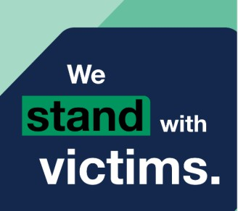
The VWCU will allocate you with a VLO, who will be your single point of contact and remain with you throughout the process. They will:
- Tailor and co-ordinate your support plan.
- Provide guidance and any services you need.
- Keep you updated on your case.
- Ensure your rights as a victim of sexual violence are met, as outlined in the Code of Practice on Services to be provided by the Armed Forces to the Victims of Crime.
Independent Sexual Violence Advisor (ISVA)

Once you have reported your investigating officer will offer you support from an ISVA or a Sexual Liaison Officer (SOLO).
They are specialist advisers, independent from the chain of command, for people who have experienced sexual violence.
You do not need to report to Service Police or help with the investigation to receive ISVA support. You can also change your mind about getting ISVA support at any time.

ISVAs can support you in lots of ways, they:
- Offer you health and wellbeing advice.
- Explain the criminal justice process and your rights within it.
- Support you to access housing or welfare services.
- Become your single point of contact and reach out to the Service Police and other services on your behalf.
- Discuss and support you in accessing any ‘special measures’ throughout the process.
- Support you to raise any concerns you have about the Service Police investigation.
What happens after you report to Service Police?


A Service Police officer from the investigation team will contact you within a day of reporting, often by phone call. They will offer you the chance to meet them in person at your home, or in a safe and private place.
They will talk you through the next steps and will:
    - Ask some ‘risk assessment’ questions to check you are safe. If you are they will carry out a needs assessment.
    - Give information on how to access support services. Refer you to the VWCU and ask if you would like an ISVA or SOLO support officer.
    - Ask some questions to understand what happened, especially if you didn’t have an initial visit from the response team.
    - Create a communication plan on how and when you’d like to be contacted. This is very important, please make sure you have one. If you have a VLO, ISVA or SOLO they should have some input as well.
    - Check that you’re still happy with the communication plan each time they contact you. Your preferences can be updated at any time.
It is important that you feel comfortable with us
Tell us if there’s something that would make you feel more comfortable, and we will try our best to support this. For example, speaking to non-uniformed officers or officers of a particular gender.
We understand it can be difficult to talk about sexual abuse, especially, to the Service Police. Your VLO is there to support you and can help or arrange to have someone with you. There are many people who are able to help you:

A Person of your Choice
It can be helpful to have someone present that you can trust. You have the right to be supported by a person of your choice when reporting to Service Police and during the interview, unless we do not think it is in your best interests or if they are witnesses in the investigation.
Your supporter cannot speak for you or get involved in the questioning, but they can be a friendly face and ask for a break or other practical help, e.g. a drink.

Intermediary


A communication support worker can help you understand the questions that are being asked. They can arrange for the best way to communicate with you and help you in the Service Police interview and in court.
If you are aged under 18 or struggle to communicate due to a disability or mental health issue, ask your Service Police officer for an intermediary.

Interpreter
If you do not feel confident or comfortable speaking English, you can ask for an interpreter to translate between English and your chosen language (including sign language) when you are speaking to the Service Police.
You also have the right to get important documents about the interview or court translated into your chosen language.
Examples of documents that can be translated include:
    - Written acknowledgement of the reported crime.
    - Any documents that you will be asked about in the interview or at court.
    - Letters about the time, date, location of the trial, the outcome of your case, and the reasons for the decision.
    - Responses to any complaints or requests for
your case to be reviewed.
Ask your Service Police officer or your VLO for an interpreter and translated documents if you feel you need the help.

Following your contact with the investigation team, the investigation process will start. Throughout the process you will receive regular updates, and you will be able to choose the preference and frequency of how you would like to be contacted.
They will interview you, usually by video, to capture your description of what happened in detail, this is called your statement of complaint or witness statement.

Depending on the circumstances the investigator may need to gather evidence from you, such as forensic evidence, medical records, photographs, or digital evidence. They will explain why and ask for your consent. You have a right to refuse any part(s).
If you have identified a suspect(s), then we will invite them for interview to capture their account of events, any comments on the allegations and relevant evidence. Depending on the nature of the allegation, in some cases we may arrest the suspect and hold them in custody, this is called ‘Custody Pre- Charge’.

Accounts of any witnesses they find, or you or the suspect(s) have mentioned, will be captured. If the suspect contacts you or other witnesses in the case, it’s important that you tell us.

Specially trained officers may conduct an interview to gather your description of what happened.
This can be a difficult process as you will be talking in detail about the sexual offence. It’s important to have someone to support you nearby, a friend, family member or your VLO, ISVA can sit outside the interview room.
Some questions may feel very direct, embarrassing, or silly. This is because the Service Police have to follow certain rules when they ask what happened, and they need to be clear about some details that might not feel important to you.
The interview will be video recorded as it can be played in court if the case goes to trial. This can assist you to provide your best evidence. If you do not wish to be recorded, consideration can be given to having your account written.
To help you feel comfortable, you have the right to request an officer that is a gender of your choice.
The interview process can bring up some new memories. If you remember these after the interview, just write them down and send them to your Service Police officer.
Gathering digital evidence and personal information


Service Police may ask for your personal electronic devices or access to other digital evidence, such as your social media accounts. They can also ask to see records from your doctor or social services (this is called ‘third-party material’).

When the Service Police officer asks for your private information, they must ask for your consent and tell you why it’s important for the case. You have the right to refuse and have any belongings back.
You will receive a form from the Service Police officer
explaining:
- What private information they want (e.g., your phone or doctor’s records), how it’s relevant and strictly necessary, and how it will be limited (e.g., by timeframe or type of data).
- How your information will be downloaded and stored.
- Who will be able to see your information and may include when it will be deleted.
- Who they might share your private information with (e.g., prosecution lawyers, the suspect, the suspect’s lawyers, the courts).
What happens at the end of an investigation?

The Service Police will assess all the evidence collected throughout the investigation from all involved, including any witnesses.
A decision will be made on whether the case will be referred or not.
What are the main outcomes?


  - Your case is referred to the Service Prosecuting Agency (SPA), who will decide if there is enough evidence to charge the suspect and take them to trial.
  - Your case is referred to the suspect’s Commanding Officer who decide to either carry out a summary hearing if no sexual offence is being referred, refer the case to the SPA or take alternative actions or no further actions.
  - No further action (NFA) may be taken. If this is the case, then an Investigation Summary will be produced, with the proviso that if new information does come to light, the case can be reopened. You have the right to challenge the decision not to charge the suspect under the Victim Right to Review Scheme.
Role of the Service Prosecuting Authority
The Service Prosecuting Authority (SPA) is an independent chain of command responsible for the prosecution of criminal offences in the Service Courts.
The SPA also have a dedicated sexual offence and domestic abuse team whose lawyers are specially trained to deal with these types of offences.

What do the SPA do?
If your case is referred to SPA, they will review the case and decide if a suspect should be taken to court (this is called ‘charging’).
The SPA are guided by the decision-making rules applied by the Crown Prosecution Service (CPS).

What is their approach to victims and measures?
The SPA recognise that leading up to and during a
court case is an unfamiliar and challenging process.
Whatever the nature of the offence might be, you can expect that the SPA’s approach to be one of care and sensitivity.
They also have many measures to make it easier and ensure you have any support you need.
If the SPA decides to take the case to court, they will ‘charge’ the suspect with an offence(s), who then becomes a defendant.

An application can be made for post-charge custody until the court hearing. This decision sits with the Judge Advocate.

The defendant will then go to a court and declare if they are
guilty or not guilty. This is called a ‘plea hearing’.

There may also be several other hearings (meetings) in court about the case that will involve technical matters or deciding dates for next steps in the procedure. You will not be in court for any of these hearings.

Below is a diagram setting out what happens to a defendant during a court process:
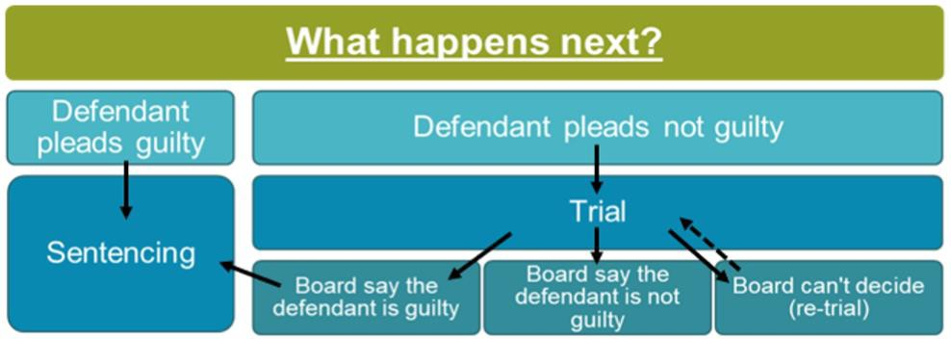

If either the Service Police or the SPA decide to take ‘no further action’ against the suspect, this means they will not be taken to court or ‘charged’.
There can be several factors as to why a cases are not referred. They do not meet the sufficient evidence threshold; no suspect was identified; or there was no evidence present to support the allegation.
A letter will be sent to explain why the decision was made. An Investigation Summary will be produced, with the
proviso that if new information does come to light, the case

can be reopened.
You have a right to challenge the decision under the Victim Right to Review (VRR). Your VLO, ISVA or other support officers can help you challenge decisions.
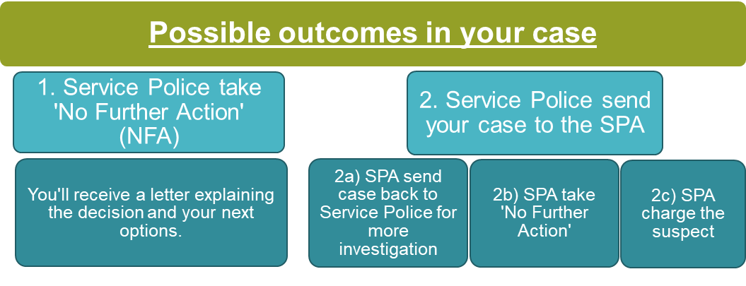

Below is a diagram setting out the possible outcomes for your case:

In a plea hearing the defendant will declare if they are guilty or not guilty.

If the defendant pleads guilty:


The suspect will be sentenced. This may take place at a later date at a sentencing hearing.
During the sentencing hearing you can read a Victim Personal Statement (VPS). A VPS tells the court about how the sexual abuse made you feel and how it has affected you.
Anything you write in the VPS can feature in any news reports about your case (you won’t be named).

If the defendant pleads not guilty
Your case will be taken to court where a trial will take place to determine if the defendant is guilty or not.
Throughout the trial you will receive support from your VLO who can explain any processes or services to you. You can also receive support from your ISVA or SOLO, if you would like.

When will I get a date?
It might take months from the moment the defendant pleads not guilty to the trial taking place.

While you wait for the trial, the VLO, ISVA, SOLO or VWCU will update you if there are any changes.
It can be common for the trial or hearing date to be rescheduled, and on some occasions delayed on the day of the trial.
This can happen if the defendant pleads guilty on the morning of the trial. This can cause delay, or the Court can decide to proceed to the Sentencing Hearing dependant on the charge(s).

Will I need to attend?
If you need to attend court to give evidence your VLO or Prosecution Team (SPA) will explain the process, what you are entitled to and what to expect ahead of time.

If you need to attend court to give evidence for the trial your VLO, Prosecution team (SPA), or ISVA will explain the process, what you are entitled to, support available and what to expect ahead of time.
Prior to attending court
You will have the opportunity to be shown around the court to familiarise yourself with the layout.
You can also arrange to use an alternative court entrance if you are worried about seeing the defendant when you arrive at court for the trial.
Your support officer can also help organise any travel or accommodation if required.

On the day you need to attend court
You will be met by a member of the Prosecution Team or your VLO who will show you to a Witness Room.
You can wait here until you are called to the stand, and you will have time to read through your statement before you give evidence.
When you are on the stand, the suspect's lawyer may also ask you questions to challenge your account, unless this took place earlier as a recorded session.
If any special measures were agreed to enhance your ability to give evidence or make you more comfortable in court, these will be set up in advance for you.

You are entitled to support at the trial. Your VLO, Prosecution Team (SPA), or ISVA will explain and provide any support, information or updates you want throughout the trail – your safety and wellbeing is their greatest priority.
They will also ensure any agreed special measures are in place ahead of the trial to help you give your best evidence in court and help relieve any stress associated.

What type of support can you access?
- Help and support on the day:
  - Family members and friends
  - Your VLO
  - Your chosen IVSA or SOLO
  - Representatives from the VWCU or SPA
- Special measures such as:
  - Privacy screens
  - Giving evidence in private
  - Attending via video or TV link
  - The removal of wigs and gowns
  - Video-recorded statements

JSP 839 – Victims Code outlines the Victims Code of Practice and your rights to review and/or complain if you want to raise concerns, review decisions made or are unhappy with the actions of your service providers (such as the Service Police, Service Prosecuting Authorities or Military Court Services).

The Code states that you are entitled to:
- Be treated with respect, dignity, sensitivity, and compassion.
- Be protected from re-victimisation, intimidation, and retaliation.
- Have your privacy respected.
- Help to understand and engage with the service justice process without discrimination.

Examples of what you can ask to review or complain about
- Service providers have failed to inform you or provide you with your entitlements.
- Decisions made by the Service Police, CO or the SPA, in respect of the suspect.
- Concerns about your Service Police officer.
- If you are unhappy with, or been adversely affected by, the actions of members of the Service Police.

Use a ‘civil order’ to stop the suspect
contacting you
If the suspect tries to contact or harass you, then you and the Service Police may be able to apply for a ‘civil order’.

There are lots of different types of civil order, but most try to stop the suspect from contacting you. You can find out more on the CPS website. Your SOLO, ISVA or support worker may also be able to help.

Apply for compensation
You may be able to get compensation from the Government using the Criminal Injuries Compensation Scheme (or CICS) and is free to apply. There are some useful videos about getting compensation on the Victim Support website.

You can choose a friend or family member to make an application for you. You may also be able to get advice and support from your ISVA or support worker.

How to give feedback or raise concerns

You can give anonymous feedback
Take the Service Police victim of crime feedback survey.
This helps improve the service provided and understand what is going well.

Contact your Service Police officer
If you have any concerns about your case or how it’s being investigated – you can email or phone using the contact details provided to you by your Service Police officer.
Your VLO, ISVA or other supporter officers can help you do this.

Raise concerns about your Service Police officer or make a formal complaint
Email the Defence Serious Crime Command Professional Standards Department. Your VLO, ISVA or other supporter officers can help you make a complaint.

Policy
- Victims code of practice
- JSP 839: Victims’ Services
- Service Police Complaints System

Guides
- Victims Support’s information portal
- Service Prosecuting Authority (SPA) guide
- Guide to the Military Court Service
- From Report to Court Handbook
- Women’s Aid Survivor’s Handbook
- Grounding exercises

Main points of contact
- The Victim Witness Care Unit
- National Helplines: Sexual violence
- National Support: Domestic violence

A full list of support and advice channels can be found on the Defence call it out hub, or below you can find a selection of internal and external support and advice for all personnel, military or civilian personnel.

Internal advice and support channels

All personnel
- Defence Victim Witness Care Unit
- Defence Call it out hub

Military personnel
- Royal Navy Family and Personnel Support (RN FPS): Phone: 0800 145 6088 / 02392 728 777 / 9380 287 77
Email: navynps-peoplesptrnfpsptl@mod.gov.uk
- Army Welfare Service: Phone: 01904 882 053 / 94777 30
53 Email: C-AWS-IAT-0Mailbox@mod.gov.uk
- Royal Air Force Welfare: Details are provided locally via the Unit Personal Support (PS) staff.
- Forces Helpline: a free and confidential helpline for serving personnel, veterans, and their families. Phone: 0800 260 6767

Civilian personnel
- The Employees Assistance Programme (EAP)
- Trade Unions: Civilians who are members of a Trade Union can call their National Trade Union Helpline

External advice and support channels

All personnel
- Citizen’s Advice (www) can offer general support on 0800 144 8848 (England) or 0800 702 2020 (Wales)
- The Samaritans (www) can offer general emotional support on 116 123 or jo@samaritans.org
For those affected by sexual or domestic violence:
- Victim Support (www) or call: 0808 168 9111, in Scotland call 0300
3321000 or for Northern Ireland call 0289 0243133.
- Women’s Aid(www) or call: 0808 200 0247.
- Survivors UK (www) or call: 0203 5983 898 / email: help@survivorsuk.org.
- Rape Crisis (www) or call: 0808 802 9999.
- Local Sexual Assault Referral Centre (www).
- Male survivors’ partnership (www) or call: 0808 800 5005.
- Aurouria New Dawn (www) or call: 023 92 479254.

For those affected by or dealing with domestic abuse:
- National Centre for Domestic Violence (www) or call: 0800 970
2070.
- The Men’s Advice Line (www) or call: 0808 8010327.
- Respect(www) or call: 0203 5596 650 / email: info@respect.uk.net)
- Help at Hand (www) for under-18s in care, those leaving care or living away from home can call 0800 528 073 or
email: help.team@childrenscommissioner.gov.uk
- ACAS: a free service providing advice on workplace rights, rules and best practice. Call on 0300 123 1100 or visit www.acas.org.uk

External advice and support channels

Military
- The Soldiers, Sailors, Airmen, and Families Association (SSAFA - The Armed Forces Charity) (www)
- Combat Stress (www) for former service personnel
needing support with mental health - Veterans: Tel - 0800 138 1619, Serving personnel - 0800 323 444, or you can text 07537 404719 or email: helpline@combatstress.org.uk
- Veterans' Gateway for information, advice and support for veterans and their families or call 0808 802 1212
- Naval Families Federation / Army Families Federation / RAF Families Federation
- The Royal British Legion: Tel - 0808 802 8080 or Web -
www.britishlegion.org.uk.
- The RAF Benevolent Fund / RAF Association

Civilian personnel
- Civilians can contact ACAS (www) or call on 0300 123 1100
- Civil Servants can contact The Charity for Civil Servants (www) or call on 0800 056 2424

