NOTICE OF ORDER

Highways Act 1980

Norfolk County Council (Field Dalling Footpath No. 8) Diversion Order 2021

Notice is hereby given that the above referenced Orders have been submitted to the Secretary of State for Environment, Food and Rural Affairs for determination. An Inspector will be appointed by the Secretary of State to determine the Orders.

The start date for the above Order is 17 October 2023.

Consideration of the Order will take the form of exchanges of statements of case and comments on statements of case.

The effect of the Order, if confirmed without modifications, will divert the full width of the path starting at grid reference TG 0360 3999 and running in a generally easterly and then east south-easterly direction for approximately 89 metres to grid reference TG 0369 3998 to a line running from grid reference TG 0360 4000 in a generally easterly and then a generally south south-easterly direction for approximately 104 metres to grid reference TG 0369 3998 as shown on the Order Map. The new path will have a width of 2 metres.

Any queries relating to this Orders should be referred to Phil Wilton at The Planning Inspectorate, Rights of Way Section, Room 3/A Eagle Wing, Temple Quay House, 2 The Square, Temple Quay, Bristol, BS1 6PN. Telephone: 0303 444 5228. Email: Philip.Wilton@planninginspectorate.gov.uk. Please quote reference number ROW/3304518 on all correspondence.

Any person wishing to view the statements of case and other documents relating to these Orders may do so by appointment at County Hall, Martineau Lane, Norwich, and at the offices of North Norfolk District Council, Council Offices, Holt Road, Cromer, NR27 9EN during normal office hours or purchased at a cost of £5.00 from the undersigned or available electronically free of charge from legalordersandregisters@norfolk.gov.uk .
Timetable for sending in statements of case and comments Within 2 weeks of the start date [31 October 2023]
The Order Making Authority must ensure their statement of case is received by the
Secretary of State. As soon as possible after the deadline, the Secretary of State will send a copy (excluding copies of any supporting documents - these will be available to view at the Authority’s offices) to everyone who has made an objection or representation, the applicant and any other person who has written to us in respect of the Order.
Within 8 weeks of the start date [12 December 2023]
Everyone who has made an objection or representation or any other written representation must ensure their statement of case is received by the Secretary of State. As soon as possible after the deadline, the Secretary of State will send full copies to the Authority. Copies (excluding copies of any supporting documents - these will be available to view at the Authority’s offices) will also be sent to the applicant, every person who has made an objection or representation and any other person who has written to us in respect of the Order.

Within the same period the applicant (if applicable) must ensure their statement of case is received by the Secretary of State. As soon as possible after the deadline, Secretary of State will send a full copy to the Authority. Copies will also be sent to everyone who has made an objection or representation and any other person who has written to us in respect of the Order (excluding copies of any supporting documents - these will be available to view at the Authority’s offices).

Within 14 weeks of the start date [23 January 2024]
Everyone who has made an objection or representation, the Authority, the applicant (if applicable) and anyone who has written to us in respect of the Order must ensure that their comments on any or every other statement of case is received by the Secretary of State. As soon as possible after the deadline, the Secretary of State will send copies of these comments to everyone else.

Any other person wishing to make representations in writing to the Secretary of State in respect of the above Order must do so in line with the timetable set out above.

In fairness to the other parties everyone should keep to the timetable to ensure that statements of case and comments are received on time. Late documents will be returned.

We cannot accept any libellous, racist or abusive comments. Any documents containing such comments will be returned.

Notice of order for w/r
PUBLIC PATH DIVERSION ORDER HIGHWAYS ACT 1980

NORFOLK COUNTY COUNCIL
(FIELD DALLING FOOTPATH NO. B(PART)) DIVERSION ORDER 2021

This order is made by Norfolk County Council ("the authority") under section 119 of the Highways Act 1980 ("the 1980 Act") because it appears to the authority that in the interests of the owner of the land crossed by the footpath described in paragraph 1 of this order it is expedient that the line of the path should be diverted.

Field Dalling Parish Council and North Norfolk District Council have been consulted as required by section 120(2) of the 1980 Act.

BY THIS ORDER:

- The public right of way over the land situate at Field Dalling and shown by a bold continuous line on the map contained in this order and described in Part 1 of the Schedule to this order shall be stopped up with effect from the date on which Norfolk County Council certifies that the work to bring the new route of the footpath as described in paragraph 2 of this order in to a fit condition for use by the public has been carried out. Certification shall not take place prior to the creation of the new route as described in paragraph 2 below.

- There shall at the end of 9 weeks from the date of confirmation of this order be a public footpath over the land situate at Field Dalling and described in Part 2 of the Schedule and shown by a bold broken line on the map contained in this order.

- Where immediately before the date on which the highway is diverted in pursuance of this Order there is apparatus on, under or over that highway belonging to statutory undertakers for the purpose of carrying on their undertaking, the undertakers shall continue to have the same rights in respect of the apparatus as then then had.

SCHEDULE

PART 1

DESCRIPTION OF SITE OF EXISTING PATH OR WAY

Footpath No. 8 (Part) The full width of the path starting at grid reference TG 0360 3999 (point A on the map contained in this order) and running in a generally easterly and then east south-easterly direction for approximately 89 metres to grid reference TG 0369 3998 (point C on the map contained in this order).

PART2

DESCRIPTION OF SITE OF NEW PATH OR WAY

Footpath No. 8 (Part) Starts at grid reference TG 0360 4000 (point B on the map contained in this order) and runs in a generally easterly and then a generally south south-easterly direction for approximately 104 metres to grid reference TG 0369 3998 (point C on the map contained in this order). The width of the path is 2 metres.

PART3

LIMITATIONS AND CONDITIONS

No limitations or conditions

11

Dated this 15 dayof S' ioe.r

THE COMMON SEAL of the NORFOLK COUNTY COUNCIL
was hereunto affixed in the presence of:-
2021.

Director of Governance
Authorised to sign on behalf of lhe Director of Governance Norfolk County Council
••.. •••••••U•••o•....••••••.. •••••V.{u,,,,,,,
Date..1?......./.....9......./....,.. \
:'.) c;-:r '',//

11.
•• -- -
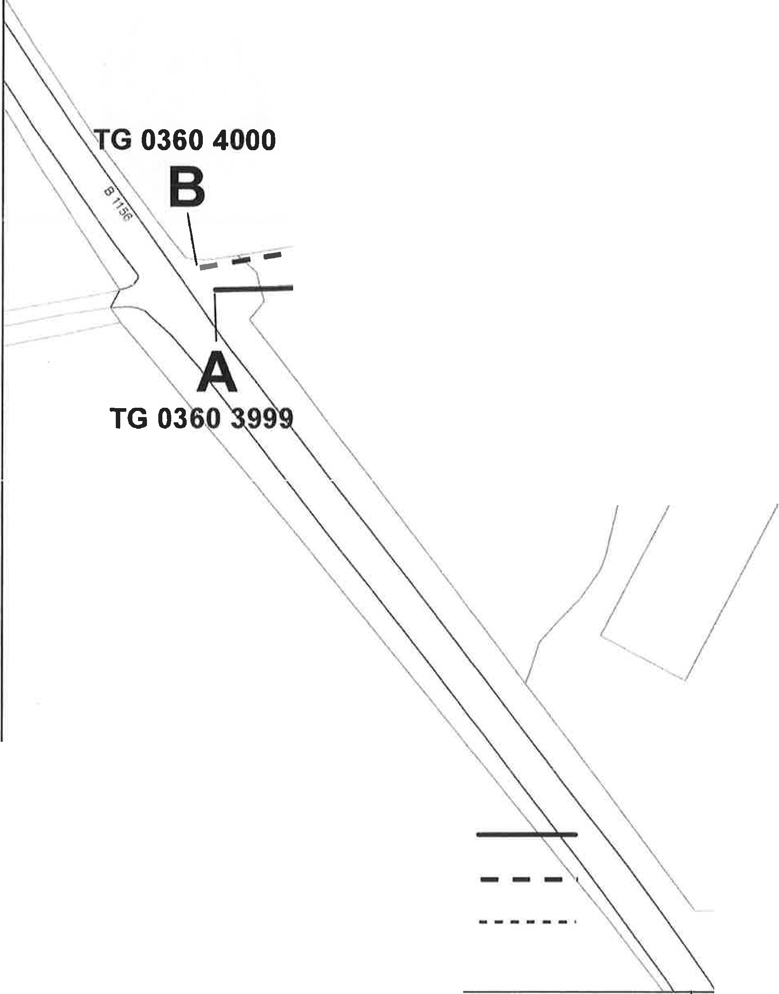
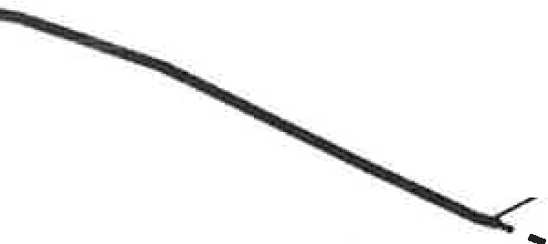

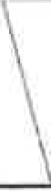
-.• -... -- -----'
\
1& 0369 3998
\
\ ..C..
..... ... ... ... ...
,//"-'\ !1
Well Ip House '-

Workings (dis)

Current route to be diverted (A to C) New route to be created (B to C)
Unaffected footpath
© Crown copyright and database rights 2011 Ordnance Survey 100019340
Norfolk Couny Council (Field Dailing Footpath No. 8 (Part)) Diversion Order 2021  603,643.6436 339,981.0607 | Date created: 25/08/2021  Scale:  1:750 | N  A
0

