NOTICE OF ORDER
Highways Act 1980 - Section 119
Bedford Borough Council
Bedford Borough Council (Carlton & Chellington: Part of Bridleway No.
12) Public Path Diversion Order 2022
Notice is hereby given that the above referenced Order has been submitted to the Secretary of State for Environment, Food and Rural Affairs for determination. An Inspector will be appointed by the Secretary of State to determine the Order.
The start date for the above Order is 10 November 2023.
Consideration of the Order will take the form of exchanges of statements of case and comments on statements of case.
The effect of the Order, if confirmed without modifications, will divert that length of Public Bridleway number 12 Carlton and Chellington running from a point where it has a junction with the north-western margin of Borough Road C28 "Turvey Road, Carlton" at Ordnance Survey Grid Reference (OSGR) SP 9442/5479 shown as Point A on the Order map then running a generally north-westerly and westerly direction for 234 metres to a point where it has a junction with that part of Public Bridleway number 12 Carlton and Chellington unaffected by this Order at OSGR SP 9419/5481 shown as Point B on the Order map to a line running from a point where it has a junction with the western margin of Borough Road C28 "Turvey Road, Carlton" at OSGR SP 9438/5475 shown as Point C on the Order map then running a generally west-north-westerly, westerly and northerly direction for 225 metres to a point where it has a junction with that part of Public Bridleway number 12 Carlton and Chellington unaffected by this Order at OSGR SP 9419/5481 shown as Point B on the Order map.
Any queries relating to this Order should be referred to Ian Aston by email: ian.aston@planninginspectorate.gov.uk quoting reference number ROW/3318247 on all correspondence. Alternatively, queries may be sent in writing to The Planning Inspectorate, Rights of Way Section, Room 3/A Eagle Wing, Temple Quay House, 2 The Square, Temple Quay, Bristol, BS1 6PN. Telephone: 0303 444 5670.
Any person wishing to view the statements of case and other documents relating to this Order may do so by appointment at Bedford Borough Council, Main Reception Desk, Borough Hall, Cauldwell Street, Bedford MK42 9AP. Appointments can be arranged between the hours of 10.00am and 3.00pm on weekdays (Bank and Public Holidays excepted). Please contact April Quinn Tel: 01234 276791 or email: April.quinn@bedford.gov.uk.
Timetable for sending in statements of case and comments

Within 2 weeks of the start date [by 24 November 2023]
The Order Making Authority must ensure their statement of case is received by the Secretary of State. As soon as possible after the deadline, the Secretary of State will send a copy (excluding copies of any supporting documents - these will be available to view at the Authority’s offices) to everyone who has made an objection or representation, the applicant and any other person who has written to us in respect of the Order.

Within 8 weeks of the start date [by 05 January 2024]
Everyone who has made an objection or representation or any other written representation or any other person wishing to make representations in writing must ensure their statement of case is received by the Secretary of State. As soon as possible after the deadline, the Secretary of State will send full copies to the Authority. Copies (excluding copies of any supporting documents - these will be available to view at the Authority’s offices) will also be sent to the applicant, every person who has made an objection or representation and any other person who has written to us in respect of the Order.
Within the same period the applicant (if applicable) must ensure their statement of case is received by the Secretary of State. As soon as possible after the deadline, Secretary of State will send a full copy to the Authority. Copies will also be sent to everyone who has made an objection or representation and any other person who has written to us in respect of the Order (excluding copies of any supporting documents these will be available to view at the Authority’s offices).

Within 14 weeks of the start date [by 16 February 2024]
Everyone who has made an objection or representation, the Authority, the applicant (if applicable) and anyone who has written to us in respect of the Order must ensure that their comments on any or every other statement of case is received by the Secretary of State. As soon as possible after the deadline, the Secretary of State will send copies of these comments to everyone else.
In fairness to the other parties everyone should keep to the timetable to ensure that statements of case and comments are received on time. Late documents will be returned.
We cannot accept any inflammatory, discriminatory or abusive comments. Any documents containing such comments will be returned.
Notice of order for w/r
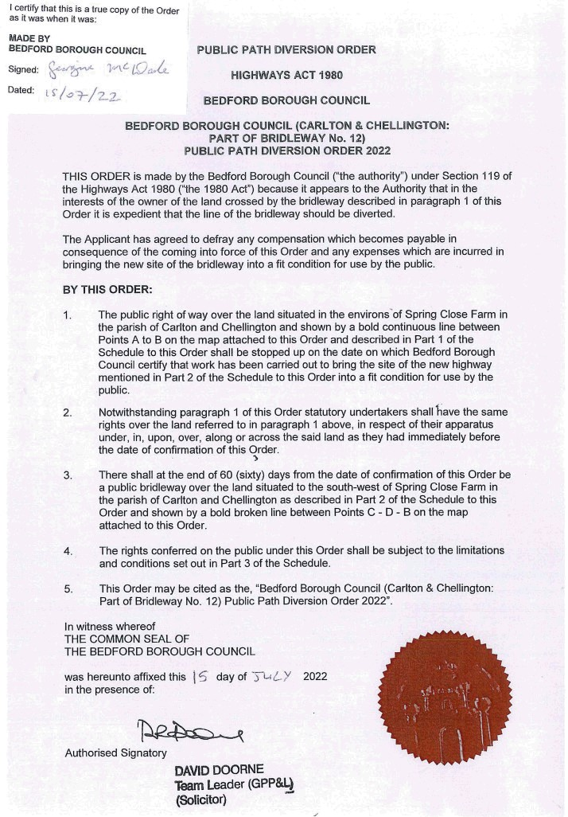
Bedford Borough Council – Submission to Secretary of State Documents Required by Planning Inspectorate


