Order Decisions
Site visit made on 17 August 2023
by J Ingram LLB (Hons) MIPROW
An Inspector appointed by the Secretary of State for Environment, Food and Rural Affairs
Decision date: 3 November 2023

Order A: ROW/3291105
- This Order is made under Section 257 of the Town and Country Planning Act 1990 and section 53A(2) of the Wildlife and Countryside Act 1981. It is known as The Bournemouth, Christchurch and Poole Council Public Footpath B20 – Winter Gardens, Bournemouth Diversion Order 2021.

- The Order is dated 26 January 2021 and proposes to divert part of the public right of way. The Order would modify the Definitive Map and Statement accordingly. Full details are shown on the Order plan and described in the Order Schedule.

- There was one objection outstanding when The Bournemouth, Christchurch and Poole Council submitted the Order to the Secretary of State for Environment, Food and Rural Affairs for confirmation.

Summary of Decision: The Order is confirmed.

Order B: ROW/3291107
- This Order is made under Section 257 of the Town and Country Planning Act 1990 and section 53A(2) of the Wildlife and Countryside Act 1981. It is known as The Bournemouth, Christchurch and Poole Council Public Footpath B20 – Winter Gardens, Bournemouth Diversion Order (2) 2021.

- The Order is dated 28 September 2021 and proposes to divert part of the public right of way. The Order would modify the Definitive Map and Statement accordingly. Full details are shown on the Order plan and described in the Order Schedule.

- There was one objection outstanding when The Bournemouth, Christchurch and Poole Council submitted the Order to the Secretary of State for Environment, Food and Rural Affairs for confirmation.

Summary of Decision: The Order is not confirmed.

Procedural Matters
- Both Orders relate to the proposed diversion of part of a public footpath in the area known as Winter Gardens in Bournemouth. The Bournemouth, Christchurch and Poole Council, the order-making authority (the OMA) made Order A, which received one objection. In order to expedite a solution, the OMA made a second alternative Order with a revised diversion route (“Order B”). However, Order B also received one objection therefore the OMA submitted both Orders for consideration.

Main Issues
- Section 257(1) of the Town and Country Planning Act 1990 (the 1990 Act) provides for an Order to be made authorising the diversion (or stopping up) of a footpath if it is necessary to do so in order to enable development to be carried out in accordance with planning permission already granted under Part III of the same Act. In this case the Orders seek to stop up approximately 55 metres of footpath B20 which currently partly crosses the Winter Gardens car park. The Orders propose two alternative diversion routes.
- In considering whether or not to confirm an Order, the disadvantages or loss likely to arise as a result of the stopping up or diversion of the way to members of the public generally or to persons whose properties adjoin or are near the existing highway should be weighed against the advantages of the proposed order.
- In short there are two issues that must be considered here. These legal tests, as outlined above, have been described by the Courts as “the necessity test” and “the merits test”. Confirmation of an Order requires that both are satisfied.
- In addition, in reaching my conclusions I have considered the requirements of the Equality Act 2010 where appropriate.

Reasons

Order A

Background
- Outline planning permission (7-2017-1273-AY) was granted on 28 March 2019 for the demolition of existing buildings and construction of a mixed use scheme including 352 residential apartments, leisure, convenience retail, restaurant/café, mixed use restaurant/bar, offices, associated servicing and loading areas, 225 public car parking spaces, 369 private car parking spaces, public open space, public realm enhancements and associated engineering works.
- A further planning permission (7-2020-1273-BB) was granted on 17 September 2020 which modified aspects of the previous permitted layout.

Whether the diversion of the path is necessary to allow development to be carried out in accordance with planning permission
- I am satisfied that the relevant planning permissions are extant and directly relate to the land crossed by the Order route.
- The planning permission permits the remodelling of the existing Winter Gardens car park and surrounding area to allow for the construction of the mixed use scheme. Features including a replacement electrical sub-station and switch room, and a wall with railings would obstruct the public footpath. The footpath would also diagonally cross the proposed private vehicular access. Due to the permitted physical obstruction, the diversion order is necessary to allow development to be carried out in accordance with the planning permission.

Disadvantages of the proposed Order
- The Open Spaces Society (“the OSS”) objects to Order A on the basis that the proposed diversion crosses the entrance/exit road to the development, without any safety measures for pedestrians. Further safety concerns are raised regarding pedestrians traversing a turning area. The OSS believes the route does not need to cross two vehicular roads, an alternative diversion route where there is only one road to cross would be a safer solution in their opinion. The OSS state that the proposed diversion is far less commodious to the footpath users.
- Whilst I acknowledge that it is not best practice having the diverted route crossing the access roads, as the footpath runs east to west across the whole site, it appears unavoidable in this case. It is noted that tactile paving and contrasting surface material would be provided at the crossing points to improve the safety of pedestrians. The existing route, which crosses the Winter Gardens car park, although marked on the ground with faint painted lines, has no formal crossing points.
- The second access road serves block D on the west side of the development. This is a residential/office block, the building car park has 13 spaces. It is unlikely that there will be a high number of vehicles entering/exiting the car park on this access road. I agree with the Road Safety Appraisal provided by the OMA that both pedestrian crossings on the proposed route are relatively short, this would be safer for pedestrians than one longer crossing.
- The area to the south east of the proposed diversion is marked on one of the planning application drawings as a turning area. It is noted from the Road Safety Appraisal that it would be unlikely that vehicles would reverse in this area, as there is sufficient room to manoeuvre in the block D car park. Therefore, vehicles would be able to enter/exit the car park in forward gear.

Advantages of the proposed Order
- As the existing path would be obstructed by the new substation and the alignment would cut diagonally across the access road, the new path has the advantage of being unobstructed. It is similar in length, being only around 5 metres shorter. The route of the diversion, although crossing two access roads, is safer and more direct than crossing a road diagonally. The proposed safety measures would be an improvement on what is currently on the ground for pedestrians crossing the car park. Taken together, the benefits identified above form moderate advantages of the Order.

Whether development is substantially complete
- On the day of my site visit of the area of land which is subject to planning permission no significant work had been undertaken. Thus, I am satisfied that development is not substantially complete.

Other Matters
- In reaching my conclusions I have considered the requirements of the Equality Act 2010 and considered the effect of the Order on all sections of the community. The existing alignment of the public footpath is very steep at the western end, from Tregonwell Road down to the car park and there are a significant number of steps. There are also proposed steps on the diverted route for this section. In addition, there are proposed steps to the east of the access road. As there are currently steps to negotiate for pedestrians using the remainder of the route, it is unlikely to be used by those with limited mobility or, difficulty climbing steps, to access Tregonwell Road. There is however an alternative step free access proposed from the eastern end of the footpath diversion, for the public to be able to access the development site.

Conclusion
- I have found above that the Order would result in limited disadvantages to the public. I have identified advantages which together form moderate benefits of the Order. These advantages consequently outweigh the identified disadvantages.
- Thus, in view of the above considerations, I conclude that the Order should be confirmed.

Order B

Background
- As stated above outline planning permission (7-2017-1273-AY) was granted on 28 March 2019 for the mixed use development. A further planning permission (7-2020-1273-BB) was granted on 17 September 2020 which modified aspects of the previous permitted layout.
- As the OMA received an objection to Order A they attempted to expedite a solution and made a second alternative Order with a revised diversion route. However, Order B also received one objection from the OSS.

Whether the diversion of the path is necessary to allow development to be carried out in accordance with planning permission
- I am satisfied that the relevant planning permissions are extant and directly relate to the land crossed by the Order routes.
- As Order A above has been confirmed, the alternative diversion Order B, is now not necessary to allow the development to be carried out in accordance with the planning permission.

Conclusion
- Thus, I conclude that the Order should not be confirmed.

Formal Decisions

Order A
- The Order is confirmed.

Order B
- The Order is not confirmed.

J Ingram

INSPECTOR

ROW/3291105

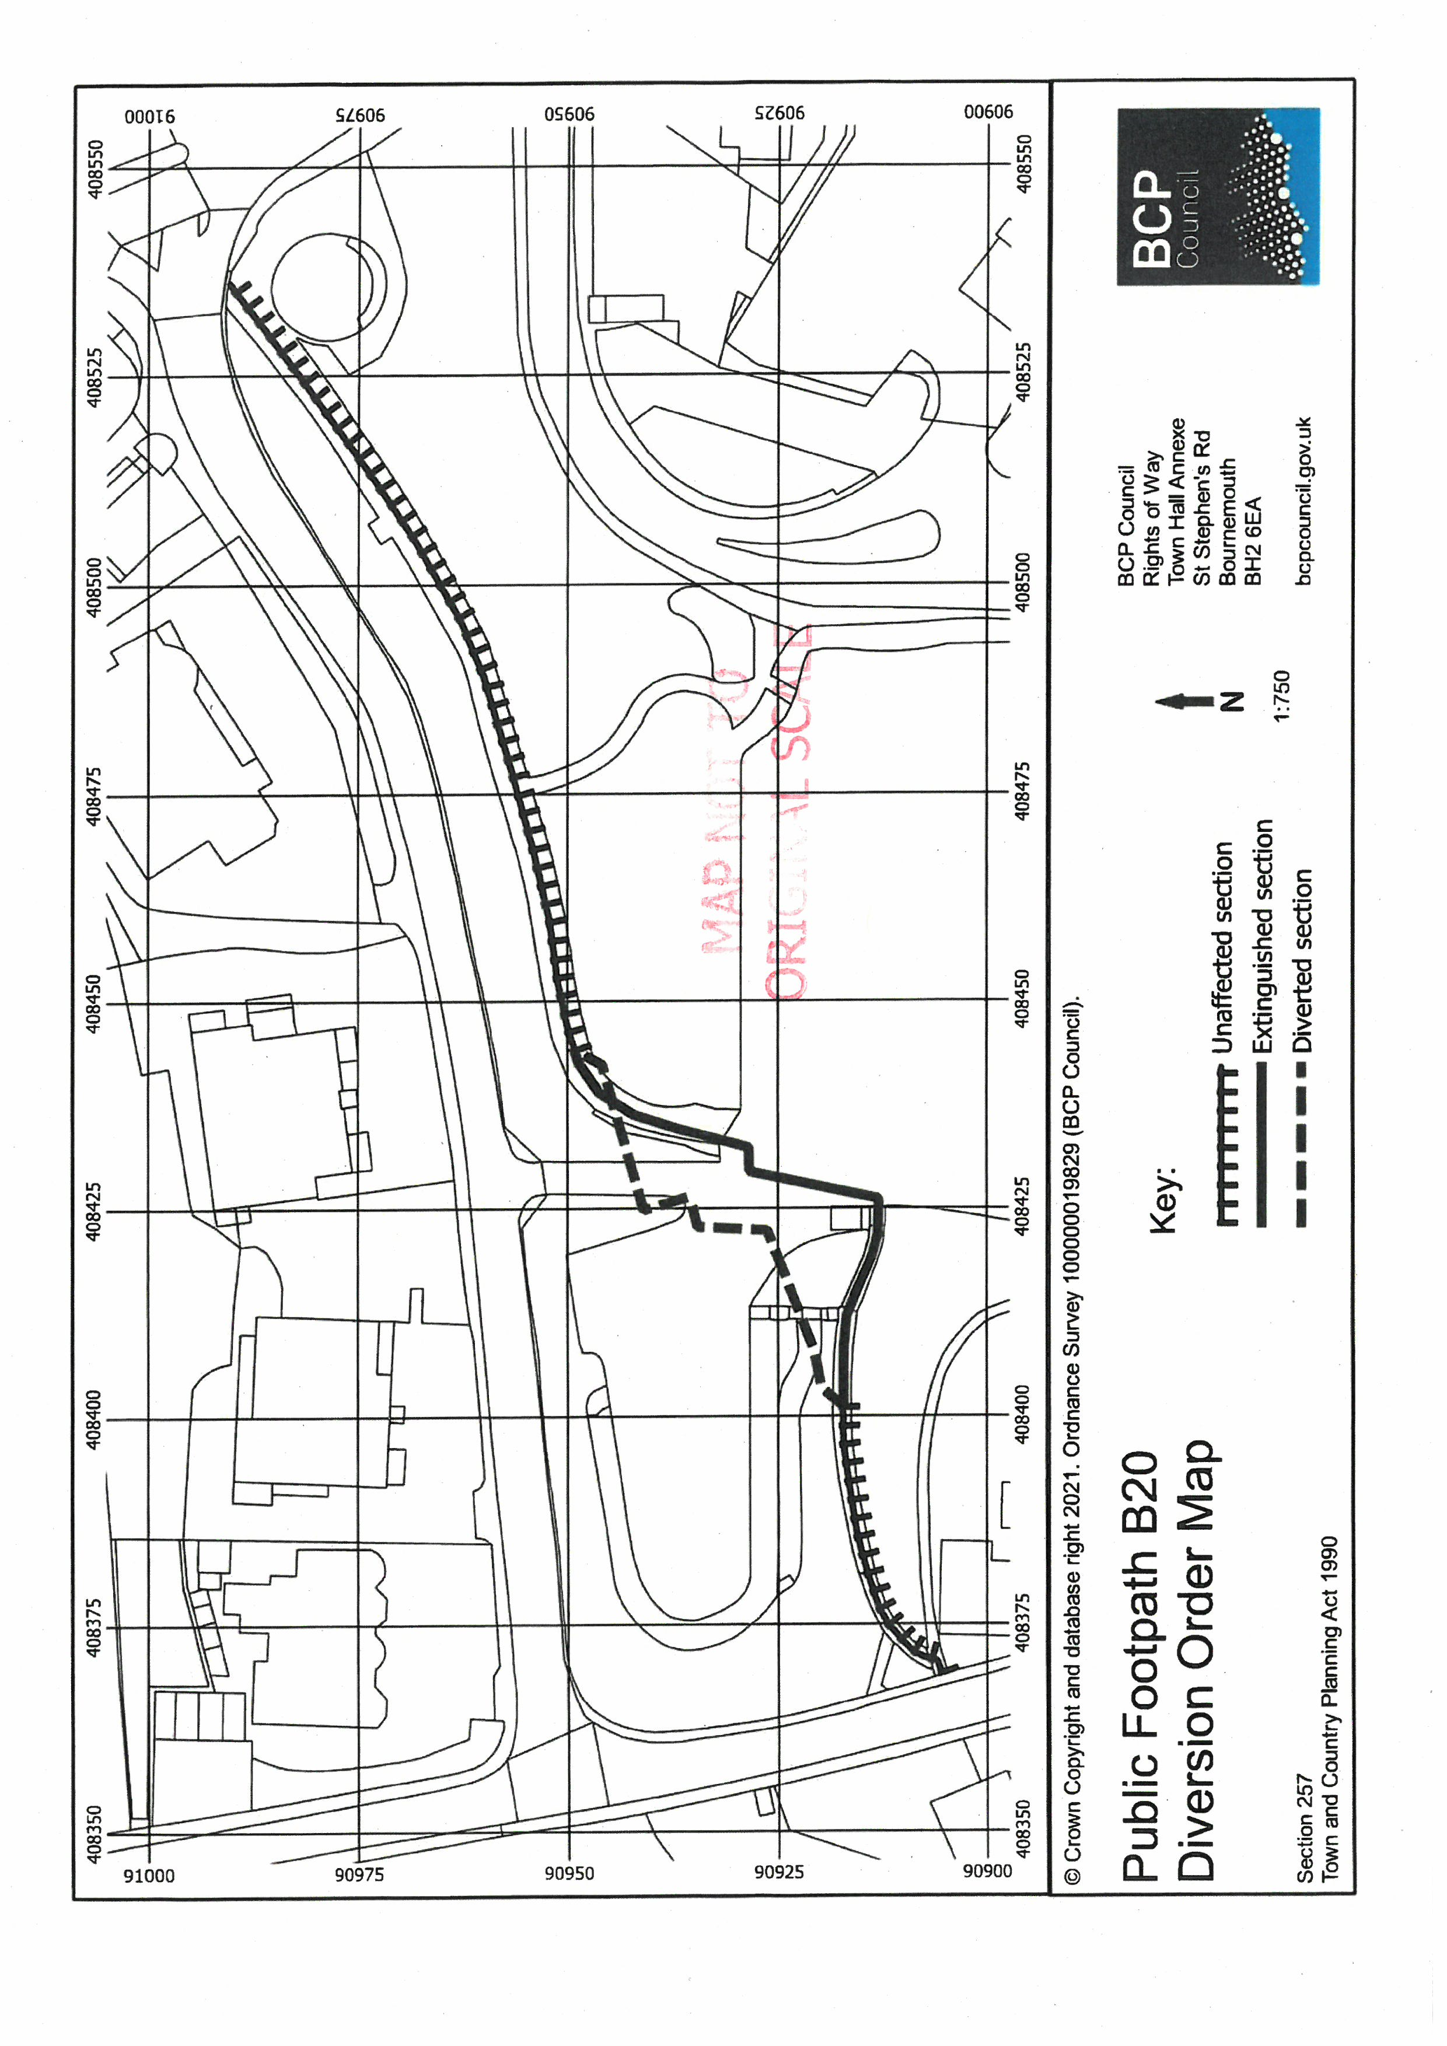
ROW/3291107
