Fishing gear requirements and Landing Obligation exemptions 2022-23

Applicable to Demersal towed gears fishing in UK waters of the North Sea

See separate guidance for Nephrops vessels and Beam Trawlers

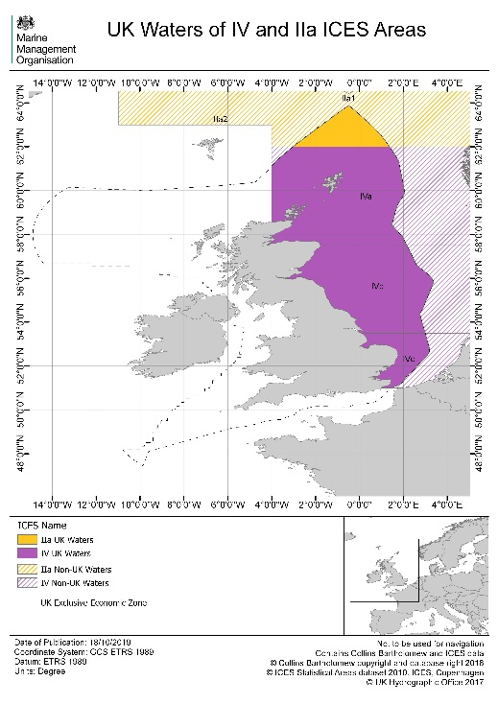

Introduction
This document explains rules on the fishing gear you should be using in UK waters of the North Sea when fishing for demersal species with towed gear (other than Beam Trawls or fishing for Nephrops). It also summarises which Landing Obligation exemptions are available to you.

This guidance is for all sizes of fishing vessel (including those under 10 metres). It does not cover IFCA byelaws – please consult your local IFCA for further information.

General fishing gear rules - All mesh sizes given in this document are minimum sizes. You can choose to use a larger mesh than that stated.

- 8mm maximum for single twine cod-ends. (Further single twine restrictions apply in Farne Deeps (5mm))

- 5mm maximum for double twine thickness

- UK non-beam trawls operating in IVb and IVc north of 53°N using multi-rig cod-ends must be of ≥95mm.

- Square mesh panel must be fully fitted within 12m of cod-line for cod-ends between 80 to 119mm.

- The baseline mesh size in this area is now a 120mm cod-end and this must be used where catches exceed 20% of cod haddock and saithe combined.

- If you have a landed catch of less than 20% of cod, haddock and saithe combined, then you may use a mesh size below 120mm as specified below in table 1.
- North Sea prohibition on demersal towed nets of mesh size range 70 to 79mm in area IV

Gear selectivity requirements

All mesh sizes specified are the minimum.
Table 1: Standard gears that you must use

Fishery | Gear(s) | ICES Area | Conditions
Plaice and Sole and non-TAC species | All demersal trawls | IVb | 100mm cod-end and 90mm square mesh panel
Mixed demersal fishery including Skates and Rays, and non-TAC species | All demersal trawls | IVc | 80mm cod-end, 90mm square mesh panel and 140mm headline panel.
Sole (minimum 40% sole) | All demersal trawls | IVc | 80mm cod-end and 80mm square mesh panel
Squid | All demersal trawls targeting squid | IV | REMOVED: 40mm mesh net if catch is below 20% of cod, haddock and saithe combined.  From 24/10/23 this measure has been removed (SI 2023/1054). The removal of the squid mesh size derogation means that squid can only be targeted with at least 80mm trawls OR larger mesh sizes as required under existing regional technical measures.

Landing Obligation exemptions

In the table below is a brief summary of exemptions from the Landing Obligation for these fisheries which allow you to discard fish. All quantities of fish discarded under the Landing Obligation must be recorded in your logbook, but will not come off your quota.

You must ensure that the following rules are complied with:

- All catches of quota species must be kept on board, landed and counted against quota, except where the exemptions listed below apply.

- All catches and discards must be recorded in your logbook.

- Any fish returned to the sea under the exemptions described below must be kept in good condition in order to maximise their survival chances. This includes keeping them wet, handling them carefully and releasing them promptly.

Survival exemptions - allow you to discard fish under certain conditions based on the likelihood of a fish being able to survive being caught and returned to the sea.
You are permitted to discard certain species of fish provided you comply with the conditions specified in the table below.

De minimis exemptions - allows a small percentage of the total catch of certain species to be discarded because it is difficult to completely avoid unwanted catches.
It is important that discards are recorded in your logbook. De minimis exemptions may be withdrawn where discard levels are too high.

Species you can discard | Gears | UK ICES Area | Exemption Type | Conditions
Skates and Rays | All Gears | IIa and IV | Survival | No Conditions
Dover Sole (SOL) below the minimum size of 24cm | Otter Trawls | IVc | Survival | Fishing takes place no more than 6 nautical miles from the coast but outside identified nursery areas.  The fishing vessel is no more than 10m long (LOA). Maximum engine power is 221kW.  The depth of water is no more than 30m.  The towing time is less than 90minutes.  Minimum cod-end mesh size of 80mm.
Plaice (PLE) | Danish Seine | IV | Survival | No Conditions
Plaice (PLE) | Otter trawls and Pair trawls | IV | Survival | Minimum cod-end mesh size of 80mm.
Nephrops (NEP) | Otter Trawls | IIa and IV | De Minimis | Cod-end mesh size of 80mm to 99mm.
Cod (COD) below the minimum size of 35cm | Otter trawls and Seines | IVc | De Minimis | Cod-end mesh size of 80mm to 99mm.
Whiting (WHG) below the minimum size of 27cm | Otter trawls and Seines | IV | De Minimis | Cod-end mesh size of 80mm to 99mm.
Mackerel (MAC) and Horse Mackerel (JAX) | Otter trawls and Pair trawls | IV | De Minimis | Cod-end mesh size of 80mm to 99mm.
Sprat, Sandeel, Norway pout and Blue whiting | Otter trawls, Pair trawls and Seines | IV | De Minimis | Minimum cod-end mesh size of 80mm*

When operating in EU waters please refer to the EC rules on discarding https://ec.europa.eu/oceans-and-fisheries/fisheries/rules/discarding-fisheries_en

