Department for Environment, Food and Rural Affairs  The Tuberculosis in Animals (England) Order 2021 - Article 10(3) | 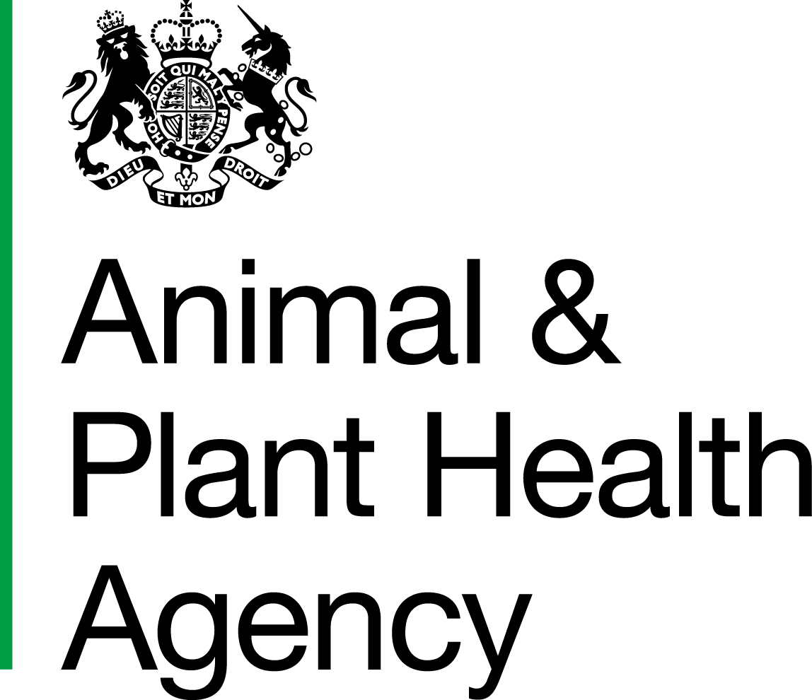
Application for Authorisation of Private Use of a Non-validated or Non-Defra Approved Test for TB in Cattle in England

Name of Owner/Keeper
Address
 |  | Postcode:
CPH Number
Location of cattle at time of sampling (if different to the above address)
Number of animals to be tested
Total herd size at the time of sampling
Type of animals to be tested | Dairy |  |  |  | Beef |  |  |  | Other
Type of animals to be tested | Adult |  |  |  | Breeding heifers |  |  |  | Stores |  |  |  | Calves
Type of animals to be tested |  |  |  |  |  |  |  |  | Other
Test(s) proposed
Do any of the tests proposed require ‘boosting’ by a previous tuberculin skin test (e.g. antibody tests such as IDEXX and Enferplex)? |  |  |  |  |  |  |  |  |  |  | Yes |  |  | No
If yes, what is the window for sampling following tuberculin injection?
Sample type proposed  e.g. Blood/Milk/Faeces/Bulk milk |  |  |  |  |  |  | Proposed sampling date (if known)
Name of Private Veterinary Surgeon (PVS)
Email address
Address of Veterinary Practice
 |  | Postcode:

Information about the proposed test

Has APHA been provided with details of the current known performance of the test(s) proposed? |  | Yes |  | No
Will data generated from use of the test(s) in this herd contribute to evidence for test validation in collaboration with the test manufacturer? |  | Yes |  | No
Is a Home Office licence required? (If not required, please provide evidence below) |  | Yes |  | No
If yes, has a licence been obtained? |  | Yes |  | No
Test purpose, i.e. what will be done with the test results?
What will be considered a positive test result?
How will APHA be kept informed of the test results?

I confirm the following:

1. The herd owner has been informed in writing that:
- the test(s) in question is/are not validated and/or not approved by Defra for routine use in cattle
- the test results may be unreliable and difficult to interpret, meaning the test may not offer any certainty about
the animals’ true infection status
- APHA is under no obligation to remove (nor is Defra liable to pay compensation for) any test-positive animals. Therefore, the removal and slaughter costs will be the responsibility of the herd owner, unless any of those animals becomes positive to a subsequent government-funded mandatory TB test, or APHA considers it necessary to remove any of those animas as a direct contact
- any animal that gives a positive result to a private non-validated test, or to an (World Organisation for Animal Health) OIE-validated test not yet approved by Defra for routine use, will be restricted to the premises for its lifetime. Such animal(s) can be moved under licence to slaughter, directly, via a slaughter gathering, to a veterinary research centre for post-mortem examination, or to an Approved Finishing Unit (AFU)
- additionally, in the specific case of any positives to a private IDEXX or Enferplex TB test performed in a TB breakdown herd, it will be necessary for the herd owner to privately slaughter all such animals before APHA can restore the Officially TB Free (OTF) status of the affected herd

2. The herd owner has acknowledged receipt of this information and signed that they consent to the use of the proposed test(s) in their herd and that any test-positive animals will remain under lifetime restrictions unless consigned to one of the permitted outlets mentioned above for private slaughter.

3. The test results and the planned management of any test-positive animals will be reported and shared with APHA after every testing event, within one working day if there are any positive animals, and within five working days if all the results are negative.

4. Skin test reactors and other animals positive to a government-funded TB test deployed by APHA that may be awaiting removal from the herd will not be privately re-tested, except where sampling of such animals takes place at the point of slaughter to obtain suitable material for test validation purposes. In any case, the results of a private test performed on a TB positive animal slaughtered by APHA will not be disclosed to the herd owner.

I understand that it is a legal requirement to report the suspicion of TB in cattle under The Tuberculosis in Animals (England) Order 2021.

Signature of PVS
Name in  BLOCK LETTERS |  | Date

DATA PROTECTION
For information on how we handle personal data please go to www.gov.uk and search Animal and Plant Health Agency Personal Information Charter.
Please send this completed application form (with a signed authorisation from the owner/keeper giving permission for the APHA Veterinarian to discuss details of their TB breakdown with the PVS) by email to TB.Advice@apha.gov.uk for the attention of the APHA Case/Duty Vet and the TB Delivery Advice Team (TB DAT).
Please note that for an application to be considered this completed form must be submitted to APHA with a minimum of ten working days’ notice before the intended date of sampling.
Test results should be sent for attention of the Case/Duty Vet and TB DAT by email to TB.Advice@apha.gov.uk

APHA is an Executive Agency of the Department for Environment, Food and Rural Affairs and also works on behalf of the Scottish Government, Welsh Government and Food Standards Agency to safeguard animal and plant health for the benefit of people, the environment and the economy.
HM3 Stamp | Name: |  | Date Received: |  | WS ID:

