 Lancashire

**Area name here**



# **Annual Report 2022/2023**

# Foreword to the report

Neil Drummond – MAPPA SMB Chair

On behalf of the Lancashire MAPPA Strategic Management Board (SMB) it is my pleasure to introduce the 2022-23 Annual Report.

The last year has presented challenges as the volume of cases referred and accepted into MAPPA has increased at the same time as we have lost experienced staff from the MAPPA Team. The efforts of those remaining should be acknowledged as they have done a sterling job in keeping the complex rota operational and providing support both in and out of meetings.

We send thanks as we say goodbye to our lay advisor Ronald Barham who over the last 7 years has provided scrutiny and constructive challenge to the work of MAPPA in Lancashire, this has been greatly appreciated and we will miss Ronald but wish him all the best as he moves on to new projects.

I will also be saying farewell after 3 years as Chair and will be succeeded by Dan Cooper, Governor at HMP Preston which will be timely as agencies increase their focus on pre-release work to enhance MAPPA effectiveness and achieve better outcomes for perpetrators and victims. The introduction of short term sentence teams in custody to ensure all prisoners are referred to appropriate housing, health and substance misuse support with community appointments arranged in advance of release is one new initiative to benefit MAPPA.

Whilst I will continue to take an active part in the Lancashire SMB and support Dan in his role as chair, I would like to take the opportunity to highlight the continued professionalism of all those working within MAPPA across Lancashire. Our annual staff awards show the highest levels of commitment and passion from staff across all agencies, working together, going above and beyond every day to keep the public safe. I am also extremely grateful to all board members in their continued support during my time as Chair.

This detailed report will give readers an insight into the complexities of MAPPA and the high standard of oversight given to cases by all partners.

**Neil Drummond**

**Chair, Lancashire MAPPA Strategic Management Board**

# What is MAPPA?

MAPPA background

MAPPA (Multi-Agency Public Protection Arrangements) are a set of arrangements to manage the risk posed by individuals who have committed the most serious sexual, violent and terrorist offences (MAPPA-eligible individuals) under the provisions of sections 325 to 327B of the Criminal Justice Act 2003.

They bring together the Police, Probation and Prison Services in each of the 42 Areas in England and Wales into what is known as the MAPPA Responsible Authority.

A number of other agencies are under a Duty to Co-operate (DTC) with the Responsible Authority. These include Social Services, Health Services, Youth Offending Teams, Department for Work and Pensions and Local Housing and Education Authorities.

Local Strategic Management Boards (SMB) comprising senior representatives from each of the Responsible Authority and DTC agencies are responsible for delivering MAPPA within their respective areas. The Responsible Authority is also required to appoint two Lay Advisers to sit on each MAPPA SMB.

Lay Advisers are members of the public appointed by the Minister with no links to the business of managing MAPPA-eligible individuals act as independent, yet informed, observers; able to pose questions which the professionals closely involved in the work might not think of asking. They also bring to the SMB their understanding and perspective of the local community (where they must reside and have strong links).

How MAPPA works

MAPPA-eligible individuals are identified and information about them is shared between agencies to inform the risk assessments and risk management plans of those managing or supervising them.

That is as far as MAPPA extend in the majority of cases, but some cases require more senior oversight and structured multi-agency management. In such cases there will be regular MAPPA meetings attended by relevant agency practitioners.

There are 4 categories of MAPPA-eligible individual:

* **Category 1** –subject to sex offender notification requirements.
* **Category 2** – mainly violent offenders sentenced to 12 months or more imprisonment or a hospital order.
* **Category 3** – individuals who do not qualify under Categories 1, 2 or 4 but whose offences pose a risk of serious harm.
* **Category 4** – terrorism convicted and terrorism risk individuals.

There are three levels of management to ensure that resources are focused where they are most needed: generally, those presenting the higher risks of serious harm.

* **Level 1** is where the individual is managed by the lead agency with information exchange and **multi-agency support** as required but without formal MAPPA meetings.
* **Level 2** is where formal MAPPA meetings are required to manage the individual.
* **Level 3** is where risk management plans require the attendance and commitment of resources at a senior level at MAPPA meetings.

MAPPA are supported by ViSOR. This is a national IT system to assist in the management of individuals who pose a serious risk of harm to the public. The use of ViSOR increases the ability to share intelligence across organisations and enables the safe transfer of key information when high risk individuals move between areas, enhancing public protection measures. ViSOR allows staff from the Police, Probation and Prison Services to work on the same IT system, improving the

quality and timeliness of risk assessments and interventions to prevent offending.

MAPPA and Terrorism

The government published an Independent Review of the MAPPA used to Supervise Terrorism and Terrorism-risk individuals on 2 September 2020 and published its response on 9 December. Both documents are available at <https://www.gov.uk/government/publications/multi-agency-public-protection-arrangements-review>. The report made a number of recommendations, the majority of which have been implemented, including via the Counterterrorism and Sentencing Act 2021 and the Police, Crime, Sentencing and Courts

Act 2022. The Secretary of State has also revised the statutory MAPPA Guidance on terrorism offenders.

The Probation Service, via its National Security Division, has created a specialist dedicated and highly skilled workforce, which provides an enhanced level of management and intervention for the most high-risk, complex, and high-profile individuals in the community. This includes the management of terrorist connected and terrorist risk offenders. The NSD and Counter-Terrorism Policing work closely with local SMBs to ensure the robust management of terrorism cases. Data on Category 4 individuals is not included in this report due to data protection issues related to low numbers. This data will be aggregated and published nationally.

All MAPPA reports from England and Wales are published online at: [www.gov.uk](http://www.gov.uk)

# MAPPA Statistics

MAPPA-eligible individuals on 31 March 2023

|  |  |  |  |  |
| --- | --- | --- | --- | --- |
|  | Category 1: Subject to sex offender notification requirements | Category 2: Violent offenders | Category 3: Other dangerous offenders | Total |
| Level 1 | 2949 | 707 | - | 3656 |
| Level 2 | 11 | 9 | 16 | 36 |
| Level 3 | 4 | 3 | 3 | 10 |
| Total | 2964 | 719 | 19 | 3702 |

MAPPA-eligible offenders in Levels 2 and 3 by category (yearly total)

|  |  |  |  |  |
| --- | --- | --- | --- | --- |
|  | Category 1: Subject to sex offender notification requirements | Category 2: Violent offenders | Category 3: Other dangerous offenders | Total |
| Level 2 | 24 | 22 | 29 | 75 |
| Level 3 | 14 | 3 | 6 | 23 |
| Total | 38 | 25 | 35 | 98 |

|  |  |
| --- | --- |
| Category 1 cautioned or convicted for breach of notification requirements | 55 |

|  |  |
| --- | --- |
| Category 1 who have had their life time notification revoked on application | 6 |

Restrictive orders for Category 1 offenders

|  |  |
| --- | --- |
| Sexual Harm Prevention Order (SHPO) | 190 |
| SHPO with foreign travel restriction | 1 |
| Notification Order | 0 |

|  |  |
| --- | --- |
| Number of individuals who became subject to sex offender notification requirements following a breach(es) of a Sexual Risk Order (SRO) | 0 |

Level 2 and 3 individuals returned to custody

|  |  |  |  |  |
| --- | --- | --- | --- | --- |
| Returned to custody for breach of licence | Category 1: Subject to notification requirements | Category 2: Violent offenders | Category 3: Other dangerous offenders | Total |
| Level 2 | 9 | 8 | 11 | 28 |
| Level 3 | 5 | 3 | 3 | 11 |
| Total | 14 | 11 | 14 | 39 |

|  |  |
| --- | --- |
| Breach of SHPO |  |
| Level 2 | 0 |
| Level 3 | 0 |
| Total | 0 |

|  |  |
| --- | --- |
| Total number of individuals subject to sex offender notification requirements per 100,000 population | 218 |

**“This figure has been calculated using the mid-2021 estimated resident population, published by the Office for National Statistics (ONS) on 21 December 2022, excluding those aged less than ten years of age.**

**Consistent with previous publications, this figure should be based on mid-2022 estimated resident population; however, the ONS has changed its publication schedule such that the mid-2022 estimates will be published later this year. As such, the current figure may differ from the corresponding figure based on the mid-2022 estimates.”**

# Explanation commentary on statistical tables

MAPPA background

The totals of MAPPA-eligible individuals, broken down by category, reflect the picture on 31 March 2023 (i.e., they are a snapshot). The rest of the data covers the period 1 April 2022 to 31 March 2023.

(a) MAPPA-eligible individuals – there are individuals defined in law as eligible for MAPPA management because they have committed specified sexual, violent or terrorist offences or they currently pose a risk of serious harm. The majority are managed at Level 1 without formal MAPPA meetings. These figures only include those MAPPA eligible individuals living in the community. They do not include those in prison or detained under the Mental Health Act.

(b) Subject to Sex Offender Notification Requirements – those who are required to notify the police of their name, address and other personal details and to notify of any subsequent changes (this is known as the “notification requirement.”) These individuals are assessed and managed by the police. They may also be managed by probation or health services if they are subject to licence or a hospital order. Failure to comply with the notification requirement is a criminal offence that carries a maximum penalty of 5 years’ imprisonment.

(c) Violent Offenders – individuals convicted of violent offences who were sentenced to imprisonment or detention for 12 months or more, or detained under a hospital order and a small number of individuals convicted of sexual offences who are not subject to notification requirements. These individuals are assessed and managed by the Probation Service, Youth Offending Team, or Mental Health Services.

(d) Other Dangerous Offenders – individuals who do not qualify under the other MAPPA-eligible categories but have committed an offence that indicates that they pose a risk of serious harm which requires management via MAPPA meetings. These individuals are assessed and managed by whichever agency has the primary responsibility for them.

(e) Terrorism and Terrorism Risk Offenders – individuals subject to terrorism offender notification requirements; individuals convicted of terrorism or terrorism related offences who were sentenced to imprisonment or detention for 12 months or more or detained under a hospital order; and those who have committed an offence and may be at risk of involvement in terrorism-related activity. These individuals are assessed and managed by Counter-Terrorism Police and the National Security Division of the Probation Service.

(f) Breach of Licence – individuals released into the community following a period of imprisonment will be subject to a licence with conditions (under probation supervision). If the individual does not comply with these conditions, the Probation Service will take breach action and the individual may be recalled to prison.

(g) Sexual Harm Prevention Order (SHPO) (including any additional foreign travel restriction).Sexual Harm Prevention Orders (SHPOs) and interim SHPOs replaced Sexual Offence Prevention Orders are intended to protect the public from individuals convicted of a sexual or violent offence who pose a risk of sexual harm to the public by placing restrictions and/or positive obligations on their behaviour. They require the individual to notify their details to the police (as set out in Part 2 of the 2003 Act) for the duration of the order.

The court must be satisfied on the balance of probability that an order is necessary to protect the public (or any particular members of the public) in the UK, or children or vulnerable adults (or any particular children or vulnerable adults) abroad, from sexual harm from the individual. In the case of an order made on a free-standing application by a Chief Officer, the National Crime Agency (NCA), British Transport Police (BTP) or the Ministry of Defence Police (MODP), the chief officer/NCA/BTP/MODP must be able to show that the individual has acted in a way since their conviction that makes the order necessary.

The minimum duration for a full order is five years. The lower age limit is 10, which is the age of criminal responsibility, but where the defendant is under the age of 18 an application for an order should only be considered exceptionally.

(h) Notification Order – this requires individuals convicted of qualifying sexual offences overseas to register with the police, in order to protect the public in the UK from the risks that they pose. The police in England and Wales may issue a notification order directly to an offender who is already in the UK or who is intending to come to the UK who must notify within three days of receipt. Individuals have a right of appeal against notification.

(i) Sexual Risk Order (including any additional foreign travel restriction) –The Sexual Risk Order (SRO) replaced the Risk of Sexual Harm Order (RoSHO) and may be made in relation to a person without a conviction for a sexual or violent offence (or any other offence), but who poses a risk of sexual harm.

The SRO may be made at the magistrates’ court on application by the police, NCA, BTP or MODP where an individual has committed an act of a sexual nature and the court is satisfied that the person poses a risk of harm to the public in the UK or children or vulnerable adults overseas.

An SRO may prohibit the person from doing anything described in it, including travel overseas, or place positive obligations upon them. Any prohibition and/or obligation must be necessary to protect the public in the UK from sexual harm or, in relation to foreign travel, protecting children or vulnerable adults from sexual harm.

An individual subject to an SRO is required to notify the police of their name and home.

address within three days of the order being made and also to notify any changes to this information within three days.

An SRO can last for a minimum of two years and has no maximum duration, with the exception of any foreign travel restrictions which, if applicable, last for a maximum of five years (but may be renewed).

The criminal standard of proof continues to apply. The person concerned is able to appeal against the making of the order and the police or the person concerned are able to apply for the order to be varied, renewed or discharged.

A breach of an SRO is a criminal offence punishable by a maximum of five years’ imprisonment. Where an individual breaches their SRO, they will become subject to full notification requirements.

Individuals made subject of an SRO are recorded on VISOR as a Potentially Dangerous Person (PDP).

(j) Lifetime notification requirements revoked on application – A legal challenge in 2010 and a corresponding legislative response means there is a mechanism in place that allows qualifying individuals to apply for a review of their notification requirements. Qualifying individuals may submit an application to the police to review their indefinite notification requirements. The police review the application and decide whether to revoke the notification requirements. This decision is made at the rank of Superintendent. Those who continue to pose a significant risk will remain subject to notification requirements for life, if necessary.

Individuals will only become eligible to seek a review once they have been subject to indefinite notification requirements for a period of at least 15 years for adults and 8 years for juveniles.

# MAPPA – At work in Lancashire

Ronald Barham – Lancashire MAPPA Lay Advisor

As I enter the final few months of my second, and final, term as Lay Adviser to the Strategic Management Board, I look back on my 7 years’ service with some satisfaction.

Over those years, and with each meeting, my understanding of the complexities of MAPPA operational activity increased and, thus, my ability to contribute better to the debates – both at SMB meetings and at the individual case review meetings that I have attended.

The first few years were spent, in the main, familiarising myself with the categories and levels applied to case nominals and in visiting Approved Premises, Prisons and other secure facilities to be able to understand the references to them in SMB discussions. Then, as an observer, I attended a regular but random sample of Level 2 and Level 3 review meetings in order, better, to fulfil the requirement to act as “critical friend” to the SMB. I also visited the EMS tagging HQ in Greater Manchester to see how that system worked and gain an understanding of any problems affecting the efficiency of its operations – reporting my findings back to SMB.

Over the last few years, I have attended many Thresholding Meetings and, where possible, followed cases through their regular review meetings, gaining an insight into how the risks are managed and, where appropriate, contributing to the discussions – reporting back to SMB on any apparent problems in the process. I have also participated in several of the annual sample audits of case management files, taken part in a Serious Case Review and, additionally, a national review of Quality Assurance processes leading to the publication of new guidance for MAPPA staff.

It has been gratifying to see many offenders rehabilitated and restored to “normal” life in the community whilst, also, seeing the more serious recidivist offenders properly controlled. I was also pleased that my regular argument for more control of very serious and terrorist/radicalised offenders was reflected in the recommendations of Jonathan Hall KC which resulted in the introduction of a Category 4, now controlled, and reviewed by the new National Security Division.

MAPPA Lancashire continues to operate efficiently and effectively. All in all, I have enjoyed my ever-increasing involvement in its work over the past 7 years and I am sure my successor(s) will, as well.

**Ronald Barham, MStJ, LLM, PhD, FCIArb.*(rtd)***

Victim safety, preventing re-victimisation and avoiding the creation of new victims are fundamental to MAPPA and the Victim Contact Scheme (VCS) has an important role.

The statutory VCS, provided by the Probation Service, enables eligible victims (or in the case of a death, bereaved close relatives of the victim) to be informed about key developments in the offender's sentence and for their views to be represented.

To achieve this, the Probation Service has a statutory duty under the Domestic Violence, Crime and Victims Act 2004 (DVCVA 2004) to contact the victims of offenders convicted of a specified violent or sexual offence who are sentenced to 12 months or more imprisonment.

In 2005 and 2008 respectively, victims of restricted patients and non-restricted patients also became eligible for this service and was further updated by The Code of Practice for Victims of Crime 2020 (Victims’ Code). Since the 1st April 2021 victims of all Hospital patients where the conviction relates to a specified sexual or violent offence are now entitled to receive information via the VCS.

The Probation Service also has some limited discretion to offer the VCS to victims who do not meet the statutory criteria for the service, e.g., where the offence pre-dates the statutory introduction of the Scheme in 2001.

Victim Liaison Officers (VLO’s) will firstly write to a victim to ask if they would like to receive contact, which can include a face-to-face meeting and all methods of contact are attempted before making a case dormant.

All communications are managed sensitively and tailored to meet the diverse needs of individual victims often traumatised by their experiences. Whilst the VCS is not a support service, VLO’s are able to signpost victims to appropriate services in their home areas.

The VCS provides a confidential service, operating within systems separate from those used by sentence management colleagues and will ensure the rights of victims are upheld and compliance with the Victims Code of Practice.

VLO’s provide information to victims about the criminal justice process, what the offender's sentence means, and how decisions are made about how long the offender will remain in prison or hospital. This includes information on tariffs, appeals, parole eligibility, release (including release on temporary licence and escorted or unescorted leave), conditional discharge, and recalls. In relation to Hospital Orders, the information will come directly from the hospital to the VLO for communication. The role requires extensive sentence knowledge. Excellent communication skills, partnership working and professional judgement.

Victims under the VCS have a right to make representations about licence conditions, including release on temporary licence. They can request an exclusion zone to cover, for example, home or work areas. They also have the right to submit a Victim’s Statement to the Mental Health Tribunal or Parole Board highlighting the impact of the offence and future concerns.

These requests are based on the risk of emotional harm to the victim; a separate consideration to the risks of reoffending and serious harm normally considered by the Probation Practitioner but one that is no less important for the purpose of evidencing the necessity of licence conditions.

The VCS in Lancashire is via a team of 12 Victim Liaison Officers working flexibly across Cumbria and Lancashire. At the time of publication VLO’s were responsible for 490 victims resident in Cumbria and 1399 in Lancashire including the two Unitary Authorities of Blackpool and Blackburn with Darwen. The team are managed by Jeanette Flynn Senior Probation Officer and are part of the Public Protection Unit (PPU), led by Gemma Truesdale, Head of PPU.

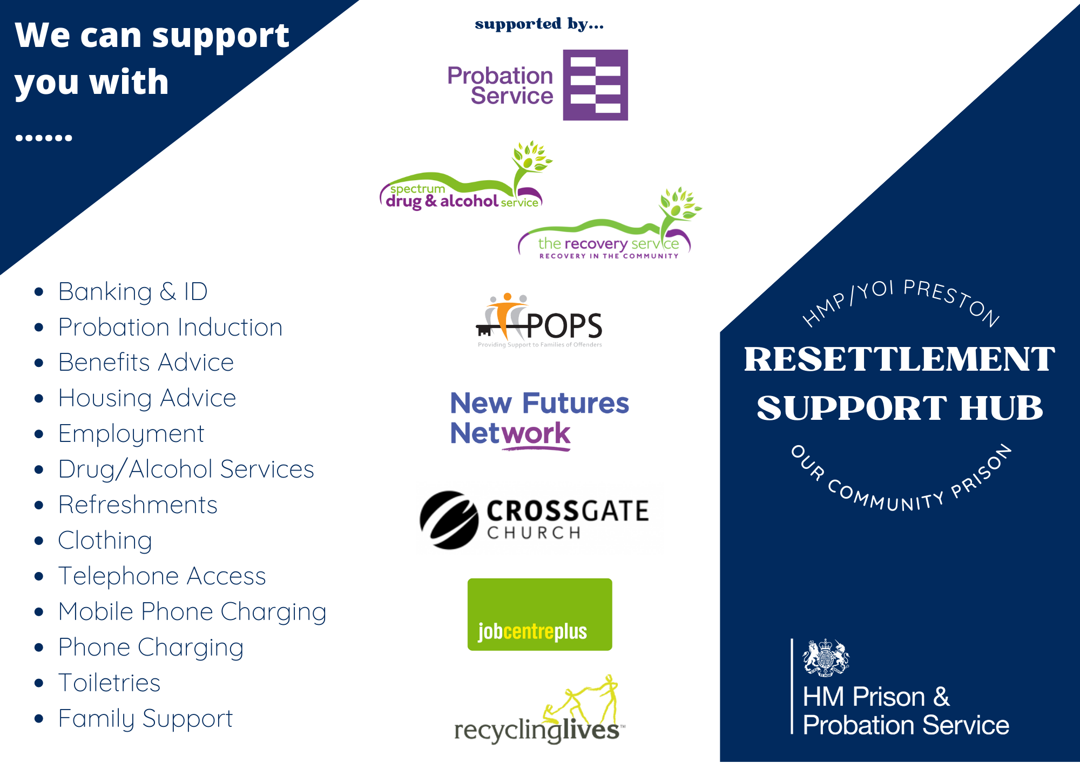

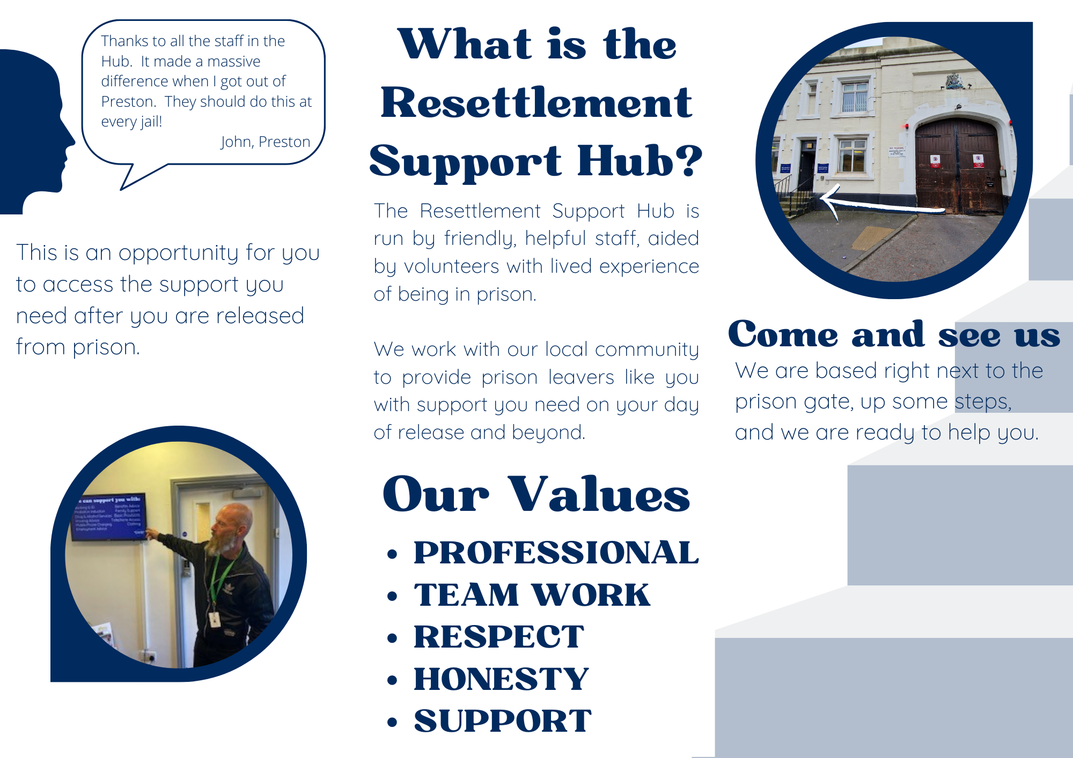

MAPPA Victims & Veterans Team

The MVV Team within Lancashire and South Cumbria NHS Foundation Trust provide a single point of contact for partnership agencies as well as internal staff across three areas of practice MAPPA, Victims and Veterans. The team can be contacted via email **MVVTeam@lscft.nhs.uk.**

**Who are Veterans?**

**Within the Armed Forces Covenant document, a Veteran is defined as anyone that has served for at least one day in His Majesty’s (HM) Armed Forces.** This includes Regular, Reserve personnel or Merchant Mariners and Fishermen (including women) who have seen duty on legally defined military operations. Some individuals may prefer the term ‘ex-armed forces’ or similar so it is useful to confirm with the individual how he/she wishes to be defined.

According to the British Legion (2019) there are around 2.5 million veterans living in the UK. Many are elderly, 49% of veterans are aged over 75 compared to non-veterans 8%. The high rate of older veterans can be related to those who completed National Service, which officially ended in 1960.

Veterans are more likely to be male (90%) compared to non-veterans (47%).

**The Armed Forces Covenant (2011)**

The Covenant is an enduring commitment to ensure that those who serve or have served, and their families are treated with respect, fairness and face no disadvantage compared to other citizens. Also, where appropriate are prioritised for services if he/she has been injured or experienced illness during military service or transition to civilian life.

The Government, the NHS, local authorities, the wider public sector, charities, commercial organisations, and civil society all have a role in supporting the Armed Forces community. This includes in areas such as employment, healthcare, housing, education, and financial advice.

**Veterans in the Criminal Justice System**

It is reported that small numbers of the veteran population have involvement in the criminal justice system. The Veteran population are no more likely to commit offences; however, there is evidence of higher incidence of violent offending often in the context of substance misuse, specifically alcohol. Research has highlighted a strong association with adverse childhood experiences and the potential protective features of military life such as companionship/belonging to a forces family, employment/training and financial security. However, on discharge from the military such individuals may experience greater losses as there may be limited protective factors within the community.

There is much debate about the numbers of veterans involved in the criminal justice system. Ministry of Justice data suggests among 49,610 (61.5%) of the prison population (as of the 30 June 2022), included 1,768 (3.6%) who had indicated they were ex-service personnel. This does not reflect veteran numbers among a whole prison population. According to Veterans HQ it is estimated 20,000 veterans are now in the criminal justice system, with 8,500 in prison, which makes up over 10% of the prison population. This constitutes a rise of 30% in the Veteran prison population over the last five years.

**Healthcare for Veterans and families**

The NHS is responsible for providing health care to Veterans in the community alongside charities and independent organisations. Each year approximately 15,000 people leave the Armed Forces and most successfully transition into civilian life. However, some experience mental health difficulties and need to access appropriate support in the community. Veterans are known to underuse services (Greenberg, 2014; Kitchiner et al, 2012), with only around 50% seeking help for mental health problems (Iversen et al., 2005). Veterans may not present with mental health difficulties for many years after leaving the Armed Forces (Murphy, 2016). Long term, untreated and underlying mental health difficulties can have a big impact on Veterans’ health, relationships, and overall quality of life (Kessler, 2000; Pittman et al, 2012).

Veterans often reach crisis point before accessing services (Zinzow et al, 2013). There may be many reasons for this such as stigma, shame, or an inability to recognize mental health difficulties (Murphy, 2014). This means that by the time Veterans access services they may have significant mental health needs. There have been examples where mental health needs have been recognized; for example, by watching films or documentaries, news about conflicts and discussion with family/peers.

A number of UK studies have found links between active service and mental health problems in armed service personnel involved in recent conflicts. A recent study of 10,000 serving personnel (83% regulars; 27% reservists) found lower than expected levels of PTSD. However, common mental disorders (anxiety/depression) and alcohol misuse are most frequently reported among UK armed forces personnel. In particular, levels of alcohol misuse overall were substantially higher than in the general population.

**Ask the Question?**

Individuals should routinely be asked at the first point of contact or assessment if at any time in the past he/she or a close family member have served in the Armed Forces or as a Reservist?

Also, if his/her current symptoms/illness are as result of their time in service or transition to civilian life? If yes, then then records should indicate 'ex-forces member’ and the individual should be prioritised for treatment and support (for that specific condition).

**Armed Forces Champions Network**

The MVV Team coordinate a Champions Network comprising of staff across different agencies as well as local teams. The meeting is held quarterly and aims to raise the profile of Veteran related services and supports as well as widening understanding across staff teams of the unique needs of the Armed Forces Community.

**Mental Health Treatment and Support**

**Members of the Armed Forces Community (Veterans and their families) can access the full range of services provided through Lancashire & South Cumbria NHS Trust (LSCFT) and will be prioritized for service or transition-related conditions. Services include IAPT/ Positive Lifestyles Team for time-limited psychological intervention, Community Mental Health Teams for individuals with complex or severe, enduring mental illness, Early Intervention Team for individuals experiencing a first episode of psychosis, Older People Services for people over the age of 65years who have mental illness or dementia and Crisis and Home Treatment Services for those experiencing overwhelming symptoms and requiring additional support.**

Alternatively, Veterans can choose to access Veteran-specific services which provide psychological treatment for service or transition related conditions, which include:

**Op Courage**

Op Courage is funded by the NHS to provide specialist services for serving personnel in the process of leaving the military, Veterans and their families and Reservists. The service provides support during transition to civilian life, working closely with the Defence Medical Services (DMS). This can assist with early recognition and treatment including more advanced psychological treatment for complex psychological traumas. There is also support for substance misuse, including alcohol problems and signposting to local treatment and support services. There are two intervention pathways as below:

**Core Intervention Pathway** – comprises of low-intensity brief interventions, including substance misuse interventions, clinical case management, peer support and/or military specific trauma focused therapies such as CBT/EMDR/DBT.

**Enhanced Intervention Pathway** – provides support to clients who are already involved in services such as urgent/crisis/inpatient pathways. The Enhanced Pathway provides additional support for a period of up to 12 weeks often during a period of acuity, before onward referral/transfer to either the core pathway or another treatment pathway/provider.

**Veteran Community Health Passport**

The transfer of care between different health and social care systems can often be associated with poor outcomes and disengagement. Following the transition from military to civilian life, ex-service personnel report difficulties in navigating civilian health and social care services.

In recognition of this the MVV Team has developed an Armed Forces Health Passport, which is available for staff to print out and complete with Veterans who are accessing services. The Health Passport enables individuals to input relevant details about health needs in readiness for the transition to civilian life or at the entry point into services. The Health Passport includes the military service number and regiment as an identifier. The Health Passport can include information about physical, psychological, and social needs including current treatment and useful interventions in for example, crisis situations.

**Service Directory**

A Service Directory has been developed by the MAPPA, Victims & Veterans Team by the Administrator/Project Officer as part of the Veterans Places, Pathways and People (VPPP) programme. It is designed to support staff within LSCFT and partner agencies to improve access and engagement of the Armed Forces Community into appropriate assessment, treatment, and support services within the community. The directory contains the pathways and a range of Armed Forces charities/services that are available in each locality of Lancashire and South for the Armed Forces Community.

# This Service Directory will be updated on an annual basis; therefore, if there are organisations that are not included within this document, please email the MVV Team [MVVTeam@lscft.nhs.uk](mailto:MVVTeam@lscft.nhs.uk) for inclusion when it is updated.

**Veteran Support in the Criminal Justice System**

There are a number of Veteran/Armed Forces organisations that provide support within the Criminal Justice System.

**Healthier Heroes**

Healthier Heroes provides a wide range of support including Veteran only accommodation in Burnley. The team also provide drop in, activities, groups and supports to Veterans and families. The aim is to reduce homelessness and social isolation and improve mental health and wellbeing. The team will visit probation offices and go into prisons to assess and support individuals.

T: 24HOUR SUPPORT LINE: [01282 966730](tel:01282966730)

E: [referral.healthierheroes@outlook.com](mailto:referral.healthierheroes@outlook.com)

**New Beginnings**

The New Beginnings Programme was designed by Veterans HQ to provide a unique, multi-entry point support programme for Veterans in the Criminal Justice System or at risk of offending or re-offending. The team is based in Liverpool but cover the North West.

**New Beginnings Programme is a 3-phase support programme:**

1. Referral to Veterans HQ New Beginnings Programme by Police Custody Staff for a one to one visit to the Veteran to draw up a personal action plan….or
2. Referral to Veterans HQ New Beginnings Programme by HMP Prison Staff/VICSO’s or Probation Officers 3 months prior to release from Custody….or
3. Referral to Veterans HQ New Beginnings post release programme to provide continuing support for the veteran post release.

T: 0151 261 9878

E: [info@veteranshq.org.uk](mailto:info@veteranshq.org.uk)

**Op Nova**

Op NOVA, delivered by the Forces Employment Charity and commissioned by [NHS England](https://www.england.nhs.uk/), provides support for veterans who are in contact with the justice system, enabling them to access the services they need.

Op NOVA may be contacted on:

Freephone **0800 917 7299**

or by email at [opnova@forcesemployment.org.uk](mailto:opnova@forcesemployment.org.uk)

Secure justice email address for Police, Probation Service and Liaison and Diversion use only: [opnova@forcesemployment.cjsm.net](mailto:opnova@forcesemployment.cjsm.net)

**Care after Combat**

The Care after Combat Teams work with volunteers to support within the CJS for the wellbeing of former and serving personnel and families.

E: [enquiries@careaftercombat.org](mailto:enquiries@careaftercombat.org)

T: 01636 557543 Head office and helpline 0300 343 0255

**SSAFA**

Network of in-reach volunteers provides advice and information - not only to those in custody, on probation or in the community, but also to their families and includes:

* Practical and emotional support
* Signposting to services
* Financial support
* Family support
* Travel assistance
* Accommodation

North West Hub: [ENW.Region@ssafa.org.uk](mailto:ENW.Region@ssafa.org.uk)

**Forces in Mind**

Forces in Mind Trust is an overarching Armed Forces organisation that aims to improve knowledge and understanding, build capacity, assert influence, and provide collaboration and leadership across organisations. They also commission and oversee a number of funding awards to advance understanding such as a recent project to explore the serious offending patterns among the Armed Forces Community (3 years duration - 2019-2022), supported by the Probation Institute.

For further information please contact the MAPPA, Victims and Veterans Team email **MVVTeam@lscft.nhs.uk.**

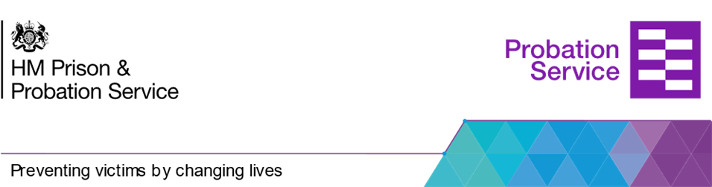



**SEXUAL OFFENDING**

We deliver a suite of accredited programmes designed for individuals who have both contact and internet offending. We also deliver an adapted programme to be responsive to individuals with learning challenges. The ethos of the programmes are to instil hope and optimism in the participants through working with them to strengthen and develop protective factors within their lives.

**DOMESTIC ABUSE**

We run the accredited 30 session Building Better Relationships programme alongside the 14 session Help Structured Intervention. Both of these programmes have victim support linked to them. BBR has a strong skill focus and participants are provided with a range of cognitive and behavioural skills to promote the use of positive behaviours in their intimate relationships.

We are the Programmes Team which is part of Interventions within Probation. Our main goal is to provide quality group work programmes for Persons on Probation. Our facilitators go through an intensive training programme to be able to deliver the national accredited programmes alongside our less intensive Structured Interventions.

Part of the accredited programmes team role is to attend and contibute to MAPPA, in particular addressing risk management via appropriate interventions.

**hello!**

**THINKING SKILLS**

We deliver the accredited 19 session Thinking Skills Programme alongside the 5 session Better Solutions Structured Intervention. These aim to reduce recidivism by focusing on developing people’s ability to manage their emotions, make decisions and use pro-social interpersonal skills in their interactions with others.

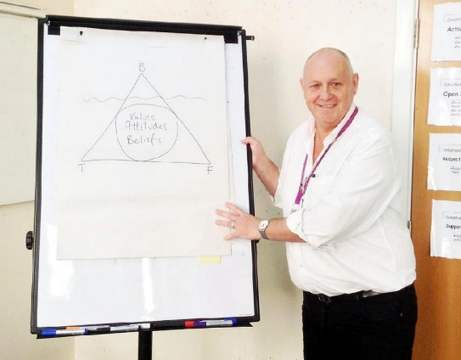

The Strategic Housing Specialist Roles

There has been a national roll-out from pilot of the original housing specialist role to Strategic Housing Specialist, moving to 48 FTE (49 posts) operating in a cluster of geographically close prisons, rather than the establishment-based model role of the pilot design.

They will identify, develop, and deliver a range of solutions that remove barriers to accommodation, including solutions to logistical barriers, create training for staff, improving efficiency, maximising impact at that strategic level streamlining housing pathways by providing a regional view and strengthening relationships with housing partners/LA's.

Strategic Housing specialist’s work with a range of stakeholders, including local authorities and Homelessness Prevention Teams to improve pathways to housing for prison leavers. For example: pre-release meetings, quality assurance meetings, delivering Accommodation Awareness Week.

The SHSs will have greater in-reach and influence within prisons to facilitate pre-release homelessness prevention activities and oversee referrals pathways into CAS3 accommodation.

This also creates specific leads for housing in both prisons (SHS) and probation (HPTs) operational structures. The SHSs and HPT leads will continue to work together to ensure a unified HMPPS approach.

The SHS’s will act as subject matter experts on housing and homelessness for prison senior leaders and regional prison structures.​ Arranging training and upskilling staff within prison with housing knowledge.

The SHS’s will work in partnership to improve regional responses to homelessness amongst prison leavers and help to remove some barriers to housing.

Short Sentence Function overview

The Short Sentence Function is a delivery model aimed at providing an enhanced service to people in prison with 10 months or less left to serve at the point of sentence. These individuals will have an allocated Community Probation Practitioner (CPP) and will also receive support from embedded pre-release staff based within prison. The CPP and pre-release team work closely together in order to ensure that interventions started within custody continue into the community and that the barriers typically experienced by people serving short sentences are reduced. The key focus is on addressing those factors which are present in offending/harmful behaviour, specifically substance misuse, accommodation, relationship breakdown and finance benefit and debt.

The delivery principles of the Short Sentence Function are that:

* Accommodation, drug services appointments, etc. are already in place when a person attends their induction appointment post-release.
* People being released from prison have at least one week’s worth of medication (or means to secure this).
* People being released from prison are seen by their own officer on induction.
* The community practitioner receives a ‘status update’ (what has been done/what is outstanding) from the pre-release team.
* People are offered 3 contacts a week for the first 4 weeks post-release* (can include drugs/alcohol, housing, personal well-being etc. and ideally, support from a lived experience peer mentor).
* Prison resettlement hubs provide support to people being released in planning the journey to their home probation office.

Probation Service – Working with women

After working with women in both community and custodial settings, I was fortunate enough to begin working in my current role as Women’s Lead for the region. Within this role I have remained based at HMP Styal so I can still keep in touch with some of the day-to-day experiences of women in our care and staff who help support them.

The focus of my role is to support the delivery of the Female Offender Strategy and National Delivery Plan in the region and to try and ensure our service meets the needs of women who are in contact with it.

Following the Corston Report in 2007, which explored the experiences of women in custody, there have been numerous efforts to try and improve the experience of women within the criminal justice system. The Equality Act (2010) is the basic legal framework against direct and indirect discrimination and the UN Bangkok Rules (2010) and the Equal Treatment Benchbook (updated 2018) provide guidance to sentencers around meeting the specific needs of women. The 2018 Female Offender Strategy first set out the Government’s commitment to improving outcomes for women in CJS and this was supported by the Farmer Review on Women in 2019 which highlighted the importance of maintaining family ties. The National Concordat (2020) was a national agreement by all statutory organisations to work together to improve outcomes for women in or at risk of CJS involvement and most recently the Delivery Plan (2023) builds on Government’s commitment to improve outcomes for women with focus on four main areas.

1. Fewer women entering the justice system and reoffending.
2. Fewer women serving short custodial sentences with a greater proportion managed successfully in the community.
3. Better outcomes for women in custody
4. Protecting the public through better outcomes for women on release

This is a very varied role as it explores all areas of a woman’s journey and it involves working with colleagues both internal and external to the organisation in both statutory and third sector agencies. I am often in contact with colleagues who are so knowledgeable, passionate, and committed to supporting women on Probation and it feels a privilege to be working in this space.

North West Probation Division

Senior Probation Officer

Women’s’ Lead.

