 CHESHIRE

**Area name here**







Annual Report 2022/23

# Introduction

On behalf of Cheshire’s Strategic Management Board, I am pleased to share the 2022 - 2023 MAPPA Annual Report which is intended to provide an insight into the Multi-Agency Public Protection Arrangements (MAPPA) across Cheshire.

These arrangements are statutory and were introduced by the Criminal Justice and Court Service Act 2000 and strengthened under the Criminal Justice Act 2003. Since this time, the Police, Probation and Prison Service have worked closely together with other key partners in Health and Local Authority based services to identify, assess and manage violent, sexual and now terrorist convicted or terrorist risk offenders. The protection of the public and management of violent, sexual and terrorist risk offenders is a difficult and challenging task which is why deploying the joint expertise and resources of agencies through MAPPA is so important.

The MAPPA statistics and the updates provided within this report highlight the commitment, professionalism and focus of our partner organisations, who work tirelessly to robustly manage those offenders who pose the most significant risk of serious harm to our communities.

As a partnership we are always strongest when working together; sharing information and developing collaborative risk management and safety plans to protect the people of Cheshire and to support the effective management and rehabilitation of the most serious offenders in our communities. Over the coming year we will continue to develop even stronger working practices and approaches to MAPPA to ensure that we effectively protect the public and prevent future victims from harm.

# What is MAPPA?

MAPPA background

MAPPA (Multi-Agency Public Protection Arrangements) are a set of arrangements to manage the risk posed by individuals who have committed the most serious sexual, violent and terrorist offences (MAPPA-eligible individuals) under the provisions of sections 325 to 327B of the Criminal Justice Act 2003.

They bring together the Police, Probation and Prison Services in each of the 42 Areas in England and Wales into what is known as the MAPPA Responsible Authority.

A number of other agencies are under a Duty to Co-operate (DTC) with the Responsible Authority. These include Social Services, Health Services, Youth Offending Teams, Department for Work and Pensions and Local Housing and Education Authorities.

Local Strategic Management Boards (SMB) comprising senior representatives from each of the Responsible Authority and DTC agencies are responsible for delivering MAPPA within their respective areas. The Responsible Authority is also required to appoint two Lay Advisers to sit on each MAPPA SMB.

Lay Advisers are members of the public appointed by the Minister with no links to the business of managing MAPPA-eligible individuals act as independent, yet informed, observers; able to pose questions which the professionals closely involved in the work might not think of asking. They also bring to the SMB their understanding and perspective of the local community (where they must reside and have strong links).

How MAPPA works

MAPPA-eligible individuals are identified and information about them is shared between agencies to inform the risk assessments and risk management plans of those managing or supervising them.

That is as far as MAPPA extend in the majority of cases, but some cases require more senior oversight and structured multi-agency management. In such cases there will be regular MAPPA meetings attended by relevant agency practitioners.

There are 4 categories of MAPPA-eligible individual:

* **Category 1** –subject to sex offender notification requirements;
* **Category 2** – mainly violent offenders sentenced to 12 months or more imprisonment or a hospital order;
* **Category 3** – individuals who do not qualify under Categories 1, 2 or 4 but whose offences pose a risk of serious harm.
* **Category 4** – terrorism convicted and terrorism risk individuals

There are three levels of management to ensure that resources are focused where they are most needed; generally those presenting the higher risks of serious harm.

* **Level 1** is where the individual is managed by the lead agency with information exchange and **multi-agency support** as required but without formal MAPPA meetings;
* **Level 2** is where formal MAPPA meetings are required to manage the individual.
* **Level 3** is where risk management plans require the attendance and commitment of resources at a senior level at MAPPA meetings.

MAPPA are supported by ViSOR. This is a national IT system to assist in the management of individuals who pose a serious risk of harm to the public. The use of ViSOR increases the ability to share intelligence across organisations and enables the safe transfer of key information when high risk individuals move between areas, enhancing public protection measures. ViSOR allows staff from the Police, Probation and Prison Services to work on the same IT system, improving the quality and timeliness of risk assessments and interventions to prevent offending.

MAPPA and Terrorism

The government published an Independent Review of the MAPPA used to Supervise Terrorism and Terrorism-risk individuals on 2 September 2020 and published its response on 9 December. Both documents are available at <https://www.gov.uk/government/publications/multi-agency-public-protection-arrangements-review>. The report made a number of recommendations, the majority of which have been implemented, including via the Counter-Terrorism and Sentencing Act 2021 and the Police, Crime, Sentencing and Courts Act 2022. The Secretary of State has also revised the statutory MAPPA Guidance on terrorism offenders.

The Probation Service, via its National Security Division, has created a specialist dedicated and highly skilled workforce, which provides an enhanced level of management and intervention for the most high-risk, complex and high-profile individuals in the community. This includes the management of terrorist connected and terrorist risk offenders. The NSD and Counter-Terrorism Policing work closely with local SMBs to ensure the robust management of terrorism cases. Data on Category 4 individuals is not included in this report due to data protection issues related to low numbers. This data will be aggregated and published nationally.

All MAPPA reports from England and Wales are published online at: [www.gov.uk](http://www.gov.uk)

# MAPPA Statistics

MAPPA-eligible individuals on 31 March 2023

|  |  |  |  |  |
| --- | --- | --- | --- | --- |
|  | Category 1: Subject to sex offender notification requirements | Category 2: Violent offenders | Category 3: Other dangerous offenders | Total |
| Level 1 | 1417 | 341 | - | 1758 |
| Level 2 | 5 | 9 | 13 | 27 |
| Level 3 | 2 | 2 | 2 | 6 |
| Total | 1424 | 352 | 15 | 1791 |

MAPPA-eligible offenders in Levels 2 and 3 by category (yearly total)

|  |  |  |  |  |
| --- | --- | --- | --- | --- |
|  | Category 1: Subject to sex offender notification requirements | Category 2: Violent offenders | Category 3: Other dangerous offenders | Total |
| Level 2 | 11 | 19 | 16 | 46 |
| Level 3 | 3 | 2 | 6 | 11 |
| Total | 14 | 21 | 22 | 57 |

|  |  |
| --- | --- |
| Category 1 cautioned or convicted for breach of notification requirements | 24 |

|  |  |
| --- | --- |
| Category 1 who have had their lifetime notification revoked on application | 10 |

Restrictive orders for Category 1 offenders

|  |  |
| --- | --- |
| Sexual Harm Prevention Order (SHPO) | 155 |
| SHPO with foreign travel restriction | 0 |
| Notification Order | 0 |

|  |  |
| --- | --- |
| Number of individuals who became subject to sex offender notification requirements following a breach(es) of a Sexual Risk Order (SRO) | 1 |

Level 2 and 3 individuals returned to custody

|  |  |  |  |  |
| --- | --- | --- | --- | --- |
| Returned to custody for breach of licence | Category 1: Subject to notification requirements | Category 2: Violent offenders | Category 3: Other dangerous offenders | Total |
| Level 2 | 0 | 2 | 6 | 8 |
| Level 3 | 1 | 0 | 1 | 2 |
| Total | 1 | 2 | 7 | 10 |

|  |  |
| --- | --- |
| Breach of SHPO |  |
| Level 2 | 0 |
| Level 3 | 0 |
| Total | 0 |

|  |  |
| --- | --- |
| Total number of individuals subject to sex offender notification requirements per 100,000 population | 145 |

This figure has been calculated using the mid-2021 estimated resident population, published by the Office for National Statistics (ONS) on 21 December 2022, excluding those aged less than ten years of age.

Consistent with previous publications, this figure should be based on mid-2022 estimated resident population; however, the ONS has changed its publication schedule such that the mid-2022 estimates will be published later this year. As such, the current figure may differ from the corresponding figure based on the mid-2022 estimates.

# Explanation commentary on statistical tables

MAPPA background

The totals of MAPPA-eligible individuals, broken down by category, reflect the picture on 31 March 2023 (i.e. they are a snapshot). The rest of the data covers the period 1 April 2022 to 31 March 2023.

(a) MAPPA-eligible individuals – there are individuals defined in law as eligible for MAPPA management because they have committed specified sexual, violent or terrorist offences or they currently pose a risk of serious harm. The majority are managed at Level 1 without formal MAPPA meetings. These figures only include those MAPPA eligible individuals living in the community. They do not include those in prison or detained under the Mental Health Act.

(b) Subject to Sex Offender Notification Requirements – those who are required to notify the police of their name, address and other personal details and to notify of any subsequent changes (this is known as the “notification requirement.”) These individuals are assessed and managed by the police. They may also be managed by probation or health services if they are subject to licence or a hospital order. Failure to comply with the notification requirement is a criminal offence that carries a maximum penalty of 5 years’ imprisonment.

(c) Violent Offenders – individuals convicted of violent offences who were sentenced to imprisonment or detention for 12 months or more, or detained under a hospital order and a small number of individuals convicted of sexual offences who are not subject to notification requirements. These individuals are assessed and managed by the Probation Service, Youth Offending Team or Mental Health Services.

(d) Other Dangerous Offenders – individuals who do not qualify under the other MAPPA-eligible categories, but have committed an offence that indicates that they pose a risk of serious harm which requires management via MAPPA meetings. These individuals are assessed and managed by whichever agency has the primary responsibility for them.

(e) Terrorism and Terrorism Risk Offenders – individuals subject to terrorism offender notification requirements; individuals convicted of terrorism or terrorism related offences who were sentenced to imprisonment or detention for 12 months or more, or detained under a hospital order; and those who have committed an offence and may be at risk of involvement in terrorism-related activity. These individuals are assessed and managed by Counter-Terrorism Police and the National Security Division of the Probation Service.

(f) Breach of Licence – individuals released into the community following a period of imprisonment will be subject to a licence with conditions (under probation supervision). If the individual does not comply with these conditions, the Probation Service will take breach action and the individual may be recalled to prison.

(g) Sexual Harm Prevention Order (SHPO) (including any additional foreign travel restriction).Sexual Harm Prevention Orders (SHPOs) and interim SHPOs replaced Sexual Offence Prevention Orders are intended to protect the public from individuals convicted of a sexual or violent offence who pose a risk of sexual harm to the public by placing restrictions and/or positive obligations on their behaviour. They require the individual to notify their details to the police (as set out in Part 2 of the 2003 Act) for the duration of the order.

The court must be satisfied on the balance of probability that an order is necessary to protect the public (or any particular members of the public) in the UK, or children or vulnerable adults (or any particular children or vulnerable adults) abroad, from sexual harm from the individual. In the case of an order made on a free standing application by a Chief Officer, the National Crime Agency (NCA), British Transport Police (BTP) or the Ministry of Defence Police (MODP), the chief officer/NCA/BTP/MODP must be able to show that the individual has acted in a way since their conviction that makes the order necessary.

The minimum duration for a full order is five years. The lower age limit is 10, which is the age of criminal responsibility, but where the defendant is under the age of 18 an application for an order should only be considered exceptionally.

(h) Notification Order – this requires individuals convicted of qualifying sexual offences overseas to register with the police, in order to protect the public in the UK from the risks that they pose. The police in England and Wales may issue a notification order directly to an offender who is already in the UK or who is intending to come to the UK who has to notify within three days of receipt. Individuals have a right of appeal against notification.

(i) Sexual Risk Order (including any additional foreign travel restriction) –The Sexual Risk Order (SRO) replaced the Risk of Sexual Harm Order (RoSHO) and may be made in relation to a person without a conviction for a sexual or violent offence (or any other offence), but who poses a risk of sexual harm.

The SRO may be made at the magistrates’ court on application by the police, NCA, BTP or MODP where an individual has committed an act of a sexual nature and the court is satisfied that the person poses a risk of harm to the public in the UK or children or vulnerable adults overseas.

An SRO may prohibit the person from doing anything described in it, including travel overseas, or place positive obligations upon them. Any prohibition and/or obligation must be necessary to protect the public in the UK from sexual harm or, in relation to foreign travel, protecting children or vulnerable adults from sexual harm.

An individual subject to an SRO is required to notify the police of their name and home address within three days of the order being made and also to notify any changes to this information within three days.

An SRO can last for a minimum of two years and has no maximum duration, with the exception of any foreign travel restrictions which, if applicable, last for a maximum of five years (but may be renewed).

The criminal standard of proof continues to apply. The person concerned is able to appeal against the making of the order and the police or the person concerned are able to apply for the order to be varied, renewed or discharged.

A breach of an SRO is a criminal offence punishable by a maximum of five years’ imprisonment. Where an individual breaches their SRO, they will become subject to full notification requirements.

Individuals made subject of an SRO are recorded on VISOR as a Potentially Dangerous Person (PDP).

(j) Lifetime notification requirements revoked on application – A legal challenge in 2010 and a corresponding legislative response means there is a mechanism in place that allows qualifying individuals to apply for a review of their notification requirements. Qualifying individuals may submit an application to the police to review their indefinite notification requirements. The police review the application and decide whether to revoke the notification requirements. This decision is made at the rank of Superintendent. Those who continue to pose a significant risk will remain subject to notification requirements for life, if necessary.

Individuals will only become eligible to seek a review once they have been subject to indefinite notification requirements for a period of at least 15 years for adults and 8 years for juveniles.

# Local page

The Responsible Authorities for Cheshire are the Probation Service, His Majesty’s Prison Service (North West) and Cheshire Constabulary.

Cheshire’s “Duty to Co-operate” agencies also play a crucial role in working collaboratively with criminal justice partners, to protect the public and reduce harm to victims. Both Duty to Co-operate agencies and Responsible Authorities are guided by policy from the National MAPPA team.

The MAPPA Strategic Management Board (SMB) has a duty to ensure that MAPPA is effectively implemented and managed. The members of Cheshire’s SMB are senior representatives from each of the Responsible Authorities and Duty to Co-operate agencies, whose role is to ensure that their own agency performs effectively in line with MAPPA guidance and shares information with their colleagues across Cheshire. The SMB meets at least three times a year to monitor the arrangements and direct any necessary improvements to local MAPPA processes. Additionally, Cheshire has a Secretary of State appointed Lay Adviser who is an active member of the SMB and performs a crucial role to ensure that the public’s views are represented at SMB (their role is outlined on page 2).

The principal responsibility for protecting the public from sexual, violent and terrorist risk offenders generally rests with the three Criminal Justice agencies. However, the effectiveness of public protection often depends on more than just a Criminal Justice response. Therefore, the Duty to Co-operate agencies play an important role in helping MAPPA offenders to re-settle and avoid re-offending. For example, offenders who have stable accommodation and employment are much less likely to re-offend. Duty to Co-operate agencies make important contributions in assisting criminal justice agencies to assess risks and develop robust risk management plans, including when offenders experience mental health difficulties or pose a risk of harm to children. The Duty to Co-operate agencies include Community Mental Health Teams and Housing Associations across the area as well as Safeguarding Children and Adult Boards, Job Centre Plus and the Youth Offending Service. Within Cheshire all agencies are very well represented at SMB and at MAPPA meetings to assist in the development of effective practices.

Multi-Agency Public Protection meetings are held regularly in Cheshire when active multi-agency management is needed in order to manage high and very high-risk offenders. The meetings allow for information to be shared in a multi-agency setting and for robust risk management plans for individual offenders to be developed, which is effectively delivered, monitored and reviewed as appropriate.

There are also two sub-groups who assist Cheshire’s SMB, a Training Subgroup and an Evaluation and Monitoring Subgroup. The groups are formed by members from Responsible Authorities and Duty to Co-operate agencies and undertake work to ensure that all Duty to Co-operate agencies and Responsible Authorities adhere to their agency’s roles and responsibilities within the MAPPA processes. The work of this group includes undertaking regular audits of MAPPA referrals and MAPPA meetings; monitoring agencies attendance at meetings; reviewing and ensuring that robust risk management plans are developed for the protection of the public; and disseminating learning to all relevant partners. Along with members from the Responsible Authorities, Local Safeguarding Adult and Children Boards have representatives within the SMB and the two Sub-groups to ensure that there is effective communication between the Boards within Cheshire.

Across Cheshire Multi-Agency Risks Assessment Conferences (MARACs) are held. The focus is to share information to enable an effective risk management plan to be developed to protect those victims who are at high risk of serious harm from domestic abuse. MARAC’s support and compliment the MAPPA process. Representatives from various agencies within Cheshire are involved in both multi-agency arrangements and there are clear established links between the MAPPA and MARAC processes as agreed by protocol as published on the National MAPPA website. In addition, Cheshire Police’s Harm Reduction Unit continue to contribute to the management of perpetrators of stalking. They offer victims and professionals advice and support and work to ensure that appropriate safeguarding measures are put in place to protect victims and that perpetrators are robustly managed.

Cheshire’s Strategic Management Board

**All MAPPA reports from England and Wales are published online at:**

[**www.gov.uk**](http://www.gov.uk)



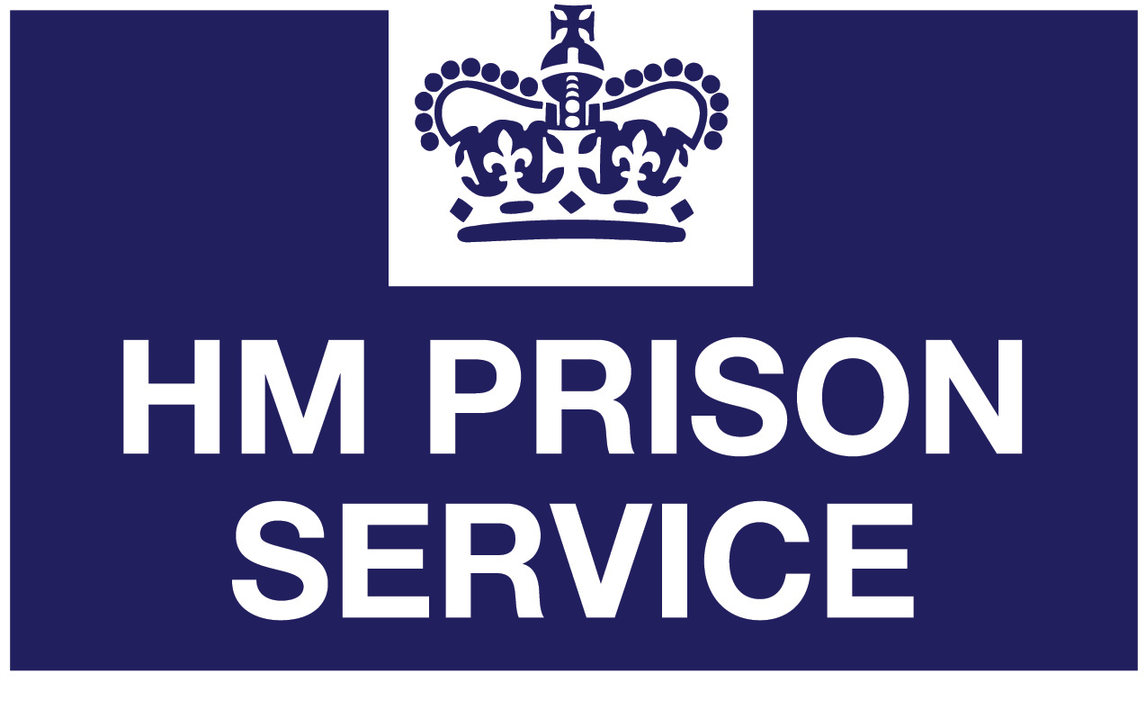

Cheshire Constabulary logo