

**Area name here**

Avon and Somerset

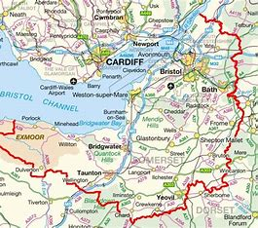

# Annual Report

# 2022-2023

# Introduction

This year has brought significant uplift in resource for Avon and Somerset MAPPA. This has been due to His Majesty’s Prison and Probation Service and Avon and Somerset Constabulary working together to build the evidence to demonstrate the requirements and the added value that the Multi Agency Public Protection Arrangements bring to the safety of the public and the management of MAPPA offenders. The impact of this will be felt in years 2023 – 2024 as 2022 – 2023 has still been significantly challenging, but the successful recruitment will bring together expertise from both police and probation into risk management across all agencies.

During this year we have recruited a new Lay Adviser and are grateful for their voluntary service as our critical friend. They report that they have been attending appropriate meetings, and will be in a better position to give fuller feedback after a year in post. We are also about to recruit for our second Lay Adviser.

The decision for Somerset to become one unified council area and for the Health Trusts to amalgamate means that we have changes to plan for to incorporate new structures and respond to new ways of working. MAPPA in Avon and Somerset are seeing a greater involvement in Health and particularly welcome the expertise from Integrated Care Boards and Health.

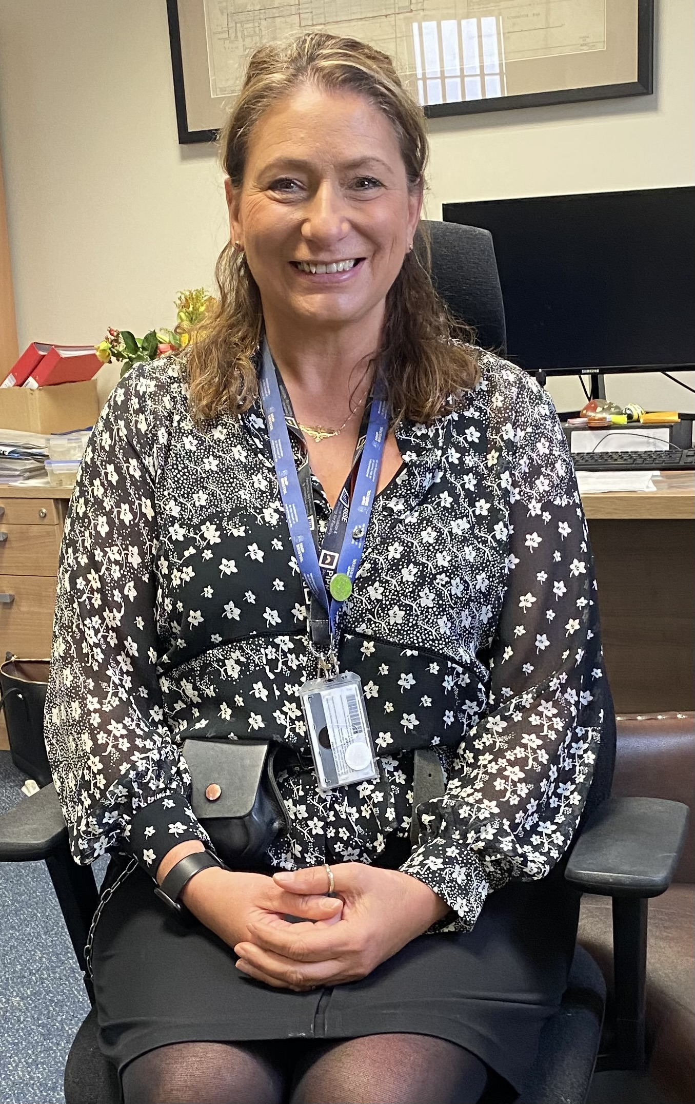

The publication of national reports involving learning in relation to MAPPA, offender management and agencies working together continues to be monitored by the MAPPA Strategic Management Board to ensure that we incorporate learning, review against our own practices and implement positive change. Our briefings to MAPPA Chairs and to the Strategic Management Board aim to propel this learning as far as possible.

We are hoping that the coming year will bring stability of resources, and also an expansion of our ability to provide learning opportunities and briefings for agencies involved in the risk management of MAPPA offenders.

# Liz Spencer Jon Reilly Vanessa Prendergast

Assistant Chief Officer Assistant Chief Constable Interim Governor

Probation Service Avon and Somerset Constabulary HMP Bristol

# What is MAPPA?

MAPPA background

MAPPA (Multi-Agency Public Protection Arrangements) are a set of arrangements to manage the risk posed by individuals who have committed the most serious sexual, violent and terrorist offences (MAPPA-eligible individuals) under the provisions of sections 325 to 327B of the Criminal Justice Act 2003.

They bring together the Police, Probation and Prison Services in each of the 42 Areas in England and Wales into what is known as the MAPPA Responsible Authority.

A number of other agencies are under a Duty to Co-operate (DTC) with the Responsible Authority. These include Social Services, Health Services, Youth Offending Teams, Department for Work and Pensions and Local Housing and Education Authorities.

Local Strategic Management Boards (SMB) comprising senior representatives from each of the Responsible Authority and DTC agencies are responsible for delivering MAPPA within their respective areas. The Responsible Authority is also required to appoint two Lay Advisers to sit on each MAPPA SMB.

Lay Advisers are members of the public appointed by the Minister with no links to the business of managing MAPPA-eligible individuals act as independent, yet informed, observers; able to pose questions which the professionals closely involved in the work might not think of asking. They also bring to the SMB their understanding and perspective of the local community (where they must reside and have strong links).

How MAPPA works

MAPPA-eligible individuals are identified and information about them is shared between agencies to inform the risk assessments and risk management plans of those managing or supervising them.

That is as far as MAPPA extend in the majority of cases, but some cases require more senior oversight and structured multi-agency management. In such cases there will be regular MAPPA meetings attended by relevant agency practitioners.

There are 4 categories of MAPPA-eligible individual:

* **Category 1** –subject to sex offender notification requirements;
* **Category 2** – mainly violent offenders sentenced to 12 months or more imprisonment or a hospital order;
* **Category 3** – individuals who do not qualify under Categories 1, 2 or 4 but whose offences pose a risk of serious harm.
* **Category 4** – terrorism convicted and terrorism risk individuals

There are three levels of management to ensure that resources are focused where they are most needed; generally those presenting the higher risks of serious harm.

* **Level 1** is where the individual is managed by the lead agency with information exchange and **multi-agency support** as required but without formal MAPPA meetings;
* **Level 2** is where formal MAPPA meetings are required to manage the individual.
* **Level 3** is where risk management plans require the attendance and commitment of resources at a senior level at MAPPA meetings.

MAPPA are supported by ViSOR. This is a national IT system to assist in the management of individuals who pose a serious risk of harm to the public. The use of ViSOR increases the ability to share intelligence across organisations and enables the safe transfer of key information when high risk individuals move between areas, enhancing public protection measures. ViSOR allows staff from the Police, Probation and Prison Services to work on the same IT system, improving the quality and timeliness of risk assessments and interventions to prevent offending.

MAPPA and Terrorism

The government published an Independent Review of the MAPPA used to Supervise Terrorism and Terrorism-risk individuals on 2 September 2020 and published its response on 9 December. Both documents are available at <https://www.gov.uk/government/publications/multi-agency-public-protection-arrangements-review>. The report made a number of recommendations, the majority of which have been implemented, including via the Counter-Terrorism and Sentencing Act 2021 and the Police, Crime, Sentencing and Courts Act 2022. The Secretary of State has also revised the statutory MAPPA Guidance on terrorism offenders.

The Probation Service, via its National Security Division, has created a specialist dedicated and highly skilled workforce, which provides an enhanced level of management and intervention for the most high-risk, complex and high-profile individuals in the community. This includes the management of terrorist connected and terrorist risk offenders. The NSD and Counter-Terrorism Policing work closely with local SMBs to ensure the robust management of terrorism cases. Data on Category 4 individuals is not included in this report due to data protection issues related to low numbers. This data will be aggregated and published nationally.

All MAPPA reports from England and Wales are published online at: [www.gov.uk](http://www.gov.uk)

# MAPPA Statistics

MAPPA-eligible individuals on 31 March 2023

|  |  |  |  |  |
| --- | --- | --- | --- | --- |
|  | Category 1: Subject to sex offender notification requirements | Category 2: Violent offenders | Category 3: Other dangerous offenders | Total |
| Level 1 | 1776 | 406 |  | 2182 |
| Level 2 | 5 | 13 | 11 | 29 |
| Level 3 | 0 | 0 | 1 | 1 |
| Total | 1741 | 419 | 12 | 2172 |

MAPPA-eligible offenders in Levels 2 and 3 by category (yearly total)

|  |  |  |  |  |
| --- | --- | --- | --- | --- |
|  | Category 1: Subject to sex offender notification requirements | Category 2: Violent offenders | Category 3: Other dangerous offenders | Total |
| Level 2 | 36 | 54 | 49 | 139 |
| Level 3 | 2 | 4 | 0 | 6 |
| Total | 38 | 58 | 49 | 145 |

|  |  |
| --- | --- |
| Category 1 cautioned or convicted for breach of notification requirements | 80 |

|  |  |
| --- | --- |
| Category 1 who have had their life time notification revoked on application | 14 |

Restrictive orders for Category 1 offenders

|  |  |
| --- | --- |
| Sexual Harm Prevention Order (SHPO) | 144 |
| SHPO with foreign travel restriction | 1 |
| Notification Order | 1 |

|  |  |
| --- | --- |
| Number of individuals who became subject to sex offender notification requirements following a breach(es) of a Sexual Risk Order (SRO) | 2 |

Level 2 and 3 individuals returned to custody

|  |  |  |  |  |
| --- | --- | --- | --- | --- |
| Returned to custody for breach of licence | Category 1: Subject to notification requirements | Category 2: Violent offenders | Category 3: Other dangerous offenders | Total |
| Level 2 | 7 | 13 | 9 | 29 |
| Level 3 | 0 | 0 | 0 | 0 |
| Total | 7 | 13 | 9 | 29 |

|  |  |
| --- | --- |
| Breach of SHPO |  |
| Level 2 | 2 |
| Level 3 | 0 |
| Total | 2 |

|  |  |
| --- | --- |
| Total number of individuals subject to sex offender notification requirements per 100,000 population | 114 |

This figure has been calculated using the mid-2021 estimated resident population, published by the Office for National Statistics (ONS) on 21 December 2022, excluding those aged less than ten years of age.

Consistent with previous publications, this figure should be based on mid-2022 estimated resident population; however, the ONS has changed its publication schedule such that the mid-2022 estimates will be published later this year. As such, the current figure may differ from the corresponding figure based on the mid-2022 estimates.

# Explanation commentary on statistical tables

MAPPA background

The totals of MAPPA-eligible individuals, broken down by category, reflect the picture on 31 March 2023 (i.e. they are a snapshot). The rest of the data covers the period 1 April 2022 to 31 March 2023.

(a) MAPPA-eligible individuals – there are individuals defined in law as eligible for MAPPA management because they have committed specified sexual, violent or terrorist offences or they currently pose a risk of serious harm. The majority are managed at Level 1 without formal MAPPA meetings. These figures only include those MAPPA eligible individuals living in the community. They do not include those in prison or detained under the Mental Health Act.

(b) Subject to Sex Offender Notification Requirements – those who are required to notify the police of their name, address and other personal details and to notify of any subsequent changes (this is known as the “notification requirement.”) These individuals are assessed and managed by the police. They may also be managed by probation or health services if they are subject to licence or a hospital order. Failure to comply with the notification requirement is a criminal offence that carries a maximum penalty of 5 years’ imprisonment.

(c) Violent Offenders – individuals convicted of violent offences who were sentenced to imprisonment or detention for 12 months or more, or detained under a hospital order and a small number of individuals convicted of sexual offences who are not subject to notification requirements. These individuals are assessed and managed by the Probation Service, Youth Offending Team or Mental Health Services.

(d) Other Dangerous Offenders – individuals who do not qualify under the other MAPPA-eligible categories, but have committed an offence that indicates that they pose a risk of serious harm which requires management via MAPPA meetings. These individuals are assessed and managed by whichever agency has the primary responsibility for them.

(e) Terrorism and Terrorism Risk Offenders – individuals subject to terrorism offender notification requirements; individuals convicted of terrorism or terrorism related offences who were sentenced to imprisonment or detention for 12 months or more, or detained under a hospital order; and those who have committed an offence and may be at risk of involvement in terrorism-related activity. These individuals are assessed and managed by Counter-Terrorism Police and the National Security Division of the Probation Service.

(f) Breach of Licence – individuals released into the community following a period of imprisonment will be subject to a licence with conditions (under probation supervision). If the individual does not comply with these conditions, the Probation Service will take breach action and the individual may be recalled to prison.

(g) Sexual Harm Prevention Order (SHPO) (including any additional foreign travel restriction).Sexual Harm Prevention Orders (SHPOs) and interim SHPOs replaced Sexual Offence Prevention Orders are intended to protect the public from individuals convicted of a sexual or violent offence who pose a risk of sexual harm to the public by placing restrictions and/or positive obligations on their behaviour. They require the individual to notify their details to the police (as set out in Part 2 of the 2003 Act) for the duration of the order.

The court must be satisfied on the balance of probability that an order is necessary to protect the public (or any particular members of the public) in the UK, or children or vulnerable adults (or any particular children or vulnerable adults) abroad, from sexual harm from the individual. In the case of an order made on a free standing application by a Chief Officer, the National Crime Agency (NCA), British Transport Police (BTP) or the Ministry of Defence Police (MODP), the chief officer/NCA/BTP/MODP must be able to show that the individual has acted in a way since their conviction that makes the order necessary.

The minimum duration for a full order is five years. The lower age limit is 10, which is the age of criminal responsibility, but where the defendant is under the age of 18 an application for an order should only be considered exceptionally.

(h) Notification Order – this requires individuals convicted of qualifying sexual offences overseas to register with the police, in order to protect the public in the UK from the risks that they pose. The police in England and Wales may issue a notification order directly to an offender who is already in the UK or who is intending to come to the UK who has to notify within three days of receipt. Individuals have a right of appeal against notification.

(i) Sexual Risk Order (including any additional foreign travel restriction) –The Sexual Risk Order (SRO) replaced the Risk of Sexual Harm Order (RoSHO) and may be made in relation to a person without a conviction for a sexual or violent offence (or any other offence), but who poses a risk of sexual harm.

The SRO may be made at the magistrates’ court on application by the police, NCA, BTP or MODP where an individual has committed an act of a sexual nature and the court is satisfied that the person poses a risk of harm to the public in the UK or children or vulnerable adults overseas.

An SRO may prohibit the person from doing anything described in it, including travel overseas, or place positive obligations upon them. Any prohibition and/or obligation must be necessary to protect the public in the UK from sexual harm or, in relation to foreign travel, protecting children or vulnerable adults from sexual harm.

An individual subject to an SRO is required to notify the police of their name and home address within three days of the order being made and also to notify any changes to this information within three days.

An SRO can last for a minimum of two years and has no maximum duration, with the exception of any foreign travel restrictions which, if applicable, last for a maximum of five years (but may be renewed).

The criminal standard of proof continues to apply. The person concerned is able to appeal against the making of the order and the police or the person concerned are able to apply for the order to be varied, renewed or discharged.

A breach of an SRO is a criminal offence punishable by a maximum of five years’ imprisonment. Where an individual breaches their SRO, they will become subject to full notification requirements.

Individuals made subject of an SRO are recorded on VISOR as a Potentially Dangerous Person (PDP).

(j) Lifetime notification requirements revoked on application – A legal challenge in 2010 and a corresponding legislative response means there is a mechanism in place that allows qualifying individuals to apply for a review of their notification requirements. Qualifying individuals may submit an application to the police to review their indefinite notification requirements. The police review the application and decide whether to revoke the notification requirements. This decision is made at the rank of Superintendent. Those who continue to pose a significant risk will remain subject to notification requirements for life, if necessary.

Individuals will only become eligible to seek a review once they have been subject to indefinite notification requirements for a period of at least 15 years for adults and 8 years for juveniles.

# Local page: MAPPA in Avon and Somerset

The Multi Agency Public Protection Arrangements were brought into being in 2003, and the MAPPA Guidance issued in order to assist the relevant agencies in dealing with MAPPA offenders. In Avon and Somerset, the arrangements were put in place in 2004, starting with the setting up of the MAPPA Unit based at Police Headquarters and the first meetings of level 2 risk management. These meetings were a revelatory way of working, with information sharing and setting of risk management plans and agreements for risk management at the forefront of the work we do today.

In Avon and Somerset, an innovative approach was taken by the leadership at the time, whereby Police and Probation would always be equal partners in terms of management of offenders in the community, jointly chairing the Strategic Arrangements and Management Board, and jointly chairing the risk management meetings. In this, the leadership have always led the way in the expectation of problem solving, joint ownership of issues and accountability (for MAPPA) and the learning required. This has also led to much greater sustainability and resilience in that a significantly greater number of managers in both organisations have been expected to chair MAPPA meetings and lead on this area of business. This brings a greater knowledge and understanding to wider risk management which the Avon and Somerset area are building on every day. This has also meant that agencies in the community have known that they will be met by this joint approach, with both Probation and Police wanting to support them and share the public protection goals.



From the start our approach has always been that we want to ensure the safety of victims of the crimes, but also potential victims, as well as vulnerable people and children. For this reason, our Victim Contact team are a valued partner in MAPPA, as well as the organisations in the community who do so much to work with victims and survivors of both sexual violence, discriminatory crimes, organised crime and other serious violence up to and including murder.

The MAPPA meetings have always been maintained to be set up on local authority areas, and the Board have resisted any changes to this model in terms of resource maximisation versus locality of delivery due to our belief that services are best delivered locally in relation to public protection in order to maintain public confidence, but also local knowledge about the concerns of the communities, community tensions and any other fears and current issues.



These arrangements have continued in Avon and Somerset to the present day. Additional developments have been brought forward, with Probation staff working within the MAPPA Unit at Police Headquarters, adding to the widespread models of integrated working and sharing of knowledge and expertise that is so essential to this area of work. Police staff have been employed as MAPPA Coordinators as well as Probation trained colleagues, which has had the added benefit of having different career histories and areas of knowledge which has enhanced the credibility of MAPPA, and reinforced the fact that the principles should operate across all areas of business in Police, Probation and Prisons. In the future there would be no reason why we could not have a MAPPA Coordinator from a Prison or other agency background as long as they possess the required skill sets.

Over the last twenty years, additional resources have been provided to the MAPPA Unit, with an increase of resources for MAPPA Coordination, due to the understanding and commitment of both Police and Probation of the critical work that this requires. There has been an increase in the number of MAPPA Administrators who are police employees but part funded by the Probation Service. The National Security Division has also brought added resources to this field with an appointment of a national MAPPA Coordinator and administration team who are building up working relationships with the local MAPPA Teams and providing expertise to regions as well as in the joint management of their own cases.

The number of additional agencies who are now embedded in the management of the most difficult, dangerous or criminal people (and often the most complex, the most vulnerable and most marginalised) has grown exponentially in a very positive fashion. We now have Immigration Enforcement and Electronic Monitoring colleagues with a place on our Strategic board. We incorporated, with the help of a Memorandum of Understanding, HMPS Ashfield (SERCO) to our Board and our MAPPA Arrangements in order to work together and gain public confidence. Youth Justice, Housing, Adult Social Care, Children’ Services, Health and Mental Health are all key components. Recent work has been done to gain the support and knowledge of General Practitioners (GPS) and of Integrated Care Boards.

We have always particularly valued our Lay Advisers – who are our critical friends – who are totally voluntary, and bring the perspective of members of the public to our work. Lay Advisers have been part of the model since its inception, and in Avon and Somerset we have been fortunate enough to have some truly remarkable Lay Advisers who bring challenge, perspective and feedback to our work.

In COVID and times of structural change for organisations, Avon and Somerset MAPPA have maintained the approach of keeping the same processes and systems, and visibility, in order to provide stability for all agencies, so that if the world around was changing, public protection priorities and visibility would remain the same. This does not mean that the management of arrangements always stays the same, but rather that we have sought not to make changes at the same time as other changes are taking place. We have adapted to new technology which has made a difference to resource management, travel time and the number of agencies able to attend our meetings which are largely carried out via Teams. We have been careful with our use of new technology to maintain confidentiality and security.



**What Next for MAPPA In Avon and Somerset?**

The Strategic Management Board accepted the recommendations from the MAPPA Thematic Inspection carried out by His Majesty’s Inspectorate of Probation. We also carefully reviewed the learning for MAPPA in the Coroner’s Report after the Fishmonger’s Hall murders. In addition, we are focussing on Domestic Abuse and Stalking. We want more individuals who are serial domestic abusers to be referred into MAPPA. In Avon and Somerset, a strong Integrated Offender Management approach is building which includes the management of High Harm individuals, those who commit domestic abuse and those who commit serious acquisitive crime. If we have the opportunity to review more individuals who are harming vulnerable people and children, then this will be essential for public safety.



We are also committed to learning, and embedding learning from any Serious Case Reviews we complete, as well as learning from other areas, and we include this in our Business Plan. We are currently looking at the risks and needs of a growing elderly prison population who will eventually be released into the community, and where they are placed, as their care needs will have to be met, but this does not mean their risks diminish and all agencies must have a robust approach to managing this.

We are also considering those who are being released from prison at the end of their sentence. We have to make sure that risk management plans and working together between agencies continues, and that for some individuals we ensure that a lifetime risk management strategy is in place.

The reassurance we would want to give to the public is that the highest priority is given to managing those who come under the MAPPA arrangements. So much of the work which is done goes unseen but it is there being done. Sometimes it is not possible to explain how these resources are being used, due to the nature and confidentiality of the risk management and the profile of the people being managed. However it is important to be clear that this is always done with the interests of the public at heart, in line with legislation and the Human Rights Act in order to ensure proportionality, but also that the rights of members of the public to be protected are paramount.

**All MAPPA reports from England and Wales are published online at:**

[**www.gov.uk**](http://www.gov.uk)





