THE HAMPSHIRE (EAST HAMPSHIRE DISTRICT NO. 44) (PARISH OF WORLDHAM)
DEFINITIVE MAP MODIFICATION ORDER 2020

Notice is hereby given that the above referenced Order has been submitted to the Secretary of State for Environment, Food and Rural Affairs for determination. An Inspector will be appointed by the Secretary of State to determine the Order.

The start date for the above Order is 25 July 2023

Consideration of the Order will take the form of a public local inquiry.

The Inquiry will be held at Alton Maltings, Maltings Close, Alton,

Hampshire, GU34 1DT
on 12 December 2023 at 10.00am.

The effect of the Order, if confirmed without modifications, will be to modify the definitive map and statement for the area by adding a Footpath commencing at a junction with Caker Lane B3004 (Point A on the Order map) and proceeding northwards along western boundary of field to a junction with Footpath 26 (Point B). A total length of 380 metres.

Any queries relating to this Order should be referred to Joanne Reid at The Planning Inspectorate, Rights of Way Section, Room 3/A Eagle Wing, Temple Quay House, 2 The Square, Temple Quay, Bristol, BS1 6PN. Telephone: 0303 444 5136. Email: joanne.reid@planninginspectorate.gov.uk Please quote reference number ROW/3308400 on all correspondence.

Any person wishing to view the statements of case and other documents relating to this Order may do so by appointment at Hampshire County Council, The Castle, Winchester, SO23 8UJ and row.notices@hants.gov.uk Council contact is kim.dawkins@hants.gov.uk

Timetable for sending in statements of case and proofs of evidence Within 8 weeks of the start date by [19 September 2023]
The Order Making Authority must ensure their statement of case is received by the Secretary of State. As soon as possible after the deadline, the Secretary of State will send a copy (excluding copies of any supporting documents - these will be available to view at the Authority’s offices) to everyone who has made an objection or representation and the applicant and any other person who has written to us in respect of the Order.

Within 14 weeks of the start date [ 31 October 2023]
Everyone who has made an objection or representation and anyone who wishes to give evidence at the Inquiry must ensure their statement of case1 is received by the Secretary of State. As soon as possible after the deadline, the Secretary of State will send full copies to the Authority. Copies will also be sent to the applicant, every person who has made an objection or representation and any other person who has written to us in respect of the Order (excluding copies of any supporting documents - these will be available to view at the Authority’s offices).

Within the same period the applicant (if applicable) must ensure their statement of case is received by the Secretary of State. As soon as possible after the deadline, the Secretary of State will send a full copy to the Authority. Copies will also be sent to everyone who has made an objection or representation and any other person who has written to us in respect of the Order (excluding copies of any supporting documents - these will be available to view at the Authority’s offices).

4 weeks before the date of the inquiry [14 November 2023]

The Authority, everyone who has made an objection or representation, the applicant (if applicable) and anyone who wishes to give evidence at the Inquiry must ensure their proof of evidence (together with any summary) is received by the Secretary of State. As soon as possible after the deadline, the Secretary of State will send copies of:

- the Authority’s proof of evidence to everyone who has made an objection or representation, the applicant and anyone who has submitted a statement of case (including copies of any supporting documents – although none should be submitted with a proof of evidence);

- the applicant’s proof of evidence to the Authority, everyone who has made an objection or representation and anyone else who has submitted a statement of case (including copies of any supporting documents – although none should be submitted with a proof of evidence); and

- all other proofs of evidence to the Authority, the applicant, everyone who has made an objection or representation and anyone else who has submitted a statement of case (including copies of any supporting documents – although none should not be submitted with a proof of evidence).

All parties must keep to the timetable set out above and ensure that statements of case and proofs of evidence are received by the Secretary of State on time. Late documents will be returned.

1 If you wish to make a legal submission, this should be submitted at the same time as your statement of case. Otherwise legal submissions will have to be submitted in writing on the day of the inquiry.
We cannot accept any inflammatory, discriminatory or abusive comments. Any documents containing such comments will be returned.

Notice of order for inquiry
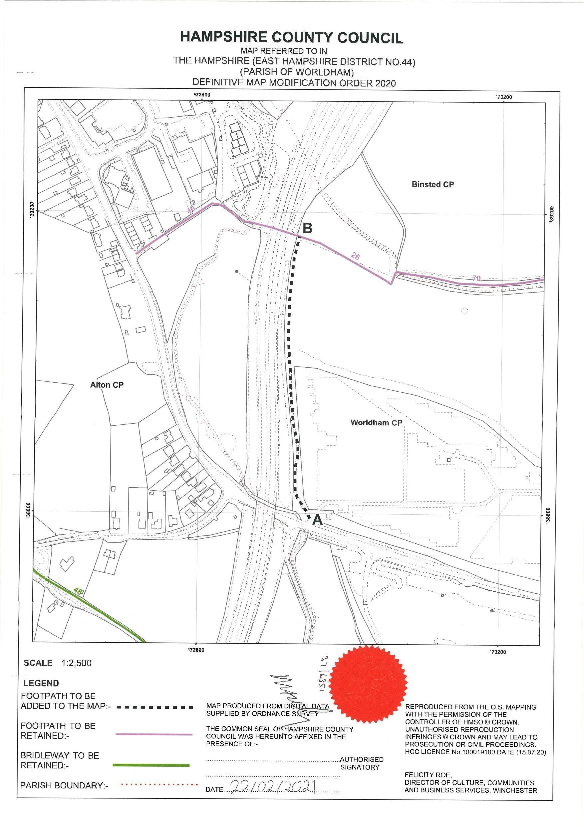
NOTICE OF ORDER

Wildlife and Countryside Act 1981 - Section 53
Hampshire County Council

