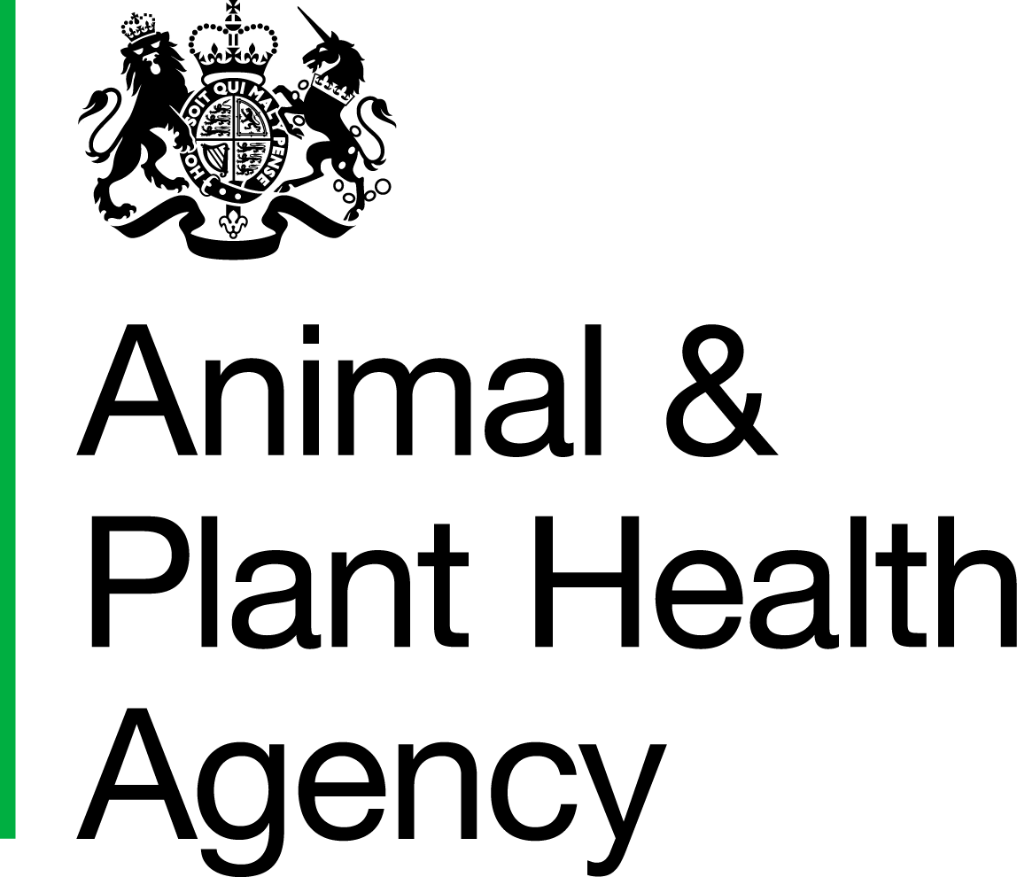 | DPP Test for Tuberculosis using Serum¹

Please send to:  Animal and Plant Health Agency  Starcross VIC  Staplake Mount  Starcross  Exeter  EX6 8PE  Tel: 03000 6000 20  Email: starcross@apha.gov.uk | LABORATORY USE ONLY  Affix barcode here

¹ N.B The DPP test is for SERUM please submit clotted blood or serum ONLY.

Sender:
[Insert name and address]

Name and address of client/owner:
[Insert name and address]

Signed: |  | Date:

- Address for account if different from above  - A copy of this report to be sent to:  Delete as appropriate | Please request TC0611
[Insert name and address] | For charges please go to:  https://science.vla.gov.uk/Tests/PDF/CDT_PdfPriceList.pdf

Continued overleaf

DPP Test for Tuberculosis using Serum

Animal Reference | Species | Date Sample Taken | Sample Reference

DATA PROTECTION
For information on how we handle personal data please go to www.gov.uk and search Animal and Plant Health Agency Personal Information charter

