
Defence Fire Safety Regulator
Fire & Rescue (Oversight Assurance)
DSA-DFSR Form 02
Aerodrome Rescue & Fire-Fighting Service (ARFF)
1000 Metre Assessment Template

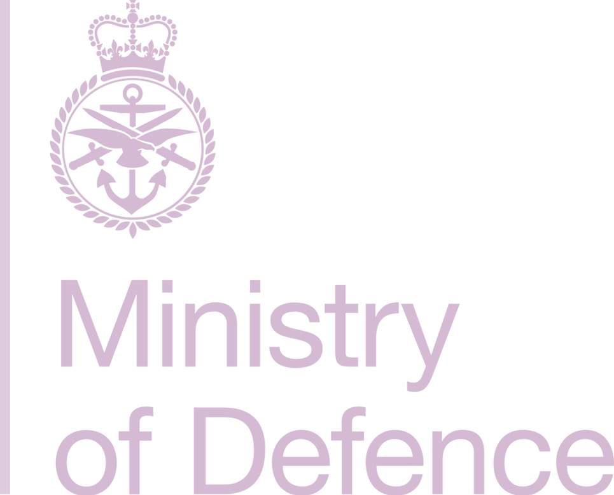


1000m
Intentionally Blank

Contents
Fire Station Manager 2
Aerodrome Operator (AO) 2
Review (2 Yearly Intervals) 3
Introduction 4
Aim 4
Difficult Environment Analysis - 1000m Response Area 5
Conclusion 8
Review 9

B.2 Fire Station Manager
Date of Assessment
Assessor Name
Assessor Signature

B.3 Aerodrome Operator (AO)
AO Name
AO Signature
Date

B.4 Review (2 Yearly Intervals)
Review Date | Reason for Review | Assessor Signature | AO Signature | Remarks

B.5 Introduction
B.5.1 Historical data suggests the majority of aircraft accidents occur in and around the immediate vicinity of aerodromes during the take-off or landing phase of flight. There is a responsibility placed on the AO, whereby aircraft which depart or approach over difficult environments, if required, are to provide specialist facilities or equipment to cover 1000 metres from either threshold
(If required, insert Rotary Wing operational requirements).

This assessment details specific pre-planned access and egress routings to the
(Insert numbers)
undershoot/overshoot areas for (insert numbers)
runway(s).

B.5.2 This assessment provides procedural guidance and procedure in relation to the full or limited response of (Insert Station Name)

Aerodrome Rescue & Firefighting (ARFF) service to incidents in the stated areas.

B.6 Aim
B.6.1 In accordance with DSA DFSR 02: Defence Aerodrome Rescue & Fire-Fighting Regulations DFSR 02: ARFF Response the aim is to assess the approach and departure areas within 1000m of the runway threshold
(If required, insert Rotary Wing operational requirements).

B.7 Difficult Environment Analysis - 1000m Response Area
B.7.1 The following factors were analysed for normal flying operations at:
(Insert Station Name)
The environment, in particular the topography and composition of the surface. | Click or tap here to enter text.
Physical hazards and associated risks that exist within the area. | Click or tap here to enter text.
Options for access and for ARFF purposes. | Click or tap here to enter text.
Hazards, risks and control measures of the options for rescue. | Click or tap here to enter text.
Use of alternative routes. | Click or tap here to enter text.
The environment, in particular the topography and composition of the surface. | Click or tap here to enter text.
Physical hazards and associated risks that exist within the area. | Click or tap here to enter text.
Options for access and for ARFF purposes. | Click or tap here to enter text.
Hazards, risks and control measures of the options for rescue. | Click or tap here to enter text.
Use of alternative routes. | Click or tap here to enter text.
The environment, in particular the topography and composition of the surface. | Click or tap here to enter text.
Physical hazards and associated risks that exist within the area. | Click or tap here to enter text.
Options for access and for ARFF purposes. | Click or tap here to enter text.
Hazards, risks and control measures of the options for rescue. | Click or tap here to enter text.
Use of alternative routes. | Click or tap here to enter text.

B.7.2 Identified risks are recorded on the unit’s risk register, the Aerodrome Operating Hazard Log within the DAM and are elevated to the HoE/AM(MF) with the implications of the ARFF response within the 1000m response area.
B.8 Off Aerodrome Driver Training
B.8.1

B.9 Conclusion
B.9.1

B.10 Review
B.10.1 Review of the 1000 metre assessment is undertaken by the FSM on an operational needs basis and revisited at planned two yearly intervals or when any material change has occurred at the aerodrome which may affect the emergency response.

(Insert - Aerial maps, crash maps, photos of emergency exits’ (airside/landside view) etc.)



(Insert - Crash Map, aerial photographs etc. - identify main routes)

Intentionally Blank

Paragraph 22 Assessment of the approach and departure areas within 1000m of the runway threshold or suitable point(s) for rotary bases), will be carried out by the Senior ARFF Officer present to determine the options available for rescue. In considering the need for any specialist rescue and access routes, the environment of the risk area, in particular the topography and composition of the surface should be considered.

