Dear Adnan Khan,
I am writing to propose three policies to tackle extreme poverty, which is defined as ‘living on less than $1.90 per day’. The key is ensuring that everyone has access to, or can afford, the basic resources needed to survive, whilst economically empowering the poor.

- Solar (photovoltaic) systems
Firstly, governments should provide households in near or extreme poverty with solar photovoltaic (PV) systems. PV systems convert sunlight directly into electrical energy.
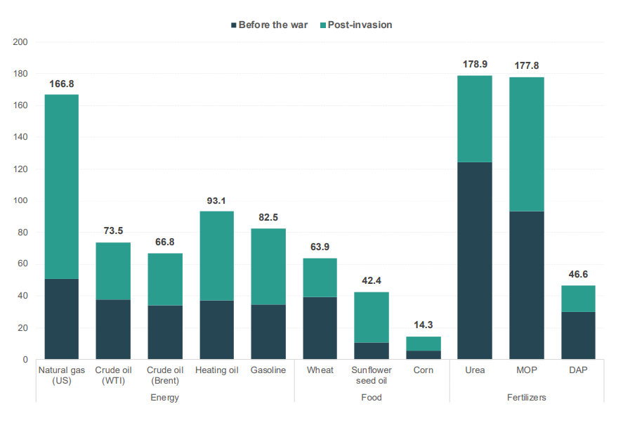
As shown in Figure 1, the war in Ukraine has led to rises in the cost of living, mainly necessities, including food, water and energy. Poorer households spend a larger share of their disposable incomes on utility services. The Chinese government implemented this policy, providing power to over 800,000 families living in poverty. In one county, families had an additional income of over $400. So, if this policy is implemented, households may have more money to spend on other commodities, reducing the detrimental impacts of rising food and energy prices.
Figure 1
Additionally, recipients of solar PV systems should be offered solar training programs. This will enable households to maintain the systems effectively, whist increasing the employability of the individuals. In February 2022, around 20,000 UK households received ‘energy efficiency upgrades’, including solar panels. This generated 9,000 jobs in the green energy sector. Therefore, this policy would create job opportunities in the green energy sector and increase the connectivity of the poor.
However, solar panel installation has high upfront costs which will be a significant burden for the government. Nonetheless, solar PV systems are cheaper than fossil fuels in the long-run. Indeed, the potential rise in employment in the green energy sector could lead to higher tax revenues for the government.

- Financial literacy training
Secondly, governments should run financial literacy training programmes for the poor. This is known as ‘state provision of information’. Such programmes could be community-based, helping the poor navigate through the unique challenges they face, providing personalised paths out of poverty.
A large proportion of the poor are self-employed yet are financially illiterate. This is an ‘information gap’, where consumers (the poor) have insufficient knowledge to make rational economic decisions. In Banerjee and Duflo’s ‘Poor Economics’ they refer to the poor as ‘capitalists without capital’ , illustrating the consequence of financial illiteracy. As such, financial literacy courses for the poor should incorporate modules detailing the importance of asset building for firms. A study in Indonesia found that an increase in financial literacy is associated with a 9.8% increase in entrepreneurship skills. Increased investment in capital amongst poor entrepreneurs could lead to efficiency gains, a decrease in the cost per unit of output and increases in marginal profits. Thus, teaching poor entrepreneurs how to create a successful enterprise could lift households out of poverty.
Moreover, such programmes should teach households how to budget and create financial safety cushions. A unique characteristic of poor is the unpredictability of their incomes and expenses. This ‘unpredictability’ was worsened by COVID, when lockdowns reduced consumer spending, leading to fewer sources of income for the poor. Similarly, the war in Ukraine caused unanticipated rises in household expenses. Through a targeted financial literacy programme, lower-income households can learn how to prepare for and navigate through such situations without facing indebtment. For example, the COVID-19 pandemic led to the loss of assets, pushing many households into extreme poverty. Therefore, understanding the importance of having a financial safety cushion can increase financial resilience, reducing extreme poverty. For instance, a study of Kenya, Tanzania and Uganda found that an increase in financial literacy is associated with a 6.9% decrease in poverty.
The key to the successful implementation of this policy is catering the programme to the specific needs of the poor by regularly conducting surveys and updating the programme accordingly.

- Water wells in schools
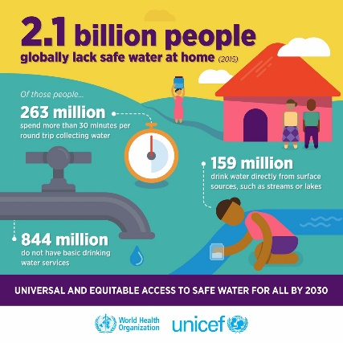
Water is a merit good (a good whose consumption has external benefits). Water is underprovided in the free market, causing market failure. Figure 3 shows the unrealised ‘welfare gain’ when water is underprovided.
Figure 2
By providing water wells in schools, countries can move towards the social optimum position (Q*), thus internalising the external benefits of water consumption.
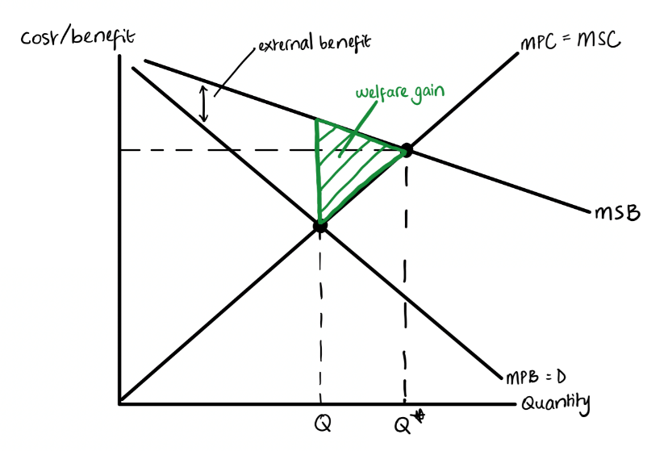
Currently, women and girls in Sub-Saharan Africa spend approximately 40 billion hours each year collecting water, leading to significant opportunity costs (the next best alternative foregone). Women lose time that could have been spent earning money. Girls lose time they could have spent in school. This is often referred to as ‘time poverty’, which is ‘the chronic feeling of having too many things to do and not enough time to do them’. This may lead to lower productivity and a lower chance of escaping poverty.
Figure 3
Providing schools with water wells will lift the burden of collecting water for their families from women and children and ensure access to safe water. Consequently, the attendance rates of girls in schools will increase, the number of children missing school due to water-borne illnesses will decrease (443 million school days are lost due to water-related illnesses right now) and women will be able to utilise their skills in the workplace – all of which are external benefits of this policy. Furthermore, water wells will provide an incentive for poorer children to attend school, offering academic opportunities, promoting skill development and thus, increasing their chances of getting employed in the future, which may lead to an escape from poverty.
Despite the costly nature of this policy, on average, every $1 invested in water and sanitation generates $8 worth of time, productivity and health. So, in the long-run, governments and societies will reap the benefits of this policy. Additionally, this policy will help make up for the significant ‘learning losses’ caused by the pandemic.

Conclusion
These three policies aim to reduce global extreme poverty by providing the poor with necessities, whilst increasing their human capital and creating economic opportunities, thus simplifying the route out of poverty.

Best regards,
Moradeke Akisanya

Bibliography
“2.1 Billion People Lack Safe Drinking Water at Home, More than Twice as Many Lack Safe Sanitation.” 2017. Www.who.int. July 12, 2017. https://www.who.int/en/news-room/detail/12-07-2017-2-1-billion-people-lack-safe-drinking-water-at-home-more-than-twice-as-many-lack-safe-sanitation. (Figure 2)
Banerjee, Abhijit V, and Esther Duflo. 2012. Poor Economics . London: Penguin Books.
Bishop, Katie. 2022. “The ‘Time Poverty’ That Robs Parents of Success.” Www.bbc.com. February 3, 2022. https://www.bbc.com/worklife/article/20220201-the-time-poverty-that-robs-parents-of-success#:~:text=Defined%20as%20the%20chronic%20feeling.
Darilek, Paul. 2010. “Water & Poverty.” https://thewaterproject.org/resources/twp-handouts.pdf.
Dembitzer, Benny. 2009. The Attack on World Poverty. Merlin Press.
Department for Business, Energy & Industrial Strategy, and Lord Callanan. 2022. “Funding for Energy Efficiency Upgrades Will Slash Fuel Bills for 20,000 Social Housing Properties.” GOV.UK. February 7, 2022. https://www.gov.uk/government/news/funding-for-energy-efficiency-upgrades-will-slash-fuel-bills-for-20000-social-housing-properties.
Energy Saving Trust (n.d.). Solar panels. [online] Energy Saving Trust. Available at: https://energysavingtrust.org.uk/advice/solar-panels.
Gavin, Mark. 2015. Edexcel A-Level Economics a Student Guide: Theme 1 Introduction to Markets and Market Failure. Philip Allan.
Healing Waters Media. 2020. “Water Poverty: Can Access to Safe Water Help Poverty? | Healing Waters.” Healingwaters.org. October 18, 2020. https://healingwaters.org/can-access-to-safe-water-diminish-poverty.
Koomson, Isaac, David Ansong, Moses Okumu, and Solomon Achulo. 2022. “Effect of Financial Literacy on Poverty Reduction across Kenya, Tanzania, and Uganda.” Global Social Welfare, December. https://doi.org/10.1007/s40609-022-00259-2.
McCord, Mark , and Annabel Walker. 2022. “The Cost-of-Living Crisis Has Pushed 71 Million People into Poverty - Here’s What Needs to Happen.” World Economic Forum. August 19, 2022. https://www.weforum.org/agenda/2022/08/cost-of-living-crisis-poverty-un/. (Figure 1)
Rank, Mark R, Lawrence M Eppard, and Heather E Bullock. 2021. Poorly Understood What America Gets Wrong about Poverty. New York, Ny, United States Of America Oxford University Press.
Wiggins, Brandon. 2020. “Solar Energy Is Key in the Fight to End Extreme Poverty.” Global Citizen. April 30, 2020. https://www.globalcitizen.org/en/content/solar-energy-poverty-non-profits/#:~:text=In%20China%2C%20solar%20energy%20has.

“Understanding Poverty.” n.d. World Bank. https://www.worldbank.org/en/understanding-poverty#:~:text=Source%3A%20Lakner%20et%20al%20(2022.
Energy Saving Trust. 2022. “Solar Panels.” Energy Saving Trust. October 14, 2022. https://energysavingtrust.org.uk/advice/solar-panels/.
“Solar Energy Is Key in the Fight to End Extreme Poverty.” 2020. Global Citizen. April 30, 2020. https://www.globalcitizen.org/en/content/solar-energy-poverty-non-profits/#:~:text=In%20China%2C%20solar%20energy%20has.
“Funding for Energy Efficiency Upgrades Will Slash Fuel Bills for 20,000 Social Housing Properties.” n.d. GOV.UK. https://www.gov.uk/government/news/funding-for-energy-efficiency-upgrades-will-slash-fuel-bills-for-20000-social-housing-properties.
Banerjee, Abhijit V, and Esther Duflo. 2012. Poor Economics . London: Penguin Books.
Koomson, Isaac, David Ansong, Moses Okumu, and Solomon Achulo. 2022. “Effect of Financial Literacy on Poverty Reduction across Kenya, Tanzania, and Uganda.” Global Social Welfare, December. https://doi.org/10.1007/s40609-022-00259-2.
Koomson, Isaac, David Ansong, Moses Okumu, and Solomon Achulo. 2022. “Effect of Financial Literacy on Poverty Reduction across Kenya, Tanzania, and Uganda.” Global Social Welfare, December. https://doi.org/10.1007/s40609-022-00259-2. ‌
Healing Waters Media. 2020. “Can Access to Safe Water Diminish Poverty? | Healing Waters International.” Healing Waters. October 18, 2020. https://healingwaters.org/can-access-to-safe-water-diminish-poverty/.
Bishop, Katie. n.d. “The ‘Time Poverty’ That Robs Parents of Success.” Www.bbc.com. https://www.bbc.com/worklife/article/20220201-the-time-poverty-that-robs-parents-of-success#:~:text=Defined%20as%20the%20chronic%20feeling.
Darilek, Paul. 2010. “Water & Poverty.” https://thewaterproject.org/resources/twp-handouts.pdf.
Darilek, Paul. 2010. “Water & Poverty.” https://thewaterproject.org/resources/twp-handouts.pdf.

