Dear Adnan Khan,
For years, our pursuit of economic growth has led to exploitation of our natural resources, resulting in the degradation of our environment and the destruction of our ecosystems. Carbon emissions are at the highest it has ever been and by 2050 global waste generation is expected to rise by 70%, impacting the biodiversity that encompasses our planet. A majority of countries globally follow a free market system, where scarce resources are allocated based off signals generated from prices, but this fails to account for the negative externalities in production (such as through pollution and deforestation), often resulting an overconsumption of goods/services greater than the social optimum. Whilst governments around the world have resorted to regulation (such as the UK enforcing blanket bans under the Wildlife and Countryside Act 1981), this often results in increased costs for producers, severely impacting their business operations. Hence, I would like to share 2 innovative policies which incentivise producers to protect to the environment, fuelling the transition into a sustainable economy.
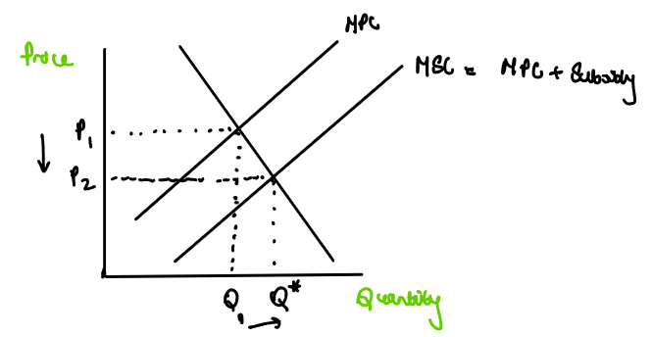
The first suggestion that will facilitate this change is a Payments for Ecosystem Services scheme, or a PES scheme. This approach will compensate producers to invest in capital to enable a change into a more sustainable and environmentally friendly form of production, usually coming in a form of a subsidy from the government to producers such as farmers or manufacturers. Subsidies aim to encourage the production of merit goods (which are typically under produced in the free market) as they are usually associated with providing a positive externality. The graph shows the marginal social cost shifting outwards when a subsidy is added to the marginal private costs, as marginal private cost is greater than the marginal social benefit. This will not only shift the price from P1 to P2, reducing cost of production for firms, but will shift production from Q1 to Q*, reaching the socially optimum level of production. An increase in production accompanied by a reduction in costs will reduce the price of merit goods in the market, thus increasing the consumption of such goods, ensuring allocative efficiency. This increase in demand will create a new market for sustainably produced goods, incentivising not just businesses to use such goods as raw materials (reducing their dependency on unethically sourced materials) but also other producers (as signals which’ll show an increase in price for these goods will cause producers to enter into the market, via the price mechanism). For example, in 1997 Costa Rica implemented the Payment for Environmental Services Program, incentivising forest owners to maintain their forests. Since then, over half of the country’s land area is covered with forest, and around 26% of its territory is devoted to protected areas for wildlife, with Costa Rica being home to 4% of the world’s total biodiversity. Through such efforts, Costa Rica not only won the United Nations Champions of the Earth Awards in 2019, but also has inspired other nations, such as Morocco in 2015, who’ve provided subsidies to farmers to pursue sustainable farming practices to converse water. However, subsidies provide huge administrative costs towards governments, and environmental change in one country will not have a strong global impact. Moreover, around 83% of countries around the world are classified as being ‘developing’ and will prioritise spending on macroeconomic objectives such as economic growth far higher than on the environment. Therefore, I propose that a UN council should form, consisting of ‘developed’ nations, to create a fund to invest in PED schemes in the highest-risk areas in the world for biodiversity, such as the Amazon Rainforest, to create a global effort towards a sustainable transformation.
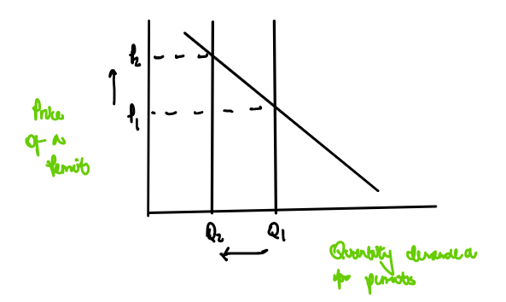
Another policy which would drive this transition is a Cap-and-Trade System, which is a market-based approach to ensure biodiversity. This method will ensure that only a certain limit of resources are used up annually, allowing for governments to meet targets to reduce pollution, for example. In this system, firms are allowed to purchase a permit to exploit a specific resource for a set limit in a market. Firms which have bought a permit are allowed to sell the permit back onto the market, creating a market for permits. However, to reduce the negative externality in production, governments will reduce the limit that can be exploited. The graph shows that at the current cap Q1, the price demanded for a permit is at P1. However, when the permit limit is reduced from Q1 to Q2, prices will increase to P2. As the price of permits will increase over time, producers are incentivised to sell their permits. Dynamically efficient firms will reinvest the profits received from the sale of these permits into greener capital that will allow them to produce goods sustainably. As firms are profit-seeking entities, over time demand for permits may reduce due to higher costs of production, causing firms to change their production methods. For example, in Chesapeake Bay in America, agricultural runoff is resulting in nutrient pollution, where nitrogen levels decreased by 57% since 1985. Therefore, the local government has provided a set limit of permits to firms to restrict the volume of nutrients that can be fed to the soil, aiming to reduce issues such as algal blooms which kill local wildlife. Since its implementation in 2016, the has been a 63% reduction in phosphorous levels, increasing wildlife figures by 22%, protecting local habitats. This model can easily be implemented against deforestation. By forming a coalition of countries with predominantly woodland or tropical terrain, countries can limit the amount of deforestation by distributing permits which restrict the number of trees which can be felled. This will aim to reduce the rate of deforestation as well as encourage firms to a more sustainable form of production.
Overall, whilst these policies have provided significant change in local communities, without global cooperation, our change to an environmentally thriving economy will not succeed. I believe the UK should use its influence as a pioneer in innovation to inspire this change to protect our planet.

Your sincerely,
Arjun Javagal.

Bibliography

Pagolia, S: Payments for Environmental Services in Costa Rica. Last Accessed: 23.06.2023. Available at: Payments for environmental services in Costa Rica - ScienceDirect
Gov.UK: Payments for Ecosystem Services (PES): best practices guide. Last Accessed: 24.06.2023. Available at: Payments for Ecosystem Services (PES): best practice guide - GOV.UK (www.gov.uk)

StudySmarter: Tradeable Pollution Permits. Last Accessed: 22.06.2023. Available at: Tradable Pollution Permits: Diagram & Example | StudySmarter

LSE, Grantham Research Institute on Climate Change and the Environment: Which is better – carbon tax or cap-and-trade? Last Accessed: 23.06.2023. Available at: Which is better: carbon tax or cap-and-trade? - Grantham Research Institute on climate change and the environment (lse.ac.uk)

Chesapeake Bay Program: Nutrient Runoff. Last Accessed: 23.06.2023. Available at: Nutrient Runoff (chesapeakebay.net)

Anderton, Alain: Economics A Level Edexcel. Last Accessed: 24.06.2023.

