NOTICE OF ORDER

Wildlife and Countryside Act 1981
Barnsley Metropolitan Borough Council
(West Riding of Yorkshire County Council Definitive Map and Statement) (Dearne) Modification Order (No. 20) 2022

Notice is hereby given that the above referenced Order has been submitted to the Secretary of State for Environment, Food and Rural Affairs for determination. An Inspector will be appointed by the Secretary of State to determine the Order.

The start date for the above Order is 15th June 2023

Consideration of the Order will take the form of a public local inquiry.

The Inquiry will be held at The Town Hall, Church Street, Barnsley S70 2TA on 24th October 2023 at 10.00am.

The effect of the Order, if confirmed without modifications, will be to modify the Definitive Map and Statement for the Dearne Area by adding a public footpath commencing at the northern end of Rectory Lane, Thurnscoe and proceeding south, east then south along a track to join High Street, Thurnscoe, as shown between the points marked A B C on the Order map (SE 40 NW 4475 0581 4483 0557).

Any queries relating to this Order should be referred to Jessica Weatherby at The Planning Inspectorate, Rights of Way Section, Room 3/A Eagle Wing, Temple Quay House, 2 The Square, Temple Quay, Bristol, BS1 6PN. Telephone: 0303 444 5147. Email: Jessica.Weatherby@planninginspectorate.gov.uk. Please quote reference number ROW3305451 on all correspondence.

Any person wishing to view the statements of case and other documents relating to this Order may do so by appointment at the Branch Library, Shepherd Lane, Thurnscoe, Barnsley. Contact at Barnsley MBC: Ms Cheryl Redford, Tel: 01226773040, Email: cherylredford@barnsley.gov.uk

Timetable for sending in statements of case and proofs of evidence

Within 8 weeks of the start date by [by 10th August 2023]

The Order Making Authority must ensure their statement of case is received by the Secretary of State. As soon as possible after the deadline, the Secretary of State will send a copy (excluding copies of any supporting documents - these will be available to view at the Authority’s offices) to everyone who has made an objection or representation and the applicant and any other person who has written to us in respect of the Order.

Within 14 weeks of the start date [by 21st September]

Everyone who has made an objection or representation and anyone who wishes to give evidence at the Inquiry must ensure their statement of case is received by the Secretary of State. As soon as possible after the deadline, the Secretary of State will send full copies to the Authority. Copies will also be sent to the applicant, every person who has made an objection or representation and any other person who has written to us in respect of the Order (excluding copies of any supporting documents - these will be available to view at the Authority’s offices).

Within the same period the applicant (if applicable) must ensure their statement of case is received by the Secretary of State. As soon as possible after the deadline, the Secretary of State will send a full copy to the Authority. Copies will also be sent to everyone who has made an objection or representation and any other person who has written to us in respect of the Order (excluding copies of any supporting documents - these will be available to view at the Authority’s offices).

4 weeks before the date of the inquiry [by 26th September]

The Authority, everyone who has made an objection or representation, the applicant (if applicable) and anyone who wishes to give evidence at the Inquiry must ensure their proof of evidence (together with any summary) is received by the Secretary of State. As soon as possible after the deadline, the Secretary of State will send copies of:

- the Authority’s proof of evidence to everyone who has made an objection or representation, the applicant and anyone who has submitted a statement of case (including copies of any supporting documents – although none should be submitted with a proof of evidence);

- the applicant’s proof of evidence to the Authority, everyone who has made an objection or representation and anyone else who has submitted a statement of case (including copies of any supporting documents – although none should be submitted with a proof of evidence); and

- all other proofs of evidence to the Authority, the applicant, everyone who has made an objection or representation and anyone else who has submitted a statement of case (including copies of any supporting documents – although none should not be submitted with a proof of evidence).

All parties must keep to the timetable set out above and ensure that statements of case and proofs of evidence are received by the Secretary of State on time. Late documents will be returned.

We cannot accept any inflammatory, discriminatory or abusive comments. Any documents containing such comments will be returned.

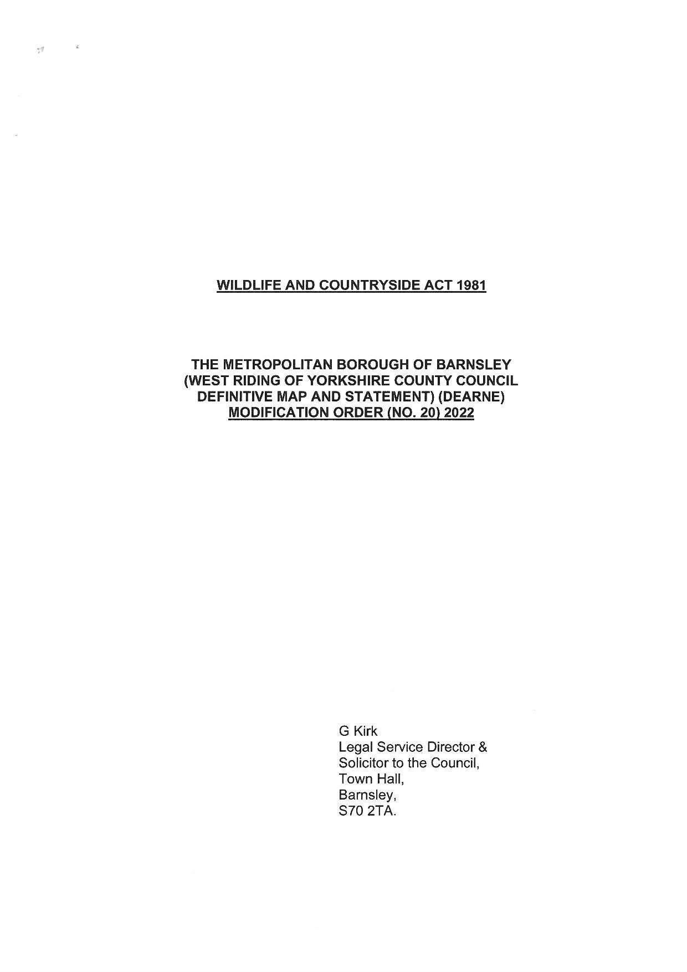
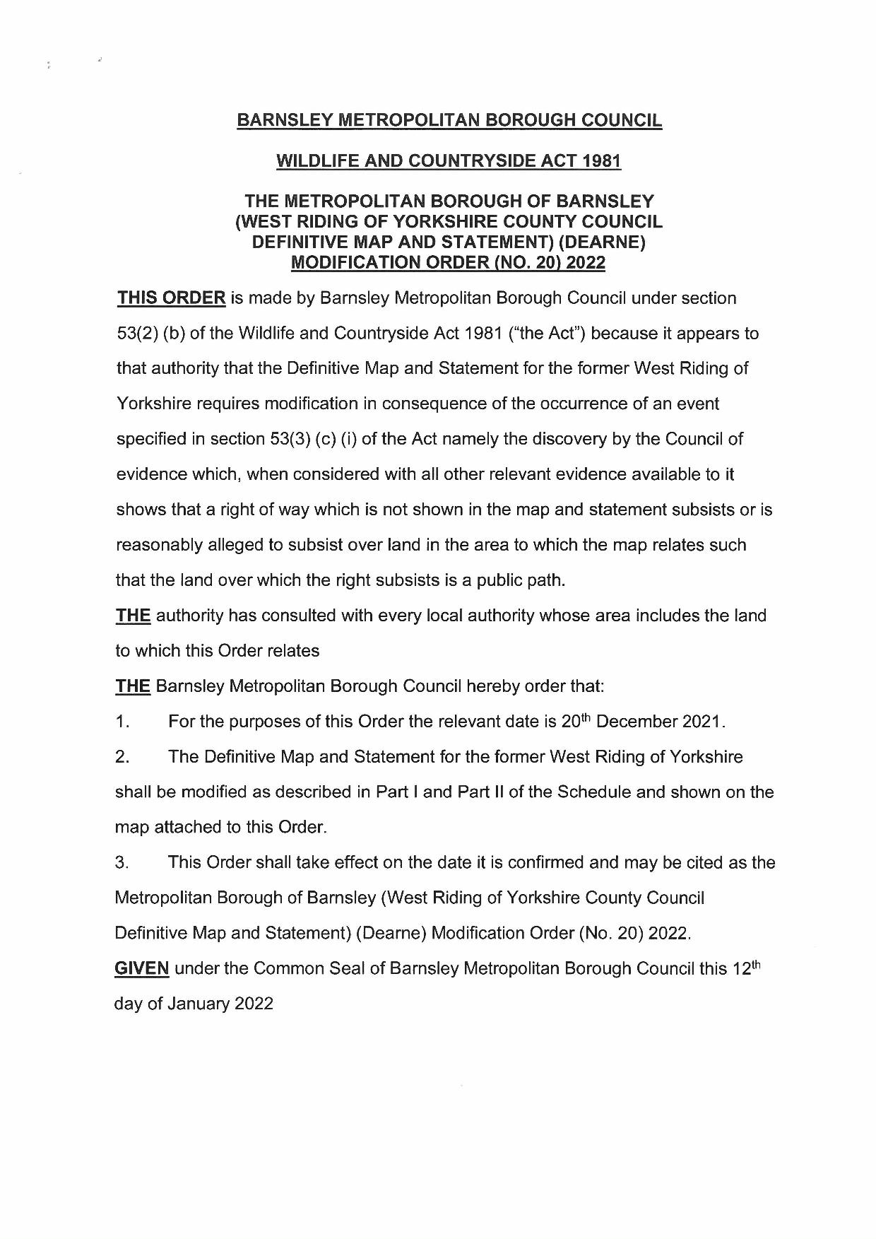
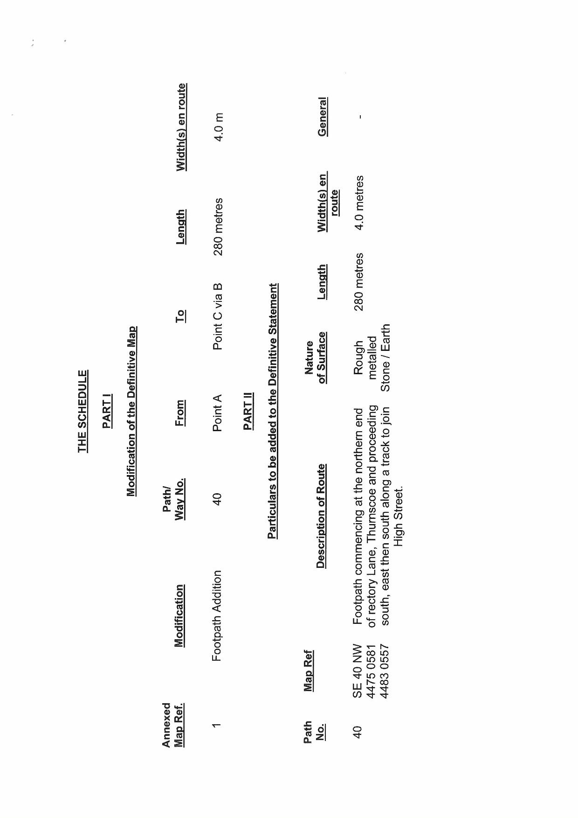
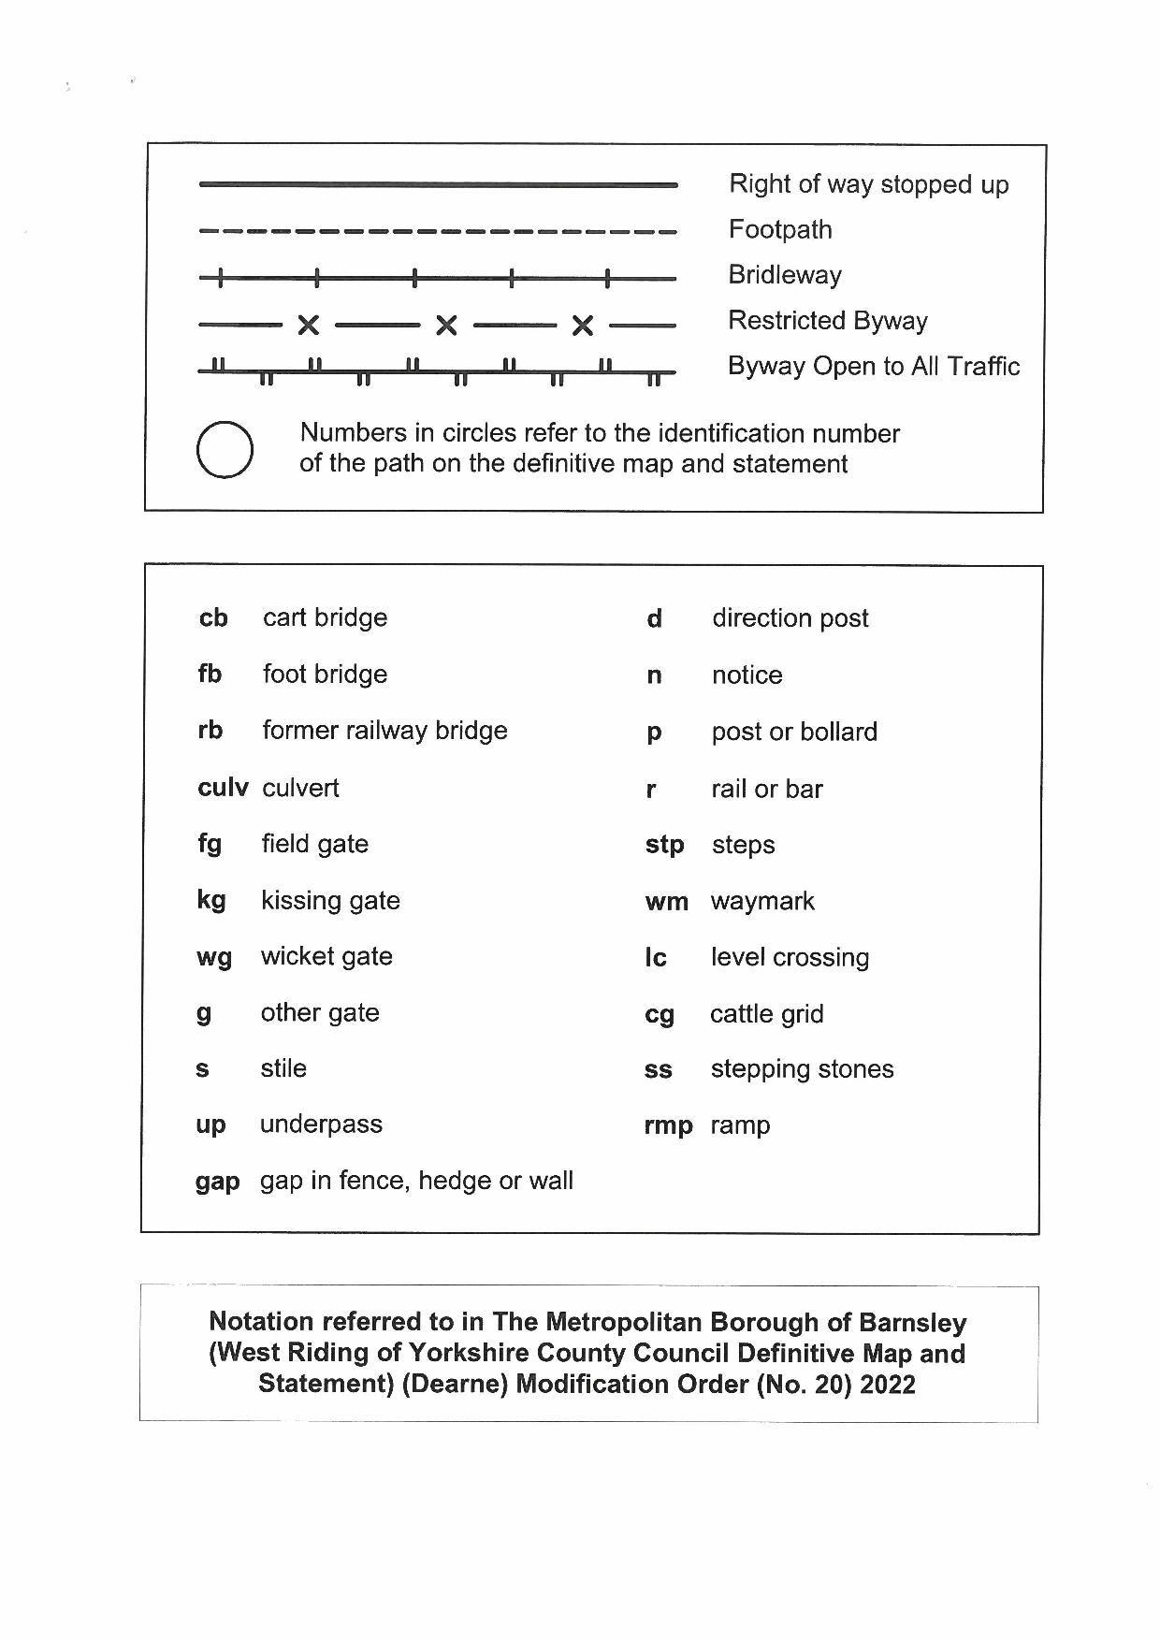
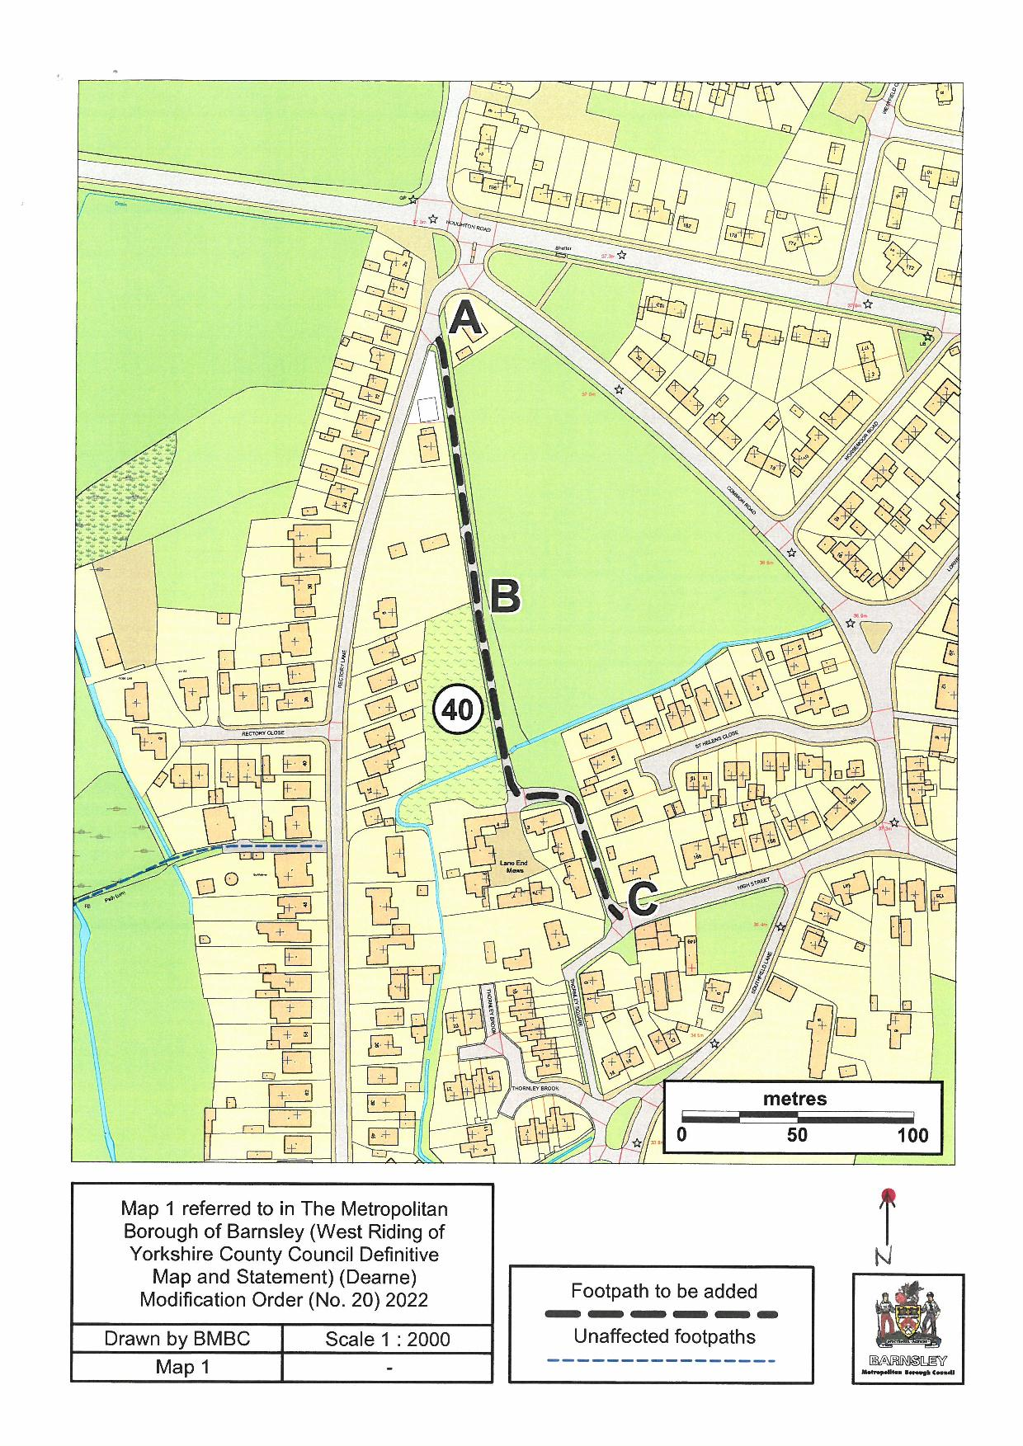
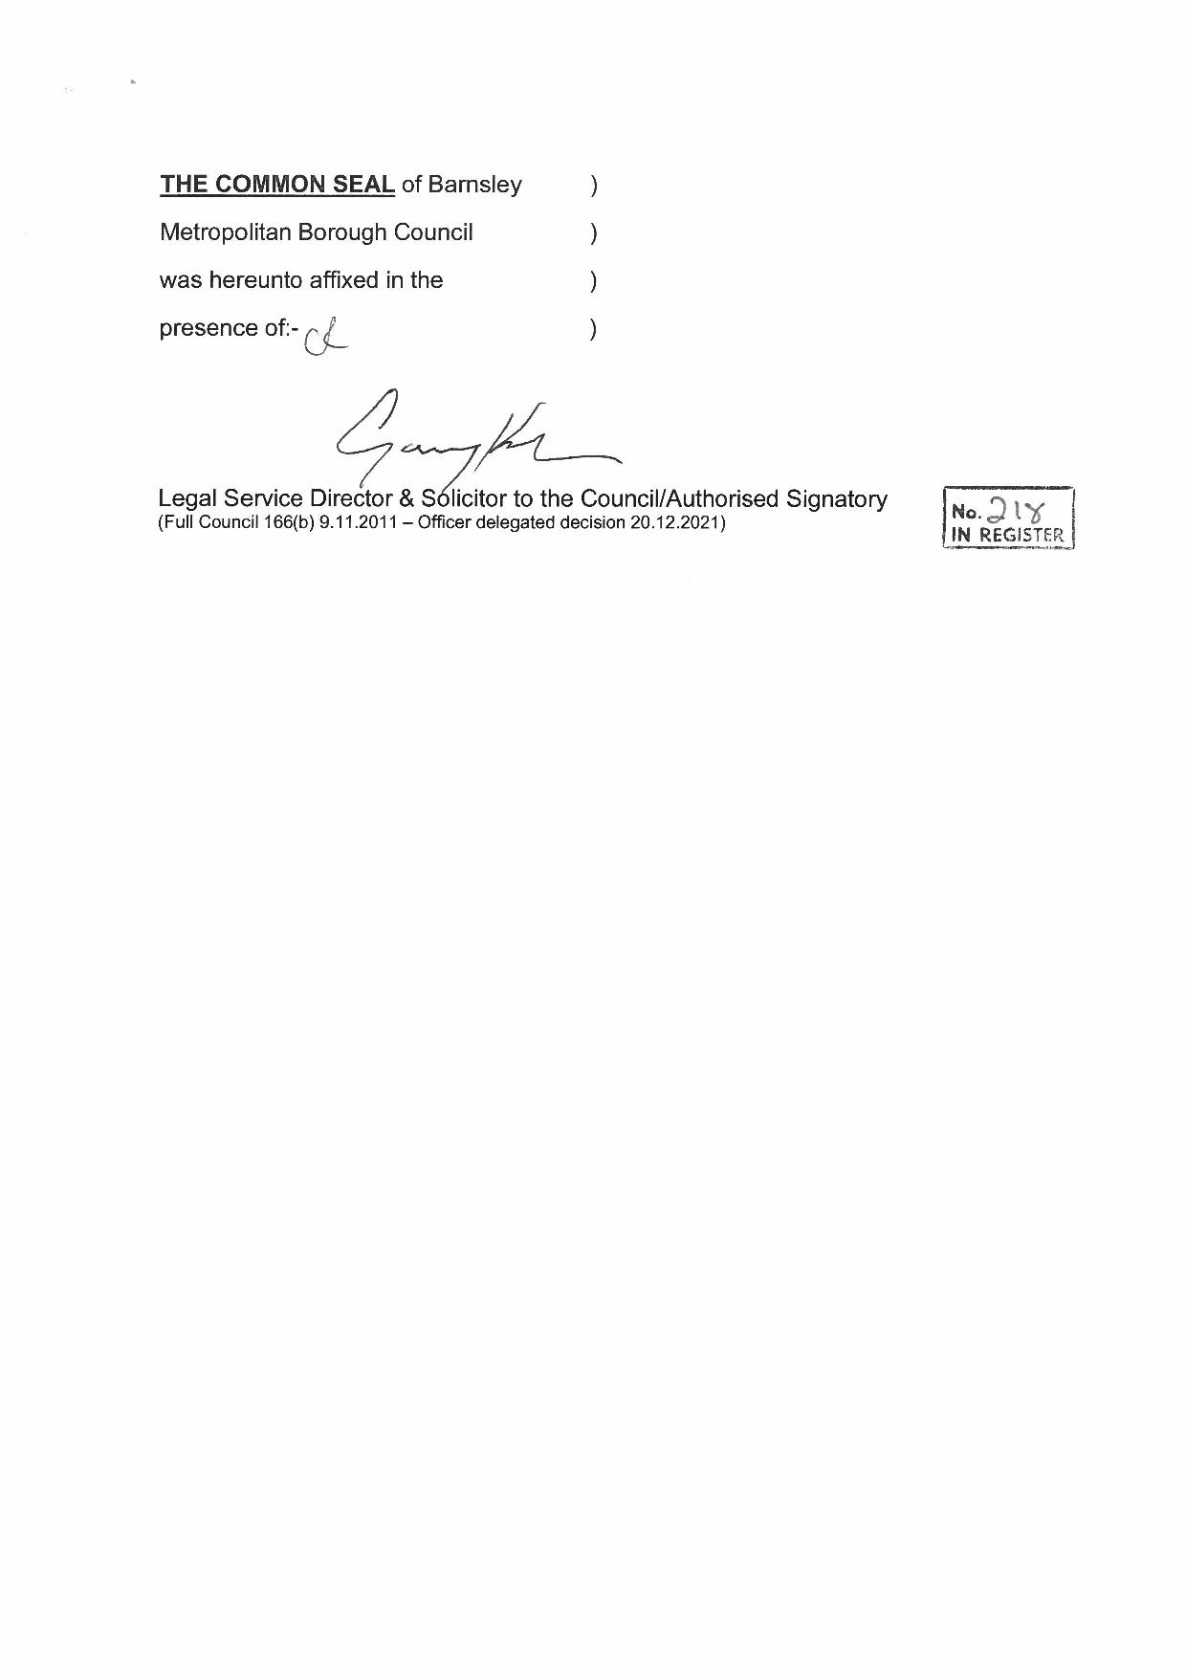

If you wish to make a legal submission, this should be submitted at the same time as your statement of case. Otherwise legal submissions will have to be submitted in writing on the day of the inquiry.

