Order Decision
Site visit made on 18 July 2023
by Gareth W Thomas BSc(Hons) MSc(Dist) DMS MRTPI
an Inspector appointed by the Secretary of State for Environment, Food and Rural Affairs
Decision date: 9 August 2023

Order Ref: ROW/3293515
- This Order dated 22 October 2021 is made under Section 53 (2)(b) of the Wildlife and Countryside Act 1981 (the 1981 Act) and is known as The East Sussex (Public Restricted Byways Long Man 44a and Long Man 44b) Modification Order 2021.
- The Order is dated 22 October 2021 and proposes to modify the Definitive Map and Statement for the area by adding a Public Restricted Byway as set out in the Order plan and described in the Order Schedule.
- There were two objections outstanding when East Sussex County Council submitted the Order for confirmation to the Secretary of State for Environment, Food and Rural Affairs.
Summary of Decision: The Order is confirmed

Procedural Matters
- No party requested an inquiry or hearing into the Order. I have therefore considered this case on the basis of the written representations submitted to me. I made an accompanied site visit on 18 July 2023 in the company of representatives of the Council and representatives of the landowners and Trustees who are statutory objectors for the purposes of the Order.

The Main Issues
- The Order has been made under section 53(2)(b) of the 1981 Act in consequence of the occurrence of events specified in section 53(3)(c)(i) and (ii). If confirmed by me, the effect of the Order would be to add several sections of a Restricted Byway along points A-B-C-D-E to form a continuous Restricted Byway between points A-B-C-D-E.
- From the submissions of the OMA and others, there is no suggestion that I should rely on the provisions of section 31 of the Highways Act 1980 (the 1980 Act) as to whether dedication of the way as a public highway has occurred through public use over a prolonged period. I shall assess whether the documentary evidence is sufficient to infer the dedication of a public right of way at some point in the past based on the balance of probabilities and applying common law principles. Section 32 of the 1980 Act requires a court or tribunal to take into consideration any map, plan or history of the locality, or other relevant document which is tendered in evidence, giving it such weight as appropriate, before determining whether or not a way has been dedicated as a highway.
- The main issue therefore is whether the discovery of evidence which, when considered with all other evidence available, is sufficient to show that in relation to A-B-C-D-E, that a right of way which is not shown in the Definitive Map and Statement (DMS) subsists over land in the area to which the map relates (section 53(3)(c)(i); and that there is no public right of way over land shown in the DMS as a highway of any description or that any other particulars in the map and statement require modification (section 53(c)(iii).
- I shall examine the evidence as a whole to establish whether a public right of way for vehicles exists along the Order routes. However, the Natural Environment and Rural Communities Act 2006 (the 2006 Act) extinguished rights for mechanically propelled vehicles and, should I find in favour of public vehicular rights existing, the way would be recorded as a Restricted Byway.

Reasons

Background and physical conditions
- The Order route in its entirety falls within the parish of Long Man, a rural parish some 5 miles to the west of Eastbourne. The claimed route commences at point A on the Order Map on an existing public Byway Long Man 16a – a track known locally as Robin Post Lane. It extends for some 420 m in a southerly direction within a woodland area to a point B on an existing bridleway Long Man 18c. It continues again in a southerly direction within a now densely wooded area for a further 260m or so to point C and slightly beyond before crossing open fields for a distance of some 385m to point D adjoining the entrance to Hide Cottage. From here, the route follows a gravel farm type track in a south-westerly direction for about 540m before turning gently in a southerly direction for approximately 600m reaching over a railway bridge before proceeding for 100m onto the main trunk road of the A27 at Point E.
- Point D represented the site of the former Glyndebridge Turnpike (the old turnpike) which was closed following The Turnpike Act of 1819 in favour of a new Turnpike - now the A27.
- Although the route at Point A forming a natural entry point into the Order route is visible and understandable, the clarity of the route through woodland thereafter worsens heading southwards towards Point C and where beyond, particularly difficult terrain is encountered before accessing the open field area to the south of Point C in the vicinity of 132kv overhead power lines. Although the objector suggests that A to C was unenclosed, I was able to note the presence of remnants of hedges that are now trees, raised areas with ditches either side that to my mind may reasonably be interpreted as a more formal route between Points A and C. Generally, the route A to C does not follow a continuous alignment however and the sense of direction is not readily discernible through much of this area of scrub woodland.
- Once crossing the area of difficult terrain beyond Point C in a southerly direction, the route heading to Point D generally follows existing hedged field boundaries towards what is agreed was the now defunct east-west ‘Old Turnpike’ road in the vicinity of The Hide, which acts as a marker across otherwise open pasture fields. The evidence suggests that this field was gated and the route unenclosed. It has a different character than the Order route between A–B-C and of that which follows from Point D to E.
- From Point D to E, the Order route follows a farm track crossing the existing railway bridge before reaching the A27. The parties presented evidence in relation to the coming of the railway in these parts, including the Act of Parliament, which realigned the historic route at the point where it met the A27 at Point E. I deal with this later in this decision. However, during my site visit, I was able to inspect a length of a former route to the east of Point E, which was altered when the railway was constructed in the early nineteenth century. Remnants of the former route still exists, including old hedgerows, ditch and remains of gateposts assumed to be of some antiquity. I agree with the objector’s view that this short section formed the original route heading from Folkington northwards towards the old turnpike prior to the railway being constructed although it is the objector’s case that it was never public but rather formed the ‘Back Road’ to Wootton Manor.
- The application was made on the basis of historical documentary evidence with the OMA carrying out its own research and verification of the applicant’s evidence. At this juncture, it is worth noting that the evidence submitted by both the applicant and objectors is very comprehensive. It is particularly noteworthy that the OMA has undertaken its own extensive research and assessment of the substantial evidence submitted. This has been extremely helpful to my understanding and consideration.
- The historical existence of a track for at least in part and which is on or is in proximity to the Order route does not appear to be of issue. Submissions from the landowner and objector acknowledge that there was a historic line of a track that might add weight to it being a highway but it the status of the route as a public highway that is disputed. The submissions from the objector also point to a significant number of inconsistencies, including the precise route of any historic highway, particularly between Points B and D, together with uncertainty as to the alignment of the original line as it approaches the railway beyond Point E. Together, the landowner claims that the evidence undermines the case for a historic highway.
- The OMA does not rely on user evidence.
- As stated above, substantial documentation was submitted in support of the application and similarly in opposition. Some of those documents fail to show the entirety of the claimed route or its precise alignment. I shall not refer to each and every document presented in evidence; rather, for the purposes of this Decision, I shall focus on the core strands of the evidence relied upon by the applicant along with matters of dispute.
- The OMA is persuaded that, on the balance of probabilities, despite a number of ambiguities, the Order route alignment has provenance although no part of the claimed route presently enjoys public highway status. For the purposes of referral to the Planning Inspectorate, the OMA adopts a neutral position on whether the Order should be confirmed.

Documentary evidence
- The OMA investigated a large number of historical maps and documents, old highway and railway records and local historical books and guidebooks that were submitted by the applicant and objector. Whilst it does not rely on any one piece of evidence as conclusive, the OMA submits that overall, on a balance of probability, it points towards the existence of historic public vehicular rights.
- I have decided to set aside references to the trespass cases cited by the objector. Such history is interesting in so far as it indicates that the landowner at the time was keen to exercise his rights over his land holdings. However, it is either unclear what land was precisely the subject of action or that any inference can be drawn that the claimant was actively attempting to remove public highway status of the actual Order route. There is a great deal of ambiguity in this regard with the applicant maintaining that the disputed matter did not affect the Order route at all.
- Although documentation is submitted concerning the 1876 sale and the coming of Mr Gwynne as the new landowner, who was rigorous in protecting his rights over the land, I do not consider that it adds anything in terms of the status of the Order route. The aggressive stance that appears to have been adopted by Gwynne may have contributed to a limited degree to the reluctance by members of the public to use sections of the route and its subsequent physical demise in some sections. This is however mere conjecture with the passing of time and the robustness and relevance of evidence to the case in hand.
- It is to the documentary evidence that I now turn.

Miscellaneous early mapping and records

The Yeakall and Gardner’s Sussex 1778-1783, the Gardener and Cream Map 1795, the Greenwood and Greenwood Map of Sussex 1825 and the Mudges Map updated to 1873
- The Order route features on a number of commercially produced maps of the 18th and 19th centuries although their accuracy is questionable. The Yeakall and Gardner’s Sussex 1778-1783, the Gardener and Cream Map 1795 and the Greenwood and Greenwood Map of Sussex 1825 show the route along with other similarly penned routes, including the route of the old turnpike described above. The key to the 1825 Map indicates how roads were depicted. In similar vein, the Mudges Map updated to 1873 and based on a survey of 1813 also indicates the Order route along with other features still discernible today and also show the new later Lewes to Eastbourne Turnpike (now the A27) as well as the railway. Interestingly, none of these maps show direct access from the route to Wootton Farm. Notwithstanding their lack of fine detail, I attach some weight to these maps as they were produced for sale to the public to depict amongst other things, roadways although as the objector points out, it remains uncertain whether these were public roads.

Turnpike plans
- According to the objector, the creation of the Turnpike (now the A27) in 1821 resulted in the formal closure of the old turnpike as well as the bridleway from Wannock Lane to Monkynpin Green and which allowed the landowner to reorganise his fields north of Point D in particular. The plan of the new turnpike produced by William Figg in 1817 does not show the Order route but also did not appear to show any turnings from the new road between Arlington and Hailsham despite evidence on other maps to the contrary. It also shows Wootton as being south of the road and that the new turnpike eventually took a more southerly route. The objector points to the fact that no toll house was erected in the vicinity of Point E, which may have indicated that the Order route at this point was public. However, it is doubtful whether toll houses would be built at every junction given the aim of turnpikes was to improve the efficiency of those routes to travellers. I take little inference as to the status of the Order route on the basis of these plans.

Tithe records
- Tithe maps were concerned with identifying land on which a tithe was due to the church and officially recorded the boundaries of all areas on which the tithe-charge was appointed. Their purpose was not to identify highways. However, as statutory documents involving the status of land ownership, they were required to have a high degree of accuracy.
- It is generally accepted that no tithe was payable on roads, whether these be private or public although some drift roads could carry a tithe as they were used for pasture and therefore productive. Although tithe documents were not intended to show public rights of way, landowners would have been keen to ensure that roads were accurately portrayed to lessen the burden of this form of taxation.
- The applicant and the OMA agree that the Tithe maps show the Order route between Points A and B as not forming part of any apportionment and is coloured sienna, which would be consistent with highway status. It does not show the route B-C-D with the applicant maintaining that there was no need to do so as it crossed pasture and would have been titheable irrespective of its status. The track from Points D to E was also coloured sienna and did not form part of any apportionment.
- Tithe maps alone are rarely conclusive evidence of the status of a route. However, an un-tithed route containing solid lines and coloured, coupled with other evidence, can give a good indication that a route generally may be considered as a public highway. I agree with the OMA that the roads on the Tithe maps in this case are open to interpretation and should be viewed as such in the balance of considerations.

Railway Records
- It is in relation to railway plans that has generated the greatest debate between the parties. The Railway Acts allowed for compulsory purchase of land to build railways. Although they were not produced to record public rights of way, the plans needed to be accurate and I agree with the OMA that they needed to provide evidence of locations of roads in the vicinity of railway routes with their locations based on 1805 Ordnance Survey Maps and accompanied by a Book of Reference, which had numbered plots and names of landowners. The Railway Clauses Consolidation Act 1845 states a minimum width for a bridge crossing a railway should be 25 feet for public roads, which coincided with the width specified in the Railway Act for this railway.
- The parties agree that the Railway plans of 1839 and 1843 states that the route E-D is a Parish road with the owner as being the ‘Surveyor of Highways’. The railway bridge was not built as originally planned whilst the route beyond the railway to the south where it met the A27 was also moved further to the west and from its former position where it formed a crossroads with Folkington Lane.
- The objector points to the fact that the gradients to the bridge are too steep for public use and its design in the form of a humped back bridge is more typical of a farm track. According to the objector, there are no other similarly designed bridges serving the public that cross the railway between Lewes and Polegate. The width of the road is not capable of permitting two vehicles to pass whilst the width of the railway bridge is also substantially less than the original statutory requirements. In addition, it is also pointed out that no official records exist of any Parish having maintained this bridge. Being gated beyond the bridge, the objector suggests that the reference to a parish road was an error in the Book of Reference and that it was designed specifically to meet the farming needs of Wootton farm.
- By contrast, the applicant suggests that the width and gradients may have altered over time with the strengthening of the bridge, probably in the middle of the last century together with the provision of sidewalks.
- I do not disagree with any of the above and the evidence of the objector in relation to the bridge design is convincing as I was able to note during my site visit. However, I must attach considerable weight to the written evidence presented and do not accept that an error in documentation would have occurred given the need for accuracy and public consultation. The 1843 Railway Plans, the 1844 Diversion plan, the 1877 Diversion plan and the 1910 Finance Act all show the southern section of the Order route northwards as a public road. I also attach weight to the argument that the moving of the final southern section of the route was in connection with the construction of the railway in 1846. Reliance must therefore be placed to the depiction of this part of the route in the 1887 Diversion plan and the 1910 Finance Act, which both indicate the route of D1 to E on its current alignment and as a public road. I attach considerable weight to these documents.

Quarter Sessions Records
- The Quarter Sessions roll 1080 of 1877 although not affecting the majority of the land surrounding the Order route, does contain a number of coloured plans of diversions near Folkington Manor, which include the southernmost section of the claimed route. By 1877 the records show the realigned southernmost section and the crossroads removed. The claimed route is coloured much in the same way as the new turnpike with the new road to Folkington created from the diversion arrangements. The Order route is shown as being taken further than that shown in the railway plans as far as the back entrance to Wootton farm. I agree that the diversions would have been subject of public consultation and scrutiny. Landowners would have been aware of processes affecting their land and would not have sought to prevent public roads being incorrectly identified on their land. I attach considerable weight to these documents.

Ordnance Survey (OS) mapping
- Although the depiction of a way on an Ordnance Survey (OS) map is not, in isolation, evidence of the existence of a highway, the inclusion of a route on OS maps can provide useful evidence in helping to determine the status of a route when combined with other evidence. They are though surveys of land and are indicative as what is on the ground at the given time of the survey.
- The information shown in the Railway plans and Quarter Session Records indicate that there was a strong likelihood that the southern section up to the back entrance to Wootton farm was a public road at that time; however, they fail to show the continuation of the route northwards. It is useful therefore to consider what is shown in the various OS maps.
- The OS maps of 1875, 1878, 1895, 1909, 1910, 1928 and 1939 show Points E-D as a physical route on the ground. Points D-C is not clear however, with the objector claiming that it is a stock drift road and gated at Point D. C-B-A is clearer and is depicted very much in the manner as other byways in the area, including Robin Post Lane. For the objector, it is pointed out that such depiction does not confer public rights while the prominently drawn route between Points E-D is indicative of a track bounded by shaws on both sides to prevent stock wandering over the arable fields. The route north of Point D according to the objector is a driftway created in the eighteenth century over wet grounds on the clay.
- Notwithstanding the limitations of OS mapping, this information lends some support but only in terms of what is shown on the maps as roads and routeways. It cannot provide further conclusive evidence of status. I attach only moderate weight to these documents.

Finance Act 1910
- The Finance Act 1910 required all land to be valued. Sometimes, reference can be found to a possible public right of way in the documentation used as part of the valuation process. Otherwise, where a route is shown uncoloured and unnumbered on the map record so that it is outside of the hereditaments it is indicative of a public highway and usually one which is vehicular.
- In this case, a substantial amount of the claimed route is shown as ‘white’ (uncoloured) road and not treated in terms of the Finance Act as part of the property of the landowner. However, I note that the Finance Act’s primary purpose was not the identification of highways and there may be other reasons for the exclusion of the route. This can only be assigned moderate weight in my decision.

Conclusion on the documentary evidence
- It is apparent that the claimed route is a feature of some antiquity. This potentially applies to a greater extent to the sections D to E and A to C and there is some evidence in support of this section historically being part of a longer route as per the claimed route, which would have connected Folkington to the south and towards Hailsham to the north. This is irrespective of the land changes that took place during the nineteenth century.
- The depiction of the claimed route on the OS maps in the same manner as the connecting highways could be supportive of it forming part of the highway network. However, these maps were not concerned with recording the status of the routes shown. The tithe maps could be indicative of the route being a highway or a private road. They are though helpful in terms of interpreting other evidence of greater relevance.
- As noted earlier in this decision, I take little inference as to the status of the Order route on the basis of the Turnpike plans.
- Some weight should be given to the exclusion of the route from the surrounding parcels on the Finance Act map. This could be supportive of public vehicular rights but also would not be inconsistent with private status.
- It is though, the documentation concerning the railway and the diversions that took place that is decisive. I do not agree with the objector that the gradient of the approach road and railway bridge offers any tangible evidence of status of this part of the route. The construction would have had to take account of the prevailing topographical conditions. The humped-back nature of the bridge is something of a paradox but no evidence has been submitted that would demonstrate that this design would have been anathema to public use. However, and coupled with the Quarter Sessions Records, the evidence suggests that the public would clearly have been consulted and any concerned landowner would have sought to prevent the elevated status being formalised. This is particularly pertinent in this instance given the objector’s elaborate and detailed account of the character of the landowner at the time that these events occurred.
- The evidence taken as a whole appears supportive of the claimed route being a highway. This was also the view of the OMA albeit applying a lesser test. Having regard to my conclusions regarding the various pieces of evidence, I conclude that the evidence as a whole tips the balance slightly in favour of the route being a Restricted Byway. I therefore find on the balance of probabilities that a public restricted byway subsists.

Other Matters
- I am satisfied that the widths of the way as indicated in the Order are consistent with the evidence that has been submitted and what I saw during my site visit.
- In the light of the submissions of the parties, I am persuaded that the documentary evidence is on the balance of probabilities supportive of the claimed route being an ancient vehicular highway. By virtue of the Natural Environment and Rural Communities Act 2006, the public rights for mechanically propelled vehicles are extinguished and the appropriate status for the route is a restricted byway.

Overall Conclusion
- Having regard to these and all other matters raised in the written representations, I conclude that the Order should be confirmed as indicated in the Order.

Formal Decision
- I confirm the Order.

Gareth W Thomas

INSPECTOR

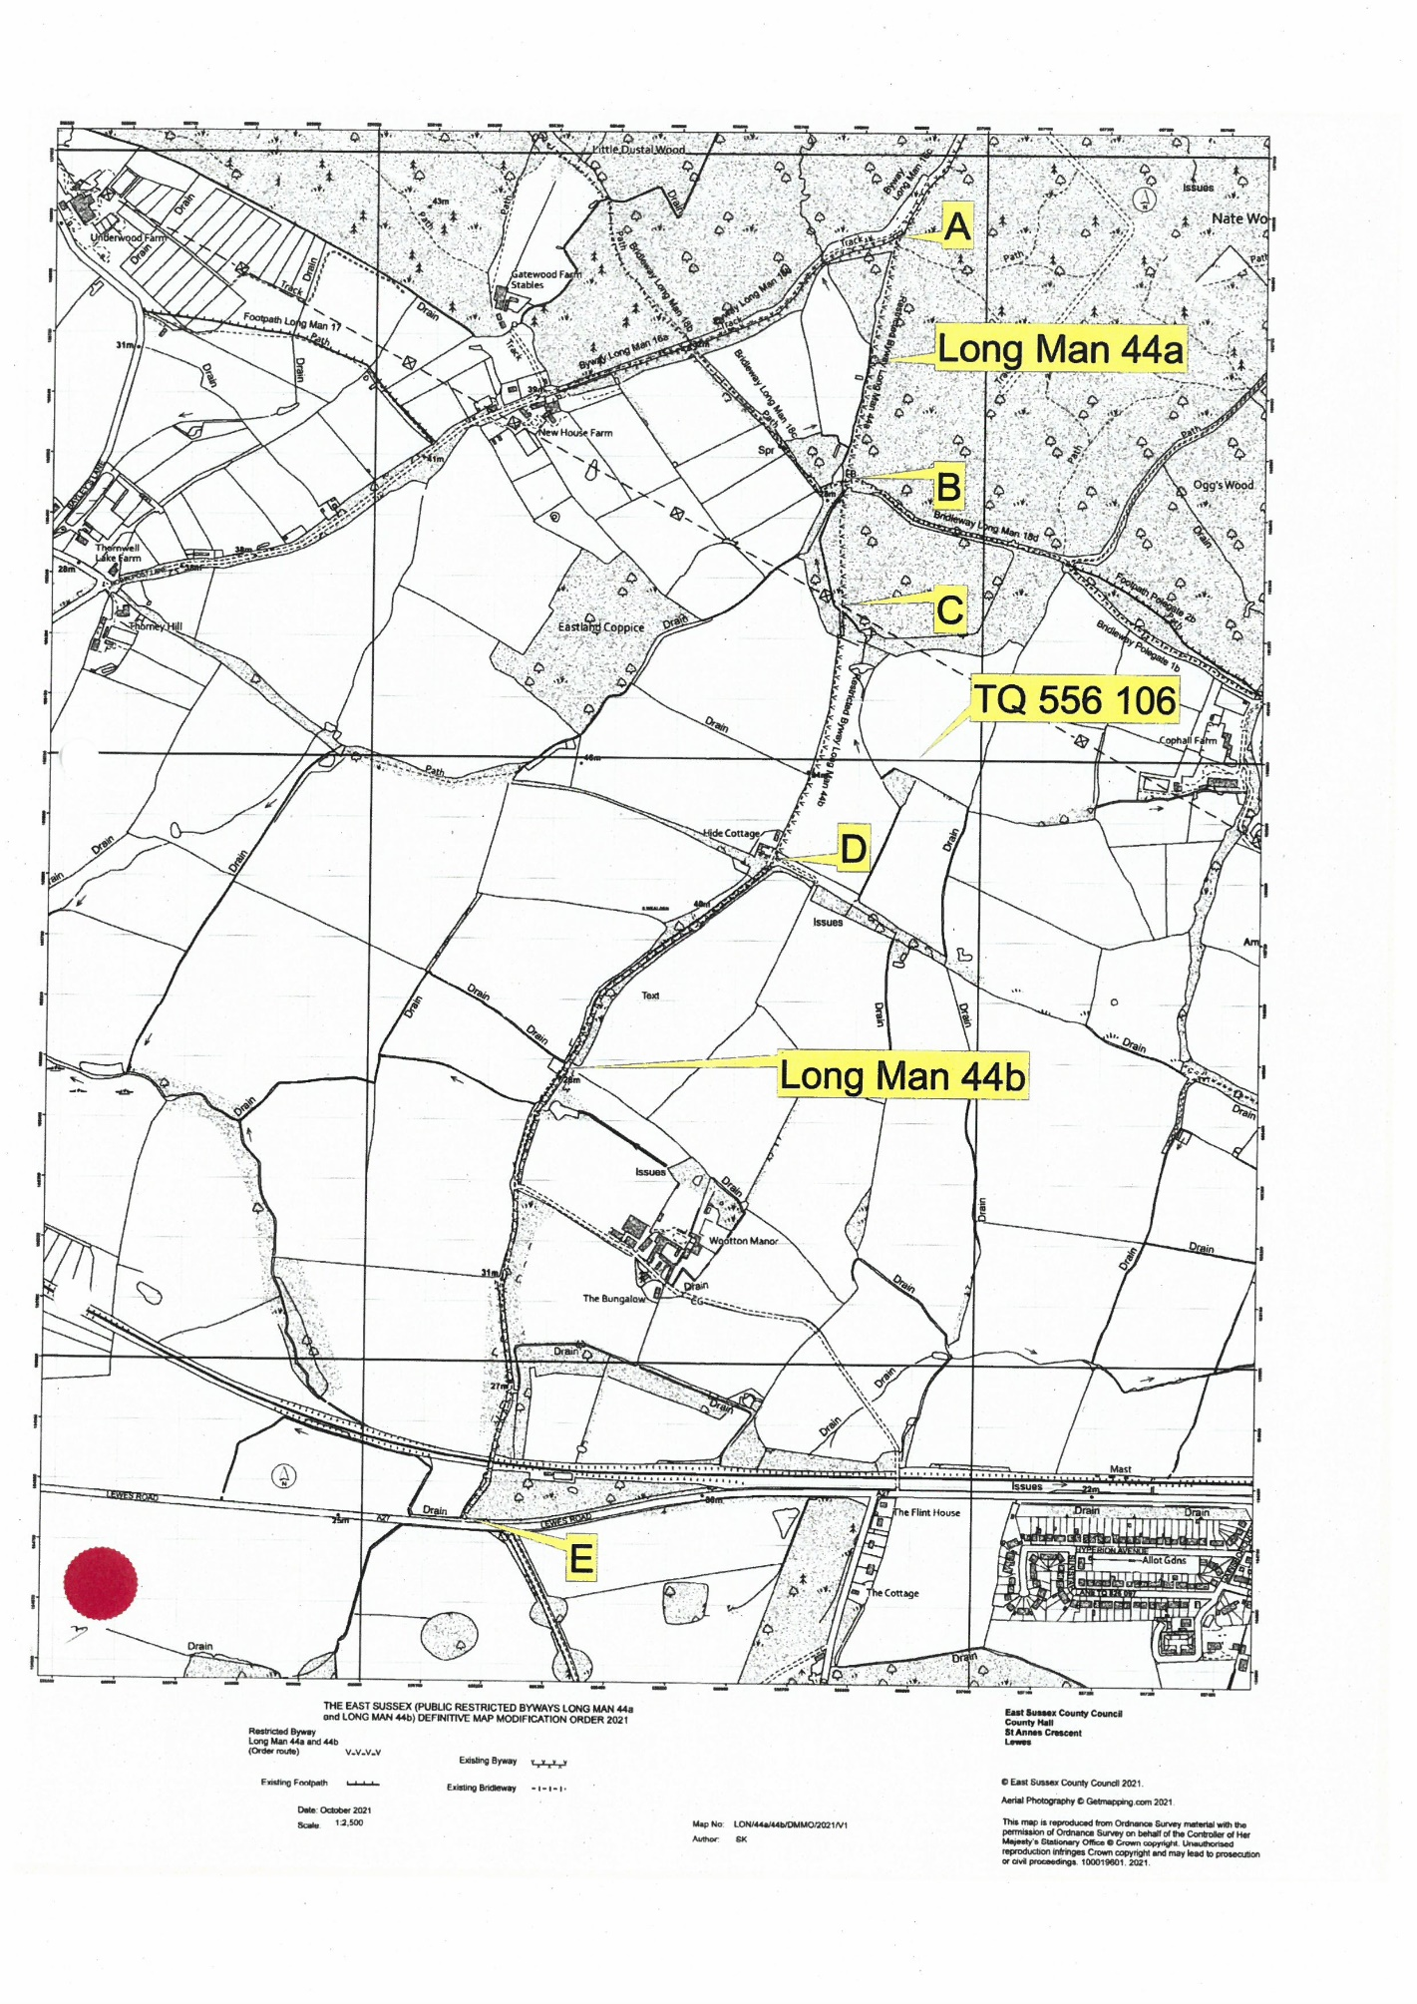

Ms Sabrina Jane Harcourt-Smith of Wootton Manor, Folkington, Polegate and the Trustees of The Folkington 1982 Settlement

