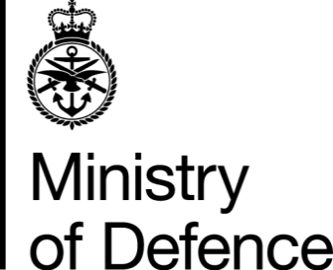

War Pension and Armed Forces Compensation Scheme Complaints – Customer Journey

- Start - Customer submits online complaint form to AFVS Complaint Resolution Team (CRT) Veterans UK acknowledge receipt of claim form, usually within 5 working days.

Note: Click on the link What is your full name? - War Pension / Armed Forces Compensation Scheme Complaints Form – GOV.UK (forms.service.gov.uk) to complete an Online Complaint Form.

Note: Additional Support: Customers are asked to provide any previous Veterans Welfare Service (VWS) and/or Veterans Advisory and Pensions Committee (VAPC) contact when completing the online complaints form.

Note: Additional complaint support can be obtained from the Complaint Resolution Team (CRT) by emailing DBS-AFV-ComplaintResolution-Team@mod.gov.uk or by telephoning the Helpline on 0808 1914218 requesting a call back from CRT. Should customers require assistance at any point during their claim, this may be obtained from Veterans UK Helpline: UK: 0808 1914218 or Overseas: +44 1253 866043 or by email to: Veterans-UK@mod.gov.uk
- CRT calls the customer to discuss the complaint, usually within 3 working days

- If the complaint cannot be resolved verbally at initial contact, CRT will register a Stage 1 or Stage 2 complaint.

Note: A Stage 1 Complaint is registered where the complaint is about a new issue. A Stage 2 Complaint is where the customer has additional evidence to show the stage 1 outcome was incorrect.

Note: Requests to escalate to Stage 2 must be made within 28 days from the date of the Stage 1 response letter

- CRT have 20 working days from the date the online complaint form was received to respond

Note: CRT keep the customer informed of progress via text messaging if this option has been selected on the complaint form

- CRT investigate the complaint by liaising with Subject Matter Expert(s) (SME’s).

- CRT pass SME responses to the Senior Officer for approval and sign off

- CRT send the final response to the customer and close the complaint.

Note: Customer feedback on how we can improve our services will be reviewed and actioned

- If a customer remains unhappy following a Stage 2 complaint, they can approach the Parliamentary and Health Service Ombudsman (PHSO).

Note: Further information about the PHSO: You should normally complain to the PHSO within a year of when you become aware of the problem. The PHSO service is free of charge. The PHSO website has details of what they can look at and how to complain. You can also telephone to PHSO on 0345 0154033 for advice.

- The PHSO will investigate the complaint independently

- The PHSO prepare a provisional report and ask the customer and AFV to comment.

- The PHSO complete the final report, send to customer and AFV, asking AFV to action any recommendations

