

National Travel Survey Digital Diary

BETA REPORT

1st August 2022
Version1.1
David Evans
For Ghost (Digital) Limited


Contents
1. Beta phase summary 4
2. Background 5
2.1 Problems with the paper diary 5
3. Aims of the Project 6
4. COVID-19 Pandemic 7
5. Challenges of the diary itself 8
6. Who the users are 9
6.1 Digital diary keepers (Citizens) 9
6.2 Interviewers (currently NatCen) 9
6.3 Coders/Keyers (currently NatCen) 9
6.4 DfT/NTS/Researchers 10
7. Understanding the user’s wider journey 11
7.1 Research from Discovery and Alpha 11
7.2 Field team input into workshops during Beta 11
7.3 Coder input into workshops during Beta 12
7.4 Insights from other projects 13
8. Scope of Beta 14
8.1 Projected outcomes for public beta at commencement 14
8.2 Beta outputs 14
8.3 Scope of beta in relation to the end-to-end service 16
9. User needs 18
9.1 Who are the users? 18
9.2 Persona user journeys 18
9.3 Top line identified needs 21
9.4 User needs: methodology and confidence 23
9.5 User needs: Accessibility 24
9.6 Addressing specific user needs highlighted in the Alpha Service assessment 25
9.7 How user feedback informed the team 25
10. Challenges 27
10.1 Journey Purpose 27
10.2 Transport method 37
10.3 Journey sharing 38
11. Content design 44
11.1 Consistency with GOV.UK 44
12. Technology 46
12.1 Technical stack specifications 46
12.2 Security 46
12.3 Ensuring the right tools are chosen 47
12.4 Database Schema 50
12.5 Architecture design diagram 51
13. Channel Shift 52
13.1 Process changes at NatCen 52
13.2 Process changes at DfT 52
13.3 Survey participant attitudes towards channel shift 53
13.4 The Role of the Interviewer in Channel Shift and Accessibility 55
13.6 Plan for the digital service being unavailable 60
13.7 Plan for support model in beta/live 61
13.8 Digital take-up strategy 61
13.9 Ongoing work/development 61
14. Support 63
15. Team 64
15.1 Wider engagement 64
15.2 Ways of working 65
16. Performance and analytics 67
16.1 What performance indicators tell us the service is meeting needs? 67
16.2 How do performance indicators inform improvements? 67
16.3 Mandatory KPIs 67
17. Next steps 69

1. Beta phase summary
The beta phase saw us take the prototypes from Alpha and develop them into an end-to-end digital version of the diary.

We also developed an API to allow export of the data, and supported the development of a new area in the NatCen Diary Entry System.

The diary was tested and refined with 120 active users and a full backlog for the next phase has been identified.

The service met the Service Standard and passed the CDDO assessment, with particular commendation for the user work, and can now progress into public beta.

The next phase is a pilot test with a random sample in November 2022, conducted by NatCen, followed by a 1:1 scale parallel run with the paper diary in January 2023. That will allow NatCen to refine the interviewer processes and also assess what the changes to the data will be that come from changing the mode of collection. This will give enough information to allow the integration of the digital diary data with the full National Travel Survey.

2. Background
The National Travel Survey has been running for over 50 years and is a questionnaire and one-week travel diary, completed annually by 15,000 random participants throughout England using pen and paper. Participants are steered and guided by interviewers who visit in person. The resulting diaries are collected and transported to NatCen. NatCen ‘coders’ assign codes to journey purpose, travel method and ticket type. Diaries are transcribed from paper into a Diary Entry System (DES) by NatCen. The data is then weighted and passed to the Department for Transport for further processing.

2.1 Problems with the paper diary
There are several issues with the paper diary specifically identified during Discovery and Alpha:
- Response rates are falling
- Respondents frequently forget to include shorter trips and return journeys
- Fatigue - people record less in the diary as the week progresses
- Accuracy - respondents tend to round figures (e.g. trip 10 minutes long) rather than be exact, and can be poor at estimating journey distances
- Potential recall error - some respondents don’t fill entries in until several days later
- No front-end validation - checking diaries and converting free text to code is resource intensive

3. Aims of the Project
A Discovery phase concluded that a digital diary would better meet user needs than a paper diary, as it could collect better quality data and reduce respondent burden.

The Alpha phase concluded that a Minimum Viable Product digital diary should be built that replicates the paper diary. Once an MVP digital diary has established the baseline data, further development should be carried out to improve the service.

This is a stepping stone in a wider evolution of the National Travel Survey and an increase in scale of the survey itself.

At the Alpha phase the possibility of using a native app was examined. Although it was felt an app had potential in terms of expanding the scope of the survey and possibly ease of use there were too many uncertainties around data collection, geolocation and technical performance to confidently take an app forward into beta development. On the advice of data protection staff, the technical operations team and the Digital Business Partner, establishing an MVP for the diary itself was agreed to be the focus of the beta phase.

4. COVID-19 Pandemic
Alpha took place at the start of 2020 with the COVID-19 pandemic unfolding during the project, and the pandemic effectively ‘broke’ the data series. NatCen had to change mode of collection from paper diaries delivered in person, to transcription of journeys via phone calls with the diary keepers.

However, during the pandemic itself, the need for citizens to access reliable COVID information, and order/report on tests increased the public exposure to, and familiarity with, the Gov.uk design patterns. This came up many times during testing with users saying they knew how to use the site and felt assured by the presentation.

From a statistician’s perspective, with the series ‘broken’ there is now more acceptance that the series integrity could, to some extent, be sacrificed in order to make a bridge into digital collection. If we are going to break the series by adding in a digital collection method, there’s unlikely to be a better time to do it.

5. Challenges of the diary itself
The specific data requirements for the diary and how it’s inputted by the diary keeper can be complex, often leading to diary keepers ‘doing it wrong’. In order to mitigate the potential pitfalls for the user, interviewers need to ‘train’ the diary keepers to input the data correctly. For example:
- Not recording short walks after day 1
- Splitting ‘home-to-home’ journeys (round trips) into two journeys
- What is classed as a journey Stage
- Not to record time waiting for public transport

Changing the mode of collection from paper to digital will have an effect on the data itself. There are significant concerns from statisticians and the field team as to how the mode of collection will alter the data and to what extent.
Input from statistics experts warned that alterations to the way the questions are asked will bias selection (e.g. the paper diary has a blank field while the Alpha prototype digital diary had radio button choices).

From a statistician point of view, rules underpinning the diary can’t be improved until a digital baseline is achieved and understood, so to start with, the digital diary must be as close as possible to the paper diary and the sample must be generated in the same way. The data will still be changed by changing the mode of collection, but by following the format of the paper diary as much as possible, we should be able to tell what the change that comes from that shift will be.

6. Who the users are
There are four different main user types for the diary itself:

- Diary keepers (citizens)
- Interviewers (currently NatCen)
- Coders/Keyers (currently NatCen)
- Data analysts (DfT/NTS/Researchers)

6.1 Digital diary keepers (Citizens)
- Households of citizens selected at random via postcode
- Visited by an interviewer for an hour-long survey
- Invited by interviewer to fill in a one-week travel diary
Top line needs:
- Easy access to diary
- Easy to record data and edit
- Be able to fill it in from mobile devices or desktop

6.2 Interviewers (currently NatCen)
- Visit households and carry out a 1-hour-long interview/survey (CAPI)
- Invite citizens to keep a one-week travel diary
- Show diary keepers how to fill the diary in
- Collect the diary at the end of the week, check and correct data
Top line needs:
- Live monitoring of diary keepers’ input
- Ability to edit/input into diaries on behalf of diary keepers

6.3 Coders/Keyers (currently NatCen)
- Visual check of the diary
- Assign a code to travel method, journey purpose and ticket type
- Input the codes into the Digital Entry System (DES)
Top line needs:
- See diary data at a glance
- See original diary keeper input and interviewer corrections
- Understand diary keeper input
- Be able to assign a code to the three areas they need to

6.4 DfT/NTS/Researchers
- Currently don’t see any data until NatCen have cleaned it
- Receive cleaned statistical data from NatCen
- Perform data analysis to inform evidence base for policy decision-making

Top line needs:

- Better quality data
- Larger sample size and higher response rates
- Account for disruption of 50+ year time series

7. Understanding the user’s wider journey

7.1 Research from Discovery and Alpha
- The Discovery report showed a roughly 50/50 split amongst diary keepers preferences between paper and digital diary. This is further borne out by anecdotal evidence from interviewers
- 90% of citizens who had consented to the interview/questionnaire were happy to fill in the one-week travel diary
- Current pen-and-paper set-up can’t easily be scaled any further
- There is a lot of burden on interviewers, including multiple trips to hand over/collect diaries, chasing respondents and correcting data
- Some demographics under-represented (e.g. young men)
- Some data users place high importance on the time series and don’t want it interrupted, whilst others would be happy for the time series to be sacrificed for better quality and more granular data

7.2 Field team input into workshops during Beta
We pulled on Discovery and Alpha research and spoke to interviewers in workshops.

Interviewers had a wealth of experience and information on how citizens interact with the paper diary. What’s clear is the amount of work put in by the interviewers to ensure the diaries are filled in:

- Interviewers intervene to fill in diaries for those not able to, and correct diaries where mistakes are made
- Interviewers’ local knowledge is invaluable in sense-checking diary keeper input
- Interviewers have an indispensable role in onboarding and supporting diary keepers through the travel week
- Interviewers can ‘correct’ the diaries using their ‘green pen’ often this needs to be done extensively - (see example and quote below)

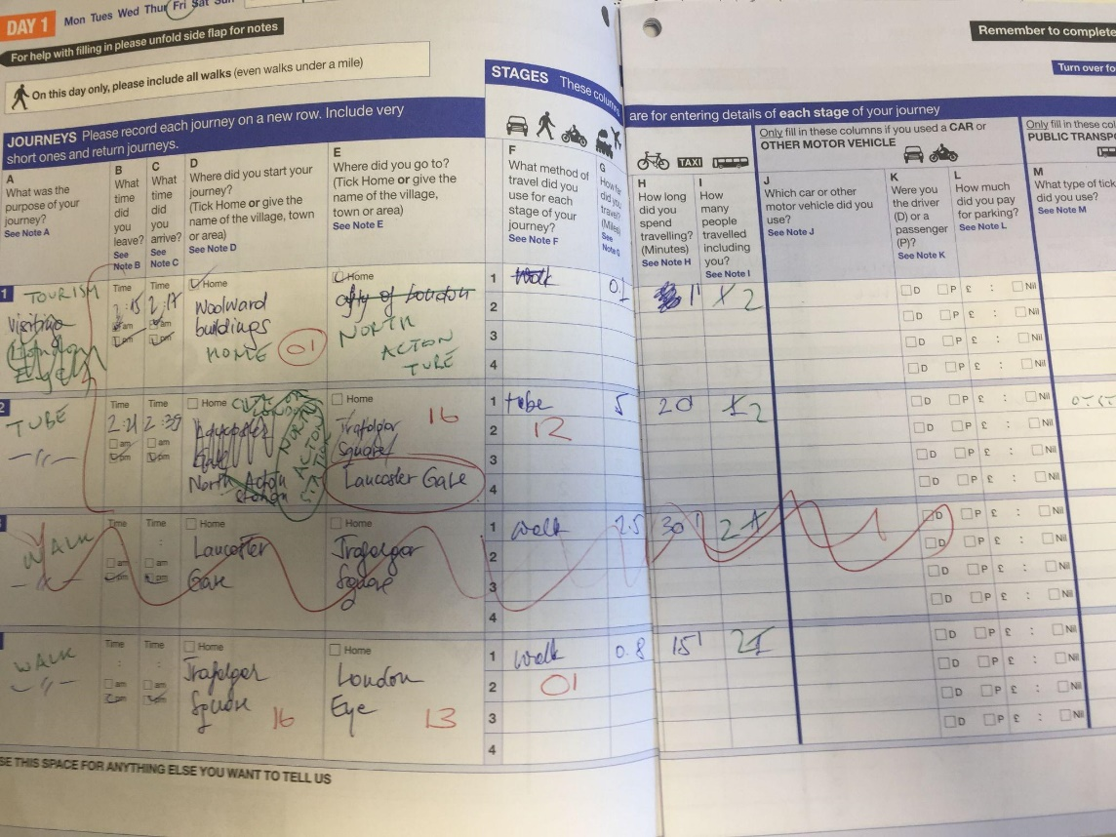
"Sometimes when I get hold of a paper diary, it's a total dog's dinner and they've done absolutely everything wrong.
What I do is get a new blank one and write on the serial number and fill it all in for them on a fresh diary myself. That happens a fair amount actually - as a result, pick-up can take a while."

– MBW - Interviewer

7.3 Coder input into workshops during Beta
We had meetings and workshops with coders and NatCen Diary Entry System (DES) programmers

- Coders write codes directly onto the paper diaries, then transcribe to DES
- Extensive experience and knowledge of transport systems helps coders to assign the right codes
- The majority of journey purposes come under 5-6 main codes
- As the codes are written on the paper diary and only the codes are transcribed to the DES, there is currently no interface for machine learning to be used to automatically suggest codes in response to diary keeper inputs

7.4 Insights from other projects
We specifically drew on feedback from two other projects:

- Intake24 (Food diary)
  - NatCen digital survey in collaboration with Cambridge University
  - NatCen staff and interviewers from project worked with us
- Road Freight Survey
  - Currently in Public beta
  - Uses same technology stack
  - Similar issues with data series change
  - Same development team working on it

The Road Freight Survey was a very similar survey with an invitation email and login setup that drew on the same systems. Perhaps of greater interest though was the effect on the data that came with shifting channel from paper to digital. The scale was a lot smaller, but the completion of surveys and change in the quality of data was very pronounced.

From Intake24 we had a model for how we could design the integration of the sample data with the onboarding process, as well as evidence of how digital uptake could work.

8. Scope of Beta

8.1 Projected outcomes for public beta at commencement
- Web-based digital travel diary that replicates the paper diary as a Minimum Viable Product
- Enhancements to the web-based diary to improve data collection beyond the paper version
- Plan for change of mode, in terms of shift from paper to digital and how the change to the data affects the series
- A secure API to export the data allowing NatCen to import it into their DES

8.1.1 In addition - Post assessment
- A ‘super admin area’ for NatCen’s field team to manage assigning area codes to interviewers
- An API integration that allows the area codes to be generated all at once at the beginning of the survey year
- Additional backlog items including journey sharing, both by proxy and within non-proxy households

8.2 Beta outputs

8.2.1 Web-based digital diary
During beta, we carried out the following:

- 4 waves of pre-private beta user testing to refine MVP (34 active users)
- Accessibility audit from Digital Accessibility Centre
  - Automated testing
  - Testing in person with wide range of actual users with specific needs
- Achieved A and AA standard where no conflict with DfT Principles and standards (e.g, security)
- Further list of recommended user experience adjustments from DAC acted on
- Accessibility statement published and linked to from service
- Private beta tested at scale in the field (89 active users)
  - 66 diary keepers
  - 21 interviewers
  - 2 coders
- Tested with 120 active users overall, including new diary keepers, previous NTS respondents, coders and interviewers
- Users were over a wide geographic scope and included all age groups and a wide range of abilities/confidence levels
- Refined via iterations from user feedback

8.2.2 Enhancements to the digital diary
We developed the following enhancements to the diary:

- Practice day
- Return journey wizard
- Repeat journey wizard
- Coding of transport methods and all ‘to go home’ purposes
- Logging of validation errors
- Viewing of completed stages
- Proxying of diary keepers
- Personalised diary keeper frequent locations list
- ‘Green Pen’ record of interviewer edits while keeping original diary keeper input

8.2.3 API, NatCen DES Development
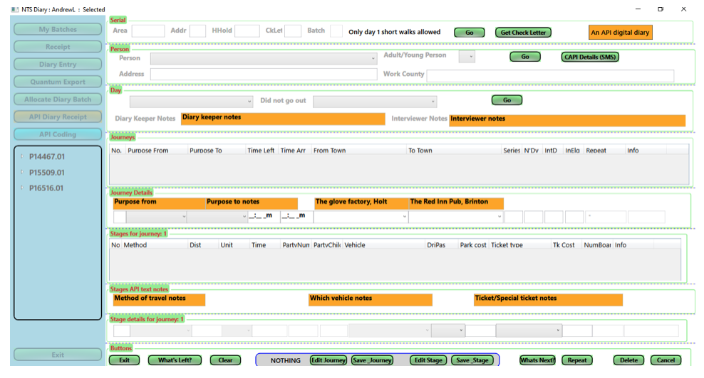
As the paper diaries are transcribed into the Diary Entry System (DES), we needed to design and develop a process to get the data from the digital version of the diary directly into the DES. The DES is a NatCen proprietary system, so we developed an API to export the data (once it’s confirmed as checked and ready for export by an interviewer).
NatCen’s team, supported by the Ghost team, worked to develop a new area for the DES that allows the import and coding of the data from the digital diaries. The API was completed (and is extendible if more questions/outputs are added to the survey). At the point of beta Service Assessment, the DES integration is completed and tested with actual data being imported via the API. The coding screens are also built and ready for a full test during the next phase which is the pilot run of November 2022. In that test we’ll make sure the sample data is fully integrated and working properly in the field.

8.3 Scope of beta in relation to the end-to-end service
The Service Blueprint for the full service is included in this report as Appendix 2 - this diagram shows where on the full service the scope of beta falls:
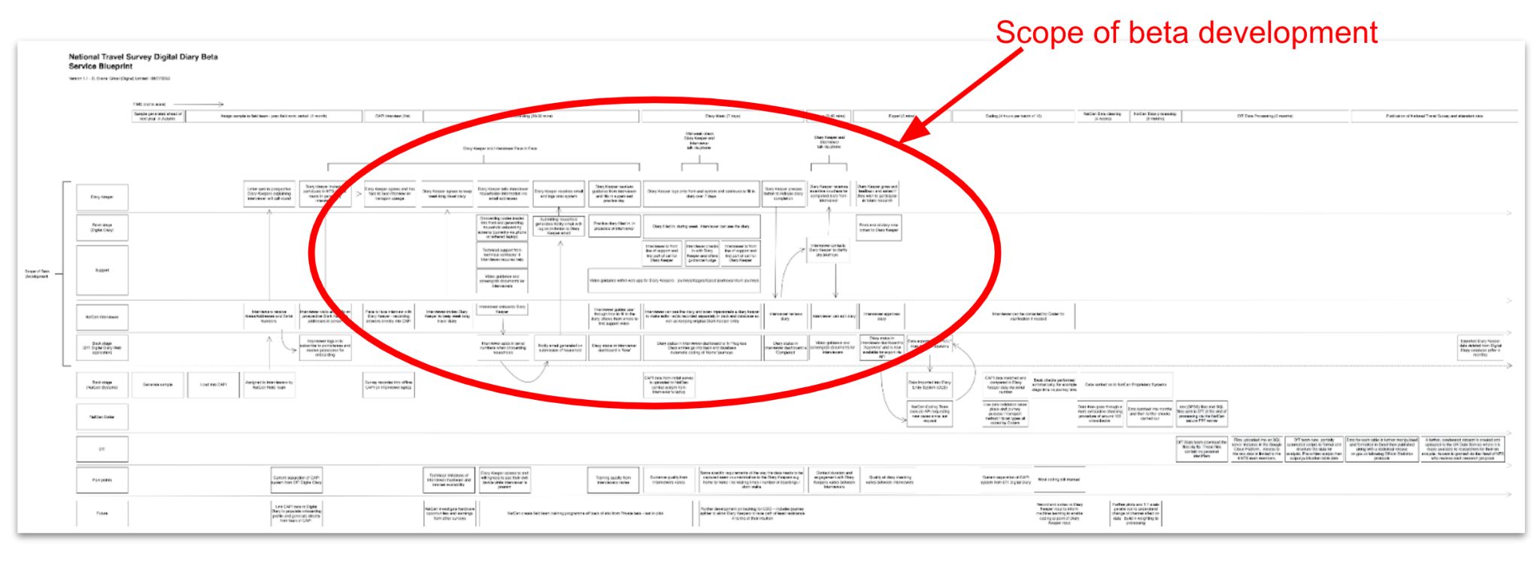

9. User needs
We carried out extensive work to identify the range of users and their particular needs, with special focus on the Digital Accessibility Scale and the Lloyds Essential Digital Skills report (2021).
Link to Lloyds Bank Essential Digital Skills 2021 report

9.1 Who are the users?
- Diary keepers (citizens)
- Interviewers (currently NatCen)
- Coders/Keyers (currently NatCen)
- Data analysts (DfT/NTS)

We developed and explored 16 user personas and user journeys throughout beta, including 3 new ones. These personas were made up of amalgamations of the users from discovery as well as different users we tested with through alpha and into beta. The names and personas are fictional and don’t represent any one user.

9.1.2 Personas, Diary Keepers:
- Busy professional, no family
- Dyslexic mother with family
- Young post-college male with partner
- Schoolchild proxying for whole family to earn vouchers
- Middle-aged male, time-poor
- Elderly diary keeper with low digital confidence
- University student, shared accommodation
- Dyslexic 6th form student living at home
- Vision impaired diary keeper
- Previous paper diary respondent
- Single mother with anxiety issues & young family

9.1.2 Personas, Interviewers:
- Veteran interviewer working on NTS for a while
- Interviewer with low digital skills
- New interviewer, fresh to the NTS

9.1.3 Personas, Coder:
- Experienced coder

9.1.4 Personas, DfT
- Analyst

9.2 Persona user journeys
We collected the feedback from our user testers and applied them to the different personas. This enabled us to map out user journeys and record the emotions of the user at the various points of the process.

As the process is repeated several times during the week, sometimes a map shows two paths. We use a dotted line to show something that was directly addressed and dealt with, or that was resolved and retested by someone with the same user persona.

The user journey map also records touch points - for example where a diary keeper might also contact an interviewer for support, or where the interviewer might intervene in order to correct a diary keeper. These are shown in a different colour.

We added a separate ‘uncertain’ emoji this time in order to record where the process had caused some confusion - or where the user was uncertain about something. By mapping out the journey with an emotion line, we can see where the pinch points are across user groups.

There are many areas of the journey where specific users had difficulty but where others navigated with ease, but there are a few areas (such as entering stages) where enough personas found difficulty to show that we needed to make universal changes in order to meet the service standard in terms of users succeeding first time.

A full image pack of user persona and journeys can be found in Appendix 3, which you can request by emailing XXX@dft

9.3 Top line identified needs
The first set of user needs were identified during the discovery phase and we’ve built on those throughout alpha and into beta, refining them as we’ve received testing. These user needs, along with the feedback from testing, have become our user testing acceptance criteria, directly driving the development process.

9.3.1 Diary keeper user needs

As a Diary Keeper, I can record journeys in my Travel Diary when I'm away from home so I can fill it in anytime, anywhere.

As a Diary Keeper, I can record journeys in my Travel Diary when I am using more than one mode of transport e.g walk, bus, walk.

As a Diary Keeper, I can record some details about a journey so I can complete the rest later.

As a Diary Keeper, I can check and edit my recorded journeys so I can provide accurate info.

As a Diary Keeper, I can repeat / reuse a journey I've already recorded in my Travel Diary (e.g. commute) so I can save time.

As a Diary Keeper, I can make notes to give context/insight into my journeys.

As a Diary Keeper, I can easily create a return journey using information I’ve already entered.

As a Diary Keeper, I can select from my most-visited places to save time when filling in my diary.

As a Diary Keeper, I can fill in someone else’s diary from my household for them.

9.3.2 Interviewer user needs

As an interviewer, I can remotely check and review any live travel diaries so I know how the diary keeper is getting along.

As an interviewer, I can fill in a travel diary for a diary keeper if they're not digitally confident.

As an interviewer, I can edit/correct a travel diary on behalf of a diary keeper.

As an interviewer, I can add notes to coders to give context to diary keepers' journeys.

9.3.3 Coder user needs

As a coder, I need enough information to check and assign the correct codes.

9.3.4 DfT/NTS user needs

As a DfT/NTS analyst, I need to see better quality data.

As a DfT/NTS analyst, I would like a larger sample size and higher response rate.
As a DfT/NTS analyst, I want minimal disruption to the 50+ year time series.
As a DfT/NTS analyst, I want the system to be flexible enough to accommodate new modes of transport.

As a DfT/NTS analyst, I want more granular data for wider questions/queries beyond the NTS.

9.4 User needs: methodology and confidence
We used a combination of methods for user testing, sometimes watching people in person or via screen recording. In every case we carried out a post-testing interview. We found the Smartlook screen recording software to be invaluable as often we would see users having issues with sections of the diary on the screen recording, which they wouldn’t volunteer during the interview, until we brought it up.

We did four waves of testing, refining and iterating, before moving into the private beta test.

- Tested with 97 diary keepers in 68 households
  - 36 new households (i.e. never kept a paper diary)
  - 24 previous NTS households, who had previously kept a paper diary
  - 8 previous NTS households, who had previously done the survey via other means (COVID)
  - 43 male, 54 female respondents
- Tested with 21 NatCen interviewers
- Tested with 2 NatCen coders (100%)
- Moderated and unmoderated testing
  - 18 moderated testing sessions (in person or via screen recording)
  - 13 unmoderated user testers
- Smartlook technology to observe sessions coupled with post-testing interviews with user testers/diary keepers

We also found some users with additional needs in our testing group:

- Users with accessibility and/or additional needs
  - User testers with additional needs in pre-private beta testing, of which:
    - 2 users with dyslexia
    - 1 user with dyspraxia
    - 1 user with ASD
    - 2 users with mental health disorder
    - 1 child user of minimum diary age (11 years old)
- Users with lowest digital skills and those that lack confidence
  - 4 interviewer users with low digital literacy
  - 18 diary keepers over 65 years
  - 3 diary keepers over 75 years
- Users preferring non-digital channels

9.5 User needs: Accessibility
We spent a significant amount of time working to ensure the digital diary could be used by those with low digital literacy. We referred to the Lloyds Essential Digital Skills report for 2021, which showed us that 6% of citizens have no digital literacy and are therefore digitally excluded, and a further 14% have basic digital ability.

There will always be a need to support the significant number of people who are excluded, either through lack of access to technology or internet, or low levels of digital confidence. This is further explored in the Channel Shift section of this report (section 13).

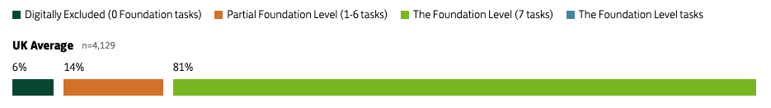
Source : Lloyds Essential Digital Skills report for 2021

9.5.1 Accessibility testing
We engaged The Digital Accessibility Centre for an accessibility audit and extended usability testing. We acted on the recommendations from the DAC report and the site now has A and AA status. Further usability guidance beyond the accessibility ratings was given by DAC. We acted on most of these where there was no conflict with other principles. The site contains an up-to-date accessibility statement on the service.

9.5.2 Accessibility and interviewers
As tested in Private beta, the interviewers will act as support for diary keepers. The ability for interviewers to impersonate diary keepers (while being recorded in the database as an interviewer), means they can intervene if there’s a problem, and edit/correct diaries prior to submission.

Interviewers can also fill diaries in on behalf of diary keepers, as they sometimes do for paper diaries or as has been done during the pandemic. The paper diary will be retained and can still be used.

However…

We discovered there is significant variation in interviewer digital ability and confidence; Many interviewers are digitally ‘task specific’ and had concerns about their digital skills - others were over-confident in their digital abilities (this tended to take the form of initially disregarding instructions).

We organised small-group, online briefing workshops for interviewers to ensure a consistent level of training and digital capability, and provided additional small-group sessions, and 1-to-1 training sessions where requested or required. These findings have been taken on board by NatCen for the next stage of their pilot test when planning training for larger scale field work.

9.6 Addressing specific user needs highlighted in the Alpha Service assessment
The following actions were planned at the beginning of the Beta phase to address specific user needs that were recommended for exploration during the Alpha Service assessment:
- Testing with users who have anxiety issues, particularly around journey stages and reviewing day summaries
- Onboarding workshop with interviewers to identify issues with setting up and engaging households in the field
- Alpha testing focussed on individual diary keepers; Beta testing has included whole households, including multiple accounts per household and proxy diary keepers

These risks were tested to a high degree of confidence during beta, both in the four waves of pre-private beta testing and the private beta itself.

9.7 How user feedback informed the team
Post-testing feedback was gathered in person, or via phone or email, and then posted on Basecamp in a to-do list for all of our team to see, coded with the tester’s initials.

The list on Basecamp was then rearranged to group common issues, with verbatim quotes from users, so we had what the issues were, in the user’s own words. We used these quotes to plot out the user journey maps as well. The user testing team also noted their own observations of the user’s behaviour from Smartlook screen recordings, or from the moderated testing (see example below).

The daily stand-ups were used to arrange a feedback discussion with the team. The team then talked through feedback, iterations were suggested and technical feasibility discussed. NatCen were involved in these discussions to get their expert views and to sense-check that proposed changes or solutions wouldn’t bias or alter the data.

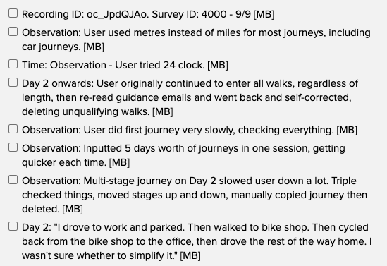
Sample of user feedback recorded on Basecamp

10. Challenges
During the project, we encountered areas that were challenging to develop; the three areas of largest challenge were the journey purpose, transport method, and sharing journeys within a household.

10.1 Journey Purpose
The journey purpose is the lynchpin of the National Travel Survey; it’s the only piece of information that can’t be gleaned or inferred from other sources available to the DfT, for example, traffic CCTV, public transportation figures, transit stats, retail footfall, etc.

On the paper diary, the Diary Keeper has a small space and some guidance in order to write in what the main purpose of the journey was. Interviewers give them some steer initially and clarify entries at the point of physically picking up the diary. They do this by going through the diary and carrying out an exit interview.

The Coders then use the entry in that box, alongside inference and context, to assign a code to each journey.

- At no point in the paper diary do Diary Keepers see the categories or have an awareness of what they’re called
- The coding process is complex and nuanced - for example, visit a friend and stay for more than three nights and that’s coded as a holiday. Go to play table tennis and that’s classed as watching sport/entertainment (code 13), Go to take part in a Judo competition in the same sports centre and it’s classed as participation in sport (code 14)
- Going out for a day trip, walking the dog, going for a walk, cycling for exercise or pleasure (rather than to go somewhere specific) are all assigned the same code
- Coders write the codes directly onto the paper diaries in pen and then enter the information into the digital entry system (DES) at NatCen
- DfT feel that new cognitive testing could be carried out on the questions in the paper diary to check continued relevance and language

10.1.1 Remit/Scope for Private/Public beta
The project brief was to digitally replicate the paper diary as a kind of beach-head into further digitisation and automation. At the same time, we’re looking to improve the data quality and where possible, code what can be coded ahead of the Coders receiving the data.

The act of making the diaries digital has an immediate effect on the workflow of the current transcription process

- Interviewers can check-in live to the diary and see the Diary Keeper progress at any point
- Interviewers and Coders would no longer have to interpret handwriting
- Transcription itself is removed from the process (and therefore transcription error)
- Transport Mode and Ticket Types could be largely pre-coded
- Coders would code directly into the DES rather than onto the diaries

The act of moving to a digital diary will also have an effect on the data itself in terms of how people fill the diary in and what they fill in, and it was this area that needed to be carefully considered when designing question screens in the digital diary. One of the great difficulties in creating a solution for Journey Purpose is that it will be difficult to untangle how much the collected data has been altered by the change to the question format (i.e. moving from a free text field to radio button options), and how much by simply switching to a digital mode of collection.

10.1.2 Potential Solutions: Options for testing

Option 1: Initial Alpha test: All codes upfront on one page
The first iteration tested in Alpha was a complete list of all codes, split into Personal, Escort and Non-escort.

Pros
- Every entry had a code attached to it, if someone clicked one of the 23 options it was coded
Cons
- It was way too much on a page - would not pass an Accessibility assessment and would not meet the Service Standard
- People selected the first one that was closest to what they did rather than read through them all
- The code terminology is not Diary Keeper-facing so people were unsure what the categories meant
- Any attempt to put guidance notes on increased the size of the page and the text on view, violating Government Design System principles in terms of readability

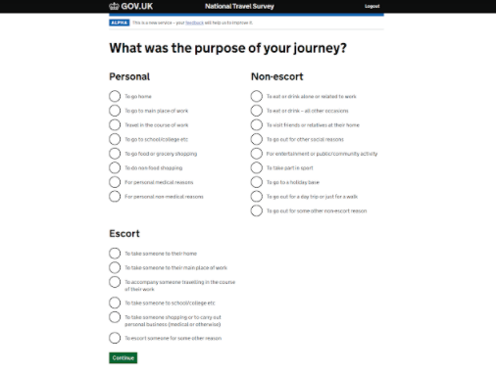
Complete list of Journey Purpose codes, as presented in the initial Alpha test

Option 2: Secondary Alpha test and First Beta test: Most common responses + Other
Taking the average responses nationwide and putting the seven most common answers as selectable radio buttons, along with an ‘Other’ box with a free text field. This was the second option we tested in Alpha and underwent a further round of testing in Beta (25 diary keepers in total).

Pros
- Instantly code the most common journeys
- List is manageable on one page from an Accessibility point of view and conforms to Government Design System as well as the Service Standard
- The examples in the ‘Other’ section tested as being good guidance for what to put in that field
- Having the radio button titles shows people the format of response that’s needed
- Tested well in 4 waves of user testing

Cons
- Risk of biassing people into picking one of those options if they’re remotely close to what people were doing. We saw this in our first round of Beta testing where someone selected ‘taking someone to education’ when they were actually picking them up from school to take them home. The education option was close enough in their opinion
- Averages are not a good way of selecting which options to show as they’re made up of multiples. For someone who doesn’t work/is retired or who doesn’t have children living with them, a lot of those options won’t apply
- Burden mostly on Interviewers to check each response is correct, and on Coders to extrapolate deeper, non-typical answers
- Research from other surveys shows that people would rather select ‘Other’ when the option doesn’t match their idea of what they did

Option 3: Three step decision tree with all codes
NatCen and DfT proposed a three step (radio button) decision tree with all of the codes, prefaced by a split into escorted and non-escorted journeys. This was an entirely exhaustive list which would eventually lead to all 23 of the coded options in one way or another. There would be one ‘Other’ box with a free text field.

Pros
- Every code is covered
- Fairly easy on mobile devices (no typing unless they have to fill in the ‘Other’ field)

Cons
- Would take Diary Keeper 3-4 clicks each time to record a journey and a lot of reading through
- Potential for annoyance for Diary Keeper if they go down the wrong branch - would need to test ease of navigation and whether people could/would go back to correct themselves
- Language of presented options would need adapting quite heavily as these are all coder-facing terms
- None of the nuance of the codes is captured and the expectation is on the Diary Keeper to understand extensive guidance (e.g. 3 days with a friend is a holiday, the differences between participating and watching sport, which are not intuitive)
- Burden is all on the Diary Keeper
- Long reading and choosing process could have a chilling effect on recording later journeys in the week, which we know from the Discovery report already see recording fatigue

Option 4: Cut down list of journey purposes over two steps with escort folded in to main list with other boxes to capture details
This is a hybrid solution of other suggestions. By cutting down the list and putting people into two steps, then putting in an ‘Other’ or ‘Give us more details’ box, we can cover a good amount of the available codes without hopefully overloading the Diary Keeper.

Pros
- Enables coding of a majority of the available codes
- Fewer things for Diary Keepers to read on one page
- Only two levels to go through
- Fairly quick for the majority of Diary Keepers

Cons
- Minimum of 9 options in order to cover all the top-level options, which may be too many to be comfortable, especially on mobile devices once expanded with sub-options
- Radio button followed by more details field could be difficult cognitively as it’s a change of gear
- Fields are trickier on mobile - but we are asking for a field entry in the Destination anyway
- Showing a lot of the options gives the impression that all bases are covered - perhaps leading to people again picking the thing that’s closest to fit into the boxes we give them, particularly if it’s one of the first options that they read
- If it doesn’t precisely match, then people may want to look at all the options in order to make their decision, resulting in further clicks and repeated actions and increased recording fatigue
- Quite a lot of work needed on the language and guidance in order to present more of the options effectively and to deal with some of the nuance in the coding
- Burden still on the Diary Keeper, but with some on the Coders/Interviewers
- Still reliant on Interviewers to check the actual Journey Purpose matched with what was recorded. When presented with an appropriate statement (e.g. To participate in sport), an Interviewer might not think to ask ‘which sport was it? Tennis or table tennis?’ during the exit interview, in order to ascertain if that was the correct option, potentially resulting in hidden inaccuracies in the data.

Option 5: Free text field with some guidance text
This would most closely align with the current paper diary, as all they have on the diary is a small space in which to write it in, with a little guidance. Currently, DfT doesn’t ever get to see the raw data for this, and it’s also not loaded into the DES, just coded. This would be as close a digital replication of the paper diary as we can get.

What we can do is capture everything inputted here and keep it, regardless of whether the rest of the diary data is kept, in order to build up a database to inform machine learning. This could be done as a separate project.

This would not include a separate ‘Go home’ purpose option.

Note: The possibility of an auto-completing textbox has been mooted, however there are technical limitations - not least because the Government Design System pattern for this isn’t ideal. We tried to use it for country destinations on the Road Freight Survey and found that it tested badly with users. One wrong letter would offer either the wrong selection or no options at all, with no clear indication to the user as to why (as they couldn’t see their typo). It also wouldn’t record the field input if it wasn’t one of the things on the list.

This might be something we can revisit later if the design pattern is updated.

Pros
- Replicates the paper diary - this would give us a baseline standard for how much the transition to digital has affected the data, without the added complication of the cognitive change of asking the Journey Purpose question in a different way
- Allows the Diary Keeper to put in the purpose in their own language/phrasing
- Is then one action/field for Journey Purpose, which could allow us to fold in extra options to this page and reduce clicks for the Diary Keeper
- Less risk of users misunderstanding the question
- Reduces the need for handwriting interpretation and avoids transcription errors
- Builds up a database of purposes which can be used to ‘teach’ the system via machine learning at a later stage of development

Cons
- Is asking Diary Keeper to type rather than click, which can be tricky on mobile devices [although easier for voice to text users]
- Doesn’t automatically code any journey purpose
- Without the examples of the radio button categories from the other options, people may just put one word answers. This may not be a problem but might lose some nuance if they just put ‘pub’ or ‘work’ or ‘shops’, although this would be the same as the paper form
- Burden remains with the Coder/Interviewer as currently

Option 6: ‘To go home’ radio button and free text field - with further journeys informed by previous field entries
In this option, we use a free text field as in Option 5, but with two differences. Firstly, we would also have ‘To go home’ as a radio button as well, meaning that 43% of journeys could be automatically coded. Secondly, we would take the entered field contents and offer it as a radio button option in the list the next time they come to that screen. This would help people who do things like walk a dog three times a day, or go for a run, or go somewhere regularly. By the end of the week they could have all of their inputs (or a limited number, e.g. those with more than one use) as radio button options. We could still capture the inputs to create a database for machine learning.

Pros
- Replicates paper diary and preserves the baseline standard
- No need for handwriting interpretation and avoids transcription errors
- One action/field for Journey Purpose, allowing us to fold in extra options to this page and reduce clicks for the Diary Keeper
- Less risk of misunderstanding the question
- Still allows Diary Keepers to input answers in their own language and phrasing
- Allows them to use the same answers without having to type them out again (this came up in round 1 of the Beta testing as an issue for some users)
- Gives ‘to go home’ as a clear and quick option
- Automatic coding can occur for ‘to go home’
- Still allows the collection of a database of journey purposes for further research and development

Cons
- Difficult to tell how useful it will be for everyone to have their previous journeys appear again - particularly if they’re one-off
- We know from experience on the Road Freight Survey that some people can write a lot here, for example some people instead of typing ‘mixed load’, gave an exhaustive list of everything they carried. To have something similar happen on the NTS digital diary could result in the Diary Keeper making their own list hard to use - especially if they find spelling and grammar challenging
- Burden remains with Interviewer and Coder for the remaining 67% of Journey Purposes

For the free text field - Interviewers could add some nuance in the notes section if they can glean more information from the exit interview to aid the Coders.

10.1.3 A/B Testing Options (Wave 2)
Currently, we ask diary keepers to tell us that they’re going home twice - once as the purpose of their journey, then as their destination. The plan proposed by DfT is to re-order the question screens so that ‘Where did you go?’ is answered before we ask for the purpose. This removes the need to ask for a Journey Purpose on any journey already flagged as ‘to go home’, removing a step for Diary Keepers and reducing the number of options on the Journey Purpose screen.

Version 1
This version presents as many options as possible (within CDDO recommendations) for a user to deal with in a single screen, while capturing any opportunity to pre-code a purpose. Need to consider use of help text at the top level, and the second sub-level for nuances such as sport types.

Main Purpose of trip | Sub option | Sub-sub option
1. For your work | Your main place of work/work experience
1. For your work | To somewhere other than your main place of work
1. For your work | Other: [FIELD]
2. For education, e.g. school, college, university or any work experience | Your main place of study (school/college/university etc.)
 | To take someone to school, college, university
 | To collect someone
Other, e.g. a school trip, for work experience
[FIELD]
3. To go shopping | My journey was mainly for food shopping
3. To go shopping | My journey was mainly for shopping other than food
3. To go shopping | Other: [FIELD]
4. To go for a walk, run or cycle, or to go on a day trip  For round trips, you will need to enter the furthest point as your destination and enter it as two separate journeys - one setting out and one to return. | To go for a walk, jog or cycle
 | To take the dog for a walk
 | To go on a day trip
Other:
[FIELD]
5. For social/entertainment purposes  E.g. to eat out, visit the cinema, play/watch sport, attend a class or do voluntary work | To eat or drink (e.g. at a restaurant)
 | For entertainment, e.g., Cinema, gym, museum, music etc
 | To participate in or to watch sport | Please give details: [FIELD]
For another type of entertainment:
E.g. Evening classes or clubs, voluntary work
[FIELD]
6. For personal business e.g. go to the doctors or bank, or to take children to a childminder | Medical business, of any kind, including going to the doctor or picking up a prescription
 | To visit friends or family in hospital
 | To make use of a service (e.g. hairdressers, laundrettes, dry cleaners, the bank)
 | To attend a church service, funeral or wedding
 | To go to a childminder, nursery, childcare
Another purpose:
[FIELD]
7. To take someone somewhere or accompany them on a trip or errand  E.g. To take a child to a birthday party, or accompany a relative on a shopping trip | To go home for or with someone else
 | To go to a place of education for or with someone else
 | To go shopping for or with someone else
 | For personal business for or with someone else
Another purpose:
[FIELD]
8. Other [FIELD]

Version 2
This version is the most simple, removing the possibility of pre-coding any responses but capturing every scenario and preventing the diary keeper from reading too much or going down the wrong/closest answer route. It most closely aligns with the paper travel diary, giving us a necessary baseline for how people respond to the digital version, while still reducing some of the burden created by handwriting interpretation and transcription.

What was the main purpose for this trip?
Please tell us the main reason for going out. e.g. To go shopping, to take a child to school, to visit a friend at home, or to take the dog for a walk.

[TEXT BOX]

10.1.4 What tested well
Off the back of the testing, we took the blank field into private beta, as this was clearly easiest for the users and it replicated the paper diary inasmuch as the paper diary itself just has a space for people to write in their journey purpose.

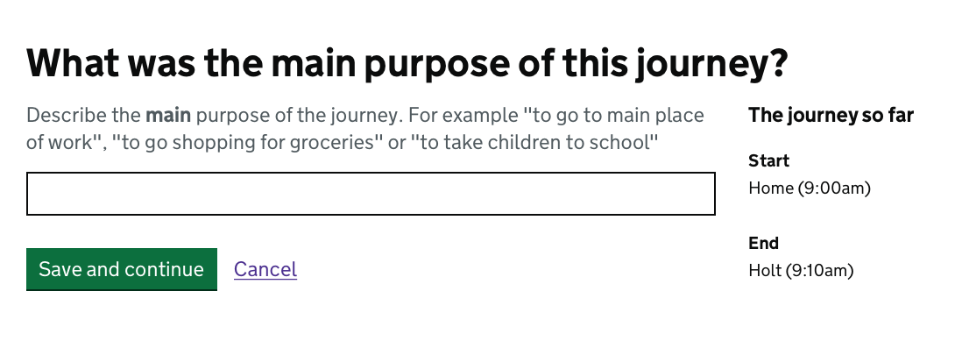

Until machine learning and the resultant coding is put in, this requires steer, moderation and checking from Interviewers, the same as the paper diary. Crucially, it allows a baseline digital response to be collected (i.e. same question wording and input as paper diary). User input will be kept, along with the final code to gather enough data to inform machine learning.

10.1.5 Using machine learning to code journey purpose
Ultimately, as the version that tested best with users was a blank field, this does mean coding would still have to be done manually (except for ‘to go home’ which we can code from people putting the destination as ‘home’). However, for the first time, we will be able to retain not only what was coded in the DES by the Coders, but also what the original input text is (that isn’t currently recorded when transcribing from the paper diaries into the DES, as the coding is done directly onto the paper diaries in pen).

With a record of what was originally entered by the Diary Keeper and the ultimate code it was given, we can train a machine learning algorithm to code the inputs with a high degree of accuracy. It would recognise Going to the cinema, going to watch a film, or going to the movies as being the same code. The AutoML system is built on Google Cloud and native machine learning functionality is part of the available suite. The National Travel Survey diary pulls in thousands of points of data on a regular basis within the same structure; ideal for teaching the algorithm. Furthermore, machine learning costs are worked out on the basis of hundreds of thousands of data points, so the cost for processing the NTS is likely to be palatable.

10.2 Transport method
One question area that worked well was ‘transport method’ which tested consistently strongly despite being the page with the most options in the diary. This was an area that had been of concern, as the amount of options pushed the limits of the Government Design System recommendations in terms of how much can be presented at once.

There were some minor adjustments to hierarchy presentation after the accessibility audit to enable ease of use for screen readers. Despite the amount of radio buttons on one page, the terms are fixed and well-known, requiring little explanation, lining up completely with people’s expectations of what they would have to put in for the transport method. There’s little cognitive load in finding ‘car’ on the page for example.

User testing showed it was easy for people to skip to the column they needed (i.e. public or private transport), without needing to read every item in both columns. We had no bad feedback from users, and watching sessions on Smartlook screen recordings showed no problems, even where someone went on a helicopter.

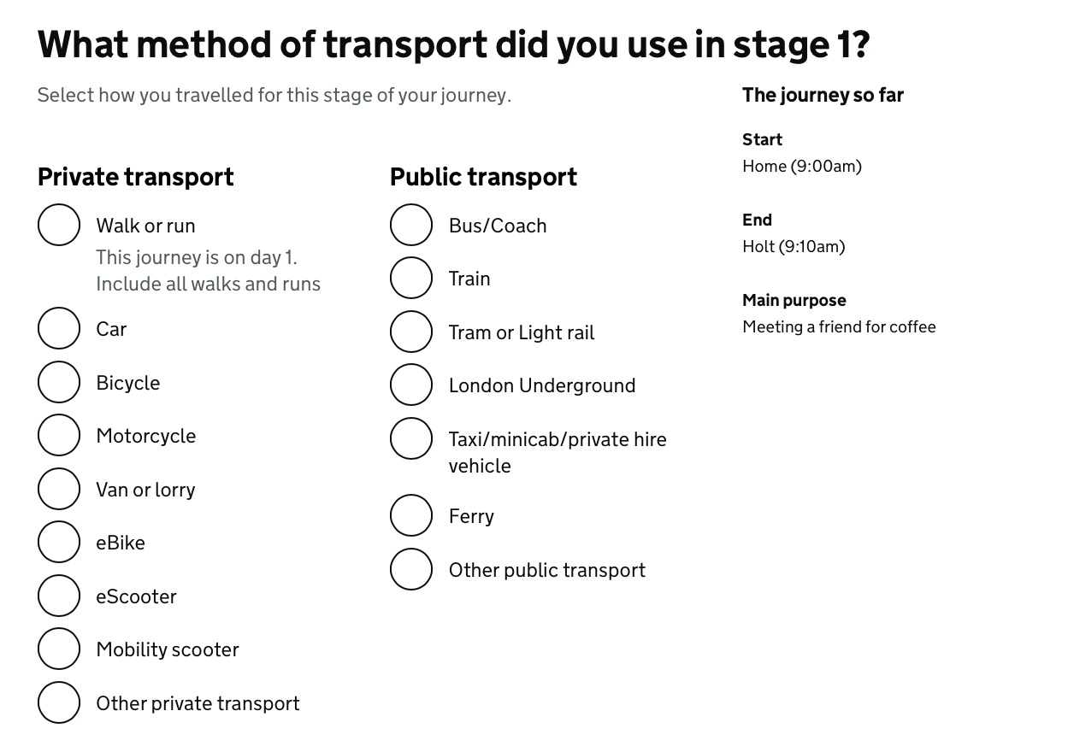
Transport method tested well, despite having many items on the page

10.3 Journey sharing
The ability for diary keepers to share journeys or quickly replicate journeys that included other members of the household, came up as a high priority requirement, but we needed a stable, tested release for the full process before we could work on it. There are broadly two types of sharing:

- Sharing inside a total proxy - for example, a parent filling in diaries for themselves and their children, where the children don’t have their own log-ins
- Sharing inside a household of separate accounts - for example a household of a mixture of adults and teenagers all with their own accounts

In the former case, the functionality is easier to create as the user has control over both accounts. If, for example, they want to record that the parent took two children to school, they want to be able to enter their own journey and then replicate the journey for the children, but with a different journey purpose.

If other people in the household have logins, then the functionality is more complex, requiring a push to the other diary keeper’s diary. There are issues of data sharing, but a push-and-pull would indicate both a willingness on behalf of the originator to share their journey and an acceptance of that journey on behalf of the receiving diary keeper. We had looked at the possibility of a ‘pull’ from another household member’s diary - but this would cause problems with data protection at DfT and also the ethics board at NatCen.

This work is currently being carried out ahead of the pilot phase in November. Current thinking for the two options is as follows:

10.3.1 Journey sharing: Full proxy
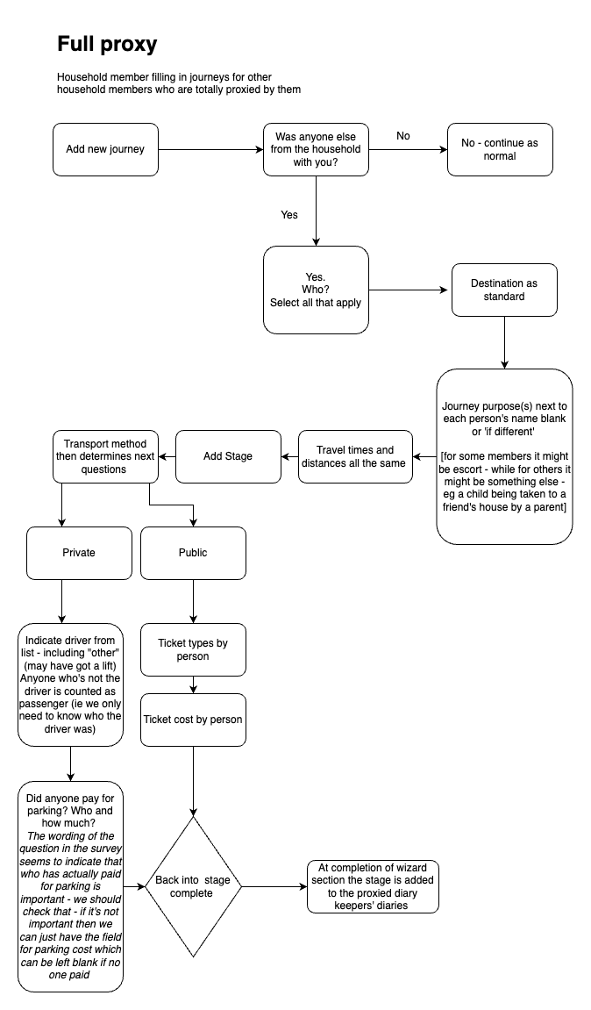

Full proxy involves a household member/Diary Keeper filling in journeys for household members who are totally proxied by them. The sequence is as follows:
- Add a new journey
- If no one else was in the household with the user on their journey then they continue to fill in their own journey as normal
- If there was someone from the household with them on the journey then they will select everyone who was with them from a list of people in the household.
- The destination is filled in as standard
- Travel times and distances will be the same
- The Stages will be the same for all household members who were on the journey
- If the transport method was public then they need to input the ticket types and ticket cost on a person-by-person basis
- If the transport method was private, the user needs to indicate who was driving from a list of people in the household (but also having an ‘Other’ option if they were getting a lift from someone outside of the household). We only need to know who the driver was, so everyone else can be counted as a passenger. We need to know if anyone paid for parking, if so, who paid and how much did parking cost?
- The stage is now complete and at the completion of the process the stage is added to the proxied Diary keeper’s diaries

10.3.2 Journey sharing: Part or no proxy
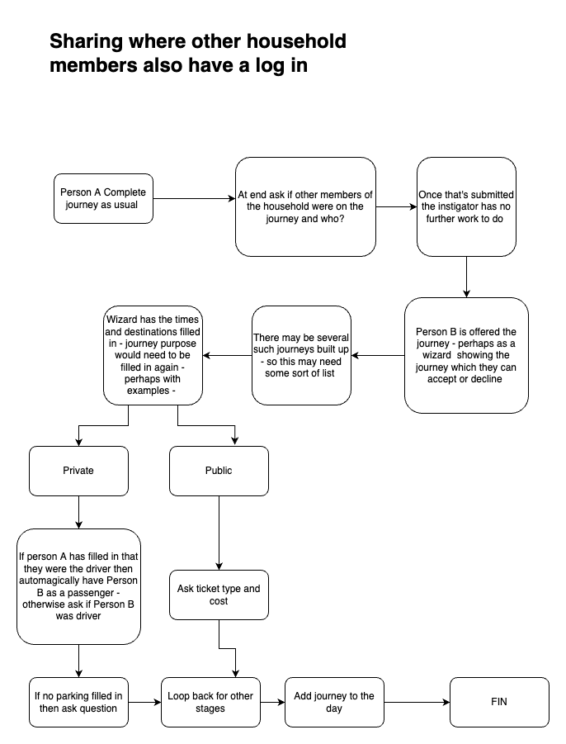

- Person A completes entering the journey in full and at the end is asked if other household members were on the same journey, and if so, is offered a list of other household members to pick from. Once they have submitted that information, they have no further work to do.
- Person B from the household is offered the journey - perhaps as a guided wizard which they can accept or decline. If there’s more than one journey offered, it will be presented as a list.
- The wizard would already have the times and destinations pre-filled. The journey purpose will need to be manually completed though - perhaps with examples listed to help.
- If the method of travel was private transport, then, if Person A has said they were the driver, Person B will automatically be listed as a passenger. If Person A has not said they’re the driver, then Person B is asked if they were. If Person A didn’t fill in anything for parking, then Person B is asked.
- If the method of transport was public then Person B is asked about ticket types and cost.
- Person B is then looped back to stage 3 of this list, until there are no more stages to fill in, at which point the journey is added to the relevant day in their travel diary.

10.3.3 User testing the sharing functionality
During August, we’ve been developing a prototype and the user testing for the sharing functionality will take place in September, ahead of the NatCen pilot study. Smartlook screen recording technology will be employed along with some moderated testing to ensure a full understanding of people’s reactions and usage of the sharing feature. We’ll iterate based on the feedback to have a working, fully-tested sharing function for mid-October 2022.

11. Content design
In order to understand whether users are succeeding first time, we carried out moderated user and usability testing. Initial user testing waves had minimal instruction, just a paragraph with no interviewers present. We wanted to make sure that we weren’t relying completely on the interviewers, or using them as a crutch to mitigate bad design or user interaction. It would be too easy to say “The interviewers will sort that out” every time a user encountered an obstacle.

Unmoderated user testing feedback and real-time moderation of inputted data, in combination with observations from Interviewers in the field during private beta testing, gave us a high degree of confidence that we were getting an accurate view of user experience. This was borne out in our service assessment, where our user work was held up for particular commendation.

We also carried out post-completion data reviews with NatCen’s interviewers, field team and coders to make sure that not only were the users able to complete the diary, but the data coming out was usable and understandable.

We also made use of form validation error logs and measured the number of completed journeys.

11.1 Consistency with GOV.UK
Currently the survey/diary is invitation-only, with users having been randomly selected via the NatCen sampling system, so the user journey would start with a link to set up their own password. A start page will still be required, as some users will search online for the service on subsequent visits rather than go back to their email. The service has been designed to look consistent with Gov.uk and uses the Government Design System frontend templates and components; we’ve followed the Gov.uk design system recommendations

The language and content was repeatedly refined based on user feedback, but also with input from NatCen experts to ensure the interpretation of the questions didn’t change and alter the series/data. In addition to the user testing and input from NatCen, the Digital Accessibility Centre gave extensive feedback on usability outside of testing to A and AA standards, which informed further iterations to the design and content.

11.1.1 Time input
Time input in the design system backlog suggests using the 12-hour clock. Our research has indicated that a 24-hour clock would be preferable for the majority of users. However, a minority of users indicated that they couldn’t understand the 24-hour clock at all.

Those people who said they couldn’t understand 24-hour clock weren’t necessarily low digital confidence users, or those with specific needs. We looked at giving the user a choice of format, but mixing 12 and 24-hour clock input creates data issues (e.g. is 8:00 0800 or 2000?).

While those users preferring 24-hour clock did still understand and were able to use 12-hour clock, those users who couldn’t use 24-hour clock said they would have struggled to input the correct time in that format, so we’ve decided to stick to 12-hour clock as per the design system recommendation. As well as providing our feedback to the design system, we will monitor the GDS frontend backlog issue for future developments relating to time input.

12. Technology
The technical stack is tried and tested with Road Freight Surveys. The application is built upon Symfony - a widely-used open-source PHP framework - and uses version 5.4, which is the current long-term support (LTS) release. Symfony provides built-in protection against a number of common security threats. It also has a suite of unit/functional tests to ensure code operates as expected and to help prevent regressions.

12.1 Technical stack specifications
- Ease of integration and deployment
  - PHP 7.4 - Can be deployed on all common cloud platforms
  - Symfony 5.4 LTS
  - Well-documented deployment procedures easily inform CI/CD
- Data privacy
  - Minimal identifying information is stored about users (email address / friendly name)
  - Locations are deliberately vague at point of collection

- Proactive / reactive to security threats/fraud vectors
- Open source, open standards, common platforms
- Hosted on Google Cloud AppEngine/CloudSQL (PaaS)
- Consistent high performance
- Scalable
- Authentication in line with DfTc architecture principles and standards.
- Approved by Architecture Change Board

There’s also a data export API for link up to the NatCen Diary Entry System, using OpenAPI documentation for export API endpoints.

12.2 Security
The technical stack was selected in part to leverage the inbuilt security features. In addition, the service has undergone a DPIA process to ensure the rationale and process for collecting/storing data is appropriate and secure.

12.2.1 Securing information
- DPIA carried out to ensure data remained pseudo-anonymised
- Permission granted to test with live data if on DfT system
- Privacy policy available on service frontend
- Data collection procedures in line with DfT standards and NatCen ethics protocols
- Diary Keeper and Interviewer passwords stored as salted hashes (bcrypt)
- API authenticated using key/secret HMAC
- One-time passcodes for on-boarding

12.2.2 Securing the platform
- Ongoing and regular patch deployment scheduled into maintenance plan
- Security unit and functional tests
- Vulnerability and penetration testing results (external audit)
  - Password change utility for interviewers (on backlog)
  - Weak SSL ciphers (fixed)
  - Logging out from IaP (only option is non-desirable)
- Proactive / reactive to security threats

12.3 Ensuring the right tools are chosen
We’ve largely used standard tools that are already within the DfT environment.

- Tools and technology
  - Hosted on Google Cloud AppEngine/CloudSQL (PaaS)
  - Written in PHP, using Symfony 5.4
  - Gov.uk Notify
  - Meets requirements of DfTc Digital Architecture standards
  - Approved by ACB
- Cost of ownership
  - AppEngine provides automatic scaling according to demand
  - PHP and Symfony widely used, reduced maintenance costs
- Open standards
  - OpenAPI documentation for export API endpoints
  - ULIDs for database PKs
  - Use of Symfony components where available (workflow, serialization, rate limiter, message bus, etc)
- Performance
  - Symfony naturally high performance
  - Google’s PaaS automatically scales to meet demand
- Managing legacy technology
  - NatCen manage the DES internally
- Future technology plans
  - Machine learning / NLP for journey coding
  - Upgrade to Symfony 6.4 LTS (Nov 2023)
  - Upgrade to PHP 8.1 (when available on AppEngine)
- Ease of iteration and deployment
  - Agile methodology, quick turn around on issues
  - Google cloudbuild allows for low disruption deployments

12.3.1 Making the source code open
Although some departments are wary of making the source code fully open, we agree with the Service Standard that all code should be available and shared. Security is often cited as a reason for not making code open, but it is quite possible to redact sensitive information before publishing. Security via obscurity is unsustainable and undesirable; developers should be confident enough to open the code up to scrutiny.

The code has been checked by the NTS GitHub Champion and is published, with only security passcodes etc occluded.

- Configuration of code
  - Is open source (DfT public git, MIT license)
  - Meets open standards
  - Is open data (published NTS report)
  - Use of common platforms
- Ownership of the intellectual property - everything developed for the digital diary is owned by DfT

12.4 Database Schema

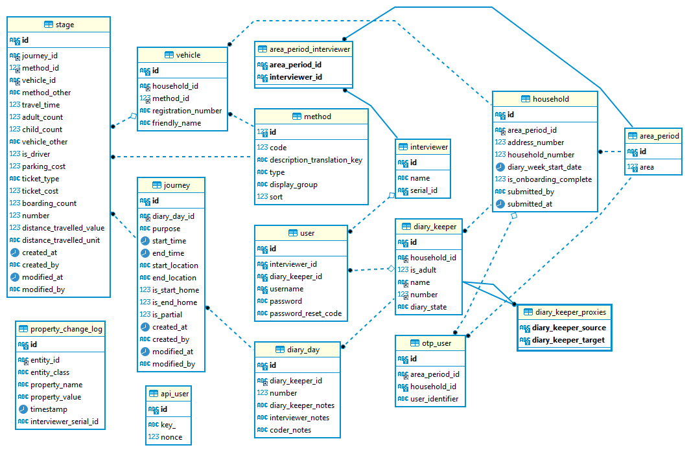

12.5 Architecture design diagram

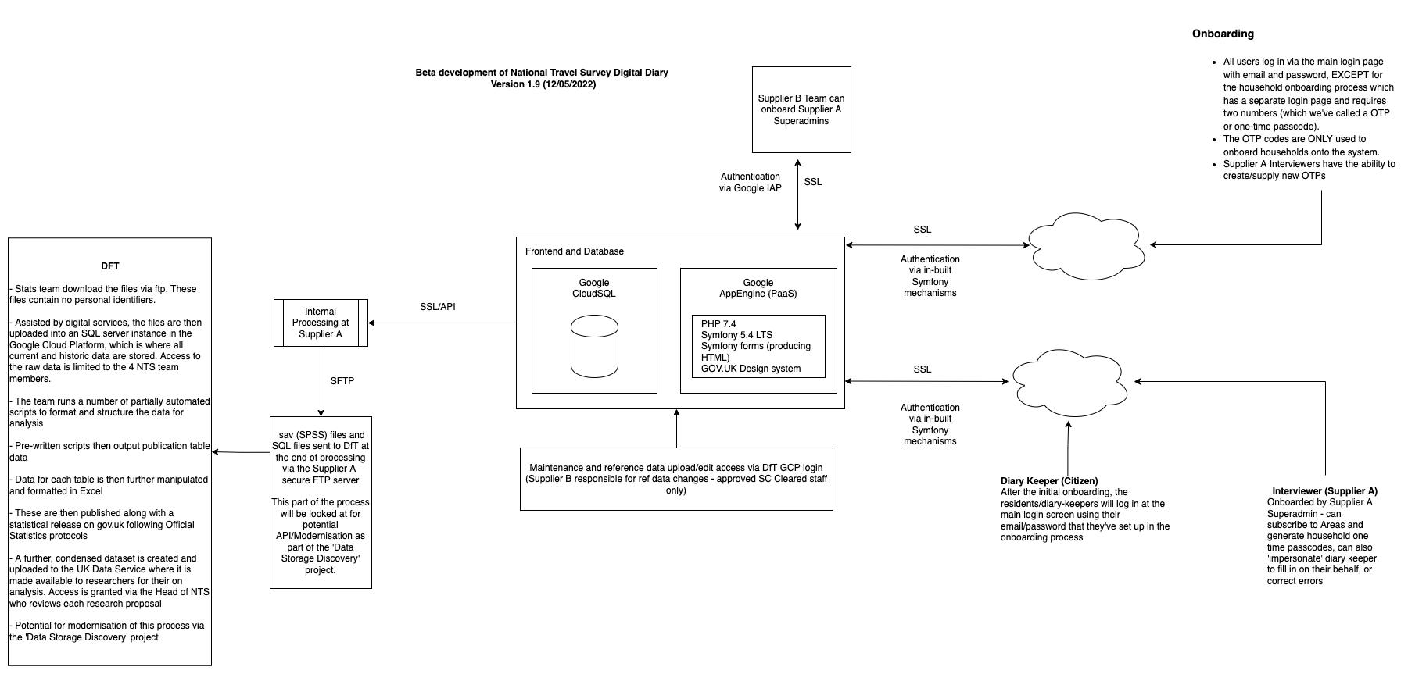

13. Channel Shift
Unlike most services, the majority of diary participants will only do the National Travel Survey once and it’s by invitation. They’re unlikely to be aware of a channel shift, as they won’t have used the previous paper channel. There is a low probability of a household being selected to participate twice. NatCen take steps to ensure that no address can be selected more than once within 3 years.
Overall, NatCen give the following probabilities of an address being selected twice in the sample in 2020:

England: 1 in 1,851 (12,852 addresses selected from 23.6million)
Inner London: 1 in 1,497
Outer London: 1 in 1,600

The main issues for channel shift will be the necessary adjustments to the existing workflow for NatCen, and the change to the data that will come from the change of collection mode. The change, both in terms of technical functionality and the field processes for NatCen, are going to be significant. Operationally for the Department for Transport, there will be non-trivial changes too, as the department becomes responsible for maintaining the service and storing participant data where previously this has all been handled by NatCen.

13.1 Process changes at NatCen
At NatCen, a system will need to be developed to receive the data and insert it into the DES, bypassing the transcription process of the paper diaries. A system will need to be designed on which to set up the interviewers and their areas/points on the service and assign the sampled households to those areas. The interviewers will need to be trained to understand the digital diaries, onboard diary keepers and act as frontline support for diary keepers, as well as learning to monitor, edit and approve the diaries.

13.2 Process changes at DfT
At DfT, a DPIA must be completed and the service assessed in terms of data protection and privacy. Several assurance gates must be navigated, not least of which is the Service Assessment. Thereafter, a support and maintenance procedure must be developed as the service will sit in a government online environment. Processes for continuous development and continuous integration (CDCI) will be put into place and a method for assessing and reporting on service performance.

13.3 Survey participant attitudes towards channel shift
At the conclusion of the current NTS process, participants are asked about their preference for either an online or a paper solution. The results from 2016, 2018, 2019, and 2020 have shown a clear preference for paper across nearly all age groups.

In 2016, 59% of respondents said they would prefer paper. In 2018 this number rose to 63%, while in 2019, 59% had a preference for a paper diary.

In 2020, 39% of people preferred paper while 24% said they would prefer an online version. 23% of respondents had no preference.

Note that for the majority of 2020, Interviewers transcribed the journeys remotely so the experience of the participants was not the same as for previous years.

Asking people to imagine:

“An online version of the diary, which you could complete on the computer, phone or a tablet”

without any reference for how it would look and work is going to provoke a variety of responses as we’re reliant on participants’ own concepts of how that might be achieved.

Interestingly, when the Discovery phase of this project was carried out, the findings were quite different. 61% of 123 participants interviewed had a preference for an online version of the diary.
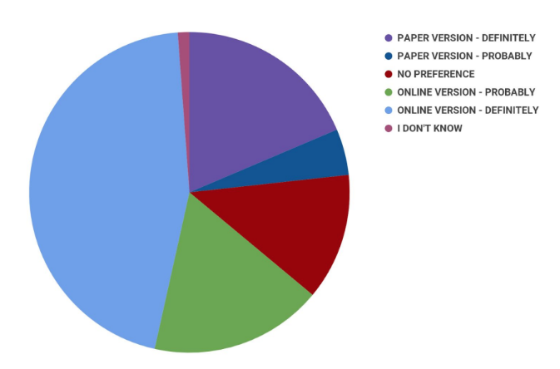
Source: NTS Digital Diary Discovery Report 2019 Stillwell & Evans et al

There may be several factors to explain the apparent discrepancy between the
sources:

- Differences in the sampling composition. People who agree to take part in follow up research tend to be attitudinally and behaviourally different to those who don’t agree to follow-up research
- The User Feedback Survey was an online survey, therefore Diary Keepers with low digital literacy or lack of access to the Internet would not be represented
- The pick-up interview questions were asked only to the main householders [Diary Keepers] - these people are typically older people in the household and presumably underrepresenting younger people
- The pick-up interview questions were asked soon after the experience of keeping a paper diary - the Discovery Phase User Feedback Survey was conducted after the event (at least 3 months after)
- The questions were not identical - the question in the User Feedback Survey offered a graded response and including ‘no preference’ (picked by 12% of respondents), whereas the pick-up interview question only offered a binary, two answer response

The Discovery phase also took pains to talk to the Interviewers about their perception of participant attitudes towards online channels, and the following results have largely been borne out in our discussions during Beta, some three years later:

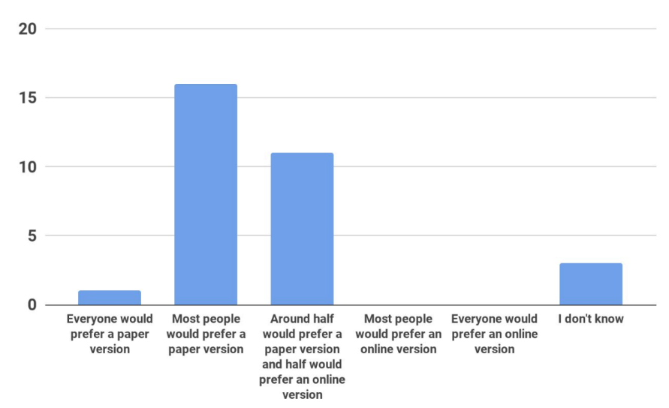
Source: NTS Digital Diary Discovery Report 2019 Stillwell & Evans et al

Anecdotally, according to Interviewers, roughly 50% of Diary Keepers would prefer a digital solution, which suggests the actual attitude lies somewhere between the approx 20% who would prefer an online version in the NatCen findings, and the 61% who would prefer online in the Discovery findings.

13.3.1 Future digital take-up
Since starting the project, NatCen have revised the projection for future digital take-up to around 90%. This is based on their experience of Intake24.

13.4 The Role of the Interviewer in Channel Shift and Accessibility
The interview for the National Travel Survey [referred to by NatCen field team as the ‘placement interview’] is out of scope for development and remains face-to-face, which means Interviewers will still be onboarding Diary Keepers face-to-face. In this way, although we’re moving to an online channel, traditionally seen as the least reassuring channel, we still have a face-to-face presence, traditionally seen as the most reassuring channel. This is important, as the Interviewers are a key part of any digital inclusion strategy

13.4.1 Interviewers & Paper Diaries
We’re working from a baseline where the paper diary is often confusing for participants, and the Interviewers are unable to see Diary Keepers struggling until the diaries are handed over. Even for the paper version of the diary, with no technological requirement on the part of the Diary Keeper, there can be significant help given out by the Interviewer due to the specific idiosyncrasies of the survey. This leads to situations such as the ones quoted in the Discovery report:

“Elderly people seem to find the diary very complex, so I may have to fill it
in for them on the follow-up interview”

“I fill in the front and some details on each page to make it easier for participants”

“If they [Diary Keepers] don’t know what they’re doing or if they’re struggling, I’ll ask them to write it on a piece of paper and we can do it together.”

Source: NTS Digital Diary Discovery Report 2019 Stillwell & Evans et al

It also leads to a lot of intervention by the Interviewers, who then adjust the diary with their green pen.

13.4.2 Interviewers & Digital Diaries
The digital version of the service allows the Interviewer to see the diaries as they are being filled in (or not), which enables the Interviewer to offer intervention, encouragement and help at an early stage. This was very popular with Interviewers during testing.

During private beta, we’ve heard from the Interviewers how they’ve been able to offer support to the digital Diary Keepers. As with the paper diary, Interviewers use their own judgement and experience to formulate the best ways to help respondents. For example, one Interviewer identified an error in a Diary Keeper’s diary while viewing it online from their own office. Having visited the household for face-to-face onboarding and seen the Diary Keeper using their own desktop PC for the practice diary, the Interviewer knew they would be fine to get the Diary Keeper to make the correction themselves and then resubmit the diary. A second Interviewer spotted a mistake early on in the diary week, and instead of waiting to do a mid-week check, called the Diary Keeper immediately to clarify, ensuring the mistake was not repeated. Another Interviewer found during a face-to-face onboarding visit that the family in the household were very concerned about COVID transmission and unwilling to have the Interviewer back, and so the Interviewer was able to carry out the exit interview via phone and make corrections to the diary himself by using the ‘impersonate’ feature to enter the updates that the family were relaying during the phone call.

Inclusion
The 2014 Digital Inclusion Scale suggests that there are 14%-20% of UK citizens who are not online and won’t go online (in effect, digitally excluded). Recent work from Lloyds Banks’ Essential Digital Skills research however, suggests that this now stands at around 6% for 2021. A further 14% have ‘partial foundation level’ digital skills, which means they can carry out about 6 different digital life tasks (this includes entering passwords, collecting emails, changing passwords, using digital media and browsing websites) and can get online. The next level is at least ‘foundation level’ which encompasses the last 80% of citizens.

Our service is designed to be as close to the lower end of the partial foundation level as possible and we recognise that some Diary Keepers will require support, not least because of the complexities of the survey itself and its seemingly idiosyncratic nature (for example, no ‘home-to-home’ or round-trip journeys, recording only walks of 1 mile and above from day two onwards, ignoring time spent waiting for public transport, recording companions who travelled at least half of the distance, recording whether the greater spend on a visit to the shops was on food or non-food etc). These specificities can become a cognitive burden for some users, regardless of their position on the inclusion scale.

Currently we’ve seen that in a number of households, one person will record the paper diaries for everyone. This could be the case for the digital diary as well, where a more digitally confident user can proxy for others who are low on the inclusion scale. Often this can be a younger member of the household who is motivated by the completion incentive. We’ve seen this happening in our wave 4 of user testing prior to private beta:

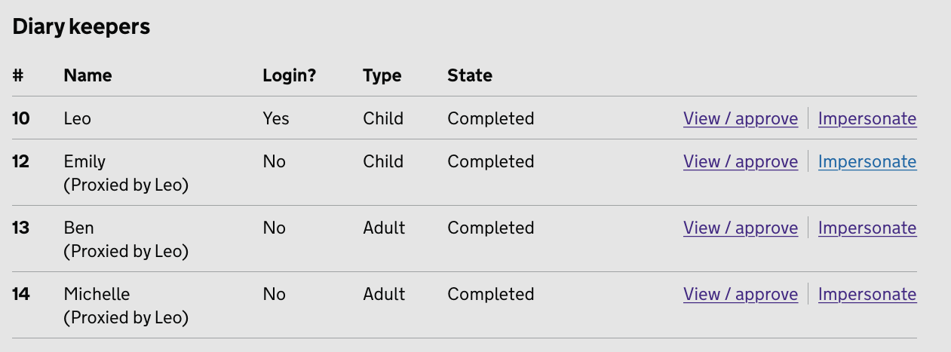
Screenshot from beta phase wave 4 user testing

The Interviewer can take over the digital diary at any point during or after the diary week and either transcribe for the Diary Keeper if they are struggling (as they did during the pandemic) or make alterations that allow the Diary Keeper to continue. Part of the channel shift strategy is a decision from NatCen about whether transcription of paper diaries can be carried out at Interviewer level, or whether Diary Keepers who have low, or zero, Essential Digital Skills can dictate their travel to Interviewers who then enter it directly into the digital diary, much as they do with the paper diary where Diary Keepers find it challenging.

Issues to be considered if Interviewers are transcribing from paper diaries include decisions over what happens to the paper diaries once they are transcribed and how quality assurance is carried out to ensure transcription is accurate.
In terms of how often this intervention would be needed, from private beta testing we’ve seen that the standard ‘mid-week check’ has been a good point for Interviewers to make contact with the Diary Keepers, although having seen via the interviewer dashboards and overview how the Diary Keeper is doing, this could be done at any point in the week the Interviewer chooses. At the moment, there are no digital prompts to start the diary for the Diary Keeper, as we’re focussed on a Minimum Viable Product (MVP) and looking to understand how a straight transfer of the paper diary into a digital medium affects data as a baseline before such elements are introduced. The Interviewer will act as the prompt, as they do for the paper diary, with the addition that they can now see the Diary Keeper’s journeys before making contact.

Interviewer Digital Skills
Something that wasn’t really touched upon in the Discovery Report was the digital ability of the (mostly) freelance Interviewers. In private beta, we’ve found that a significant number of Interviewers are not digitally confident themselves and have required almost one-to-one training, in some cases over multiple sessions. Pretty much all of the Interviewers have work-task-specific digital skills (i.e, they know how to use the CAPI on their laptops and pick up emails), but a high level of Essential Digital Skills in Interviewers cannot be assumed before going into public beta. Private beta has shown us the level the training needs to be pitched at, as well as the frequency of training sessions and the sort of support material they’ll need. NatCen will also run a further pilot and then a larger scale 1:1 test in order to standardise the Interviewer digital ability before full integration with the National Travel Survey.

13.5 Developing the Channel Shift Strategy
NatCen normally conduct a pilot test for any change to the service with 10 Interviewers. In order to ensure a decent geographic and demographic spread for private beta, we worked with three times the standard test amount to test the end-to-end service. The results of these tests will inform the strategy for a further pilot test with a random sample carried out post the service assessment, followed by a 1:1 scale parallel run.

13.5.1 Private beta
- Small-scale Interviewer user testing for onboarding
- 27 Interviewers trained via online group briefing, followed by drop-in sessions for small groups or individuals
- 3 week fieldwork period
- This included testing of existing NatCen Field Team hardware and mobile coverage
- Interviewers can give us more information on demographic and digital ability of Diary Keepers
- Obtain and maintain the WCAG 2.0 level AA rating for accessibility by all
- Individual pick-up/exit interview of Diary Keepers to gauge reactions and feedback
- Debriefings and workshops to gather feedback and inform public beta
- Testing export/receipt of data from test into NatCen systems
- Checking received data can be coded by NatCen and then passed into unchanged DfT workflows

13.5.2 Public beta
- Once beta assessment is passed, use fully random sample to run:
  - Pilot test to embed findings/recommendations from private beta testing and subsequent workshops into fieldwork for September
  - Full-scale 1:1 parallel run of the survey and diary in January 2023
- This will show the baseline data change from the channel shift which can then be weighted and accounted for in the output for the National Travel Survey (NTS)
- Full integration of data into the NTS results
- Launch of Minimum Viable Product (MVP) into live NTS
- Integration of CDCI process into workflow to enable development of items on backlog

13.5.3 Current strategy
- The current necessity of a face-to-face interview gives us a solid channel baseline to work from and to some extent creates a ‘safety net’ against the deeper risks of a full channel shift
- Offer digital first with paper as a back-up preference
- Mixed-mode not currently to be offered for households due to NatCen workflow with the data from both channels
- No mixed-mode for individual participants e.g. individual Diary Keepers cannot record some of their journeys online and some on paper
- Diary is fully responsive works on multiple devices and screen-sizes, Diary Keepers can switch between devices with the same account
- Diary Keepers can proxy for other household members - filling in diaries for other household members from the same dashboard. Those proxy Diary Keepers can either also have a log in if they have an email address - or they can be completely proxied if they don’t, or don’t wish to share their email or fill in the diary themselves but still want to take part in the survey

For consideration in the strategy
- Possibility for interviewers to ‘transcribe’ the diary via phone/remote or even on pick up, direct to digital, as previously done during the pandemic to avoid paper
- The possibility of mixed-mode households in the future - i.e, some family members on paper, some on digital
- Challenges around permissions for proxying, either for email address sharing or sharing of activity information

13.6 Plan for the digital service being unavailable
- An offline version of the service was tested in Alpha; the results were suboptimal (javascript as progressive enhancement only, duplicated development)
- In the event of the service going offline, the service itself is designed for multiple ongoing logins during the week and regarded as ‘after the fact’ rather than a single interaction. If the user encounters site maintenance and rare outages (e.g. due to Google Cloud Platform availability) they can come back again later. In an extreme and protracted outage event the paper channel is still open and Interviewers can transcribe from verbal relaying of travel details
- Users have the ability to enter journeys after the fact, so downtime isn’t critical

13.7 Plan for support model in beta/live
- Video guidance/examples on site: for diary keepers and interviewers
- NatCen interviewers represent first line of support
- Backed up by provision of screenshot instruction documents in interviewer workpacks, and online instructions on the site
- Discovery report suggested centralised first line support - we suggest this should be second line via interviewers

13.8 Digital take-up strategy
- Small offering initially in public beta via pilot
- Iterative development as digital take-up is extended in public beta

13.9 Ongoing work/development
- Channel shift will also have an effect on the data itself
- That effect will need to be measured, understood and accounted for in order to integrate digitally-acquired data into the National Travel Survey
- NatCen need to run a pilot study to confirm their ongoing field methodology and ensure consistent interviewer training and technical provision
- NatCen will then run a full scale 1:1 scale test of the digital diary to acquire that understanding
- On the backlog, we have a projected method for Diary Keepers to share journeys within a household. This will require significant development and user testing before being integrated into the MVP
- The ability for Interviewers to easily split ‘home-to-home’ journeys that Diary Keepers enter, as it’s very difficult to stop some Diary Keepers from making home-to-home or round-trip journeys particularly where the journey purpose is ‘to walk the dog’ or ‘to go for a run’
- Mapping/distance calculation to allow people to drop pins on a destination and allow auto-calculation - this needs significant exploration and can only be done once the MVP baseline for data alteration has been assessed
- Machine learning via Google Cloud’s AutoML, so the system can make an informed decision about how to automatically code some journey purposes. This will require access to a database of journey purposes as entered, and what they were ultimately coded as

14. Support
Interviewers are the support contact for the diary keepers.

- This is a continuation of the process for the paper diary
- Interviewers are highly proactive in encouraging the diary keepers and helping them - especially those less confident
- Interviewers often fill in diaries for users and have been doing so via phone during the pandemic
- Interviewers have regional field teams as their support

The digital supplier will provide support to NatCen in terms of ‘training the trainer’ and liaising with the Field Team to ensure NatCen have the most up to date information and versions. The digital supplier will also produce training videos for interviewers to refer to in order to fully understand the digital diaries.

15. Team
The core project team is made up of representatives from three organisations. DfT, Ghost (Digital) Limited and NatCen.

DfT
- Product owner
- Digital Architect
- Digital Business Partner
Ghost
- Delivery Manager/Quality Assurance
- User research and testing lead/Content
- Technical lead/Full stack developer
- Full stack developer/Assisted digital
- Full stack developer/Assisted digital
- User testing/Content

NatCen
- Field Team Coordinator/Research Director
- Developer for API integration with Diary Entry System
- NatCen Director, NTS lead
- Research assistant

15.1 Wider engagement
The team engaged with a significant range of other organisations and units in order to inform the decision making:

- NatCen - current supplier for data collection/preparation
- DfT Data Protection and Information Assurance teams
- DfT Security Team
- DfT Architecture Change Board
- DfT Road Freight Team
- Engaged wider DfT Teams during DfT ‘Away Day’
- CDDO consulted over service domain and naming protocols
- Engaged with Gov Slack community to discuss Google ‘blocking’
- Welsh Government representatives
- Advice and feedback from DfT Digital business partners
- Three formal ‘show and tell’ sessions to senior stakeholders, interested parties and wider groups within partner organisations

15.2 Ways of working
The team methodology aligns with the service manual:

- Agile methodology
- Daily stand-ups with all team members, even when not directly involved with current work (except Architects who had limited time on project due to restructuring of department)
- Regular scheduled attendance from NatCen to team meetings and ‘open door’ to other stand-ups
- Wider circulation of discussion papers beyond project team within NatCen and DfT
- Working in two-week sprints
- Sprint retros and planning sessions
- Further meetings via Teams as and when needed - often decided in stand-ups
- Weekly catch-ups
- Breakout workshops and discussion papers on key challenges
- Show and tells at regular milestones
- Basecamp as a repository for project materials and initial user feedback
- Trello as a way of managing/tracking backlog and sprints
- Risk register updated and run through at weekly catch-ups
- Support for partners who were not used to agile methodology

15.2.1 How the team learned and iterated
Throughout the project, the team was receiving feedback from users and partners. There was a tried and tested methodology for formally recording input and using it to inform decisions. In this way, there was a clear audit trail back to individual user feedback and needs from any iterations and development.

- User feedback loaded up to Basecamp as ‘to dos’ on a list - put in verbatim where possible
- Feedback discussed with team (including product owner)
- Feedback turned into tasks on backlog and grouped together into sprints on Trello cards
- Changes developed and put on internal test server for team to give feedback
- Further changes made before release to user testing
- Resulting feedback evaluated
- By involving whole team in user discussion, the learning is transmitted evenly

16. Performance and analytics

16.1 What performance indicators tell us the service is meeting needs?
- Increase journey recording rates for days 6 and 7
- Increase representation of underrepresented demographics (e.g. young men)
- Reduce time for pick-up interviews
- Reduce number of in-person pick-up interviews (reduce cost per transaction)
- Eliminate the need for transcription from paper
- Reduction in coding time (reduce cost per transaction)

16.2 How do performance indicators inform improvements?
- Up to and into Private Beta, improvements have been driven by useability testing, interviews with users, feedback passed on by interviewers, and online user feedback form
- In Public Beta, digital take-up and completion rate stats can be used from live user analytics, as well as analysis of demographics and specific day recording rates. We can also see the original diary keeper input as well as the Interviewer edit, so we can make informed decisions about improvements to instructions

16.3 Mandatory KPIs
- Cost per transaction - currently estimated at £54 per diary
- User satisfaction
  - Usability testing
  - Form analytics
  - Manual feedback mechanisms
  - Post-completion survey
- Completion rate
  - Overall diary completion success / failure
  - Per-wizard behavioural flow reports
- Digital take-up
  - Baseline - approx 14,500 Diary keepers / 6,000 households (per year, pre-pandemic)
  - Existing channels - paper diary

17. Next steps
Having met the Service Assessment for beta we are cleared to move into Public beta and use the actual sample to generate households
- Pilot study by NatCen taking lessons from Private beta testing and applying to the actual sample for 10 interviewers - around 150-170 households
- Iterations based on feedback
- 1:1 scale parallel run from sample across all interviewers to gain enough data at scale to know what the effect of collecting digitally is on the data - around 3,750 households
- Full integration with NTS
- Further development and integration of backlog items, priority being journey sharing
- Collect data/codes for machine learning/NLP integration for coding journey purpose
- Integration of CAPI/Sample info into area codes
- Further functionality in ‘superadmin’ area to allow NatCen field team to assign areas to interviewers rather than interviewers subscribing themselves

https://www.lloydsbank.com/banking-with-us/whats-happening/consumer-digital-index/essential-digital-skills.html

