MOD Corporate Environmental JSP 418
Protection Manual Leaflet 9
ENVIRONMENTAL PROTECTION ON MOD
OVERSEAS ESTATE AND ACTIVITIES
Contents
Para
1 Introduction
4 MoD Policy
8 Responsibility for Chapter Users
12 Legislation
Annex
A – List of guidance for the MOD Operational Estate
B - List of useful contacts and Links
C – Assurance Questions
INTRODUCTION
1 The MOD has a large and diverse overseas estate, the permanent estate including Garrisons across Europe and the South Atlantic and training estates in Canada and Africa, figure 1 provides a full list of the MODs overseas estate.
2 The MOD also has a presence in other parts of the world as part of NATO, EUFOR or UN lead missions.
3 This leaflet provides policy and guidance on application of MOD environmental protection policy to the permanent overseas estate.
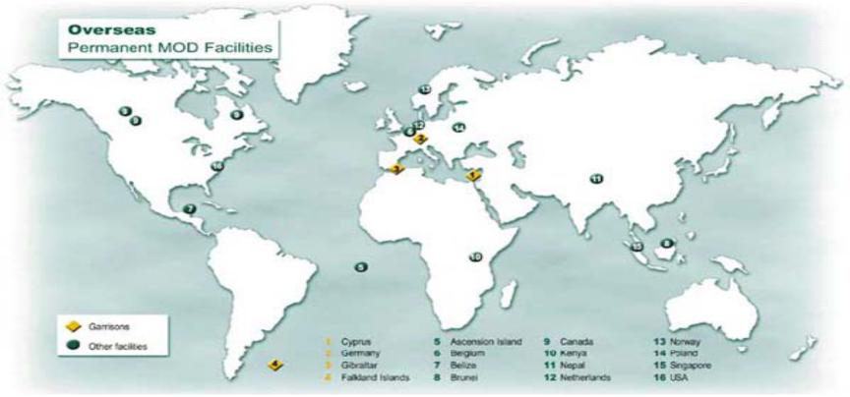
Figure 1 – Map of MODs Overseas Estate
Leaflet 6
January 2012 Page 1
MOD Corporate Environmental JSP 418
Protection Manual Leaflet 9
MOD POLICY
4 The Secretary of State for Defence’s policy statement states that:
- Overseas we apply UK standards where reasonably practicable and, in addition, comply with relevant host nations’ standards. This requires the MOD to implement and comply with Host Nation law first, implementing UK
Standards where practicable.
- Where Defence can rely on exemptions or derogations from either domestic or international law, we introduce standards and management arrangements that are, where practicable, as good as those required by legislation.
5 Coordination of Environmental Protection, including transparency of pertinent information, between the MOD and the Host Nation is essential. It must be carried out at appropriate levels. This does not preclude coordinating EP with any entity deemed to be appropriate.
6 MOD policy on Environmental Management Systems (EMS) must be applied to all of the permanent overseas estate.
7 Significant adverse environmental impacts, threats, incidents or accidents must be immediately reported to the Head of Establishment (HoE), through the appropriate chain of command, and the appropriate national authorities.
RESPONSIBILITIES
8 The Commanding Officer (CO), Head of Establishment (HoE), and Senior Managers shall ensure that:
- They comply with all applicable Host Nation Legislation
- Where applicable and appropriate that site procedures and processes are implemented in line with UK Legislation and MOD policies.
- They have put in place a site Environmental Policy; this may form part of a site Safety, Health, Environment and Fire (SHEF) Policy.
- The site is operating an Environmental Management System in line with MOD policy.
9 Site Environmental Protection Officers (EPO)/SHEF advisors or other delegated person are responsible for:
- Implementing and managing the sites environmental policy and EMS on a day to day basis.
- Providing assurance to the CO/HoE that the site operates in line with appropriate policy
Leaflet 6
January 2012 Page 2
MOD Corporate Environmental JSP 418
Protection Manual Leaflet 9
10 TLB/TFA’s Chief Environmental Safety Officers (CESO) or equivalents are responsible for implementing Corporate EP policy on their overseas estate, providing assurance of compliance in line with the MOD process ownership model.
11 To support the above PJHQ CESO organisation has implemented a structured Audit regime for its permanent overseas estate undertaking SHEF audits on a three year rolling programme.
LEGISLATION
12 The majority of applicable legislation will be that of the host nation, guidance and information regarding these should be sought through local sources such as the Ministry of Environment or Regional authorities. Within the European Union a large amount of this legislation will be driven by Regulations and Directives passed by the European Commission. Information on EU level legislation can be found though all the subject area leaflets in JSP 418 along with JSP 362, JSP 317 & JSP 319. One area of legislation to pay particular attention to is Transfrontier Shipment of Waste.
Transfrontier Shipment of Waste
13 International shipments of waste are subject to a number of regulations and requirements both within and outside of the EU.
14 EU nations are subject to Regulation EC/1013/2006 on Waste Shipments (EU WSR) – The regulation puts in place processes and rules regarding the import and export of waste within, into and out of the European Community in order to protect the environment, with particular focus on:
- Requirements to notify regulators of all shipments; regulators must provide written consent.
- Prohibiting or heavily restricting the transfer of certain types of waste particularly waste for disposal and to non OCED countries.
15 For the relevant guidance and application processes please contact your relevant National Regulatory Authority, a list of useful contacts is at Annex A.
16 The EU WSR includes provisions under the EU WSR for the transfer of waste from
Overseas territories back into the EC Community; for the UK this is laid down in The UK Plan for the Shipments of Waste http://www.ni-environment.gov.uk/waste-shipments.pdf .
17 Imports of waste back into the EC Community when generated by the Armed Forces in crisis, peacemaking or peacekeeping situations are not subject to the same regulatory requirements; however in line with the EU WSR, Regulatory Authorities should be informed of any import using the relevant form. This form and further detailed information pertaining to Transfrontier Shipment of Waste can be found in JSP 418 leaflet 3
Leaflet 6
January 2012 Page 3
MOD Corporate Environmental JSP 418
Protection Manual Leaflet 9
Annex A
List of Relevant Guidance for the MOD Operational Estate
MOD Policy Guidance
- JSP 418 – MOD Corporate Environmental Protection Manual
- JSP 362 – Defence Lands Hand Book
- JSP 317 - Safety Regulations for the Storage and Handling of Fuels and Lubricants
- JSP 319 - Safety Regulations for the Storage, Handling and Use of Gases
- JSP 375 – MOD Health and Safety Manual
Other Useful MOD Documents
- MOD SD Strategy and Action Plan
- MOD Climate Change Strategy
- PJHQ Waste Management Strategy
NATO Doctrine
- STANAG 2510 EP (Edition 2), Joint NATO Waste Management Requirements during NATO-Led Military Operations
- STANAG 2982, Essential field sanitary requirements
- STANAG 7102, (Edition 2), Environmental Protection Handling Requirements for Petroleum Handling Facilities and Equipment
- STANAG 7141, Joint NATO Doctrine for Environmental Protection During NATO Led Military Activities
Other
- AMEPP-01, NATO navies pollution abatement policies
- AMEPP-02, National navy regulations for the disposal of waste
- AMEPP-03, Shipboard pollution abatement equipment catalogue
- AMEPP-04, Guidance for the integration of maritime environmental protection functional requirements into ship design
- AMEPP-05, Alternative non-ozone depleting solvents/cleaning agents
- AMEPP-06, NATO navies hazardous material offload guide
- AMEPP-07, Glossary of terms and definitions used in the AMEPP series
Leaflet 6
January 2012 Page 4
MOD Corporate Environmental JSP 418
Protection Manual Leaflet 9
Annex B
Useful Contacts and Links
Contacts
Post | Role | Contact Details
PJHQ CESO | Chief Environment and Safety Officer for PJHQ | Pjhq-csd-sd-mgr@mod.uk
PJHQ SD Policy | Lead on Environmental and SD Policy for PJHQ | Pjhq-csd-cesocjo@mod.uk
DIO Ops International – Environmental Advisor | DIO Environmental Policy Advisor | DIOOpsInt-
DIO Ops International – Environmental Advisor | DIO Environmental Policy Advisor | EstSpEnv@mod.uk
DIO Ops International | Overseas Estate  Management Teams | Contact Local DIO Representatives/Estate Office
Safety, Sustainable  Development and Continuity Team – SD 2 | Lead on Environmental Protection Policy and JSP 418 | DSEA-CPA-EP@mod.uk

Useful Links
- German Environment Agency- http://www.umweltbundesamt.de/index-e.htm
- Gibraltar Environment Agency - http://www.environmental-agency.gi/
- Falkland Islands - http://www.falklands.gov.fk//Environment.html
Leaflet 6
January 2012 Page 5
MOD Corporate Environmental JSP 418
Protection Manual Leaflet 9
ANNEX C
ASSURANCE QUESTIONS
The purpose of these question sets is not for delivery bodies to provide answers to each question. However, they should be useful for the delivery body in stating their assurance level. If full assurance cannot be given, a short explanation of the problem area/s and the actions which are being taken to improve the assurance level is required.
Questions
- In line with SofS policy, how do you ensure environmental legislative compliance within the Host Nation, i.e. horizon scanning/liaison with local regulating authorities?
- Where appropriate, what procedures are in place for overseas sites to implement UK legislation and standards?
- How is information which is pertinent to environmental protection communicated between the MOD and the Host Nation?
- What procedures are in place to immediately report environmental accidents, incidents, impacts and threats to the relevant Host Nation and MOD command/authorities?
- On the basis of your responses to the questions, and the guidance that is provided in JSP 418, what level of assurance do you believe applies for your compliance with this policy area?
DIA Assurance Classifications
- Full assurance - The frameworks of governance, risk management and control should ensure effective, efficient and economic achievement of the business objective. Risks that threaten the achievement of that objective are adequately managed.
- Substantial Assurance - Weaknesses identified in governance, risk management or control frameworks. Achievement of the business objective is threatened by inadequate management of medium or low category risks.
- Limited Assurance - Weaknesses identified in governance, risk management or control frameworks. Achievement of the business objective is threatened by inadequate management of high category risks.
- No Assurance - The frameworks of governance, risk management and control do not support effective, efficient and economic achievement of the business objective
Leaflet 6
January 2012 Page 6
MOD Corporate Environmental JSP 418
Protection Manual Leaflet 9
Leaflet 6
January 2012 Page 7

