Widget Accessibility Report

Document Version: V2
Document Date: 02/06/2023
Created by: Leah Shirley

Item | Desc
Version | V2
Project | MyKnow V5
Test Site | Development site
Accessibility Tools | SortSite, WAVE, JAWS
WACG Standards | 2.1 AA
Device | Desktop only
Browser | Chrome, Firefox, Edge
Tested Date | 31/05/2023
Completion Report Issue date | 02/06/2023

Table of Contents
1. Execution Summary 4
2. Testing Scope 5
3. Overview Of Audit Results 6
4. Defects 7
5. Accessibility Audit Checklist 9
6. Few UI Testing Results based on WACG 2.1 AA Guidelines 23
7. Few samples of passed audits 26

Execution Summary
This audit report explains the findings of Widget accessibility testing of the MyKnow V5 project. Test scope is based on WCAG 2.1AA which includes all the level A and AA requirements.

Link Ref: https://www.w3.org/WAI/WCAG21/quickref/?currentsidebar=%23col_customize&levels=aaa&showtechniques=125#principle4

Almost all the issues raised during testing were fixed. Accessibility scoring is now between 95% and 100%.

This document also contains an overview of test execution report, issues, principle testing outcome and a detailed execution document.

Additional execution reports produced via SortSite tool and Jaws are available on request.

Testing Scope
2.1 In Scope

Widget assessments:
- Login Page
- Introduction Page
- Question type:
- Cognisco
- Fill in the blanks
- Multiple Response
- Multiple Choice
- Paired Response
- Results page

2.2 Out Of Scope

My KnowV5 system accessibility testing was tested previously, auditing results are available on request.

Overview Of Audit Results
Overall score is now between 95% and 100%.

The following table illustrates different type of assessments tested and scoring.
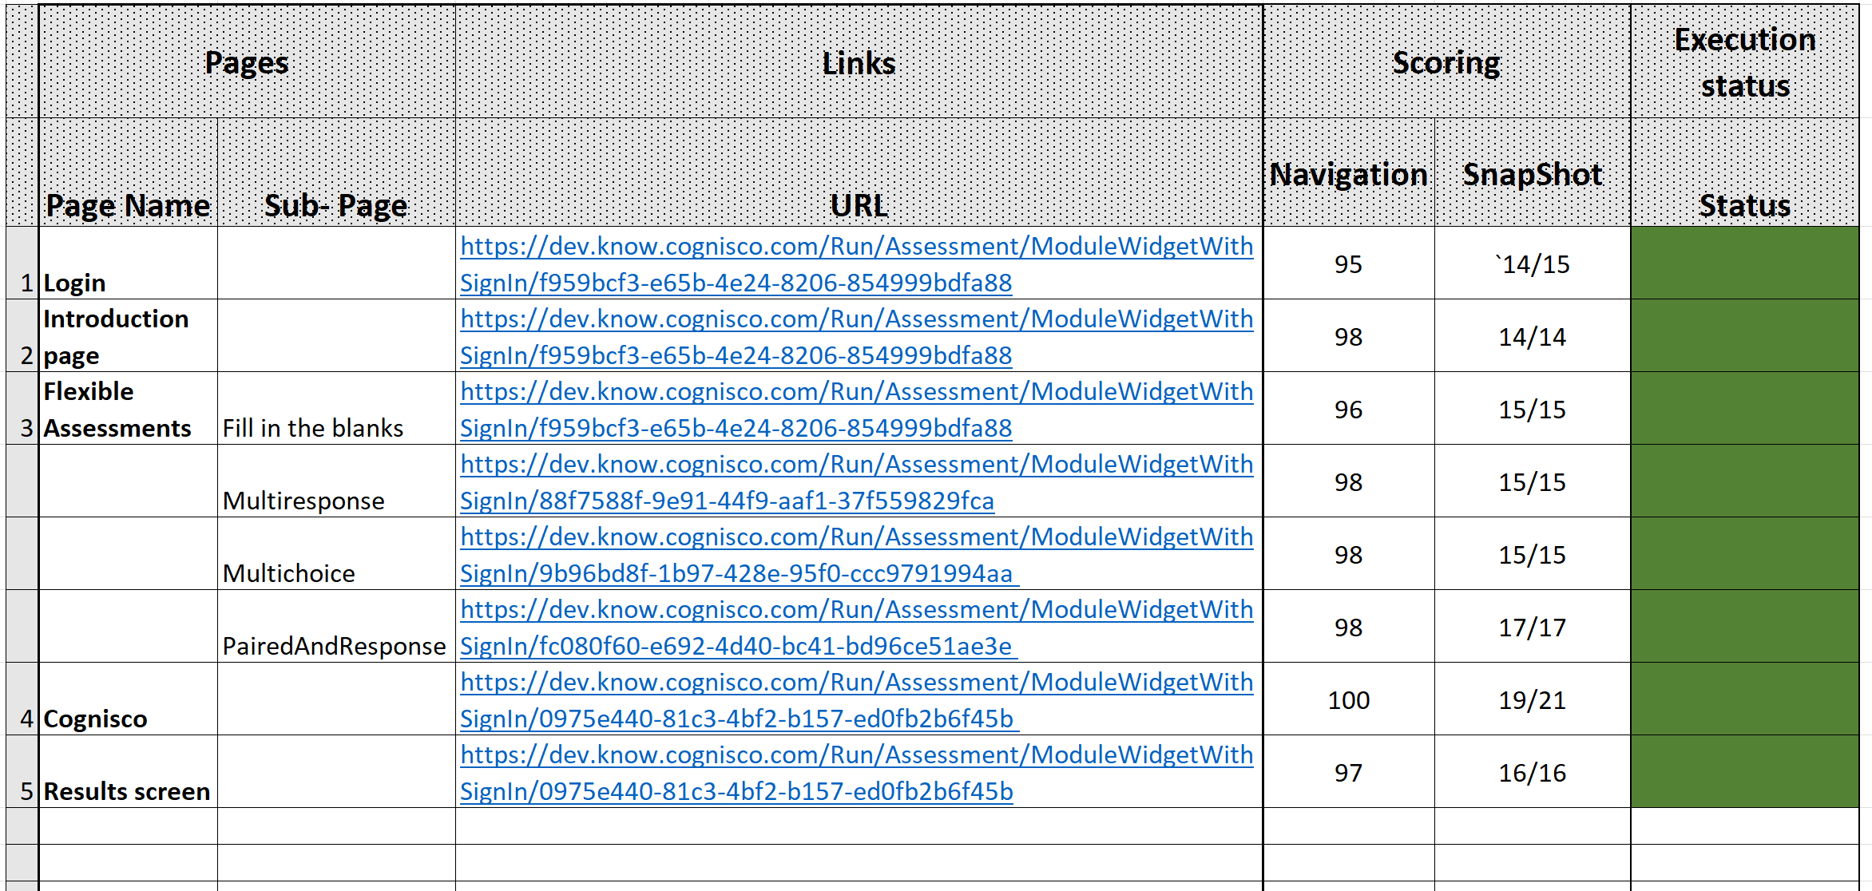

Execution document:

Defects
The following issues raised during testing are now addressed.

There are only two issues in progress/in discussion. Please see the status below.
Feature | Issue | Issue found? | Level | Severity | What it means | Status
Help and Exit icons | Help and exit icons are empty and they have no value or text. | All pages | A | Critical | A button is empty and has no value | PASS
Ellipses icon at the top bar | [aria-*] attributes do not have valid values  Failing Elements:  div#cognisco-assessment > header.MuiPaper-root > div.MuiToolbar-root > button.MuiButtonBase-root  <button class="MuiButtonBase-root MuiIconButton-root ml-2" tabindex="0" type="button" aria-controls="options"> | All pages |  | High | Assistive technologies, like screen readers, can't interpret ARIA attributes with invalid values. | PASS
Submit button | The visual label must appear in the accessible name of links and controls. | All pages | AA | High | Visual label: Submit not in Next | PASS
Questions type icons | The following icons are empty and they have no value or text.  - Cross icon  - Tick icon  - Question icon | - Multiresponse  - Multichoice  - Cognisco | A | Critical | A button is empty and has no value | PASS
Audio | A <video> or <audio> element is present |  | A | Warning | <video> defines video, such as a movie clip or other video streams. <audio> defines sound, such as music or other audio streams. Audio content must be presented in a text format to be fully accessible to users who are deaf and hard of hearing. Video content with audio must have synchronized captions and a transcript. Audio-only content must have a transcript. | In discussion.  Audio is customer specific.
Keyboard navigation | Can not navigate audio window using a keyboard | All questions | A | Critical | Keyboard users | PASS
Keyboard navigation | Could not navigate using Keyboard. User should be able to select item and drop to the correct field | Paired and response | A | Critical | Keyboard users | PASS
Accessibility: Suspicious alternative text | Images have suspicious alternative text | All questions | A | Warning | What It Means  Alternative text is likely insufficient or contains extraneous information.  Why It Matters  If the alternative text for an image does not provide the same content or information conveyed by the image, that content will not be available to screen reader users and when images are unavailable. | In Progress
Accessiblity (Widget) - Very low contrast (2.84:1) | Very low contrast between text and background colors. | All questions | AA | Critical | Adequate contrast of text is necessary for all users, especially users with low vision. | All the text contrast have passed.  One issue in discussion. i.e blue and white background
Accessibility: No heading structure | The page has no headings | Introduction page | AA | Warning | Headings provide important document structure, outlines and navigation functionality to assistive technology users | PASS
Accessibility: No page regions | No page regions or ARIA landmarks were found. | Introduction page | A | Warning | Regions and ARIA landmarks identify significant page areas. Most web pages should have regions defined, particularly for the main content area. | PASS

Detailed execution results and issues found:

Accessibility Audit Checklist
Ref: Web Content Accessibility Guidelines (WCAG) 2.1 (w3.org)
Detailed Principal: https://www.w3.org/WAI/WCAG21/quickref/?currentsidebar=%23col_customize&levels=aaa&showtechniques=125#principle4
Principle | Checklist | Guidelines/Findings | Level | Outcome
1.Perceivable  Information and user interface components must be presentable to users in ways they can perceive. | 1.1 Text Alternatives  Provide text alternatives for any non-text content so that it can be changed into other forms people need, such as large print, braille, speech, symbols or simpler language | 1.1.1 Non-text Content - Provide text alternatives for non-text content. | A | Pass
 | 1.2 Time – based Media  Provide alternatives for time-based media. | 1.2.1 Audio-only and Video-only (pre-recorded). | A | Pass
 |  | 1.2.2 Captions (Pre-recorded): Captions are provided for all pre-recorded audio content in synchronized media, except when the media is a media alternative for text and is clearly labelled as such | A | N/A
 |  | 1.2.3 Audio Description or Media Alternative (pre-recorded)  An alternative for time-based media or audio description of the pre-recorded video content is provided for synchronized media, except when the media is a media alternative for text and is clearly labelled as such. | A | In discussion
 |  | 1.2.4 Captions (Live)  Captions are provided for all live audio content in synchronized media. | AA | N/A
 |  | 1.2.5 Audio Description (Pre-recorded)  Audio description is provided for all pre-recorded video content in synchronized media. | AA | N/A
2. Adaptable  Create content that can be presented in different ways (for example simpler layout) without losing information or structure. | 2.1 Info and Relationships  Information, structure, and relationships conveyed through presentation can be programmatically determined or are available in text. | 2.1.1 Info and Relationships | A | Pass
 | 2.2 Meaningful Sequence  When the sequence in which content is presented affects its meaning, a correct reading sequence can be programmatically determined. | The sequence of content and controls across all tested pages flows in a logical and meaningful manner. | A | Pass
 | 2.3 Sensory Characteristics  Instructions provided for understanding and operating content do not rely solely on sensory characteristics of components such as shape, color, size, visual location, orientation, or sound. | Content does not rely on any sensory characteristics | A | Pass
 | 2.4 Orientation  Content does not restrict its view and operation to a single display orientation, such as portrait or landscape, unless a specific display orientation is essential. | - Using CSS to set the orientation to allow both landscape and portrait.  - Use of show/hide controls to allow access to content in different orientations. | AA | Pass
 | 2.5 Identify Input Purpose | The purpose of each input field collecting information about the user can be programmatically determined when:  - The input field serves a purpose identified in the Input Purposes for User Interface Components section; and  - The content is implemented using technologies with support for identifying the expected meaning for form input data.
3. Distinguishable  Make it easier for users to see and hear content including separating foreground from background. | 3.1 Use of Color  Color is not used as the only visual means of conveying information, indicating an action, prompting a response, or distinguishing a visual element | Colour is not used as the only visual means e.g for the pair response, there was use of colour to show user where they are dropping their answers combined with a dragged element which has a text/image ready to be dragged and dropped.  Links include an enhanced focus indicator, which shows underline, links change of colour and do not rely on colour alone.  Buttons and controls change shape or size on focus  Main menu page links highlight in different colour and set to focus and do not rely on colour alone. | A | Pass
 | 3.2 Audio Control | If any audio on a Web page plays automatically for more than 3 seconds, either a mechanism is available to pause or stop the audio, or a mechanism is available to control audio volume independently from the overall system volume level.  Audios can be played, paused | A | N/A
 | 3.3 Contrast (Minimum)  The visual presentation of text and images of text has a contrast ratio of at least 4.5:1, except for the following:  Large Text: Large-scale text and images of large-scale text have a contrast ratio of at least 3:1;  Incidental: Text or images of text that are part of an inactive user interface component, that are pure decoration, that are not visible to anyone, or that are part of a picture that contains significant other visual content, have no contrast requirement.  Logotypes: Text that is part of a logo or brand name has no contrast requirement. | Very low contrast between text and background colours i.e blue background and white text. | AA | Fail
 | 3.1 Resize text  Except for captions and images of text, text can be resized without assistive technology up to 200 percent without loss of content or functionality | Few screens checked e.g Fill in the blank questions, could zoom to 200 without loss of content or functionality | AA | Pass
 | 3.2 Images of text  If the technologies being used can achieve the visual presentation, text is used to convey information rather than images of text |  | AA
 | 3.3 Reflow  Content can be presented without loss of information or functionality, and without requiring scrolling in two dimensions for  - Vertical scrolling content at a width equivalent to 320 CSS pixels;  - Horizontal scrolling content at a height equivalent to 256 CSS pixels;  Except for parts of the content which require two-dimensional layout for usage or meaning. |  | AA | Pass
 | 3.3 Non-Text Contrast | The visual presentation of the following have a contrast ratio of at least 3:1 against adjacent color(s):  - User Interface Components: Visual information required to identify user interface components and states, except for inactive components or where the appearance of the component is determined by the user agent and not modified by the author;  - Graphical Objects: Parts of graphics required to understand the content, except when a particular presentation of graphics is essential to the information being conveyed. | AA | Pass
 | 3.4 Text Spacing | In content implemented using markup languages that support the following text style properties, no loss of content or functionality occurs by setting all of the following and by changing no other style property: Hide full description  - Line height (line spacing) to at least 1.5 times the font size;  - Spacing following paragraphs to at least 2 times the font size;  - Letter spacing (tracking) to at least 0.12 times the font size;  - Word spacing to at least 0.16 times the font size.  Exception: Human languages and scripts that do not make use of one or more of these text style properties in written text can conform using only the properties that exist for that combination of language and script. | AA | Pass
 | Content on Hover or FocusCoddfdf  Content on | 3.5 Content on Hover or Focus: Where receiving and then removing pointer hover or keyboard focus triggers additional content to become visible and then hidden, the following are true: Hide full description  - Dismissible: A mechanism is available to dismiss the additional content without moving pointer hover or keyboard focus, unless the additional content communicates an input error or does not obscure or replace other content;  - Hoverable: If pointer hover can trigger the additional content, then the pointer can be moved over the additional content without the additional content disappearing;  - Persistent: The additional content remains visible until the hover or focus trigger is removed, the user dismisses it, or its information is no longer valid.  Exception: The visual presentation of the additional content is controlled by the user agent and is not modified by the autho | AA | Pass
4. Operable  User interface components and navigation must be operable. | 4.1 Keyboard accessible  Make all functionality available from a keyboard. | 4.1.1 Keyboard  All functionality of the content is operable through a keyboard interface without requiring specific timings for individual keystrokes, except where the underlying function requires input that depends on the path of the user's movement and not just the endpoints. | A | Pass
 | 4.2 No Keyboard Trap | If keyboard focus can be moved to a component of the page using a keyboard interface, then focus can be moved away from that component using only a keyboard interface, and, if it requires more than unmodified arrow or tab keys or other standard exit methods, the user is advised of the method for moving focus away. | A | Pass
 | 4.3 Character Key shortcuts | If a keyboard shortcut is implemented in content using only letter (including upper- and lower-case letters), punctuation, number, or symbol characters, then at least one of the following is true: Hide full description  - Turn off: A mechanism is available to turn the shortcut off;  - Remap: A mechanism is available to remap the shortcut to include one or more non-printable keyboard keys (e.g., Ctrl, Alt);  - Active only on focus: The keyboard shortcut for a user interface component is only active when that component has focus | A | n/a
 | Input Modalities  Make it easier for users to operate functionality through various inputs beyond keyboard.  4.1.0 Pointer Gestures | All functionality that uses multipoint or path-based gestures for operation can be operated with a single pointer without a path-based gesture, unless a multipoint or path-based gesture is essential. | A | n/a
 | 4.1.1 Pointer Cancellation | For functionality that can be operated using a single pointer, at least one of the following is true:  - No Down-Event: The down-event of the pointer is not used to execute any part of the function;  - Abort or Undo: Completion of the function is on the up-event, and a mechanism is available to abort the function before completion or to undo the function after completion;  - Up Reversal: The up-event reverses any outcome of the preceding down-event;  - Essential: Completing the function on the down-event is essential. | A | n/a
 | 4.1.2 Label in Name | For user interface components with labels that include text or images of text, the name contains the text that is presented visually. | A | Pass
 | 4.1.3 Motion Actuation | Functionality that can be operated by device motion or user motion can also be operated by user interface components and responding to the motion can be disabled to prevent accidental actuation, except when:  Supported Interface: The motion is used to operate functionality through an accessibility supported interface;  - Essential: The motion is essential for the function and doing so would invalidate the activity. | A | n/a
5. Enough Time  Provide users enough time to read and use content. | 5.1 Time Adjustable | Timer provided including adjusted timer(extended timer) where needed. | A | Pass
 | 5.2 Pause, Stop, Hide | No animations, slide shows or auto playing videos are present within application | A | Pass
 | 5.3 Seizures and Physical Reactions | 5.3.1 Three Flashes or Below Threshold | A | n/a
6. Navigable  Provide ways to help users navigate, find content, and determine where they are. | 6.1 Bypass Blocks | A mechanism is available to bypass blocks of content that are repeated on multiple Web pages.  e.g Whilst taking the assessment, user can skip question to go the next question. New features will be added for the user to go to the previous question.  Skip, previous appear to be in keyboard focus | A | Pass
 | 6.2 Page Title  Web pages have titles that describe topic or purpose. | Each page has a unique title. | A | Pass
 | 6.3 Focus Order  If a Web page can be navigated sequentially and the navigation sequences affect meaning or operation, focusable components receive focus in an order that preserves meaning and operability. | All the interactive elements have focus | A | Pass
 | 6.4 Link purpose (In Context)  The purpose of each link can be determined from the link text alone or from the link text together with its programmatically determined link context, except where the purpose of the link would be ambiguous to users in general. | Links are descriptive in nature and their purpose is clear in the context of its surrounding text. | A | Pass
 | 6.5 Multiple ways  More than one way is available to locate a Web page within a set of Web pages except where the Web Page is the result of, or a step in, a process. | Site contains main navigation, accessed from the header, which contains top-level links.  Each top-level link leads to a category page, which lists the second-level links  Each content page has a related links or contents section  There is a Search function | AA | Pass
 | 6.7 Headings and Labels  Headings and labels describe topic or purpose. | A logical heading hierarchy is used throughout. All the pages tested were tested with a headings. Form labels and ARIA label were used | AA | Pass
 | 6.8 Focus Visible  Any keyboard operable user interface has a mode of operation where the keyboard focus indicator is visible. | All the controls tested had a keyboard focus which was visually clear, consisted of changing colour and some button size change. | AA | Pass
7. Readable  Make text content readable and understandable. | 7.1 Language of the page  The default human language of each Web page can be programmatically determined | HTML is used.  A language is also specified in HTML i.e  <html class="box no-scroll" lang="en">  <meta name="accept-language" content="en-GB"> | A | Pass
 | 7.2 Language of parts  The human language of each passage or phrase in the content can be programmatically determined except for proper names, technical terms, words of indeterminate language, and words or phrases that have become part of the vernacular of the immediately surrounding text. | The whole site is in one language  The site also support different languages  <html class="box no-scroll" lang="en"> | AA | Pass
8. Predicable  Make Web pages appear and operate in predictable ways. | 8.1 On Focus | There were no controls show a change of context when they receive focus | A | Pass
 | 8.2 On Input  Changing the setting of any user interface component does not automatically cause a change of context unless the user has been advised of the behavior before using the component. | Inputs did not change the context across the site. | A | Pass
 | 8.3 Consistent Navigation  Navigational mechanisms that are repeated on multiple Web pages within a set of Web pages occur in the same relative order each time they are repeated, unless a change is initiated by the user. | Navigation persists across all pages and is consistent, navigations remains in the same order and additionally is available at the dashboard and in all the main pages navigations | AA | Pass
 | 8.4 Consistent Identification  Components that have the same functionality within a set of Web pages are identified consistently. | Same audio icons are used across the pages, Edit and adding new items icons are the same. Calendar icons, paginations are all the same e.t.c | AA | Pass
 | 8.5 Error Identification  If an input error is automatically detected, the item that is in error is identified and the error is described to the user in text. | Good use of errors and validation to notify the user. | A | Pass
 | 8.6 Labels or Instructions  Labels or instructions are provided when content requires user input. | Some instructions are provided to guide the user e.g form inputs have faded text ‘Enter <data> here>’ | A | Pass
 | 8.7 Error Suggestion  If an input error is automatically detected and suggestions for correction are known, then the suggestions are provided to the user, unless it would jeopardize the security or purpose of the content. | Good use of suggestion errors mostly around forms e.g when response inputs are not provided and user try to navigate away. | AA | Pass
9. Robust Content  must be robust enough that it can be interpreted by a wide variety of user agents, including assistive technologies. | 9.1 Parsing  In content implemented using markup languages, elements have complete start and end tags, elements are nested according to their specifications, elements do not contain duplicate attributes, and any IDs are unique, except where the specifications allow these features. |  | A | Pass
 | 9.2 Name, Role, Value  For all user interface components (including but not limited to: form elements, links and components generated by scripts), the name and role can be programmatically determined; states, properties, and values that can be set by the user can be programmatically set; and notification of changes to these items is available to user agents, including assistive technologies. | [aria-*] attributes have valid values | A | Pass
 | 9.3 Status Messages | In content implemented using markup languages, status messages can be programmatically determined through role or properties such that they can be presented to the user by assistive technologies without receiving focus.
11. Understandable  Information and the operation of the user interface must be understandable. | 11.0 Language of the page | The default human language of each Web page can be programmatically determined | A | Pass
 | 11.1 Language of parts | The human language of each passage or phrase in the content can be programmatically determined except for proper names, technical terms, words of indeterminate language, and words or phrases that have become part of the vernacular of the immediately surrounding text. | A | n/a
 | Input assistant  Help users avoid and correct mistakes.  11.2.0 Error Identification | If an input error is automatically detected, the item that is in error is identified and the error is described to the user in text. | A | Pass
 | 11.2.1 Labels or Instruction | Labels or instructions are provided when content requires user input | A | Pass
 | 11.2.2 Error Suggestions | If an input error is automatically detected and suggestions for correction are known, then the suggestions are provided to the user, unless it would jeopardize the security or purpose of the content.  A good example was used for Fill in the blank question, if user attempt to drag and drop to a totally different response to the one they should be filling the blank, a warning message is triggered advising the user that the response are limited to each response.  Good instructions and error/warning advising for Cognisco type o questions e.g user to remember to give confidence | AA | Pass
 | 11.2.3 Error Prevention (Legal, Financial, Data) | For Web pages that cause legal commitments or financial transactions for the user to occur, that modify or delete user-controllable data in data storage systems, or that submit user test responses, at least one of the following is true: Hide full description  - Reversible: Submissions are reversible.  - Checked: Data entered by the user is checked for input errors and the user is provided an opportunity to correct them.  - Confirmed: A mechanism is available for reviewing, confirming, and correcting information before finalizing the submission | AA | n/a
12. Predictable Make Web pages appear and operate in predictable ways. | 12.0 On Focus | When any user interface component receives focus, it does not initiate a change of context. | A | Pass
 | 12.1 On Input | Changing the setting of any user interface component does not automatically cause a change of context unless the user has been advised of the behavior before using the component. | A | Pass
 | 12.2 Consistent Navigation | Navigational mechanisms that are repeated on multiple Web pages within a set of Web pages occur in the same relative order each time they are repeated, unless a change is initiated by the user. | AA | Pass
 | 12.3 Consistent Identification | Components that have the same functionality within a set of Web pages are identified consistently. | AA | Pass

Few UI Testing Results based on WACG 2.1 AA Guidelines
Multiresponse:
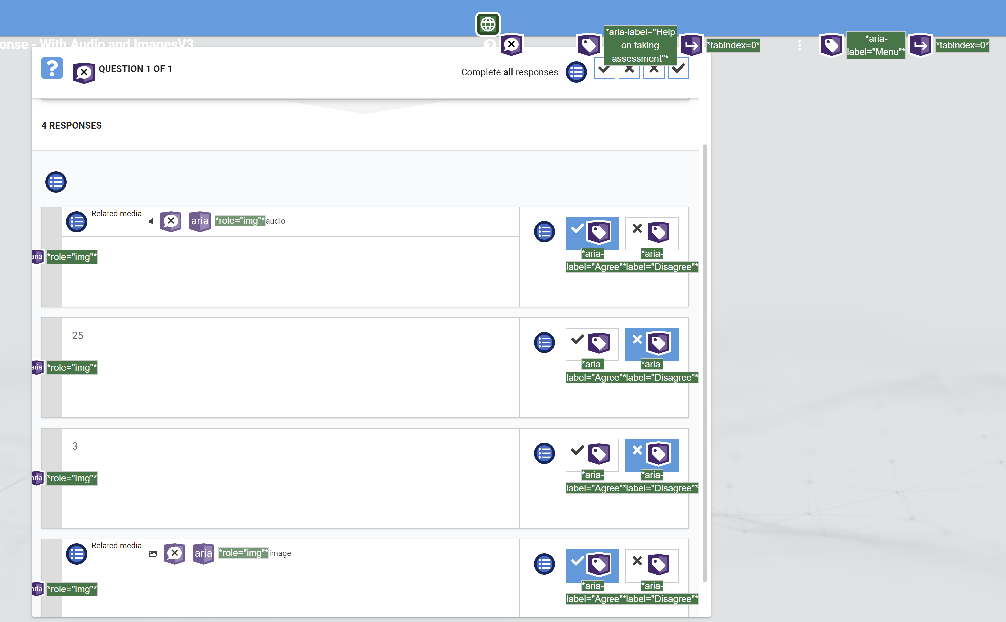
Cognisco: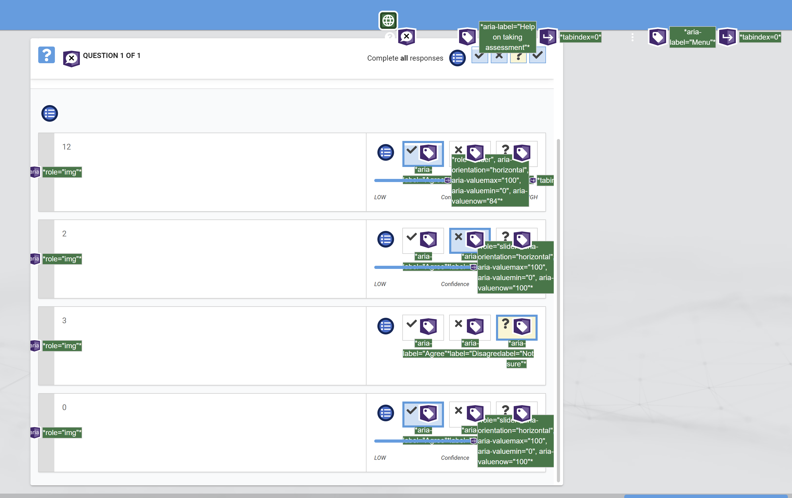

Paired and response:

Multichoice:
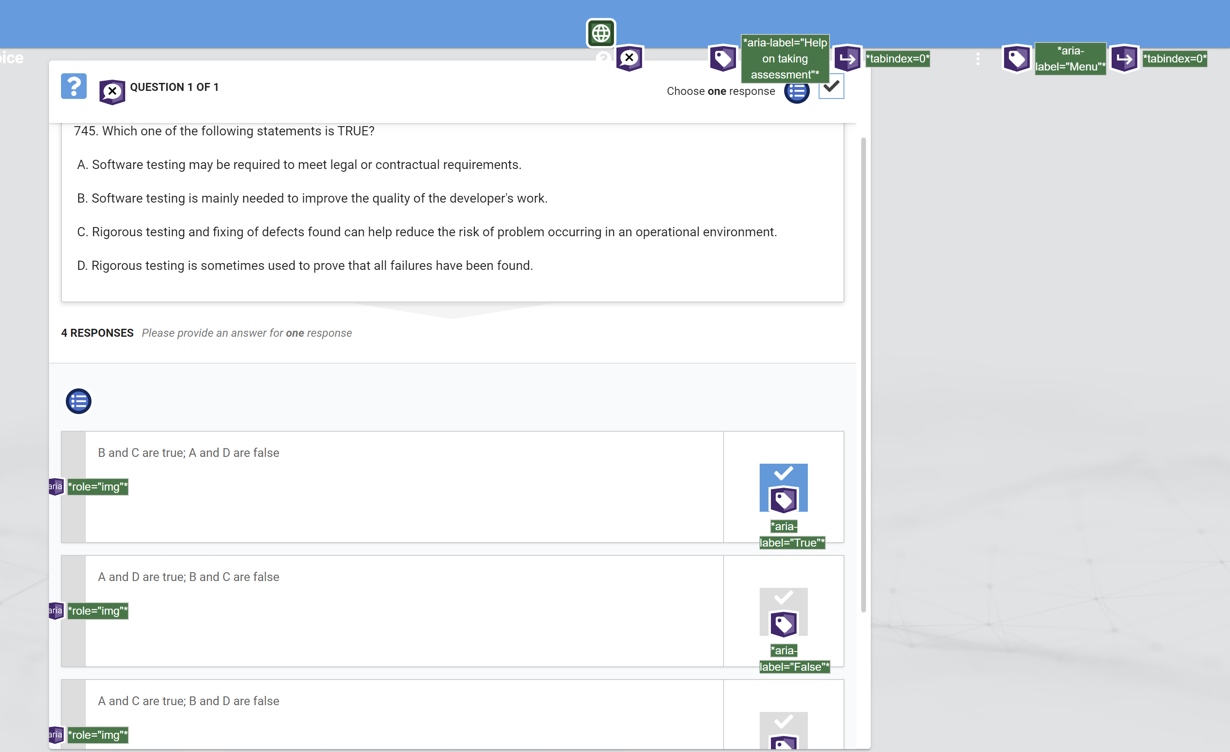

Fill in the blank:
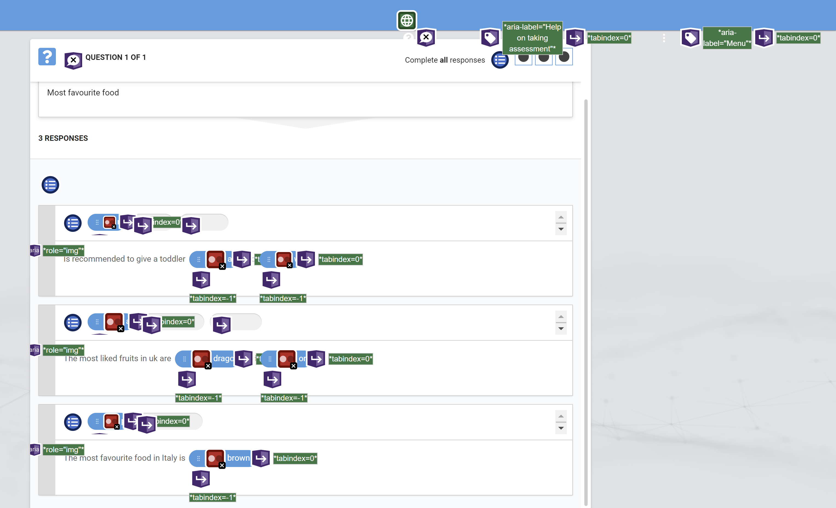

Few samples of passed audits
1.[aria-*] attributes match their roles
2. [aria-hidden="true"] is not present on the document <body>
3. [aria-*] attributes have valid values
Assistive technologies, like screen readers, can't interpret ARIA attributes with invalid values. Learn more about valid values for ARIA attributes.
4. [aria-*] attributes are valid and not misspelled
Assistive technologies, like screen readers, can't interpret ARIA attributes with invalid names. Learn more about valid ARIA attributes.
5. Buttons have an accessible name
When a button doesn't have an accessible name, screen readers announce it as "button", making it unusable for users who rely on screen readers. Learn how to make buttons more accessible.
6. [user-scalable="no"] is not used in the <meta name="viewport"> element and the [maximum-scale] attribute is not less than 5.
Disabling zooming is problematic for users with low vision who rely on screen magnification to properly see the contents of a web page. Learn more about the viewport meta tag.
7. [aria-hidden="true"] elements do not contain focusable descendents
Focusable descendents within an [aria-hidden="true"] element prevent those interactive elements from being available to users of assistive technologies like screen readers. Learn how aria-hidden affects focusable elements.
8. Background and foreground colors have a sufficient contrast ratio
Low-contrast text is difficult or impossible for many users to read. Learn how to provide sufficient color contrast.
9. Document has a <title> element
The title gives screen reader users an overview of the page, and search engine users rely on it heavily to determine if a page is relevant to their search. Learn more about document titles.
10.<html> element has a [lang] attribute
If a page doesn't specify a lang attribute, a screen reader assumes that the page is in the default language that the user chose when setting up the screen reader. If the page isn't actually in the default language, then the screen reader might not announce the page's text correctly. Learn more about the lang attribute.
11.<html> element has a valid value for its [lang] attribute
Specifying a valid BCP 47 language helps screen readers announce text properly. Learn how to use the lang attribute.
12. Lists contain only <li> elements and script supporting elements (<script> and <template>).
Screen readers have a specific way of announcing lists. Ensuring proper list structure aids screen reader output. Learn more about proper list structure.
13.List items (<li>) are contained within <ul>, <ol> or <menu> parent elements
Screen readers require list items (<li>) to be contained within a parent <ul>, <ol> or <menu> to be announced properly. Learn more about proper list structure.
14. No element has a [tabindex] value greater than 0
A value greater than 0 implies an explicit navigation ordering. Although technically valid, this often creates frustrating experiences for users who rely on assistive technologies. Learn more about the tabindex attribute.
15. Heading elements appear in a sequentially-descending order
Properly ordered headings that do not skip levels convey the semantic structure of the page, making it easier to navigate and understand when using assistive technologies. Learn more about heading order.

