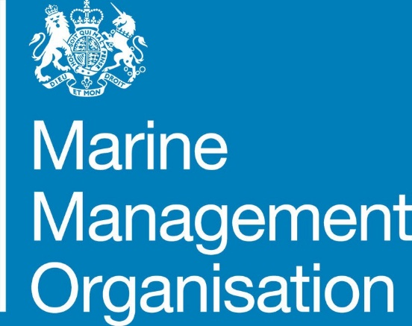
Appointment of General Members to Inshore Fisheries and Conservation Authority
...ambitious for our seas and coasts
Information for Candidates

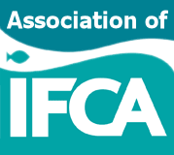

Contents

- Introduction to the Marine Management Organisation (MMO)
- Introduction to the Inshore Fisheries Conservation Authority (IFCA)
- The role of an IFCA General Member
- What skills will you need?
- Terms of appointment
- Application & Selection process

Introduction to the MMO

The Marine Management Organisation (MMO) is a non-departmental public body (NDPB) created under the Marine and Coastal Access Act 2009 and launched in April 2010 to be the UK Government’s principal delivery body in the marine area.

The MMO takes forward the policy interests of several government departments and has an overarching responsibility for the planning, licensing and enforcement of activities in the English marine area (including fisheries). The MMO and the IFCAs work together to achieve sustainable fisheries management and marine conservation and to ensure effective delivery and a joined-up approach.

The MMO have been given responsibility by Defra to manage the process of
making appointments of General Members to IFCA Committees.

MMO is required to achieve a balanced membership across various interest groups, including those with commercial, recreational and environmental interests and will seek to appoint members with an understanding of the local marine needs. Upon appointment General Members report to the Chair of the relevant IFCA.

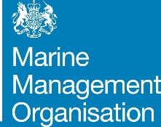
Introduction to IFCA

...ambitious for our seas and coasts
Inshore Fisheries and Conservation Authorities (IFCAs) were set up in April 2011 as a new type of regulator to work with stakeholder groups to achieve sustainable fisheries management and marine conservation in English Inshore waters.

The IFCA Vision
“Inshore Fisheries and Conservation Authorities will lead, champion and manage a sustainable marine environment and inshore fisheries, by successfully securing the right balance between social, environmental and economic benefits to ensure healthy seas, sustainable fisheries and a viable industry.”
Working towards this vision each of the ten IFCAs are responsible for protecting and managing the marine shore environment and fisheries resources in English waters out to six nautical miles. This essential work supports sustainable fisheries and seeks to protect the marine environment.

Each IFCA is governed by an authority that is a committee or joint committee of the local authorities that fall within their district, membership is made up as follows;

- Local Authority Members: Elected members of the constituent county and unitary local authorities.
- General Members: Individuals acquainted with the needs and opinions of the local fishing communities, recreational fishers, and those with knowledge of, or expertise in, marine environmental matters.
- One representative from each of three statutory bodies: Marine Management
Organisation (MMO), Environment Agency (EA) and Natural England (NE)

The role of an IFCA General Member

...ambitious for our seas and coasts

The members of the IFCA contribute their knowledge and experience to provide sustainable management of the inshore marine area of their IFCA district. Appointees to IFCAs are legally required to consider all the local fishing and marine conservation interests in the waters of the IFCA district in a balanced way, taking full account of the needs of the IFCA district. Appointees should recognise that they are part of a committee and should not regard themselves as representing solely one area of particular interest within the IFCA district.

As an IFCA General Member you will have the opportunity to contribute your knowledge and experience to committee meetings helping to shape and direct the work of the IFCA. This membership puts local people in the driving seat of fisheries management and is an exciting opportunity to shape the development of inshore fisheries in your region. As a member of an IFCA committee you will work in a team with others, helping to ensure that:

- the use of sea fisheries resources is carried out in a sustainable way and is balanced with the need to protect the marine environment or promote its recovery from, the effects of exploitation
- the different needs of those engaged in the exploitation of sea fisheries and marine resources are balanced

- the conservation objectives of marine conservation zones are achieved

Although these appointments are unpaid, members can claim reasonable expenses.
For more information on this or any aspect about the role of an IFCA General Member please don't hesitate to contact your local IFCA office.

What skills you will need

To undertake this role, you will need to:

- Attend quarterly committee meetings.
- Take part in sub-committee meetings to provide your expertise on specific issues as and when required.
- Ensure you can make time to prepare for meetings.
- Attend training to help you in your role.
- Represent your committee at other meetings when the need arises.

We anticipate this equates to approximately one day a month.

IFCA members must work collaboratively, to contribute skills and knowledge for the good of the IFCA committee and the local community, and act as one.

To be successful in this role, you will have:

- Good communication skills

- Knowledge and experience in a relevant area such as commercial and recreational fishers, environmental issues or marine research

- Experience with the local community
- Experience of working in a team
- Ability to works towards collective agreements for the good of the overall objective
- Ability to take an objective view

Terms of appointment

Being an IFCA member is a rewarding role but does require commitment and active participation. Members are required to adhere to a set of terms and conditions. In addition, appointees are also obliged to comply with IFCA governance statutes such as standing orders and codes of conduct, which can be found on IFCA websites.
General Member appointments will be for a period of between three to five years and will be subject to a satisfactory performance appraisal completed by the IFCA each year.

Application and selection process
The recruitment process will be open, transparent, objective and fair for all candidates.
To apply candidates must complete the online application form (or a printable version) which can be downloaded from the online job advert. Alternatively, if you do not have access to the internet then please contact us on telephone number 0300 123 1032 to request an application pack to be sent to you by post.

You can submit the completed application form to the MMO through: Email:ifcarecruitment@marinemanagement.org.uk
Post: IFCA Recruitment
Marine Management Organisation Lancaster House
Hampshire Court Newcastle upon Tyne NE4 7YH

The closing date for receiving applications is Monday 14 FAugust 2023 at 23:55. Please note that we cannot guarantee that late applications will be accepted.

Applications will be assessed against the role profile taking into account the need to maintain an appropriate balance of sectors and expertise on the IFCA committee.

Vacancy
Closes
Sifting
Interviews
14 August 2023
14 August 2023
August 2023
Offers
August -September 2023
Date of commencement
September 2023

Interviews

...ambitious for our seas and coasts

Interviews will be conducted remotely using Microsoft Teams and prior to the interview you will be sent a link via email. At the time of interview, you should click the link which will take you into the virtual interview room, where your interview panel will join you. You will need to ensure that the relevant video and audio software is enabled on your device or if using a smart phone, you have downloaded the App in advance.
Should there be any connection difficulties, your interview invitation will contain details of a telephone number in which case you can dial in and if necessary, the remainder of the interview will be conducted via conference call.

Should you be unable to access a virtual interview, it may be possible for you to attend a local IFCA or MMO office.

Successful applicants must complete a basic disclosure check, the fee for which can be reimbursed by the MMO upon application.
Appointments will be conditional upon candidates providing a satisfactory DBS certificate and receipt of agreed and signed terms and conditions.

Reserve lists

We may put in place a reserve list of candidates, for example in instances where there are more successful applicants than posts available. If you do not wish to be part of the reserve list, please inform us during the interview process.

