

June 2022
Research into the customs intermediaries sector
Wave 5 summary report
HM Revenue and Customs Research Report: 697

Authors: Rebecca Klahr and Steven Coutinho (Ipsos)
Sam Donaldson (Perspective Economics)
Disclaimer

The views in this report are the author’s own and do not necessarily reflect those of HM Revenue and Customs.

© King’s Printer and Controller of HMSO 2023
This publication is licensed under the terms of the Open Government Licence v3.0 except where otherwise stated. To view this licence, visit nationalarchives.gov.uk/doc/open-government-licence/version/3.
Where we have identified any third party copyright information you will need to obtain permission from the copyright holders concerned.
Published by HM Revenue and Customs, June 2023

Acknowledgements
Ipsos would like to thank all of the customs intermediaries who gave up their time to take part in any of the 5 waves of this research. We would also like to thank the British International Freight Association (BIFA), Logistics UK and the Road Haulage Association (RHA) for their continued support by both encouraging their members to participate in the survey if asked and providing information and clarification during the development of the survey and the analysis of the data.
We would particularly like to thank G Watson and K Wade at HMRC for their advice and support in shaping the research.

Contents
Glossary and abbreviations 5
Executive summary 8
1. Introduction 9
2. The make-up of the sector 12
3. The current capacity of the sector 14
4. Submitting customs declarations 18
5. Full customs controls and future capacity 24
6. Appendix 27

Glossary and abbreviations
Term | Definition
Automated software | Automated software reduces the need for human involvement in processing certain types of customs declarations, allowing customs intermediaries to process larger numbers more quickly.
Customs declaration | A form listing the details of goods being imported or exported. It is a legal requirement, although some countries or trading areas (for example the European Union, (EU)) have agreements in place which means they are not required. Six different types of declaration were asked about in the survey, noted with (*) in this glossary.
Customs Declaration Service (CDS) | The Customs Declaration Service (CDS) is an HMRC system which will entirely replace CHIEF by 31 March 2023. HMRC are currently operating a dual running of the 2 systems.
Customs Handling of Import and Export Freight (CHIEF) | The Customs Handling of Import and Export Freight (CHIEF) system records the movement of goods by land, air and sea. It allows importers, exporters, and freight forwarders to complete customs formalities electronically and automatically checks entry errors. CHIEF will close for import declarations at the end of September 2022 and for export declarations at the end of March 2023, when it will be replaced by CDS.
Customs intermediary | These are businesses that help traders to move goods across borders. They offer a range of different services including providing or arranging transportation of goods, completing customs declarations and paying tariffs or import duties. This research focused on those who currently make declarations on behalf of traders (either in-house or outsourced) or those who intended to do so once full customs declarations were required on all EU trade (in-house or outsourced).
Entry in Declarants Records* | Entry in Declarants Records allow Customs Simplified Declaration Procedures (SDP) goods to be released into circulation. The customs intermediary or trader records the goods’ details at the time of import and provide a supplementary declaration* to HMRC at a later date.
EU import and export declarations | Customs declarations allowing goods to be exported to the EU from the UK, or elsewhere, or to be imported from the EU to the UK, or elsewhere.
Export(ing) | Selling goods or services to a customer in a different country. This research focused purely on goods as customs declarations are not required for services.
Full customs export declaration* | A full customs declaration contains all the information about an export. Completion requirements will be dependent on the Commodity Code and Procedure Code entered as these will influence the mandatory fields required to support that declaration. It consists of between 65 boxes for exports and 76 boxes for imports that must be completed and accepted by CHIEF or CDS before the goods leave the UK. It is completed electronically.
Full customs import declaration* | A full customs declaration contains all the information about an import. Completion requirements will be dependent on the Commodity Code and Procedure Code entered as these will influence the mandatory fields required to support that declaration. It consists of between 65 boxes for exports and 76 boxes for imports that must be completed and accepted by CHIEF or CDS before the goods are released from the border. It is completed electronically.
Goods Vehicle Movement Service (GVMS) | The Goods Vehicle Movement Service (GVMS) is a UK Government IT platform for moving goods into or out of Northern Ireland and Great Britain. Hauliers who want to move goods through a port in the UK are required to use the GVMS.
Haulier | Hauliers deal mainly with the physical transportation of goods.
Import(ing) | Purchasing goods or services from sellers in a different country. This research focused purely on goods as customs declarations are not required for services.
In-house | When customs intermediaries complete declarations themselves.
Large | Firms with 250+ employees and/or turnover greater than €50 million.
Medium | Firms with 50-249 employees and/or turnover less than or equal to €50 million.
Micro | Firms with one to nine employees and/or turnover less than €2 million.
Northern Ireland Protocol | The Northern Ireland Protocol is the arrangement agreed between the UK and the EU regarding the movement of goods to and from Northern Ireland. Under the Protocol, customs declarations are required on goods entering Northern Ireland from the rest of the UK. Checks are not required on goods entering Ireland from Northern Ireland. For more information, please visit see The Northern Ireland Protocol.
Outsourcing | When customs intermediaries pay other intermediaries to complete their customs declarations for them.
Safety and security entry summary declaration (ENS)* | ENS, or ‘safety and security’ declarations, must be lodged at the first port of entry into the UK for goods arriving, according to EU safety and security regulations. The ENS contains advance cargo information, which is used to assess the risk of goods entering the UK.
Sanitary and phytosanitary (SPS) | Sanitary and Phytosanitary (SPS) measures refer to the EU controls to protect animal, plant or public health. These checks are separate to processes operated by HMRC and Border Force.
Simplified Customs Declaration Procedures (SCDP) | This is an electronic customs system for speeding up the importing of goods. When SCDP goods arrive at a border from outside the EU, an initial declaration known as a Simplified Frontier Declaration* is submitted, or an Entry in Declarants Records* is made to allow the release of the goods. The consignment details are sent to HMRC via a Supplementary Declaration*. This was formerly known as Customs Freight Simplified Procedures (CFSP)
Simplified frontier declaration (SFD)* | This is a shortened declaration that provides 15-20 data elements. SFDs must be completed electronically, accepted before goods are released, and then followed by a supplementary declaration* at a later date. SFDs can only be used by customs intermediaries or traders who are SCDP-authorised.
Small | Firms with 10-49 employees and/or turnover less than or equal to €10 million.
Staged controls | This is a staged approach to import controls following the UK’s exit from the EU.  From 1 January 2021 to 31 December 2021, most traders importing non-controlled goods from the EU to GB were able to make an entry in their own records (EIDR) and defer customs declarations for up to 175 days from the time of import. Records of imports had to be kept and supplementary declarations had to be made within 175 days of the goods arriving.  On 1 January 2022, full customs controls were introduced for goods moving from the EU (except Ireland) to GB.  The UK Government temporarily extended staged customs controls beyond 31 December 2021 for goods moving from the island of Ireland into GB while discussions between the United Kingdom and the European Union on the Northern Ireland Protocol are ongoing.
Standard Industrial Classification (SIC) | SIC provides an established framework to classify businesses by the type of economic activity in which they are engaged. See more information about Standard Industrial Classification (SIC).
Supplementary declaration* | This is used following an SFD* or Entry in Declarants Records*. The declaration is collated by specialist software and provides the additional data needed to meet the same standard as a full declaration.
Trader | Businesses who import goods or services to the UK or export to other countries. This research focused purely on goods as customs declarations are not required for services.
Trader Support Service (TSS) | Changes have been made to the way goods move in and out of Northern Ireland. The Trader Support Service helps businesses adapt to these changes. The service offers:  - comprehensive education, training and advice about the changes to the way goods move under the Northern Ireland Protocol Export Health Certificates  - a mechanism to complete customs and safety and security declarations on behalf of the business where these are required for movements between Great Britain and Northern Ireland
Very large | We have marked firms with 5,000 plus employees and/or turnover in excess of €250 million as ‘very large’ for analysis purposes.

Executive summary

Background and methodology
This summary report presents the key findings from the fifth wave of research with customs intermediaries, conducted on behalf of HM Revenue and Customs (HMRC). HMRC commissioned Ipsos to undertake research to understand the size and characteristics of the customs intermediary sector. Conducted over 5 waves between June 2020 and March 2022, the research explored the sector’s preparations for EU Exit, the end of the transition period, and new customs processes that are in place. The topics have varied each wave, with the overall aim being to measure change in customs intermediaries’ capacity and confidence in response to EU Exit policies, as well as to better understand the population in terms of structure and services provided to traders.
The research focused on customs intermediaries who already made customs declarations on behalf of traders (either in-house, through outsourcing to another customs intermediary, or a mix of both), and for Waves 1 to 4 those who said they intended to do so once full customs declarations were required on all EU trade (again, either in-house, through outsourcing to another customs intermediary, or a mix of both).
The Wave 5 survey took place between 17 February and 22 March 2022 and consisted of 257 telephone interviews with customs intermediaries (235 of whom had taken part in earlier surveys). In addition, 15 follow-up, qualitative in-depth interviews were conducted via telephone between 17 and 31 March 2022. The findings in this report were correct at the time of asking but may not reflect the current situation.

Key findings
        - The total number of customs declarations completed is in line with Wave 4. Four in ten customs intermediaries were planning to increase their capacity in the first 6 months of 2022 (42%) while just over half expected to maintain the same capacity (54%).
        - A third of those making customs declarations did so on behalf of goods moving from Great Britain to Northern Ireland (32%).
        - Awareness of the new Customs Declaration Service (CDS) increased to 77% from 65% at Wave 4. Overall confidence levels with the transition remain unchanged, and there is a strong appetite for practical experience of using the new system as part of preparations; customs intermediaries would feel confident once they tried using the system.
        - Customs intermediaries’ confidence in understanding the new requirements of EU trade remained high (77%), but many continued to report barriers to making additional customs declarations (39% reported no barriers at Wave 5). Lack of information or uncertainty around requirements remained the main barrier (29%), followed by uncertainty around transit times or delays (12%). Further information on barriers can be found in section 4.3. Please refer to the Appendix (Table 6.4) for the full data tables for these questions.

Introduction
HM Revenue and Customs (HMRC) commissioned Ipsos to conduct research to understand the size and characteristics of the customs intermediary sector. The research explored the sector’s preparations for EU Exit, the end of the transition period, and new customs processes that are in place. Specifically, the research aimed to:
- estimate the size and capacity of the customs intermediary population and the sub-groups within it
- build upon previous research designs to create a more robust sample frame and method for conducting surveys with this population
- better understand the population in terms of structure, characteristics, and the services that customs intermediaries provide for their customers
- conduct 5 research waves to measure change in capacity in response to EU Exit policies
The research focused on customs intermediaries who currently made customs declarations on behalf of traders (either in-house, through outsourcing to another customs intermediary, or a mix of both), or those who said they intended to make declarations once full customs declarations were required on all EU trade (again, either in-house, through outsourcing to another customs intermediary, or a mix of both).
This report presents summary findings from the Wave 5 survey and qualitative work, highlighting significant changes between the Wave 4 and Wave 5 survey findings, where relevant, throughout.

Method
The research included a development phase to build a sample of customs intermediaries and develop the questionnaire (including consultations with intermediaries and trade bodies, as well as cognitive testing); 5 waves of random probability telephone surveys to measure change in capacity over time; follow-up qualitative interviews with a targeted sample of customs intermediaries; and a sizing exercise to estimate the total size, make-up and capacity of the sector as a whole. The fifth wave telephone survey and follow-up qualitative interviews took place in February and March 2022 (as shown in Figure 1.1).

Figure 1.1: Overview of research method
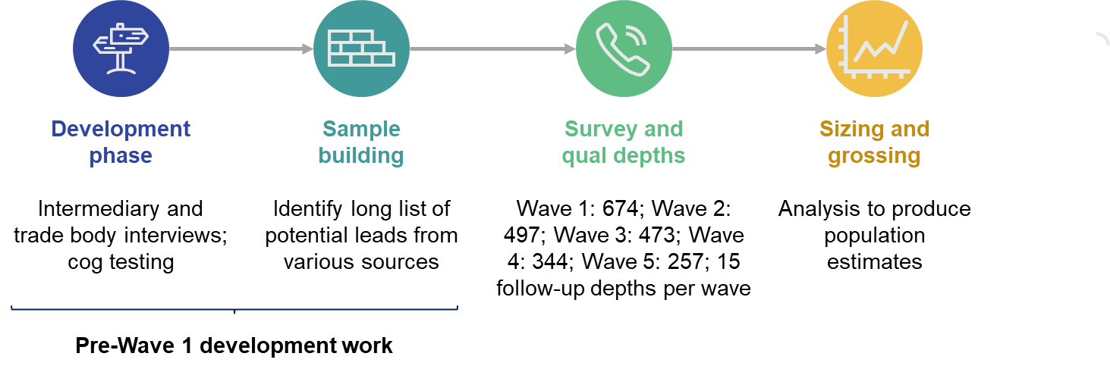
Please refer to the Appendix for a more detailed explanation of the research methodology. Fieldwork for the previous waves took place as follows:
      - Wave 1 – 29 June to 1 September 2020 (piloted with 97 customs intermediaries between 29 June and 13 July 2020), 674 customs intermediaries
      - Wave 2 – 10 November to 16 December 2020, 497 customs intermediaries (337 of whom had taken part in Wave 1)
      - Wave 3 – 26 March to 6 May 2021, 473 customs intermediaries (298 of whom had taken part in earlier waves)
      - Wave 4 – 23 September to 9 November 2021, 344 customs intermediaries (281 of whom had taken part in earlier waves)

Sizing exercise: Grossing and estimation
Following the Wave 1 survey, Ipsos provided Perspective Economics with a dataset outlining the survey responses and call outcomes for those who did not complete the survey. By analysing the call outcomes, we concluded that firms with lower scores were less likely to be involved in customs activity, and therefore more likely to be ineligible for the survey. Perspective Economics reviewed all 109,759 firms to identify which leads should be included or excluded from the final list.
Following the development of the final list of proposed customs intermediaries in the UK (which derived a final estimated population of c. 8,400 firms in Wave 1), Perspective Economics analysed the survey responses by size, and applied these estimates to the wider population. This process was updated following the completion of each survey wave, resulting in a final estimated population of c. 8,900 firms in Wave 5.

Reporting notes
This summary report provides a selection of the key findings from the Wave 5 survey.

Analysis and interpretation of the Wave 5 data
Survey results are subject to margins of error, which vary with the sample size and the percentage figure concerned. The report only comments on subgroup differences where these were found to be statistically significant at the 95% level of confidence. There is a further guide to statistical reliability in the Appendix (Section 6.3). Where figures do not sum to 100% this is due to rounding of percentages or because the questions allowed more than one response. Similarly, figures based on aggregating categories may not always reflect the sum of the individual answer categories due to rounding.
Average figures are reported using mean and median values to demonstrate the full scale of responses. Mean values were derived by taking the average of the actual figure given or the midpoint of banded responses. Median values were derived by taking the midpoint of the frequency distribution of the values. Median figures are useful where very high or low outlying figures were reported, to provide a more accurate and balanced account.
This report also contains qualitative findings from the 15 Wave 5 in-depth interviews. Qualitative approaches are used to explore the nuances and diversity of views and are not designed to be statistically representative. We have included verbatim comments to illustrate key points. Where quotes are used, they have been anonymised and attributed with the participant type and key characteristics.

Grossed and survey findings
This report includes findings from both the sizing exercise and the survey. Wherever we refer to the ‘grossed’ findings in this report, where the overall base size is noted as around 8,900 intermediaries, or where raw numbers rather than percentages are reported, these findings are from the sizing exercise. Wherever the overall base size is noted as 257 intermediaries, these findings are from the survey.

Comparability between the survey waves
The Wave 5 survey consisted of 235 longitudinal cases and 22 cross-sectional cases (fresh leads for the Wave 5 survey). This approach enabled us to carry out further analysis: the cross-sectional design provided us with a measure of aggregate change between waves for the sector as a whole (this forms the basis of the inter-wave analysis in this summary report); and a longitudinal approach offered different analytical advantages, namely in allowing us to measure business-level change over time, within the longitudinal sample.
Throughout the report, we highlight changes between waves where these were statistically significant at the 95% level of confidence. These are denoted in charts with the following symbols: ▲▼
When interpreting the grossed data on current customs declarations (Section 2.1), it is important to bear in mind the low number of very large and large businesses within the survey profile. This can generate significant variance in the wave-by-wave responses from this population, and therefore more focus may be placed on small and medium enterprises within the survey profile.

The make-up of the sector

Key characteristics of the customs intermediaries sector
Using data from the grossing estimates in terms of the key characteristics of the customs intermediaries sector as a whole, there are approximately 8,900 customs intermediaries in the sector. Nine in ten (87%) have an independent group structure, 7% are subsidiaries and 6% are a parent or holding company. Size varies, with around 6 in 10 being micro firms (63%), 2 in 10 small (23%), 1 in 10 medium (10%), 3% large and 1% very large. The highest turnover recorded was £12.6 billion, the mean £15 million, and the median £740,000. Customs intermediaries are spread across the UK, with 17% in London, 14% in the South East, 12% in Eastern England, 11% in the North West, 10% in West Midlands, 9% in Yorkshire and the Humber, 8% in the East Midlands, 5% in the South West, 5% in Scotland, 3% in Wales, 3% in Northern Ireland, and 2% in the North East. These key characteristics were mostly unchanged from previous waves. (Figure 2.1 below shows this data in a visual format).

Figure 2.1: Grossing estimates of the customs intermediaries sector

Overview of the customs intermediary sector
A total of 257 customs intermediaries took part in the Wave 5 survey. In terms of the geographic areas for which they facilitated trade:
      - 92% facilitated trade to or from the European Union (EU)
      - 91% facilitated trade to or from the rest of the world (RoW)
      - 87% facilitated trade within Great Britain (GB)
      - 63% facilitated trade to or from Northern Ireland (NI)

Intermediaries facilitating Northern Ireland trade
Customs intermediaries were asked if their business facilitated goods moving to or from Northern Ireland. Around 6 in 10 customs intermediaries facilitated trade between Great Britain and Northern Ireland (63%).
Customs intermediaries were also asked if they made declarations on behalf of traders moving goods between Great Britain and Northern Ireland. Of the intermediaries who were currently making customs declarations, one-third did so on behalf of traders moving goods between Great Britain and Northern Ireland (32%). Six in ten did not make custom declarations for GB-NI trade (61%) and a further 6% were considering doing so.

The current capacity of the sector
This section describes the volume of activity in the sector, including the total number of customs declarations completed, and the proportion of declarations completed in-house, outsourced to other intermediaries, or both. It examines the importance of customs declarations to customs intermediaries’ businesses and the complexity of customs declarations. Finally, this section also covers the use of automated software to process customs declarations.

Total customs declarations completed per year
At the time of the research, the sector completed an estimated 92-125 million customs declarations each year based on analysis from both the sizing exercise and survey responses. We provide a range estimate based upon the modelling scenarios used following analysis of the survey responses. As seen in Figure 3.1 below, grossing estimates show that micro, small and medium businesses make up 96% of the sector and currently complete just under half (47%) of customs declarations. Large and very large businesses make up 4% of the sector and complete a similar proportion of customs declarations (45%).
This covers the six customs declaration types that were the focus of the research. These are listed with (*) in the Glossary. Findings for large/very large intermediaries have been combined due to small numbers of very large surveyed.

Figure 3.1: Total current customs declarations completed by size of business (grossed)
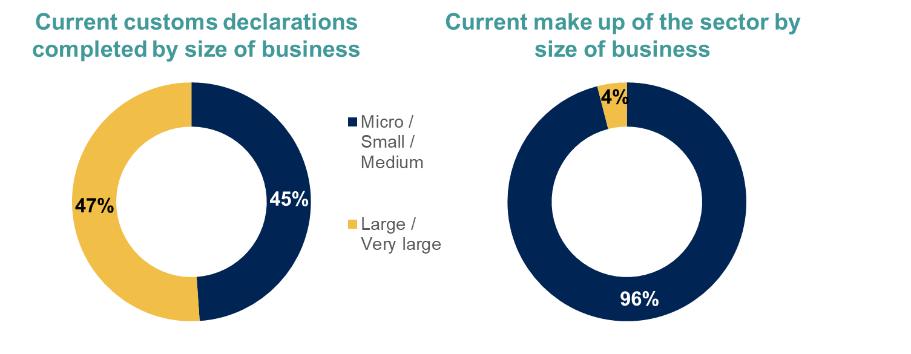

Completion of customs declarations
Customs intermediaries were asked how important customs declarations were to their business:
      - 5% said they were the main focus of their business
      - 37% said they were a core part of their business model, alongside other products or services
      - 36% said they were important, but secondary to other products or services
      - 19% said that they were an extra service they provided on an infrequent or ad hoc basis
      - 3% did not know
Overall one-quarter of customs intermediaries completed all their declarations in-house on behalf of UK customers for overseas trade (25%). Three in ten outsourced all customs declarations to another organisations (30%) and just over 4 in 10 did a mixture of both (44%).

Complexity of customs declarations
The complexity of customs declarations as well the drivers of this complexity were explored during the qualitative interviews. The complexity of a declaration determined how long it took to complete, rather than the type of declaration. For example, import declarations require more financial information and it therefore took customs intermediaries more time to source this information. Full data tables on the time and cost of conducting customs declarations can be found in the Appendix (Table 6.7 to Table 6.10). There were a range of factors that could influence this complexity, such as products being moved (and therefore having multiple codes), seeking clarification or being able to provide accurate customer information.
“Some have multiple commodity codes on different pieces of paperwork. It’s not easy to pull together from 3 pieces of paperwork.”
(Micro, North East)
Complexity could also be influenced by goods coming from different origins which then need to be declared separately, having to rely on others who were involved in the process, complications due to the import process, and the Customs Handling of Import and Export Freight (CHIEF) system issues.
“It can be an hour, it can be 3 hours, depending on what the problem is with the CHIEF system.” (Medium, South East)

Factors influencing how much customs intermediaries charge for declarations
Those who make custom declarations were asked what the key factors were that influenced how much they charged for completing customs declarations. As shown in Figure 3.2 and Table 3.1, the main factors that influenced how much customs intermediaries charged for declarations were the type and complexity of the declaration (35%), the time taken to complete the declaration (34%) and the market rate (30%).

Figure 3.2: Factors influencing how much customs intermediaries charge for declarations
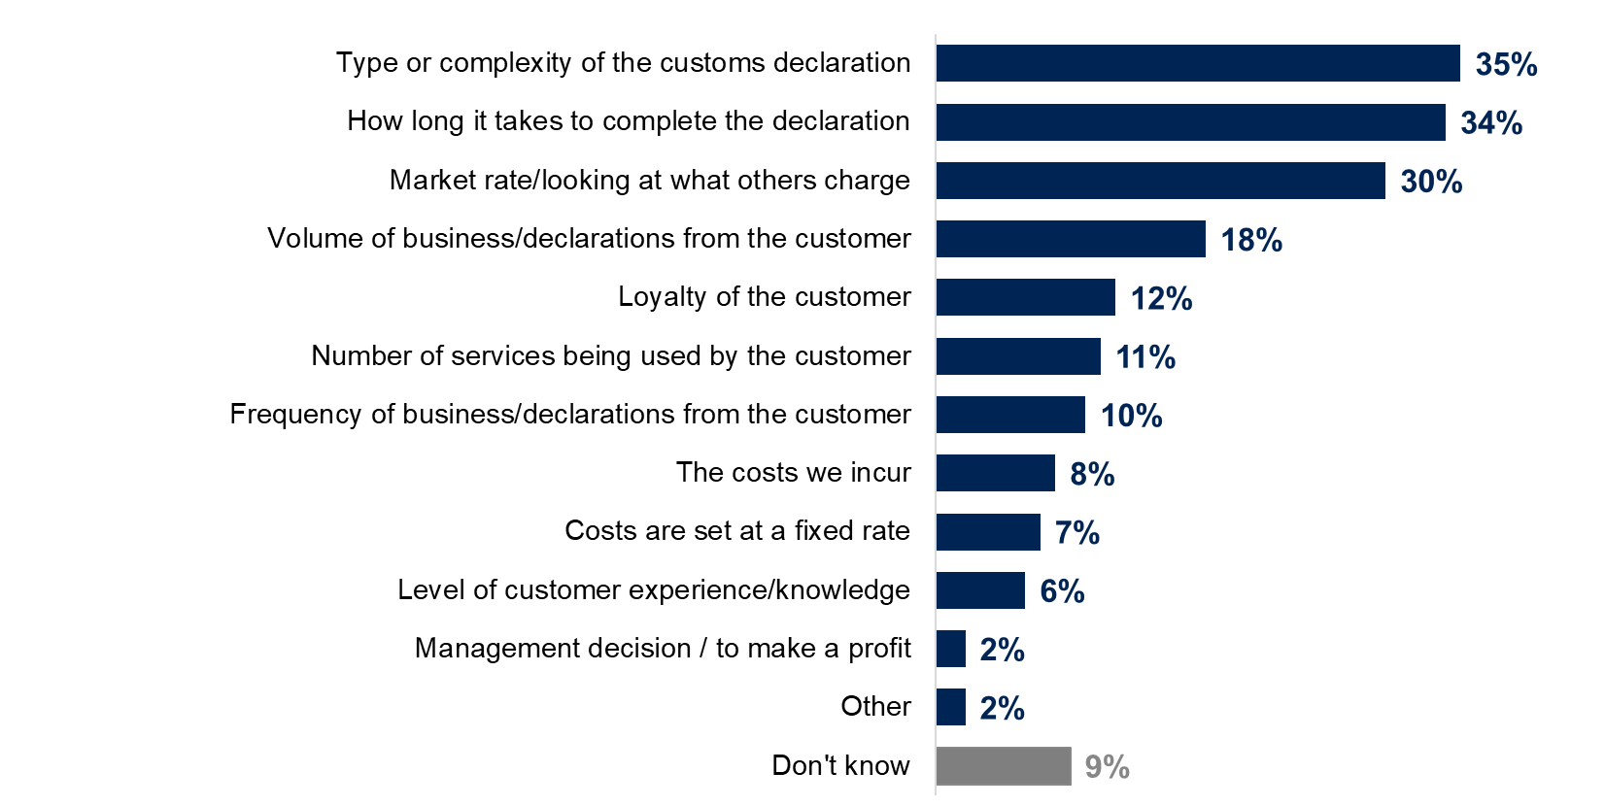
Base (unweighted): All intermediaries (257). Chart format is available below in Table 3.1.

Table 3.1: Factors influencing how much customs intermediaries charge for declarations
Factors that influence how much customs intermediaries charge for declarations | Total
Type or complexity of the customs declaration | 35%
How long it takes to complete the declaration | 34%
Market rate/looking at what others charge | 30%
Volume of business/declarations from the customer | 18%
Loyalty of the customer | 12%
Number of services being used by the customer | 11%
Frequency of business/declarations from the customer | 10%
The costs we incur | 8%
Costs are set at a fixed rate | 7%
Level of customer experience/knowledge | 6%
Management decision / to make a profit | 2%
Other | 2%
Don't know | 9%
Base (unweighted): All intermediaries (257).

Use of automated software for processing customs declarations
Customs intermediaries were asked whether they had any automated software to reduce the time taken to process customs declarations, and what proportion of their declarations were processed using that software. Half of these customs intermediaries (50%) reported that they did have automated software. Of those, 7 in 10 (70%) used this software for all their customs declarations and a further 18% used software for more than half – but not all – of their customs declarations (as shown in Figure 3.3 and Table 3.2 below).

Figure 3.3: Customs declarations completed using software
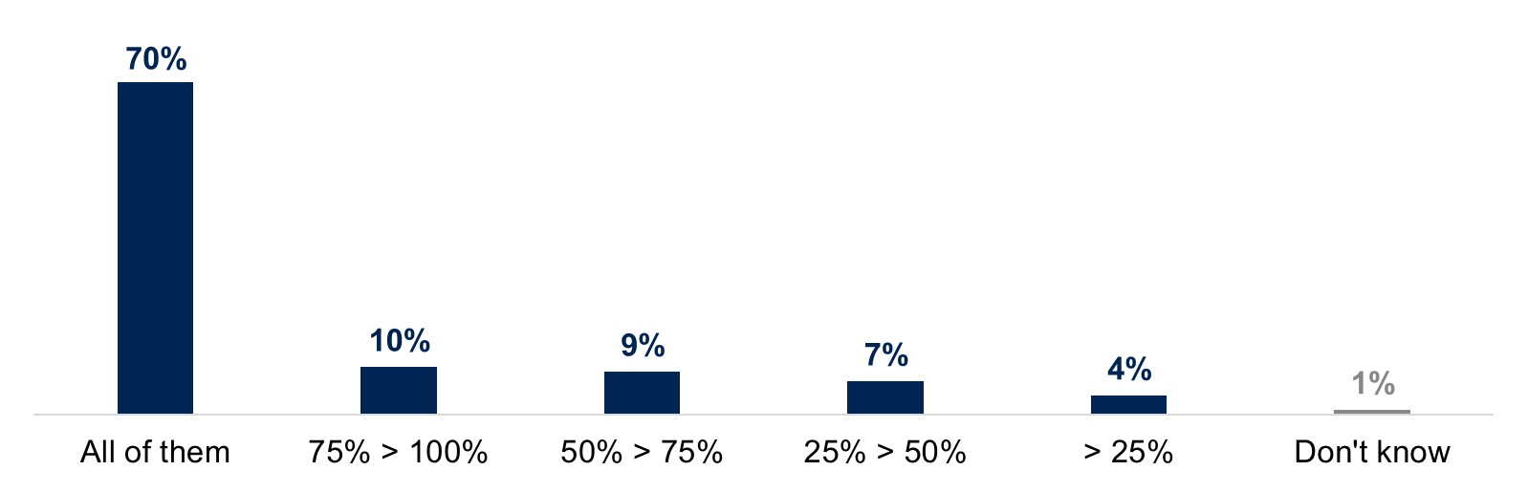
Base (unweighted): All intermediaries who have automated software (137). Chart format is available below in Table 3.2.

Table 3.2: Customs declarations completed using software
 | Total
All of them | 70%
75% to less than 100% | 10%
50% to less than 75% | 9%
25% to less than 50% | 7%
Less than 25% | 4%
Don’t know | 1%
Base (unweighted): All intermediaries who have automated software (137).

Submitting customs declarations
This section covers tasks that customs intermediaries do in-house, understanding the Safety and Security (ENS) requirements and the new Customs Declaration Service (CDS) that will eventually replace the Customs Handling of Import and Export Freight (CHIEF) system.

Customs declaration tasks done in-house
During the survey, customs intermediaries were asked which tasks associated with completing customs declarations they did in-house, rather than outsourcing them to another business in the logistics industry. As shown in Figure 4.1 and Table 4.1, 9 in 10 (92%) gathered relevant information about products being moved from the trader, an increase from 75% at Wave 4. Just under 9 in 10 (86%) gathered the relevant supporting information for the products, again an increase from 73% at Wave 4. Around two-thirds of customs intermediaries submitted the customs declaration form to HMRC (65%), and a similar proportion filled in the customs declaration form (64%).

Figure 4.1: Customs declaration tasks completed in-house
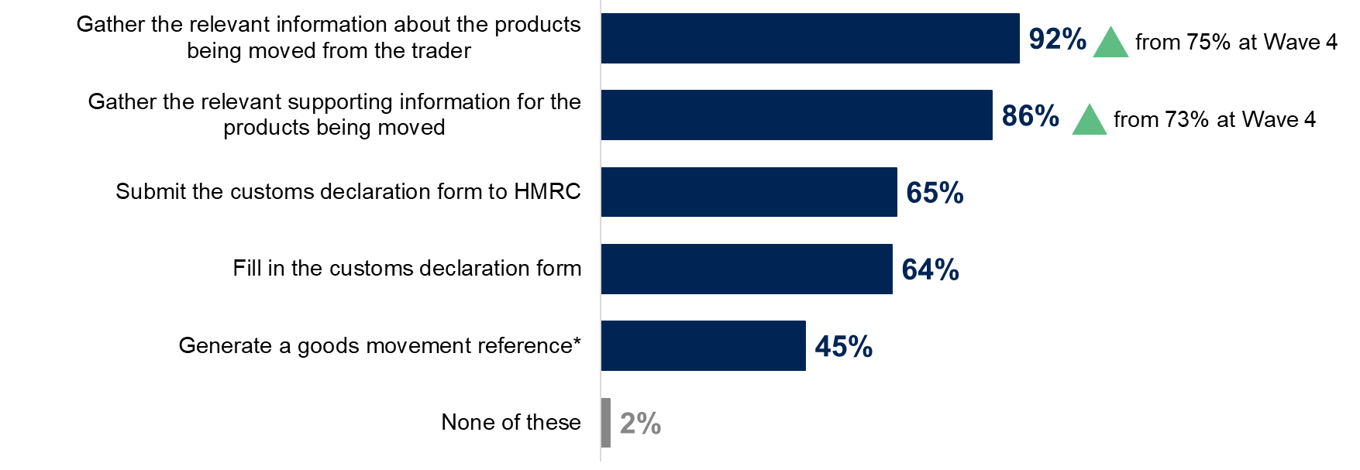
Base (unweighted): All intermediaries currently making customs declarations (W5: 257; W4: 309). *New code at Wave 5. Chart format is available below in Table 4.1.

Table 4.1: Customs declaration tasks completed in-house
 | Wave 4 | Wave 5
Gather the relevant information about the products being moved from the trader | 75% | 92%
Gather the relevant supporting information for the products being moved | 73% | 86%
Submit the customs declaration form to HMRC | 60% | 65%
Fill in the customs declaration form | 64% | 64%
Generate a goods movement reference* | N/A | 45%
None of these | 5% | 2%
Base (unweighted): All intermediaries currently making customs declarations (W5: 257; W4: 309). *New code at Wave 5.

Understanding the Safety and Security (ENS) requirements
The ENS, or ‘safety and security’ declarations, must be lodged at the first port of entry into the UK for goods arriving, according to EU safety and security regulations. The ENS contains advance cargo information, which is used to assess the risk of goods entering the UK. Four in ten of the customs intermediaries surveyed (42%) did not complete ENS declarations for business customers or on behalf of others in the logistics industry. Of this group, one in three (32%) understood ENS requirements. Please refer to the Appendix (Table 6.3) for the full data tables for these questions.
Understanding of ENS requirements were explored further during the qualitative interviews. Customs intermediaries with experience of completing ENS declarations explained that hauliers usually complete ENS declarations in-house alongside their Goods Vehicle Movement Service (GVMS). The Goods Vehicle Movement Service (GVMS) is a UK Government IT platform for moving goods into or out of Northern Ireland and Great Britain. Hauliers who want to move goods through a port in the UK are required to use the GVMS. However, customers sometimes described goods incorrectly which affected whether goods were ENS-applicable.
Those without experience of completing ENS declarations said that the responsibility for ENS declarations laid with hauliers and so were sometimes out of remit. Some customs intermediaries chose to outsource this due to convenience and cost, particularly as some hauliers applied surcharges.
“The carrier charges a fee anyway, even if we do the ENS declaration ourselves. The carrier charges a handover fee, it’s a new fee structure that has come in over the past few months. A surcharge. So, it doesn’t make sense to do it ourselves.”
(Medium, Scotland.)

Customs Declarations Service (CDS)
The CHIEF system will be replaced by the CDS. HMRC will initially run both systems simultaneously, before phasing out the use of CHIEF in stages. From:
      - Friday 30 September 2022, import declarations will close on CHIEF
      - Friday 31 March 2023, export declarations will close on CHIEF
As shown in Figure 4.2 and Table 4.2, just under 6 in 10 of customs intermediaries had access to the CHIEF system (56%) and 2 in 10 had access to the CDS system (20%). Around 4 in 10 (43%) planned to get access to the CDS system, while 35% did not plan to get access.

Figure 4.2: Access to CDS and CHIEF systems
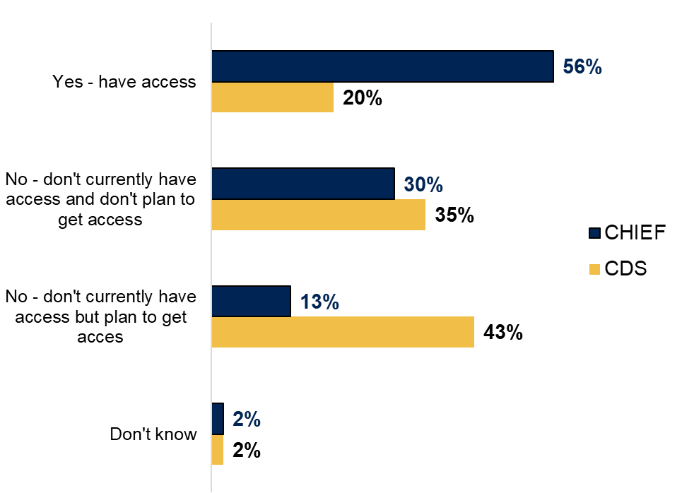
Base (unweighted): All who currently make customs declarations (257). Chart format is available below in Table 4.2.

Table 4.2: Access to CDS and CHIEF systems
 | CHIEF | CDS
Yes - have access | 56% | 20%
No - don't currently have access and don't plan to get access | 30% | 35%
No - don't currently have access but plan to get access | 13% | 43%
Don't know | 2% | 2%
Base (unweighted): All who currently make customs declarations (257)

Awareness of CDS
Three-quarters of customs intermediaries (77%) had heard of CDS, 2 in 10 had not (22%), and 1% did not know. Those who had heard of CDS were asked how much they knew about the new system, as shown in Figure 4.3 and Table 4.3 below. Of this group, only 4% said they knew a great deal, with 4 in 10 saying they knew a fair amount (39%), in line with Wave 4.

Figure 4.3: Knowledge of CDS
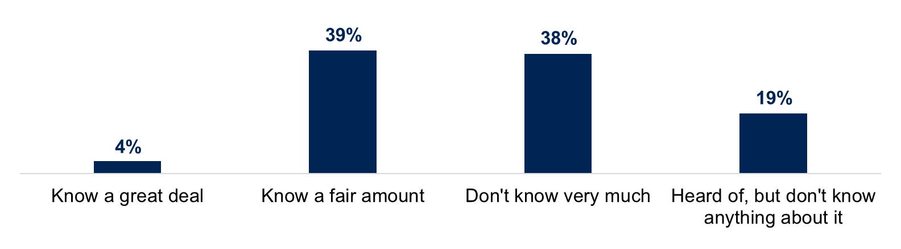
Base (unweighted): All intermediaries who are aware of CDS (168). ‘Don’t know’ was greater than 0 but less than 1%. Chart format is available below in Table 4.3.

Table 4.3: Knowledge of CDS
Total
Know a great deal about CDS | 4%
Know a fair amount about CDS | 39%
Don’t know very much about CDS | 38%
Heard of CDS, but don’t know anything about it | 19%
Base (unweighted): All intermediaries who are aware of CDS (250). The figure for ‘don’t know’ was greater than 0 but less than 1%.

Plans to use CDS
As shown in Figure 4.4 and Table 4.4, 7 in 10 (69%) customs intermediaries planned to start using CDS to submit customs declarations to HMRC at some point in the future, an increase from 58% at Wave 4. A quarter did not plan to start using CDS (25%) and 6% were not sure. Two-thirds of those who did not plan to use CDS planned to outsource all of their customs declarations (67%) and under half did not have the software (45%).

Figure 4.4: Whether customs intermediaries plan to use CDS
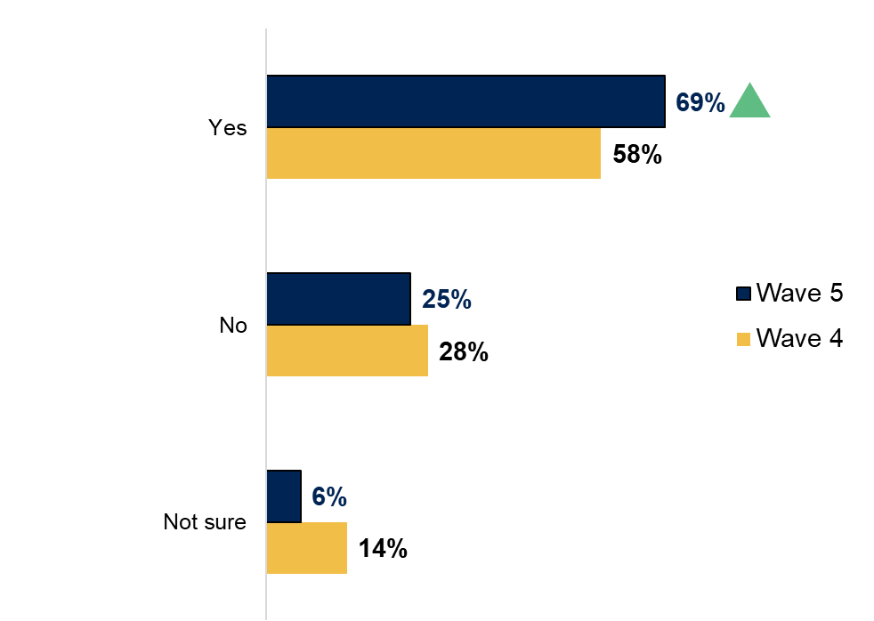
Base (unweighted): All intermediaries (W4: 344; W5: 257). Chart format is available below in Table 4.4.

Table 4.4: Whether customs intermediaries plan to use CDS
 | Wave 4 | Wave 5
Yes | 58% | 69%
No | 28% | 25%
Not sure | 14% | 6%
Base (unweighted): All intermediaries (W4: 344; W5: 257).

Transitioning to CDS
In the survey, customs intermediaries who planned to use CDS were asked when they might start to submit customs declarations to HMRC and when they might complete their transition (see Table 4.5 below). At Wave 5, just under half planned to start using CDS (45%) and around half planned to finish the transition (52%) by the export deadline of 31 March 2023. This compares with 60% expecting to start using CDS and 55% finish transitioning by the deadline in Wave 4. Uncertainty around completing the transition has also fallen at Wave 5 with 11% of customs intermediaries saying they did not know when they would complete this, compared with 23% at Wave 4.
At Wave 5, 5% of customs intermediaries said they would transition to the system when HMRC told them to do so, which is further supported by the qualitative interviews.
“I'm under the impression that we're just sitting there waiting, ready to go, until they [HMRC] tell us when they are wanting us to switch over.”
(Small, South East)

Table 4.5: When intermediaries plan to start and complete their transition to CDS
 | W4 Start | W4 End | W5 Start | W5 End
Before 31 March 2022 | 28% | 16% | 1% | 0%
Between 31 March and 30 September 2022 | 23% | 21% | 31% | 33%
Between 30 September 2022 and 31 March 2023 | 8% | 17% | 13% | 18%
After 31 March 2023 | 1% | 2% | 9% | 4%
When customs intermediaries are less busy or it is quieter | 1% | N/A | 1% | N/A
When customs intermediaries know more | 5% | N/A | 5% | N/A
By the end of this year / next year | N/A | 6% | N/A | 10%
When HMRC tells intermediaries to move across | 12% | 8% | 6% | 5%
When the system is ready | 9% | 4% | 18% | 7%
When customs intermediaries feel confident | N/A | 5% | N/A | 11%
Don’t know | 16% | 23% | 6% | 11%
Base (unweighted): All intermediaries who are aware of CDS and plan to use it (W4: 201; W5: 127). Codes marked ‘N/A’ were only asked for either the starting or finishing dates.

Confidence in using CDS
In the survey, customs intermediaries who planned to use CDS were asked how confident they felt about moving across to the new system. Seven in ten felt confident around this (70%), with 8% who were very confident and 62% who were fairly confident. A quarter were not very confident (23%), 4% were not confident at all and 1% said they did not know. These figures are in line with Wave 4. The qualitative interviews revealed that those who worked more closely with HMRC felt more confident about moving to CDS.
“If we hadn’t worked so long with HMRC, we would be thinking ‘how do we do this? What software do we need? How do you find out?’ There could be a lot of fear in the market but we are in a lucky position of being involved in the development.”
(Medium, East of England)
Customs intermediaries cited the following main barriers in transitioning to CDS:
      - lack of guidance on using CDS (29%)
      - lack of information on how CDS works (26%)
      - lack of guidance on how to make customs declarations (24%)
      - lack of information on steps to prepare (24%)
Please refer to the Appendix (Table 6.4) for the full data tables for these questions. In the qualitative interviews, some intermediaries suggested that a dedicated helpline or portal would be helpful for asking HMRC questions on how to access CDS and complete a customs entry.

Perceptions of customs declarations services in most need of improvement
In the survey, customs intermediaries were asked which services provided to customers needed improvement. Three in ten felt their services did not need improving (30%). Two in ten (19%) said they could provide better access to information for customers. Around one in ten cited more specialist knowledge (13%) better software or IT (11%) and more staff or capacity (11%) as areas of improvement. Please refer to the Appendix (Table 6.5) for the full data tables for these questions.

Full customs controls and future capacity
This section covers the perceived impact that staged controls have had on intermediaries, changes to capacity for completing declarations and whether intermediaries would consider providing custom declarations for customers with low or infrequent trade. The section also summarises the customs intermediaries perceptions on the barriers they have faced since full customs controls were introduced and levels of confidence with new operational requirements for trading with the EU.

Impact of staged controls on intermediaries
Under the temporary Staged Customs Controls (SCC) facilitation, customs declarations may be deferred for up to 175 days from goods movement. In the qualitative research, staged controls were found to have minimal impact on customs intermediaries. Many customs intermediaries explained they undertook full clearances from the start and so remained unaffected by the staged controls. Those who were affected took early steps to prepare for staged controls coming to an end.
“You could bring cargo in and then worry about the entry later on. We found it more economical with our time to purely do the entry from the start.”
(Micro, South East)

Changes to capacity for completing customs declarations
In the survey, customs intermediaries were asked if they were expecting to increase, decrease or keep their capacity the same over the first 6 months of 2022. Four in ten were planning to increase their capacity (42%) while just over half expected to maintain the same capacity (54%). Only 3% expected to decrease their capacity, with one per cent saying did not know. Of those looking to increase their capacity, 4 in 10 felt that this would be easy to do (37%). A third felt that this would not be easy of difficult (34%), while just under 3 in 10 felt it would be difficult (27%). Three per cent said they did not know.
In the qualitative interviews, customs intermediaries expecting to increase capacity explained they were looking to grow other parts of the business, for example, warehousing, consultancy or volume of freight. Those looking to maintain their capacity wanted to ensure they could service their existing clients.

Providing customs declarations for customers with low or infrequent trade
In the survey, customs intermediaries were asked if they plan to provide customs declarations for customers with low or infrequent trade. As shown in Figure 5.1 and Table 5.1, 8 in 10 said that they would provide customs declarations for those who trade infrequently (79%), up from 72% at Wave 4. Three-quarters said they would provide customs declarations for those with a low volume of trade (75%). Two in ten reported they would not provide customs declarations for either group (19%).
This was further explored during the qualitative interviews. Although customers with low or frequent trade were seen as less profitable and needed more guidance, customs intermediaries tended not to turn them away. There was a feeling that supporting these types of customers could help their business grow and become more profitable by building up a reputation for helping customers. Some customs intermediaries also explained these customers could become more profitable as their trade grew.

Figure 5.1: Providing customs declarations for customers with low of infrequent trade
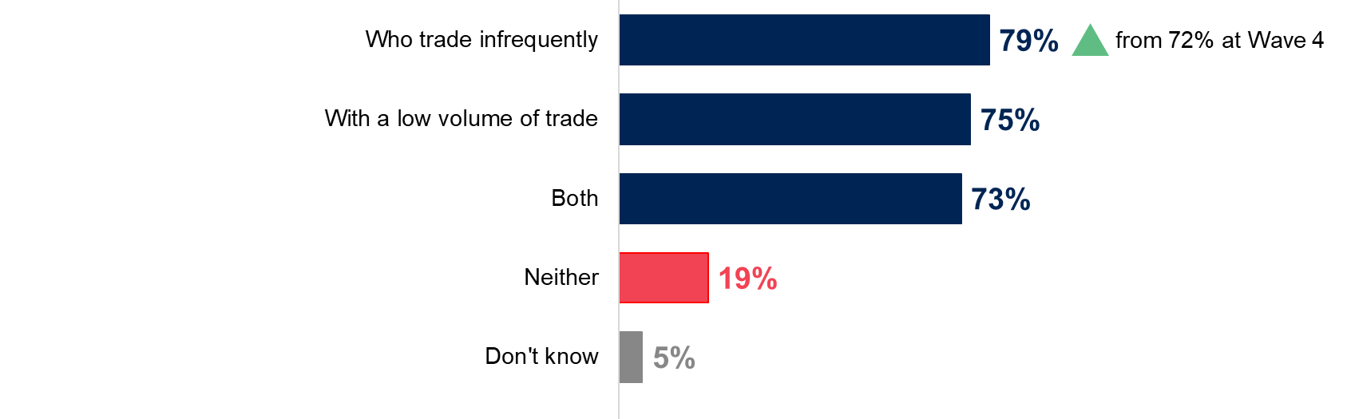
Base (unweighted): All intermediaries (W4: 344; W5: 257). Chart format is available below in Table 5.1.

Table 5.1: Providing customs declarations for customers with low or infrequent trade
 | Wave 4 | Wave 5
Who trade infrequently | 72% | 79%
With a low volume of trade | 74% | 75%
Both | 68% | 73%
Neither | 22% | 19%
Don’t know | 6% | 5%
Base (unweighted): All intermediaries (W4: 344; W5: 257).

Barriers since full customs controls were introduced
During the survey, customs intermediaries were asked what barriers they faced to making customs declarations since full customs controls were introduced in January 2022. As shown in Table 5.2 overleaf, most cited barrier was lack of knowledge or uncertainty on custom declarations requirements (29%), followed by uncertainty around transit times or delays (12%). Please refer to the Appendix (Table 6.6) for the full data tables for these questions.

Table 5.2: Main barriers since full customs controls were introduced
 | Total
Lack of knowledge/information/uncertainty need detailed guidance on customs declarations requirements | 29%
Uncertainty about transit times/clearance/hold-ups/delays | 12%
Time consuming/lack of capacity generally | 7%
Difficult to balance recruitment/training with day-to-day delivery | 6%
Difficulty recruiting staff at entry level (less than one year's experience completing customs declaration forms) | 6%
Coronavirus (COVID-19) has affected staffing levels/capacity (for example staff on furlough or made redundant) | 6%
Getting information from customers | 5%
No barriers | 39%
Base (unweighted): All customs intermediaries, excluding those who say increasing capacity will be easy (209).

Confidence in understanding the new operational requirements
Customs intermediaries generally felt confident in their understanding of the new operational requirements for continuing to trade with the EU now the transition period has ended. As shown in Figure 5.2 and Table 5.3, around three-quarters said they felt confident (77%). This comprised 36% of those who felt very confident (up from 25% at Wave 4) and 41% of those who felt fairly confident.

Figure 5.2: Confidence in understanding the operational requirements for trade with the EU
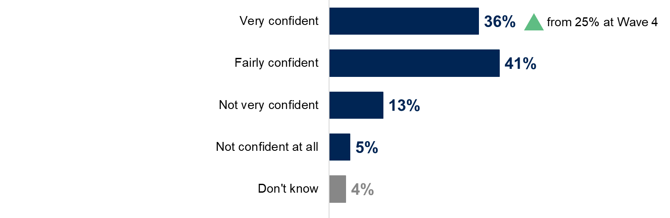
Base (unweighted): All intermediaries (W4: 344; W5: 257). Chart format is available below in Table 5.3.

Table 5.3: Confidence in understanding the operational requirements for trade with the EU
 | Wave 4 | Wave 5
Very confident | 25% | 36%
Fairly confident | 53% | 41%
Not very confident | 14% | 13%
Not confident at all | 7% | 5%
Don’t know | 2% | 4%
Base (unweighted): All intermediaries (W4: 344; W5: 257).

Appendix
The Appendix provides further technical details on the survey design and overall methodology, as well as supporting data not shown in the main body of the report.

Overview of the research methodology

Development phase and previous survey waves
Prior to Wave 1 fieldwork, Ipsos undertook a development phase consisting of depth interviews with customs intermediaries and industry trade bodies to build on existing understanding of the sector, inform the survey design and to identify search terms for the sample building exercise. Perspective Economics developed an initial longlist of 109,759 UK-registered businesses by reviewing a wide range of sources, which was refined by ‘scoring’ companies based on the sources used to identify them. Telephone numbers were available for 22,339 leads and from this, a sample of 9,451 leads were randomly selected for the Wave 1 survey. Fieldwork for the previous waves took place as follows:
      - Wave 1 – 29 June to 1 September 2020 (piloted with 97 customs intermediaries between 29 June and 13 July 2020), 674 customs intermediaries
      - Wave 2 – 10 November to 16 December 2020, 497 customs intermediaries (337 of whom had taken part in Wave 1)
      - Wave 3 – 26 March to 6 May 2021, 473 customs intermediaries (298 of whom had taken part in earlier waves)
      - Wave 4 – 23 September to 9 November 2021, 344 customs intermediaries (281 of whom had taken part in earlier waves)
For more detail on the previous waves, please refer to the Wave 1 and Wave 2 summary reports.

Wave 5 survey and qualitative work
The Wave 5 survey took place between 17 February and 22 March 2022 and consisted of 257 telephone interviews with customs intermediaries (235 of whom had taken part in earlier surveys). In addition, 15 follow-up, qualitative in-depth interviews were conducted via telephone with customs intermediaries who had taken part in the Wave 5 survey.

Sizing exercise: Grossing and estimation
Following the Wave 1 survey, Ipsos provided Perspective Economics with a dataset outlining the survey responses and call outcomes for those who did not complete the survey. 676 customs intermediaries were interviewed, but two cases were removed from the final dataset. Each lead was called at least 7 times before recording the final ‘call outcome’. Call outcomes described the status of the lead, for example: completed interview, refusal, ineligible, or unusable. By analysing the call outcomes, we concluded that firms with lower scores were less likely to be involved in customs activity, and therefore more likely to be ineligible for the survey. Perspective Economics reviewed all 109,759 firms to identify which leads should be included or excluded from the final list. This involved:
      - including firms who: completed the survey, were not available during the fieldwork period (these leads were reviewed to remove anomalies clearly not involved in customs activity), or did not complete the survey but were considered relevant to the study (well-known customs intermediaries, those with higher scores, or those with sufficient data to model)
      - removing firms who: did not complete the survey, whose call outcomes showed they were ineligible, those with limited trading data (no website or accounts), those who had significant business activity but irrelevant SIC codes or trading descriptions and removing any duplicates
Following the development of the final list of proposed customs intermediaries in the UK (which derived a final estimated population of c. 8,400 firms in Wave 1), Perspective Economics analysed the survey responses by size, and applied these estimates to the wider population. A further 43 customs intermediaries engaged with the survey in Wave 2 that were not shortlisted for the final population following Wave 1. This process was updated following the Wave 5 survey, resulting in a final estimated population of c. 8,900 firms. The population estimate draws on the sample agreed in Wave 1 and has been adjusted at each wave to remove those who are no longer trading. The population was c. 8,900 at Wave 5, including newly registered customs intermediaries (or other companies that now offer customs intermediary services) since Wave 1. Whilst we recognise this process may have omitted some firms potentially involved in customs intermediary activity (those not picked up by the search strategy, or potentially removed due to limited alignment to the study definition), this provided a more reflective overview of the likely size and scale of the customs intermediary sector in the UK. This process was updated following the completion of each survey wave.

Fieldwork outcomes and response rates
A telephone survey, based on a random probability sampling design, was undertaken with 257 customs intermediaries between 17 February and 22 March 2022. With the probability sample nature of the survey, each lead was called a minimum of 7 times unless it had already achieved a final outcome, and an outcome was sought for every lead in the sample.
The survey achieved an adjusted response rate of 57%. A breakdown of the sample outcomes is presented in Table 6.1, overleaf:
- Ineligible leads were those found to have permanently stopped trading (due to COVID-19 or another reason), who made customs declarations on behalf of non-UK businesses only, did not currently make declarations or were currently decided about whether to make declarations.
- Refusals excludes “soft” refusals, where respondents were hesitant about taking part, so interviewers backed away and avoided a definitive refusal.
- Unusable leads includes sample where there was communication difficulty making it impossible to carry out the survey (either a bad line, or language difficulty), as well as numbers called 7 or more times over fieldwork without ever being picked up.
- Unusable numbers is sample where the number was in a valid format, so was loaded into the main survey sample batches, but which turned out to be wrong numbers, fax numbers or disconnected.
- Unknown eligibility includes sample that had a working telephone number but where the respondent was unreachable or unavailable for an interview during the fieldwork period, so eligibility could not be assessed.
- Eligibility has been calculated as: (completed interviews) / (completed interviews + leads established as ineligible during screener).
- The unadjusted response rate has been calculated as completed interviews / total sample loaded.
- The adjusted response rate has been calculated as completed interviews / (completed interviews + incomplete interviews + [refusals x eligibility] + [working numbers with unknown eligibility x eligibility]).
- The cooperation rate has been calculated as: (completed interviews) / (completed interviews + refusals). Refusals have been based on expected eligibility (79%).

Table 6.1: Wave 4 fieldwork outcomes and response rate calculation
Outcome | Total | Longitudinal | Cross-sectional
Total sample loaded | 776 | 605 | 171
Completed interviews | 257 | 235 | 22
Ineligible leads, including established pre-screener | 71 | 28 | 343
Refusals | 66 | 41 | 25
Unusable leads with working numbers | 183 | 146 | 37
Unusable numbers | 17 | 12 | 5
Working numbers with unknown eligibility | 169 | 135 | 34
Eligibility of screened respondents | 79% | 89% | 34%
Unadjusted response rate | 34% | 39% | 13%
Adjusted response rate | 57% | 60% | 47%
Cooperation rate | 80% | 85% | 47%

Data cleaning, processing and weighting

Wave 1 weighting scheme
Weights were generated in 2 steps. The first step was to adjust for different sampling fractions applied during the sample selection. Leads with higher scores were over-sampled relative to those with lower scores. The second step was to adjust for customs intermediaries who were subsidiaries and unable to answer on behalf of all businesses in their group. Their weight was equivalent to the size of their group, however, there were a small number of outliers with large groups whose weights were capped at 4.
The final weight was the product of the 2 weighting steps. This was checked for large weights – there were a small number of large weights, some trimming was carried out (the top 1% were capped). The capped weight was then scaled so that the mean weight was equal to one and the weighted sample size was equal to the unweighted sample size. There was no additional stage for non-response since we did not have robust population estimates to use for weighting.

Wave 2 weighting scheme
The weights for the Wave 2 data were generated in 2 main steps. The first step was to create a set of longitudinal weights for the cases that responded at both the Wave 1 and Wave 2 surveys. These weights were generated using information from the Wave 1 questionnaire; a logistic regression model was used to model the response behaviour of customs intermediaries. Using a regression model in this way has 2 main benefits. The first is that it allows us to identify the characteristics that are most strongly related to non-response, and identifying these means we can ensure these characteristics are included in the weighting scheme. The second is that it is a good means of summarising the different patterns of non-response and allows us to identify how likely different types of customs intermediaries are to take part in the interview.
The model was used to generate, for each customs intermediary, the predicted probability that an intermediary would take part at Wave 2, given their characteristics (for example, size, sector, region). A weight was created directly from these predicted probabilities and the weight was calculated as the inverse of the predicted probability (one divided by the predicted probability). This means that customs intermediaries with characteristics associated with a low probability of taking part were weighted up, and those with characteristics related to a higher probability of taking part were weighted down.
The weights produced by the model corrected for the effects of non-response bias on the sample profile between the 2 waves. This model-generated weight was then combined with the Wave 1 weights, which corrected for unequal selection probabilities and the number of firms in the company group. The combined longitudinal weight therefore corrects for the initial unequal selection, group membership, and non-response to Wave 2.
The second step was to generate weights for the fresh sample members (the cross-sectional sample). These weights were a combination of their selection probabilities and an adjustment for group membership (this was calculated in the same way as the Wave 1 weights). These weights corrected the fresh sample for any unequal chances of selection and their group membership.
The final stage was to combine the longitudinal and cross-sectional sample weights into a single weight.

Waves 3 to 5 weighting scheme
For Waves 3 to 5, a single weight was used that incorporated adjustments for the following scenarios:
      - differential selection by score
      - whether a customs intermediary was responding on behalf of a wider group
      - non-response between an individual customs intermediary’s initial survey wave and their latest survey wave (for longitudinal cases only)
The longitudinal adjustment used was fairly minor, as the longitudinal sample for Waves 3 to 5 was relatively small and fragmented. At:
      - Wave 3 there were 298 longitudinal completes, of which 59 had responded during Wave 1 and Wave 3, 63 had responded at Wave 2 and Wave 3, and 176 had responded at all 3 waves
      - Wave 4 there were 281 longitudinal completes, of which 22 had responded during Wave 1, 62 had responded at Wave 2, and 197 had responded at Wave 3
      - Wave 5 there were 235 longitudinal completes, of which 9 had responded during Wave 1, 15 had responded at Wave 2, 50 had responded at Wave 3 and 161 had responded at Wave 4
For Waves 3 to 5, the combined longitudinal sample was weighted back to the weighted Wave 2 sample profile for size and turnover. These variables were chosen as they were shown to both be affected by attrition during the Wave 2 survey. This adjustment was used in order to reduce the chances that the longitudinal sample would contain biases relating to these variables (size and turnover), therefore smaller businesses with lower turnovers were less likely to stay in the sample.
For Waves 3 to 5, we weighted back to the (weighted) sample on the assumption that this was a fair representation of what the longitudinal sample profile should look like, since the Wave 2 sample also included an adjustment for attrition between Waves 1 and 2.

Margin of error
Final data from the survey were based on a weighted sample rather than the entire population of customs intermediaries. Percentage results are therefore subject to margins of error, which vary with the size of the sample and the percentage figure concerned. For example, for a question where 50% of the 257 customs intermediaries sampled in the survey give a particular answer, the chances are 95 in 100 that this result would not vary more or less than 6 percentage points from the true figure – the figure that would have been obtained had the entire UK customs intermediary population responded to the survey. The margins of error that are assumed to apply in this report are given in Table 6.2. In calculating the margins of error shown in these tables, a design effect of 1.2 has been assumed for the sample as a whole, and all sub-groups, due to minor post-survey weighting.

Table 6.2: Margins of error
Outcome | 10% or 90% | 20% or 80% | 30% or 70% | 40% or 60% | 50%
257 customs intermediaries | ± 3.6 | ± 4.8 | ± 5.5 | ± 5.9 | ± 6.0

Supporting data tables
The following data tables show the full list of responses from the survey where only the most commonly reported figures were shown in the main body of the report.

Table 6.3: Understanding of Safety and Security (ENS) requirements – see section 4.2
 | Total
Yes | 32%
No | 34%
Unsure - A third party looks after this | 20%
Unsure - Traders look after this | 9%
Don’t know | 2%
Refused | 3%
NET: Unsure | 29%
Base (unweighted): All intermediaries who do not complete ENS declarations (103).
Q. As an intermediary, do you understand the Safety and Security requirements, and how the obligations to complete an ENS declaration are met?

Table 6.4: Main barriers to transitioning to CDS – see section 4.3
 | Total
Lack of guidance on how to use CDS | 29%
Lack of information on how CDS will be different to CHIEF | 26%
Lack of specific guidance on how to make declarations on CDS | 24%
Lack of information on steps businesses need to take to prepare | 24%
Lack of time for trial runs using CDS (or a 'dummy' version) | 19%
Lack of practical improvements / software not working properly | 18%
Lack of webinars on how to use CDS | 15%
Lack of a dedicated support helpline | 15%
Integration with existing systems | 3%
Training / funding for training | 2%
Lack of support from customs / HMRC | 2%
Other | 5%
None/No barriers | 18%
Don’t know | 5%
Base (unweighted): All intermediaries aware of CDS, excluding those who do not plan to use it (127).
Q. What potential barriers, if any, do you foresee in transition to CDS?

Table 6.5: Improvement to customs declarations services – see section 4.4
 | Total
Having better access to information / keeping on top of changes to customs rules | 19%
More specialist knowledge | 13%
Better software / IT | 11%
More staff / capacity to complete and submit declarations | 9%
Efficiency of service | 7%
Better local knowledge | 7%
Speed of service / fewer delays | 7%
Simplification of processes / paperwork | 5%
Accuracy of service / fewer mistakes | 5%
Offering wider range of customs declarations services / facilitating more products | 4%
Support / contact from HMRC | 3%
Customer's knowledge / understanding | 3%
Nothing - we outsource customs declarations | 2%
Reduced costs | 2%
Improved communication | 2%
Other | 4%
None / no improvements needed | 30%
Don't know | 9%
Base (unweighted): All businesses (257).
Q. Thinking about the customs declarations services your organisation provides to customers, what would you say is in need of improvement

Table 6.6: Barriers to making customs declarations since full customs controls were introduced – see section 5.4
 | Total
Lack knowledge/information/uncertainty need detailed guidance on customs declarations requirements | 29%
Uncertainty about transit times/clearance/hold-ups/delays | 12%
Time consuming/lack of capacity generally | 7%
Difficult to balance recruitment/training with day-to-day delivery | 6%
Difficulty recruiting staff at entry level (less than one year's experience completing customs declaration forms) | 6%
COVID-19 has affected staffing levels/capacity (for example staff on furlough or made redundant) | 6%
Getting information needed from customers | 5%
Lack of staff / with relevant skills / training | 5%
Lack of support / contact from HMRC | 5%
Lack of knowledge/uncertainty about the impact of COVID-19 | 5%
Hard to predict demand/do not know how many new staff needed | 5%
Uncertain whether demand is likely to last | 4%
Challenges around T1 documentation | 4%
Availability of / training on new systems / IT / software | 4%
Affording to recruit/pay salaries for new staff | 4%
Concerns around system capacity, for example CHIEF or CDS | 3%
Delayed investment in IT/equipment/training due to COVID-19 | 3%
Difficulty recruiting staff at managerial level | 3%
Implementing systems correctly | 3%
Finance needed to buy access to specific badges | 3%
Concerns around HMRC capacity | 3%
Unable to move certain goods due to COVID-19 restrictions or shortages | 3%
Finance needed to invest in specific customs IT | 3%
Increased costs / tariffs / taxes / duty | 3%
Dealing with COVID-19 is an immediate concern/EU Exit is secondary | 3%
Difficulty training staff at entry level (less than one year's experience completing customs declaration forms) | 2%
Motivation / willingness / enthusiasm to prepare | 2%
Concerns about documentation / paperwork / certification | 2%
High workload | 2%
Customer's lack of knowledge / understanding | 2%
Difficulties with Trader Support Service | 2%
Difficulty training staff at managerial level | 2%
Brexit / EU exit / harder to import from / export to EU | 2%
No barriers | 39%
Don’t know | 1%
Base (unweighted): All customs intermediaries, excluding those who say increasing capacity will be easy (209).
Q. What barriers, if any, have you faced to making customs declarations since full customs controls were introduced in January 2022? * Barriers mentioned by 1% or less not shown on table.

Table 6.7: Charge for completing customs declarations for average client – Wave 1
 | Export declaration | Import declaration | Supplementary declaration | Simplified frontier declaration | Entry in Declarants records | ENS
Up to £25 | 32% | 9% | 22% | 23% | 20% | 23%
More than £25 to £30 | 9% | 4% | 6% | 9% | 7% | 8%
More than £30 to £35 | 11% | 11% | 10% | 10% | 7% | 11%
More than £35 to £40 | 4% | 9% | 6% | 5% | 5% | 2%
More than £40 to £45 | 5% | 12% | 5% | 7% | 7% | 3%
More than £45 to £50 | 6% | 10% | 3% | 2% | 4% | 3%
More than £50 to £55 | 1% | 6% | 2% | 2% | 2% | 1%
More than £55 to £60 | 1% | 3% | - | * | 2% | -
More than £60 | 9% | 15% | 10% | 10% | 12% | 10%
Don't know | 6% | 6% | 16% | 14% | 9% | 13%
We do not keep records on this | 3% | 2% | 5% | 5% | 7% | 8%
No Charge | 13% | 10% | 17% | 13% | 17% | 18%
Base (unweighted): Export declaration (494); Import declaration (461); Supplementary declaration (234); Simplified frontier declaration (241); Entry in Declarants records (188); ENS (141).
Q. How much does your business typically charge for completing customs declarations for your average client? - Figure is zero. * Figure greater than 0 but less than 1%.

Table 6.8: Charge for completing customs declarations for average client – Wave 3
 | Export declaration | Import declaration | Supplementary declaration | Simplified frontier declaration | Entry in Declarants records | ENS
Up to £25 | 24% | 6% | 25% | 29% | 29% | 33%
More than £25 to £30 | 8% | 8% | 10% | 5% | 6% | 4%
More than £30 to £35 | 15% | 6% | 8% | 11% | 12% | 8%
More than £35 to £40 | 5% | 8% | 3% | 2% | 2% | 3%
More than £40 to £45 | 9% | 11% | 7% | 7% | 10% | 1%
More than £45 to £50 | 7% | 16% | 5% | 5% | 5% | 5%
More than £50 to £55 | 2% | 13% | 4% | 4% | 6% | 2%
More than £55 to £60 | * | 2% | - | 1% | * | -
More than £60 | 9% | 14% | 4% | 8% | 5% | 8%
Don't know | 6% | 8% | 15% | 13% | 8% | 15%
We do not keep records on this | 2% | 1% | - | 5% | 5% | 3%
No Charge | 13% | 8% | 18% | 10% | 11% | 18%
Base (unweighted): Export declaration (238); Import declaration (193); Supplementary declaration (106); Simplified frontier declaration (95); Entry in Declarants records (74); ENS (90).
Q. How much does your business typically charge for completing customs declarations for your average client? - Figure is zero. * Figure greater than 0 but less than 1%.
Caution: Low base under 100 for Simplified frontier declaration (95); Entry in Declarants records (74); and ENS (90).

Table 6.9: Charge for completing customs declarations for average client – Wave 5
 | Export declaration | Import declaration | Supplementary declaration | Simplified frontier declaration | Entry in Declarants records | ENS
Up to £25 | 21% | 5% | 21% | 28% | 24% | 24%
More than £25 to £30 | 7% | 2% | 10% | 2% | 3% | 2%
More than £30 to £35 | 15% | 6% | 8% | 10% | 8% | 10%
More than £35 to £40 | 3% | 5% | 8% | 7% | 4% | *
More than £40 to £45 | 10% | 17% | 6% | 14% | 9% | 9%
More than £45 to £50 | 9% | 13% | 7% | 5% | 14% | 10%
More than £50 to £55 | 8% | 19% | 7% | 16% | 10% | 6%
More than £55 to £60 | 4% | 4% | 1% | 2% | 2% | -
More than £60 | 9% | 20% | 10% | 8% | 9% | 12%
Don't know | 3% | 3% | 8% | 2% | 5% | 3%
We do not keep records on this | * | * | 1% | 1% | 1% | 3%
No Charge | 12% | 5% | 14% | 6% | 11% | 22%
Base (unweighted): Export declaration (168); Import declaration (149); Supplementary declaration (82); Simplified frontier declaration (66); Entry in Declarants records (52); ENS (81).
Q. How much does your business typically charge for completing customs declarations for your average client? - Figure is zero. * Figure greater than 0 but less than 1%.
Caution: Low base under 100 for Supplementary declaration (82); Simplified frontier declaration (66); Entry in Declarants records (52); ENS (81).

Table 6.10: Average time taken to complete each type of customer declaration – Wave 5
 | Export declaration | Import declaration | Supplementary declaration | Simplified frontier declaration | Entry in Declarants records | ENS
Over 0 to 10 mins | 27% | 14% | 21% | 19% | 21% | 23%
Over 10 to 20 mins | 19% | 14% | 13% | 23% | 15% | 20%
Over 20 to 30 mins | 14% | 14% | 14% | 21% | 13% | 9%
Over 30 to 60 minutes | 11% | 15% | 19% | 12% | 16% | 14%
Over 60 mins to a day | 23% | 30% | 21% | 22% | 24% | 24%
Over a day | 3% | 5% | 3% | 2% | 6% | 1%
Don’t know | 3% | 8% | 8% | 2% | 7% | 9%
Base (unweighted): All intermediaries who complete in-house: export declarations (168); import declarations (149); Supplementary declarations (82); Simplified frontier declarations (66); Entry in declarants records (52); ENS declaration (81).
Q. Typically how long does it take your business to complete each type of custom declaration for your average customer?
Caution: Low base under 100 for Supplementary declarations (82); Simplified frontier declarations (66); Entry in declarants records (52); Safety and security entry summary declaration (81).

Ipsos’s standards and accreditations
Ipsos’s standards and accreditations provide our clients with the peace of mind that they can always depend on us to deliver reliable, sustainable findings. Our focus on quality and continuous improvement means we have embedded a ‘right first time’ approach throughout our organisation.
ISO 20252  The international market research specific standard that supersedes BS 7911 / MRQSA & incorporates IQCS (Interviewer Quality Control Scheme); it covers the 5 stages of a Market Research project. Ipsos was the first company in the world to gain this accreditation. |  | ISO 27001  International standard for information security designed to ensure the selection of adequate and proportionate security controls. Ipsos was the first research company in the UK to be awarded this in August 2008.
MRS Company Partnership  By being an MRS Company Partner, Ipsos endorse and support the core MRS brand values of professionalism, research excellence and business effectiveness, and commit to comply with the MRS Code of Conduct throughout the organisation. |  | Data Protection Act  Ipsos is required to comply with the Data Protection Act; it covers the processing of personal data and the protection of privacy.
ISO 9001  International general company standard with a focus on continual improvement through quality management systems. In 1994 we became one of the early adopters of the ISO 9001 business standard. |  | This work was carried out in accordance with the requirements of the international quality standard for market research, ISO 20252 and with the Ipsos Terms and Conditions.

For more information
Dr. Rebecca Klahr
Research Director (Ipsos)
rebecca.klahr@ipsos.com
Sam Donaldson
Director (Perspective Economics)
sd@perspectiveeconomics.com

3 Thomas More Square
London
E1W 1YW
t: +44 (0)20 3059 5000
www.ipsos.com/en-uk
http://twitter.com/IpsosUK

