Rt Hon Kemi Badenoch MP
Minister for Women and Equalities
Secretary of State for Business and Trade
Old Admiralty Building
London
SW1A 2AY

Amanda Spielman
Ofsted Chief Inspector
22 June 2023

Dear Amanda,

In my capacity as Minister for Women and Equalities I would like to request that Ofsted carry out a snap inspection of Rye College, in East Sussex. This is following the widely circulated recording of a teacher acting inappropriately regarding her pupils’ beliefs about sex, gender and a fellow pupil who claimed to identify as a cat, which in my view raises issues about safeguarding at the school.

As you will be aware, the UK courts have ruled that gender critical beliefs – the belief that sex is biological and immutable, that people cannot change their sex and that sex is distinct from gender-identity – are classed as a philosophical belief worthy of respect in a democratic society and are therefore a protected characteristic under section 10 of the Equality Act 2010. Through her behaviour, including her assertion that the pupils’ beliefs were ‘despicable’, my view is that the teacher was not acting in a way consistent with the Equality Act’s requirements upon schools, nor in accordance with Ofsted’s Education Inspection Framework’s requirements to promote respect for the different protected characteristics as defined in law.

In addition, by apparently teaching contested political beliefs as fact – including that there are ‘lots of genders’ or that ‘gender is not linked to the parts that you were born with’ – beliefs which are both politically controversial and have no scientific basis – it appears to me that the teacher was in breach of the political impartiality requirements set out in Articles 406 and 407 of the Education Act 1996.

Ofsted has previously conducted snap inspections where concerns have come to light about safeguarding, equality and bullying, including at Denton Community College this year, John Fisher School last year, and three Steiner schools in 2019, amongst others. Ofsted has not, to date, carried out similar snap inspections of state schools when gross misrepresentations of Equality Law, or of statutory safeguarding guidance, or of breaches of the impartiality duty, have been exposed.

You will of course be aware that the Government is intending to publish guidance on transgender issues, and is also reviewing the RSHE guidance. This guidance, on which I am working closely with my Cabinet colleagues, will be of use and guidance to teachers and school leaders who are dealing with difficult cases. It should not be necessary, however, to wait for this guidance in order to tackle gross breaches of existing legislation – whether of Equality law, safeguarding guidance or the Impartiality duty – or to take action against incidents such as those revealed by this recording.

I know that the Secretary of State for Education has asked her officials to look into recent events at the school. At the same time, we have a shared interest in the correct application of Equality Law, in ensuring that schools comply with their duty to be impartial – including around their teaching of equality-related matters – and that, most importantly, schools are safe places for all children. I am confident that you will carefully consider my request for an inspection, and trust that you will see the importance, both for this school and the integrity of the school system more broadly, in carrying one out.

Yours sincerely,

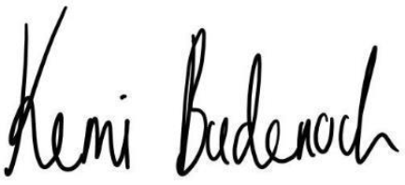

Rt Hon. Kemi Badenoch MP
Minister for Women and Equalities, Secretary of State for Business and Trade and President of the Board of Trade

